
4th International Conference
″SCIENCE AND HIGHER EDUCATION IN FUNCTION OF SUSTAINABLE DEVELOPMENT″
SED 2011
7th and 8th of October 2011, Uzice, Serbia

TITLE OF THE PAPER (Times New Roman - TNR 14 pt Bold)

First A. Author¹, Second B. Author², Third C. Author¹, … (TNR 11 pt Bold)
¹ Association name, City, COUNTRY, e-mail (TNR 10 pt)
² Association name, City, COUNTRY, e-mail (TNR 10 pt)

Summary (TNR 9 pt Bold, italic): The length of abstract maximally 8 line, type of font TNR 9 points normal, left and right centered.
Keywords (TNR 9 pt Bold, italic): keywords 1, keywords 2, keywords 3, keywords 4, keywords 5 (max. 5 TNR 9 pt)

1. INTRODUCTION (Title of chapter TNR 11 pt Bold)

These are the guidelines how to prepare a paper for the proceedings of the 4th SED 2011. They are written in the format that is being described. Please follow these instructions.

2. TECHNICAL REQUIREMENTS

Papers should be written in English or another world language (Times New Roman – TNR 10 pt normal).
Writing technique: text editor MS Word 95 or upgraded.
The length of the paper is limited to 6 (six) pages.
For the paper to be published it is necessary to send: in paper form printed on the laser printer and CD/DVD ROM by regular mail or in electronic form by e-mail: sed@vpts.edu.rs. Deadline for full paper submission is 20th of September 2011.
Announcement to the authors of accepting the paper and the final program will be sent until 1st of October 2011.

2.1. Format

Preferably use A4 (297x210 mm²) page (by ISO 216 and ISO 478) format with margins (mm): 25 top, bottom, left and right.

2.2. Tables

Each table is numbered and table captions are in TNR 10 pt, placed above the table, centered and have the following style.

Table 1: Table caption
Column 1 | Column 1 | Column 1
Row 1 | Row 1 | Row 1
Row 2 | Row 2 | Row 2
Row 3 | Row 3 | Row 3

2.3. Figures

Figures should be numbered. Please do not insert text boxes over the figures. Figure caption is in TNR 10 pt, placed below the figure, centered and has the following style:

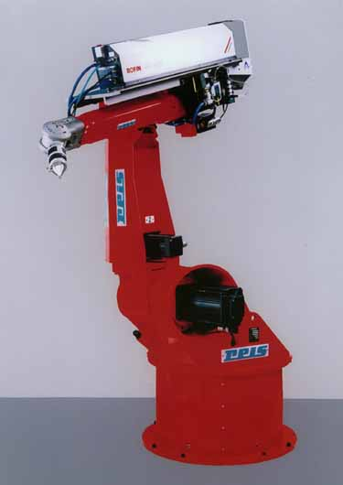
Figure 1: Figure caption

2.4. Equations

Equations are left justified 5 mm from left margin, with equation number at the right margin in font TNR 10 pt Italic.
$R_{a}=\text{ 0,65}⋅R_{\text{max}}^{0,9}$ (1)

3. CONCLUSION

Paper delivered after the due date or in incorrect form, will not be published in the proceedings.

REFERENCES

References should be indicated in the text using consecutive numbers in square brackets, e. g. [1]. In the bibliography (by ISO 690-1 and ISO 690-2) they should be cited including the title of the paper:

- ĐURIČIĆ, R.M.: Savremene menadžerske metode, IR-MIR, Užice, 2003.
- ĐURIČIĆ, R.M.: Innovation activity in metalworking business systems of Zlatibor district, Introduction article on conference “Innovation and competitions of metalworking industry”, Regional Economy Chamber, Uzice, Serbia, March 2008.
- AKSENTIJEVIĆ, S.; ĐURIČIĆ, M.; MILUTINOVIĆ, S.: Improvement of environment protection polluted by fossil fuels, First national life quality conference “Quality festival”, 10-13. May 2006., Kragujevac. Aveilableat:http://www.cqm.rs/fq2006/pdf/B/11%20Aksentijevic%20S.,%20Djuricic%20M.,%20Milutinovic%20S..pdf
[4] http://www.ekoplan.gov.rs.

