COMPARATIVE OVERVIEW OF SUSTAINABLE TOURSM IN PROTECTED NATURAL RESOURCES

M. Sc. Marija Perić¹; Dr Slobodanka Stankov²
¹ Faculty of Geography, Belgrade, SERBIA, maki.peric84@gmail.com
² Western Serbia Academy Applied Studies, College of Applied Sciences Užice, Užice, SERBIA, markovicsslobodanka@gmail.com

Abstract: In order to be competitive, the tourism industry must offer unique and innovated tourism products and attractions world demanded. Following the world tourism trends development, the recommendation is return to the traditional and nurture authentic landscapes that are represent the starting point for the development of tourist underdeveloped and developing countries. Under the influence of tourism, the transformation of space can be affirmative or negative. The main goal of the paper is pointing out the advantages and disadvantages, i.e. similarities and differences in the current and future development of ecological tourism in two protected natural assets: the river Gradac gorge and the river Trešnjica gorge. By applying adequate methods, general and special, correlation between protected objects of nature (rivers Gradac and Trešnjica) will be established. With assumed based on other examples (from the world, Europe and region), experience and knowledge will enable better integration of protected areas and their roles in the tourist offer of Serbia. If the environment is more preserved, untouched and more attractive, then there are more favorable opportunities for the ecological tourism development in a particular area.

Key words: protected natural assets; sustainable development; the river Gradac gorge; the river Trešnjica gorge; ecological tourism

1. INTRODUCTION
Ecotourism is a leading tourism industry that is in great demand in many countries. It must have authenticity and originality. Due to the transformation caused by ecotourism, the space can have: short ˗ term and long ˗ term effects. The short ˗ term effects that leave great consequences are air, water and soil pollution due to the construction of tourist infrastructure, in a word, landscape degradation. The long ˗ term effects of ecoturism in one area relate to the: protection of space, the adoption of legal meausures and the adoption of planning documents. Development of plans for special purpose areas can be short ˗ term, medium ˗ term and long ˗ term [1, 2, 3, 4].
Tourism in protected areas of the rivers Gradac and Trešnjica is reflected in the insufficient application of the concept of sustainable tourism development. Tourist movements must be based on a limited number of vistors up to twenty. The local population should participate in the promotion, marketing and creation of tourist contents of the rivers Gradac and Trešnjica. In the future, accommodation for visitors, food, touris guide services and transportation should be provided. The most necessary thing is to create your own tourist brand that contributes to the succesfful development of ecotourism. The diversity of natural and anthropogenic touris values (rivers Gradac and Trešnjica) enables the creation of complex tourism with the application of the concept of sustainable tourism [5].

2. RESEARCH METHODOLOGY

The research in this paper refers to the explanation of relevant indicators that affects the development of ecotourism in the protected areas of the rivers Gradac and Trešnjica. It is necessary to point out the importance of their planning on the tourst market. The paper will present a comparative overwiev of the gorges of the rivers Gradac and Trešnjica: similarities and disadvantages, advantages and differences. PEST and SWOT analysis were used in the paper.
Based on the obtained results, additions, changes, improvements can be made by applying various measures or following the positive examples of protected areas in the country and the region. The main purpose is to better place sustainable tourism on the tourism market.

3. SIMILARITES AND DIFFERENCES OF THE GORGES OF THE RIVERS GRADAC AND TREŠNJICA

There are many similiraties and differences between the two protected natural assets. The basic similiraties between the rivers Gradac and Trešnjica are: there are solid conditions for the development of ecotourism, hunting, and fishing (California trout/Special Nature Reserve gorge of the river Trešnjica); rich biodiversity of (flora and fauna); second and third degree of protection (for sensitive species a strict protection regime); solid application of the concept of sustainable development; for both protected natural assets there is the protected are manager (Ecologikal society Gradac and the Tourist Organization of the Municipality of Ljubovija); at the very entrance of the rivers Gradac and Trešnjica there is an information center that serves to provide basic information and data, ie natural and anthropogenic values of protected natural assets; in the immediate vicinity of the rivers Gradac and Trešnjica there is a shop selling souvenires, handicrfts and homemadefood; the highest attendace of protected natural assets during the spring and autumn (school excursions, hunters and fishermen); during the summer, tourists, enthusiasts and nature lovers mostly stay on the rivers Gradac and Tršnjica (active and passive holidays) [6, 7, 8, 9, 10].
Between the two protected natural assets, there are a number of different factors that affect the tourist content offered to visitors. They are the most important:
- A large number of information boards in the gorge of the river Gradac (about five), and in the gorge of the river Trešnjica two; [11, 12].
- The gorge of the river Gradac has a large number of speleological objects (about 60). The most important caves are: Degurićka, Kaljava, Vrataoca, Tmuša and Visoka. The gorge of the river Trešnjica has a large number of hydrological facilities: Tribuća, Crni Potok and Sušica [13, 14].
- Accommodation and catering facilities in the protected natural asset Gradac are located in the immediate vicinity, while in the protected natural asset Trešnjice in the immediate vicinity.
- The authentcity of the gorge of the river Gradac refers to the archeological sites Valva and Jerinin town, watermills Lelićka, Savatijevićeva and Filipovića. From the anthropogenic tourist potentilas, the monastery of Ćelije, which was plased under the protection of the state, as a cultural asset of great importnace [15, 16, 17, 18, 19, 20, 21].
- The authentcity of the natural resource of the river Trešnjica is reflected of a colony of griffon vultures. The most important cultural and historical values are Veliki and Mali town and the village of Gornja Trešnjica, which has been placed under state protection [22, 23, 24, 25, 26].
- In the gorge of the river Gradac, there are well˗arranged hiking trails, unlike the protected natural asset of Trešnjica, where only 10 km are arranged and for further tours, appropriate hiking equipment is necessary.

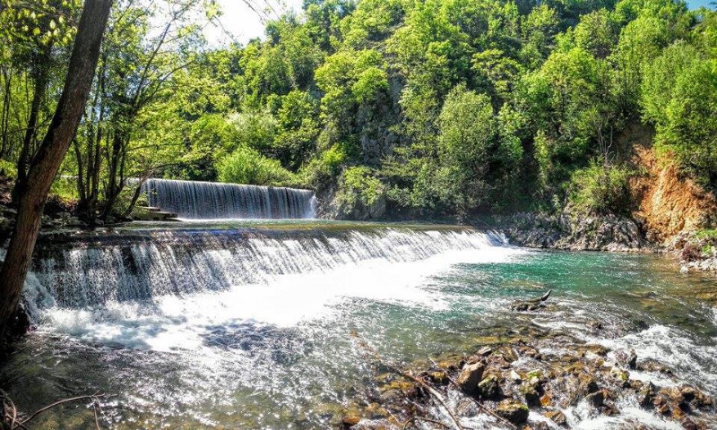
Figure 1 Gradac river
3.1. Advantages and disadvantages in protected natural resources

The main advantages in the protected natural assets of the gorges of the rivers Gradac and Trešnjica are that they favor and enable the development of specific types of tourism. These are ecological, cultural, speleological, hunting and fishing, manifestation, transit, weekend tourism, rural and youth tourism. Thanks to the rich tourist content (which is listed and described in detail in the previous chapter), there are visitors throughout the year, and mostly in the season. During the spring and autumn months, school excursions are mostly held. When visiting protected natural assets, they observe the landscape, acquire new knowledge and at the same time practice active/passive rest. At the same time, they combine beautifully and usefully.
Protected natural assets are located near the town centres of Valjevo and Ljubovija, and are therefore included in the tourist content and promotion of local govorments, regions and districts (Kolubarski). The local population is quite involved in the realization of tourist programs and facilities. They provide visitors to the gorges of the rivers Gradac and Trešnjica accommodation, food, services of a local tourist guide, means of transport and the sale of folk handicrafts.
The main shortcomings of protected natural assets relate to insufficient promotion, marketing and insufficient affirmation in the tourism market.
In the future, pay more attention to the presentation of tourist contenst of protected natural assets of the rivers Gradac and Trešnjica at fairs, seminars, congresses. It is necessary to employ people who are adequately educated for certain functions, to pay more attention to the personal employment policy.

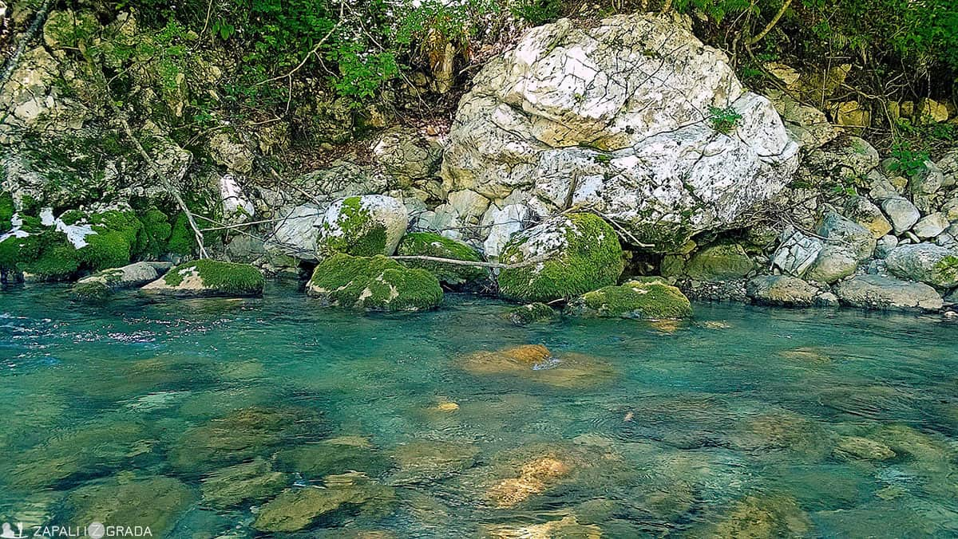
Figure 2. Trešnjica river

4. CONCLUSION
Ecological tourism in order to play a leading role in the tourism economy should possess the following characteristics of authenticity, curiosity, representativeness and originality. These are the feautures that distinguish them from other selectives types of tourism.
Sustainable tourism in the protected natural assets of the gorge of the rivers Gradac and Trešnjica represents a very important tourist offer of the Kolubara district, thanks to the natural and anthropogenic tourist values. In order for tourism to be successfully manifested on the tourist market, it is necessary to develop strategies for sustainable tourism development, spatial plans for special purpose areas, projects and studies. Based on these documents, which can be short˗term, medium˗term and long˗term, the guidelines, potentilas and perspectives of ecological tourism in this part of Serbia are determined. Based of these assumptions and possitive examples from nearby countries, which would be desirable to apply in practice, sustainable tourism would gain greater importance and affirmation in the torism market.

REFERENCES:
[1] Bartula, M. Menadžment životne sredine. Beograd: Fakultet za primenjenu ekologiju Futura; 2016.
[2] Martinić, I. Upravljanje zaštićenim područjima prirode: Planiranje, razvoj i održivost. Zagreb: Šumarski fakultet; 2010.
[3] Stojanović, V. Turizam i održivi razvoj. Novi Sad: Prirodno-matematički fakultet, Departman za geografiju, turizam i hotelijerstvo; 2011.
[4] Weaver, B. D. Comprehenesive and minimalist dimensions of ecotourism. Annals of Tourism Research, Vol. 32, No. 2, pp. 439-455; 2005.
[5] Николић, С. Туризам у заштићеним природним добрима Србије. Београд: Завод за заштиту природе Србије; 2006
[6] Спасојевић, М. Рељеф слива Трешњице (Положај, границе и ранија испитивања у сливу Трешњице). Гласник Српског географског друштва, свеска 59 бр.1, 11-25; 1979.
[7] Јовановић, В., Хегедиш, А., и Станисављевић, П. Ихтиофауна реке Градац. У: Јаневски, Б., Јовановић, Д., и Катић, М. (ур.), Монографија Река Градац, 69-76. Ваљево: ЕКОД „Градацˮ; 2002.
[8] Јовановић, В., Хегедиш, А., и Станисављевић, П. Живот на дну Градца. У: Јаневски, Б., Јовановић, Д. и Катић, М. (ур.), Монографија Река Градац, 77-84. Ваљево: ЕКОД „Градацˮ; 2002.
[9] Јовановић, В., Хегедиш, А. и Станисављевић, П. Чега све има у води Градца, а није живо. У: Јаневски, Б., Јовановић, Д., и Катић, М. (ур.), Монографија Река Градац, 65-68 Ваљево: ЕКОД „Градацˮ; 2002.
[10] Hegediš, A., Stanisavljević, P., & Jovanović, V. Ribe Gradca. Valjevo: Agencija „Konakˮ i Ekološko društvo Gradac; 1994.
[11] Трнавац, Д. Дегурићка пећина у кањону реке Градац. У Јаневски, Б., Јовановић, Д. и Катић, М. (ур.) Монографија река Градац, 39 – 50. Ваљево: ЕКОД „Градац“; 2002.

[12] Петровић, П. Сисари као део фауне клисуре реке Градац. У Јаневски, Б., Јовановић, Д. и Катић, М. (ур.) Монографија Река Градац, 51-54. Ваљево: ЕКОД „Градац“; 2002.

[13] Раковић, М. Птице слива реке Градац. У Јаневски, Б., Јовановић, Д. и Катић, М. (ур.) Монографија Река Градац, 55-60. Ваљево: ЕКОД „Градац“; 2002.

[14] Мајић, В. Гмизавци и водоземци Градца. У Јаневски, Б., Јовановић, Д. и Катић, М. (ур.) Монографија Река Градац, 61-64. Ваљево: ЕКОД „Градац“; 2002.

[15] Катић, М. Антрпогени утицаји. У Јаневски, Б., Јовановић, Д. и Катић, М. (ур.), Монографија Река Градац, 85-90, Ваљево: ЕКОД „Градац“; 2002.

[16] Старовић, А. Археологија Градца. У Јаневски, Б., Јовановић, Д. и Катић, М. (ур.), Монографија Река Градац, 99 – 105. Ваљево: ЕКОД „Градац“; 2002.

[17] Јаневски, Б. Сакрални објекти на овом подручју. У Јаневски, Б., Јовановић, Д. и Катић, М. (ур.), Монографија Река Градац, 113-118. Ваљево: ЕКОД „Градац“; 2002.

[18] Matić, V., Janićević, S. & Čerović, S. The Cultural Inheritance of the River Gradac in the Role of Tourism Development in the Area of Valjevo. Geographica Panonica No. 11, 65-69; 2007.

[19] Пјевач, Н. Ваљевске планине-могућности развоја туризма. Београд: Задужбина Андрејевић; 2002.

[20] Stojanović, P. R. Valjevski kraj u vremenu i prostoru (analitičko – komparativni prikaz). Beograd: Kulturno prosvetna zajednica Srbije; 2002.

[21] Јевтић, А. Летопис манастира Ћелије. Ваљево: Манастир Ћелије код Ваљева; 1985.

[22] Грубач, Р. Б. Белоглави суп Gyps fulvus у Србији: диструбуција и бројност, тренд, опасности и проблеми заштите у савременом периоду. Заштита природе бр. 58∕1 – 2, 123-140; 2008.

[23] Грубач, Б. Успешност гнежђења и продуктивност белоглавог супа Gyps fulvus (Hablizl, 1783) у Србији у периоду 2006-2010. године. Заштита природе бр. 64∕2, 41-48; 2014.

[24] Грубач, Б. Исхрана белоглавог супа Gyps fulvus у Србији. Заштита природе 60∕1 ‒ 2, 181-188; 2009.

[25] Грубач, Б. Монографија Белоглави суп Gyps fulvus. Београд: Завод за заштиту природе Србије; 2014.

[26] Ћирић, В., Николић, М., Ћеранић, З., Стаменић, Д. & Крстивојевић, М. Тешњар кроз три века. Ваљево: Завод за заштиту споменика културе Ваљево; 2008.

