**EXPLORING FIBONACCI NUMBERS USING MATLAB**

**Dr Ljubica Dikovic1**

1 Business-Technical College, Uzice, SERBIA, e-mail (dikoviclj@gmail.com)

***Abstract:*** *In this paper author is going to explore a very interesting sequence of numbers known as the Fibonacci sequence. The exploration of the sequence can lead to a creative classroom activity for students at the college level. Students can explore many patterns within the sequence using software like MATLAB, and the observations can lead to an enriching discussion in the classroom.* *This paper for advanced undergraduates and graduate students surveys the use of Fibonacci numbers in areas of mathematics and computer science. There are numerous examples of Fibonacci numbers and the golden ratio in nature which students can explore in the form of a project*.

***Key words:*** *recursion, Fibonacci numbers, Golden ratio, MATLAB*

1. **INDUCTION AND RECURSION**

Mathematical induction is a method for proving statements that have the form:

.

Mathematical induction consists of three steps:

* A base case: A particular statement, say  that is true.
* An inductive hypothesis: Assume we know  is true.
* An inductive step: If we know  is true, we can infer that  is true,

or symbolically,

.

There is a close connection between induction and recursive definitions: induction is perhaps the most natural way to reason about recursive processes. The most common application of recursion is in mathematics and computer science, where a function being defined is applied within its own definition. Or, we can say that recursive process is one in which objects are defined in terms of other objects of the same type.

Formally, an inductive definition of a set describes the elements in a set in terms of other elements in the set. For example, one definition of the set  of natural numbers is:

1. 1 is in .
2. If an element  is in  then +1 is in .
3.  is the intersection of all sets satisfying (1) and (2).

Properties of recursively defined functions and sets can often be proved by an induction principle that follows the recursive definition. For example, the definition of the natural numbers presented here directly implies the principle of mathematical induction for natural numbers: if a property holds of the natural number 0, and the property holds of n+1 whenever it holds of n, then the property holds of all natural numbers. [1], [2], [7]

1. **FIBONACCI SEQUENCE**

The Fibonacci sequence is a sequence of numbers where each term of the sequence is obtained by adding the previous two terms. In addition, this special sequence starts with the numbers 1 and 1. The Fibonacci sequence can also be started with the numbers 0 and 1 instead of 1 and 1 (see Table 1.).

Thus, the whole Fibonacci sequence can be generated starting with these two numbers and the above special rule. The numbers in this sequence are called Fibonacci numbers. These numbers were first obtained by the Italian mathematician Leonardo of Pisa (also called Leonardo Fibonacci) in the thirteenth century. In 1202, Fibonacci asked: „A man put a pair of rabbits in a place surrounded on all sides by a wall. How many pairs of rabbits can be produced from that pair in a year if it is supposed that every month each pair begets a new pair which from the second month becomes productive?“

Fibonacci numbers are closely related to exponential growth in nature. Botanists noticed that there are many plants that tend to have a Fibonacci number for the leaves and petals. Fibonacci numbers also appear prominently in the family tree of rabbits. Actually, Leonardo Fibonacci first noticed these numbers when he studied the problem of breeding of rabbits under ideal circumstances.

The Fibonacci Association is a mathematical organization that specializes in the Fibonacci number sequence and a wide variety of related subjects, generalizations, and applications, including recurrence relations, combinatorial identities, binomial coefficients, prime numbers, pseudoprimes, continued fractions, the golden ratio, linear algebra, geometry, real analysis, and complex analysis. [4]

The sequence of Fibonacci numbers is defined by the recurrence relation:

{\displaystyle F_{n}=F_{n-1}+F_{n-2},}

with seed values

{\displaystyle F_{1}=1,\;F_{2}=1}.

The sequence of numbers obtained this way is

0, 1, 1, 2,3, 5, 8, 13, 21, 34, 55, 89, 144, 233, … is called the Fibonacci sequence.

Below is a Table 1 of the first 24 Fibonacci numbers.

|  |  |  |  |
| --- | --- | --- | --- |
|  |  |  |  |
|  |  |  |  |
|  |  |  |  |
|  |  |  |  |
|  |  |  |  |
|  |  |  |  |

Table 1. The first 24 Fibonacci numbers

Characteristic plynomial approach is to let to be a characteristic polynomial ,



with the roots

.

The general solution to equation will be all possible combinations of roots  and :



Constants A and B can be found from the boundary conditions  and ,

.

Fibonacci numbers were obtained:



Fibonacci Identities:

* Identity Number One



* Identity Number Two



* Identity Number Three

 [8]

1. **FIBONACCI NUMBERS IN MATLAB**
   1. **MATLAB CODE FOR GENERATING FIBONACCI NUMBERS**

The MATLAB function for generating the Fibonacci sequence up until the n-th term, is illustrated below:

function f=fibonacci(n)

% This function generates the first n Fibonacci numbers

f = zeros(n,1);

f(1)=1;

f(2)=1;

for k = 3:n

f(k) = f(k-1) + f(k-2);

end

end

MATLAB script for generating the Fibonacci sequence up until the 1000-th term, is illustrated below:

>> n(1) = 1;n(2) = 1;

>> k=3

>> while k <= 1000

n(k) = n(k-1)+n(k-2);

k=k+1;

>> end

Or, simply:

>> n = 1:1000;

>> fibonacci(n)

* 1. **GOLDEN RATIO AND GOLDEN SPIRAL**

In mathematics and arts, two quantities are in the golden ratio if the ratio of the sum of the quantities to the larger quantity equals the ratio of the larger quantity to the smaller one.

The ratio of successive Fibonacci numbers converges to the golden ratio. The golden ratio is an irrational constant, approximately 1.618033988.

To the Fibonacci Numbers, the Golden Ratio is the limit as n goes to infinity of . The Golden Ratio is one of the solutions to the equation .

Identity Number Three  means that the sum of the squares of the first n Fibonacci numbers is equal to the product of the nth and the (n + 1)st Fibonacci numbers. Below is a geometric representation of this formula, in which the numbers represent the side length of each square (see Picture 1). Here's an example of the sequence revealing itself in nature.

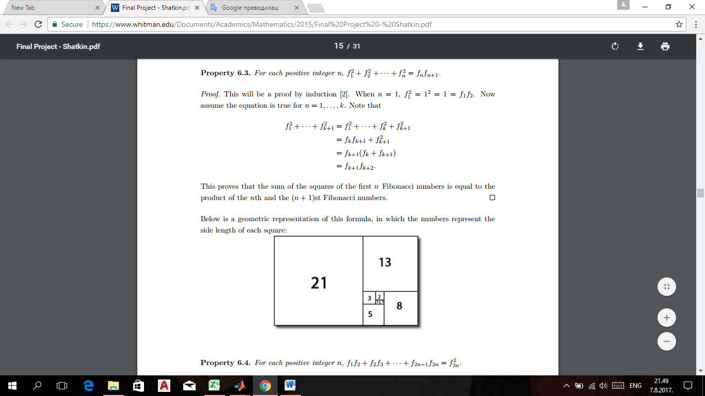 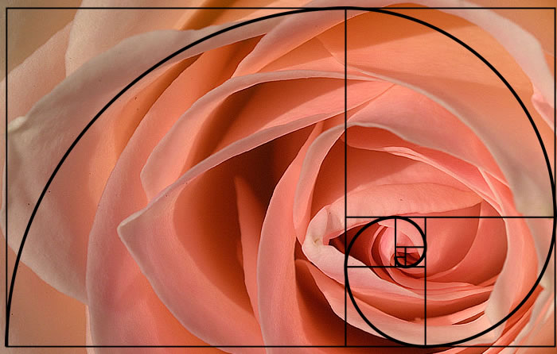

Picture 1. Geometric representation of the formula 

The appropriate MATLAB code is

%Clear screen and memory

clear; clc; format compact

% Initial values for f(1), f(2)

f(1) = 1;

f(2) = 1;

% Create the first 50 Fibonacci numbers  
for i = 3 : 50  
    f(i) = f(i-1) + f(i-2);  
    % Calculate and display the ratio of 2 consecutive elements   of the series  
    zlatni_presek = f(i)/f(i-1);  
    prikaz = [num2str(f(i)) ' ' num2str(f(i-1)) ' '  num2str(zlatni_presek, 10)];  
    disp(prikaz)  
end

We can notice that the quotient of two consecutive numbers reaches the 'golden ratio' after just a few numbers in the series:

75025 46368 1.618033989

121393 75025 1.618033989

196418 121393 1.618033989

317811 196418 1.618033989

514229 317811 1.618033989

832040 514229 1.618033989

The Fibonacci numbers are commonly visualized by plotting the Fibonacci spiral. The Fibonacci spiral approximates the golden spiral.

Below is shown a code to approximate the golden spiral for the first 6 Fibonacci numbers. [10]

x = 0;

y = 1;

syms v u

axis off

hold on

for n = 1:6

a = fibonacci(n);

% Define squares and arcs

switch mod(n,4)

case 0

y = y - fibonacci(n-2);

x = x - a;

eqnArc = (v-(x+a))^2 + (u-y)^2 == a^2;

case 1

y = y - a;

eqnArc = (v-(x+a))^2 + (u-(y+a))^2 == a^2;

case 2

x = x + fibonacci(n-1);

eqnArc = (v-x)^2 + (u-(y+a))^2 == a^2;

case 3

x = x - fibonacci(n-2);

y = y + fibonacci(n-1);

eqnArc = (v-x)^2 + (u-y)^2 == a^2;

end

% Draw square

pos = [x y a a];

rectangle('Position', pos)

% Add Fibonacci number

xText = (x+x+a)/2;

yText = (y+y+a)/2;

text(xText, yText, num2str(a))

% Draw arc

interval = [x x+a y y+a];

fimplicit(eqnArc, interval, 'b')

end



Picture 2. Golden spiral for the first 6 Fibonacci numbers.

Finally, we will show a short MATLAB function which uses the above formula to compute any Fibonacci number. The MATLAB code for the function ffib(n) is shown below:

function [ ffib ] = fib( n )

ffib = ((1+sqrt(5))^n -(1-sqrt(5))^n) /(sqrt(5)*2^n);

end

For example, performing this function we get the following values:

>>ffib(8)

ans = 21.0000

>>ffib(5)

ans = 5.0000

>>ffib(10)

ans = 55.0000

* 1. **GOLDEN FLOWER AND SPIRALS**

The MATLAB script for modeling golden flower and spirals is shown below [9]:

phi = 1/2*(1 + sqrt(5));

n = 2^10;

c = ones(n,1);

c(:) = 1:1024;

x = sqrt(c) .* cos(2*pi*phi*c);

y = sqrt(c) .* sin(2*pi*phi*c);

% To draw 50-spiral for Fibonacci number 50, starting from 1

plot(x,y, '*')

ss = 1:50:n;

plot(x,y, '*')

hold on

plot(x(ss), y(ss))



Picture 3. Golden flower and spirals

**4. CONCLUSION**

Fibonacci numbers, Fibonacci spiral, and the golden ratio are found everywhere and possess wonderful and amazing properties. Fibonacci numbers cover a wide range of interest in modern mathematics. The exploration of the Fibonacci numbers can lead to an creative classroom activity for students at the college level. There are numerous examples of Fibonacci numbers and the golden ratio in nature which students can explore in the form of a project. Students can explore many patterns within the sequence using a software like MATLAB, and the observations can lead to an enriching discussion in the classroom.

**LITERATURE**

[1] http://www.cs.cornell.edu/courses/cs280/2005fa/induction.pdf

[2] ACZEL, P. : *An introduction to inductive definitions*, Handbook of Mathematical Logic, J. Barwise (ed.), [ISBN](https://en.wikipedia.org/wiki/International_Standard_Book_Number) 0-444-86388-5, 1977.

[3] MATLAB Guide to Fibonacci Numbers and the Golden Ratio: A Simplified Approach, Available from: <https://www.researchgate.net/publication/301358476_MATLAB_Guide_to_Fibonacci_Numbers_and_the_Golden_Ratio_A_Simplified_Approach> [accessed Aug 5, 2017].

[4] <http://www.mscs.dal.ca/Fibonacci/>

[5] <http://www.purplemath.com/modules/nextnumb3.htm>

[6] <http://www.matrixlab-examples.com/fibonacci-numbers.html>

[7] <https://www1.maths.ox.ac.uk/system/files/attachments/induction.pdf>

[8] <http://math453fall2008.wikidot.com/lecture-32>

[9] <http://www.sacema.org/uploads/Flower.pdf>

[10] <https://www.chegg.com>

[11] B. Singh, K. Sisodia and F. Ahmed, “On the Product of k-Fibonacci numbers and k-Lucas numbers” International Journal of mathematics and mathematical science 2014.

[12] M. Thongmoon, “Identities for the common factor of Fibonacci and Lucas numbers” International Mathematical forum, 4(7)(2009), 303 – 308.

[13] P. Catarino, “On some identities and generating function for k-Pell numbers” International Journal of mathematical analyses, 7(30)(2013), 1077-1084.

[14] Y.K. Panwar, G.P.S. Rathore, R. Chawla, “ On sums of odd and even terms of the k- Fibonacci numbers” Global Journal of Mathematical Analysis, 2(3)(2014), 115-119.