**SOME OPTIMIZATION OF MATLAB-BASED NUMBER PLATE RECOGNITION ALGORITHM**

**Hana Stefanovic1, PhD; Radosav Veselinovic2, MSc; Dejan Milic3, PhD**

1 Comtrade Information Technology School of Applied Studies, Belgrade, SERBIA,   
[stefanovic.hana@yahoo.com](mailto:stefanovic.hana@yahoo.com), [hana.stefanovic@its.edu.rs](mailto:hana.stefanovic@its.edu.rs)

2 Faculty of Economics, Belgrade, SERBIA, [veselinovic.ceda@gmail.com](mailto:veselinovic.ceda@gmail.com)

3 Faculty of Electronic Engineering, Nis, SERBIA, [dejan.milic@elfak.ni.ac.rs](mailto:dejan.milic@elfak.ni.ac.rs)

***Summary:*** *In this paper some optimizations of a simple MATLAB-based technique for Automatic Number Plate Recognition (ANPR) are discussed. Digital image segmentation, after resizing image and removing noise, is applied, while some edge detection algorithms and some morphological techniques are also used. Additional spatial filtering, Hough transformation and dynamic threshold filtering are applied to compensate the variables that can affect the ANPR's ability to produce an accurate read, such as time of day, weather and angles between the cameras and the license plates. Free Optical Character Recognition (OCR) software is used to output results, presenting detected number plates.*

***Keywords:*** *Automatic Number Plate Recognition (ANPR), digital image processing, Hough transformation, Optical Character Recognition (OCR)*

**1. INTRODUCTION**

Automatic Number Plate Recognition (ANPR) is a technology that is used to help detect, deter and disrupt criminality at a local force, regional and national level, including tackling travelling criminals or organized crime groups [1].ANPR is used for locating stolen vehicles, tackling uninsured vehicle use and solving cases of terrorism, and also for electronic toll collection, on pay-peruse roads, as a method of cataloging the movements of traffic [2], [3]. It uses an optical character recognition on digital image to detect and output vehicle registration plate.

An algorithm proposed in this paper includes plate localization for different orientations, removing noise from digital image, normalization and segmentation character region, and finally optical character recognition (OCR), used to output the results.

Image segmentation is the process of partitioning a [digital image](https://en.wikipedia.org/wiki/Digital_image) into multiple segments or categories presented with [sets](https://en.wikipedia.org/wiki/Set_(mathematics)) of [pixels](https://en.wikipedia.org/wiki/Pixel) [4]. The goal of segmentation is to simplify and/or change the representation of an image into something that is more meaningful and easier to analyze [5]. Image segmentation is typically used to locate objects and some [boundaries](https://en.wikipedia.org/wiki/Boundary_tracing), like lines, curves, etc., in digital image. The result of image segmentation is a set of segments that collectively cover the entire image, or a set of [contours](https://en.wikipedia.org/wiki/Contour_line) extracted from the image. Each of the pixels in a region is similar with respect to some characteristic or computed property, such as [color](https://en.wikipedia.org/wiki/Color), texture or [intensity](https://en.wikipedia.org/wiki/Luminous_intensity) [6]. Image segmentation is typically used to identify objects or other relevant information in digital images. There are many different ways to perform image segmentation, including: thresholding methods such as Otsu’s method, color-based segmentation methods such as *K*-means clustering, transform methods such as watershed segmentation, and texture methods such as texture filters [7]. In this paper edge detection techniques based on Sobel algorithm [8] are applied, in order to increase the difference between the letters and the plate backing.

An effective approach to perform image segmentation includes different algorithms, tools, and a comprehensive environment for data analysis, visualization, and algorithm development. Some of them, available in MATLAB Image Processing ToolboxTM [9], [10] are used in this paper, in order to segment a color digital image into regions, to detect edges and also in order to have a simpler processing of the image.

In algorithm proposed in this paper some spatial information from a histogram-based windowing process are used [9], while a sliding window approach is applied at various scales. In order to simplify generating and processing test images, and also in order to reduce computational requirements, it is decided to operate on gray-scale images, with relatively small input resolution, but large enough for number plates to be somewhat readable. It is also supposed that the text is a certain amount darker than the plate, since retro-reflective plates are tested and captured. Retro-reflective plates reflect infrared (IR) light very well and it is undetectable for the human eye, providing constant good image quality during day and night.

After isolating the plate on the image and after its conversion from RGB layers to gray-scale layer, the contrast and brightness of the image are adjusted. A Median filter is used to reduce the noise from image, while Sobel edge detector is applied in order to increase the difference between the letters and the plate backing [11]. The Hough transform is used to isolate features of a particular shape within an image [12], [13], when the plate is partially truncated. After analyzing the horizontal and vertical projection and character segmentation, some OCR free tools, like Free Image OCR, Free Easy OCR, OnlineOCR, Recognita etc.are applied [14], [15].

An algorithm proposed in this paper depends on some country-specific rules for the plate, while the syntax-based corrections are not analysed.

**2. ALGORITHM OBJECTIVES AND OPTIMISATION STRATEGIES**

An original image captured using standard smartphone camera is presented in Fig.1. A 41.3 MP image sensor with Carl Zeiss optics and Xenon flash (Nokia Lumia 1020) is used for all test images given in this paper, while modern ANPR systems uses professional cameras, specifically designed for the task [1].



**Figure 1:** Original image

The results after converting original RGB image into gray-scale, and after applying binarization are presented in Fig.2. Binarization converts a pixel image into a binary image, and can be useful for clearing objects less than a threshold value, e.g. vehicle logo or country flag. The binarization threshold can either be set fixed or adaptive, using a clustering algorithm [9]. Results after applying different threshold values for binarization are illustrated in Fig.2, in order to remove the Mercedes-Benz logo.

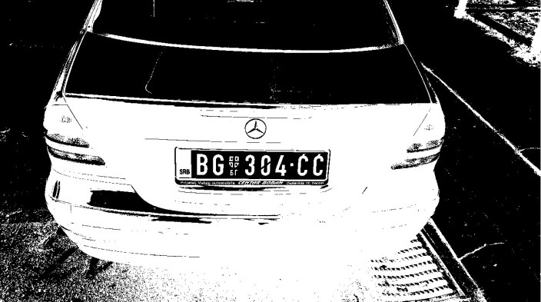 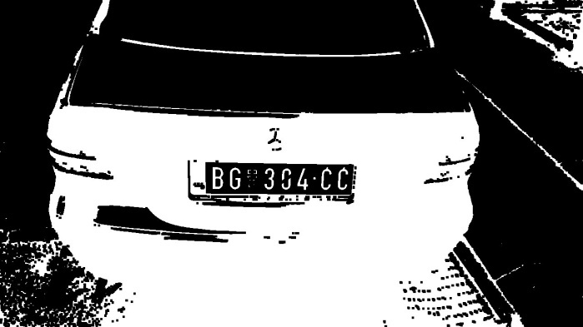

**Figure 2:** Different binarization threshold values applied in order to eliminate the Mercedes-Benz logo

Results after applying Median filter [10] in order to remove a noise and Sobel detector [8] in order to increase the difference between the letters and the plate backing are given in Fig.3a). Median filtering is a nonlinear operation often used in image processing to reduce noise and it is more effective than convolution when the goal is to simultaneously reduce noise and preserve edges [6]. An object can be easily detected in an image if the object has sufficient contrast from the background, as it is illustrated in Fig.3.

Sobel detection is an image processing technique for finding the boundaries of objects within images, based on detecting discontinuities in brightness [4]. It is realized using MATLAB edge function and the result is given in Fig.3b). The binary gradient mask shows lines of high contrast in the image. These lines do not quite delineate the outline of the object of interest. When compared to the original image, there are some gaps in the lines surrounding the object in the gradient mask. These linear gaps will disappear if the Sobel image is dilated using linear structuring elements, which can be realized using strel function in MATLAB [16], [17]. The result after applying basic morphological operations (dilation and erosion) is given in Fig.3c), d).



a) b)

 

c) d)

**Figure 3:** **a)** result after removing noise using Median filter **b)** result after detecting edges using Sobel operator   
**c)** result after applying basic morphological operations **d)** eliminating the Mercedes-Benz logo

Horizontal and vertical image projection are analysed in order to detect an area of the number plate according to a statistics of the snapshot [18]. The vertical projection of the image is a graph, which represents an overall magnitude of the image according to the axis *y*. If we compute the vertical projection of the image after the application of the vertical edge detection filter, the magnitude of certain point represents the occurrence of vertical edges at that point. Then, the vertical projection of so transformed image can be used for a vertical localization of the number plate, as it is illustrated in Fig.4a). The horizontal projection represents an overall magnitude of the image mapped to the axis *x*. The characters are segmented according to spaces detected in its horizontal projection. This projection is used to determine horizontal boundaries between characters, while the boundaries correspond to peaks in the graph of the horizontal projection [18], as it is illustreted in Fig.4b).



a) b)

**Figure 4:** **a)** Vertical projection **b)** Horizontal projection

Results after character segmentation are given in Fig.5a), while the result after applying free OCR software tool [14], [15] is illustrated in Fig.5b). Segmentation is based on the fact that the characters of the plate have a certain range of aspect ratio and a certain range of number of pixels.

After removing the noise, adaptive filter is applied to make the effect of thinning the characters in order to make sure that no two components are merged. Detecting the boundaries between the characters is followed by a horizontal projection, in order to be able to cut them individually, as it is illustrated in Fig.5a). The peaks in horizontal projection correspond to the gaps between the characters, which could be also used in a rejection process, since a true plate has a fixed range of gaps between characters. The gray level histogram is computed for the sub-image of each character. Gray level histogram of each character would have a standard shape which is one peak at the dark values, corresponding to the character’s pixels, and another peak at the bright values, corresponding to the background, and some small values between them. Some free OCR software tools, like SimpleOCR, TopOCR, FreeOCR OnlineOCR, Recognita etc also give good results [14], [15], as it is illustrated in Fig.5b).

 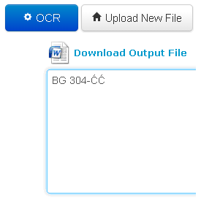

a) b)

**Figure 5:** **a)** Characters segmented according to the horizontal projection peaks **b)** Result after applying some free OCR software tools

**3. EXPERIMENTAL RESULTS IN SOME SPECIFIC SITUATIONS**

Some confusion between character “B” and digit “8”, character “G” and digit “6”, or character “O” and digit “0”, and also mark of Mercedes Benz, are analyzed in this section. The very small difference between these characters makes their recognition extremely difficult, in many situations impossible.

Fig.6 presents the situation when different eroding and dilating elements are used in order to detect difference between character “G” and digit “6”. Also, the Hough transform [12], [13] is used to evaluate its skew angle and to find and link line segments in an image.





**Figure 6:** Detection of skewed plates and applying different morphological techniques in order to detect difference between character “G” and digit “6”

Fig.7. presents the situation when different eroding and dilating elements are used in order to detect difference between character “O” and digit “0”, including an elimination of Mercedes-Benz logo.



**Figure 7:** Using different morphological techniques in order to detect difference between character “O” and digit “0” and in order to eliminate the Mercedes-Benz logo

Fig.8 presents the situation when different eroding and dilating elements are used in order to detect difference between characters “G” and “B” and digits “6” and “8”.







**Figure 8:** Detection of skewed plates and applying different morphological techniques in order to detect difference between characters “G” and “B” and digits “6” and “8”

For imperfect detection conditions, some dynamic threshold filtering techniques are used, while the plate candidates are segmented by a deeper analysis. The maximum value of peak in vertical projection is analyzed, before and after filtering, as it is illustrated in Fig.9a), while the license plate localization and license plate candidates’ segmentation are done according to horizontal edge processing histogram, presented in Fig.9b).



a) b)

**Figure 9:** **a)** Vertical edge processing histogram before and after filtering **b)** Horizontal edge processing histogram before and after filtering

Results given in this paper presents that proposed algorithm successfully detects the number plate region from the image, with correct character recognition in many situations.

As it is expected, sets of blurry or skewed snapshots give worse recognition rates than a set of snapshots which has been captured clearly.

Artificial Neural Network (ANN) based OCR or recognition OCR using template matching would improve proposed ANPR algorithm, but it is not analyzed in this paper.

**4. CONCLUSION**

This paper contains description and demonstration of simple MATLAB-based APRN algorithm, including license plate localization, character segmentation and optical character recognition, which means translating the segmented characters into text entries. Algorithm is adaptive and it gives satisfactory results in case of slight variation in the same characters due to noise, but it is developed, used and tested in restricted conditions, specific for number plates in Republic of Serbia. Syntactical analysis of recognized plate is not given in this paper, but automatic syntax-based correction could increase recognition abilities of whole ANPR system, and it will be examined in our future work.

**REFERENCES**

1. PATEL, C.; SHAH, D.; PATEL, A.: “Automatic Number Plate Recognition System (ANPR): A Survey”, *International Journal of Computer Applications*, vol. 69, no. 9, pp. 21-33, 2013.
2. LIHONG, Z.; XIANGJIAN, H.; SAMALI, B; et al.: “Accuracy Enhancement for License Plate Recognition*”, IEEE Int. Conf. on Computer and Information Techol.-CIT 2010*, pp. 511-516, 2010.
3. WEN, Y.; LU, Y.; YAN, J.; ZHOU, Z.; VON DENEEN, K.; SHI, P.: “An Algorithm for License Plate recognition Applied to Intelligent Transportation System”, *IEEE Trans. Intell. Transp. Syst*., vol. 12, no. 3, pp. 830-845, 2011.
4. TRUSSELL, H.J.; VRHEL, M.J.: *Fundamentals of Digital Imaging*,UK: Cambridge University Press, 2008.
5. ARBELAEZ, P.; MAIRE, M.; FOWLKES, C.; MALIK, J.: “Contour Detection and Hierarchical Image Segmentation“, *IEEE Trans. Pattern Anal. Mach. Intell. (TPAMI)*, Vol. 33, No. 5, pp. 898-916, May 2011.
6. POPOVIĆ, M.: *Digitalna obrada slike*, Beograd: Akademska misao, 2006.
7. PRATT, W.K.: *Digital Image Processing*, Inc. New York, NY, USA., John Wiley & Sons, 2007.
8. WANG, W.: “Reach on Sobel Operator for Vehicle Recognition”, *Int. Joint Conf. on Artificial Intelligence*, pp.448-451, 2009.
9. GONZALEZ, R.C.; WOODS. R.E.: *Digital Image Processing*. Upper Saddle River, NJ: Prentice Hall, 2008.
10. GONZALEZ, R.C.; WOODS. R.E.; EDDINS, S.L.: *Digital Image Processing Using MATLAB*, Knoxville, TN: Gatesmark Publishing, 2009.
11. CHONG, J.; TIANHUA, C.; LINHAO, J.: “License Plate Recognition Based on Edge Detection Algorithm”, *Int. Conf. on Intelligent Information Hiding and Multimedia Signal Processing*, pp. 395-398, 2013.
12. DUDA, R.O.; HART, P.E: “Use of the Hough transform to detect lines and curves in pictures“, *Commun. Ass. Comput. Mach*., vol. 15, pp. 11-15, 1972.
13. STEFANOVIC**,** H.; STRBAC-SAVIC, S.; MILIC, D.: “Detection of straight-line segments in digital image using the Hough Transform in MATLAB“, *Int. Conf. Science and Higher Education in Function of Sustainable Development-SED 2015*, pp. 2-1–2-6, 2015.
14. <http://www.onlineocr.net/>
15. <http://www.newocr.com/>
16. ZHANG, X.; XU, F.; SU, Y.: “Research on the Licnese Plate Recognition based on MATLAB”, *Procedia Engineering*, vol. 15, pp. 1330-1334, 2011.
17. LALIMI, M.A.; GHOFRANI, S.; MCLERNON, D.: “A vehicle license plate detection method using region and edge based methods”, *Computers & Electrical Engineering*, vol. 39, no. 3, pp. 834-845, 2013.
18. STEFANOVIC, H.; MILETIC, A.; MILIC, D.; NIKOLIC Z.; BANDJUR, M.: “Implementacija algoritma za izdvajanje obeležja registarskih tablica u MATLAB programskom okruženju“, *Međunarodni simp. INFOTEH 2017*, Jahorina, Bosnia and Herzegovina, pp. 597-602, 2017.