MULTILINGUAL VIDEO MATERIALS FOR STUDYING FUNDAMENTALS OF ELECTRICAL ENGINEERING
Iztok Humar¹, PhD, Srećko Simović², Jasna Ristič³, MSc
¹ University of Ljubljana, Faculty of Electrical Engineering, Ljubljana, SLOVENIA, iztok.humar@fe.uni-lj.si
² School centre Kranj, SLOVENIA, srecko.simovic@guest.arnes.si
³ Electrical Engineering High School ”Nikola Tesla”, Belgrade, SERBIA, jasnaristic@hotmail.com

Abstract: The paper presents the creation of e-materials in the field of electrical engineering for Slovenian's secondary and higher education. We chronologically present the ways of publishing the solved problems of exams, the approaches for the production of high school e-textbooks, the production of video lectures for higher education and the videos of laboratory experiments. In accordance with the trend of internationalization, we undertook the translation of laboratory exercises, especially the videos, which are now being equipped with subtitles in Slovene (as a support for hearing impaired students), as well as English, Serbian and Macedonian for those freshmans who are comming to study electrical engineering in Slovenia from other countries.
Keywords: Fundamentals of Electrical Engineering (FoEE), Multilingual videos of experiments, Internationalization

- INTRODUCTION
Generation Z, it is the generation of "young people who have been connected to the internet since their childhood, who are constantly looking at the phone display and read books only at school", use new ways of socializing, communicating, generating and publishing information, and consequently learning. In addition, students of electrical engineering (EE) have problems with the conventional learning and the visualization of abstract concepts, they are not performing enough experimental work and they do not use all the senses in studying. Studying is an insatiable process in which less active students receive less attention. All this calls for a rethink of the concepts of teaching at all levels of education.
Study concerning EE is especially demanding, particularly its theoretical basis – electromagnetics. Terms appearing in this field are often abstract and therefore hard to imagine. The relations governing electrical circuit are rather easy to explain while on the other hand, it is much more difficult to grasp them when dealing with electrical, magnetic and electromagnetic fields in the space. In order to make it easier, physical and mathematical relations are used as well as drawing of field lines, tubes of flux and equipotentials. We are constantly becoming aware of the fact that a good figure of the object and field in space is already half the way towards a successful solution of the problem.
Solutions are to be found in the abovementioned and related technologies, which seem to be very close to pupils and students (learners). Modern web technologies can represent a bridge between demanding learning programs and learners who need additional motivation for learning.
Web-based learning tools have proved to be indispensable in nowadays education, especially since the possibility to reveal extra information on demand exists, which is an excellent way to stimulate students. We welcome them in classical lessons as well as in self-study. Visualization of a certain phenomenon, animations synchronized with corresponding derivation of equations, sound and other multimedia elements allow students to understand the topics better and gain some practical experience without performing laboratory experiments. The results of past studies show that all of these things have a very stimulating effect on learning. At the same time, thoughtful and well-prepared material can be a springboard for the further research work of the learners or as supplementary literature with them.
We started to notice this very early in the partner institutions. The first steps towards the electronic publication of educational materials and the use of electronic transparencies in classroom lessons were made in 1991 at the School Center in Kranj. Further work in this direction was the development and installation of an online system for the publication of resolved colloquiums and examinations [1] in 1998 at the Faculty of Electrical Engineering, University of Ljubljana. The system now contains thousands of solved tasks and presents popular and widely used study material [2]. The accumulated experience and positive students' challenges led us to find further approaches for developing and publishing technical and professional materials online [3], [4], including addressing specific problems, such as, integrating mathematical equations [5] into material and into interactive elements.
The importance of the introduction of the presented issues was also felt at the level of the European Union (European Social Fund), and at the national level (Ministry of Education and Sports). In 2005, they launched call for projects on the development of e-materials. Considering the rich past experiences and the presented motivation, we decided to grab the opportunity offered and take a new challenge: to prepare web materials for the modern teaching of the future generations of our guild: electrical technicians, vocational high school students and electrical engineers. We have implemented three projects: eOET-1 (2006/07), eOET-1plus (2008) and eELEplus (2009/10). In the framework of the latter, a large set of videos of experiments and laboratory exercises emerged, as discussed in our contribution.
In the wish to bring students closer to the lectures, in 2011/12, as the first student at the University of Ljubljana, we started recording full lectures at the fundamental subject of the Fundamentals of Electrical Engineering (FoEE). On the basis of the successful implementation, we proceeded with the ideas of Electromagnetics (2012/13), Applied Electromagnetics (2014/15).
Following the renovation of two higher education textbooks (in paper form) - FoEE I (2016/17) and FoEE II (2017/18), recently we are running a project of advanced pedagogical approaches in secondary education (2019), and we are dealing with pilot updates of the FoEE subjects in the didactic use of ICT in the pedagogical study process, which is a project within the Digital University in 2020 (https://di.uni-lj.si/). For the purpose of the latter, we prepared the textbook Fundamentals of Electrical Engineering through computationally supported laboratory experiments (2018), which we translated into several different languages ​​in the spirit of internationalization, together with the videos of laboratory experiments.

- A COLLECTION OF SOLVED PROBLEMS IN ELECTRICAL ENGINEERING

A collection of solved exercises in mathematics, physics, mechanical and electrical engineering, chemistry and similar technical natural science disciplines has always been the most welcome and indispensable teaching tool. Due to this exercises a student is offered a better insight into the usually demanding and also hardly imaginable role and meaning of the theory of a particular discipline. Moreover, a student gets an idea of the vast spectrum of the possible practical examples being constantly useful and which represent the components of even more complex structural problems with which they will have to cope during their further study as well as by practicing their engineering profession and doing research work. By doing this type of exercises the student learns about the concept of solving them and later on manages to come to appropriate solutions by himself.
The experiences show that learning can be efficient only when supported by an adequate number of examples. Furthermore, some difficult exercises need to be done several times after a certain period since in this way the student gradually learns how to solve them without using the instructions and explanations. It is believed that a certain topic has been well presented to the student if he is able to explain the procedures and solutions to others in understandable and concise way. To sum up, a key to successful study is first of all a databank of already solved exercises.
Our experiences are based on several attempts to publish technical sketches and mathematical notations from the field of Electromagnetics on the Web. In 1998, we started publishing solved exercises using static HTML and GIF images, but since the end of 1999, when the Web site was also restructured into a portal, the Acrobat PDF format has been used for publishing similar contents. These two approaches as well as their advantages and disadvantages are presented in the beginning of the second chapter. Our digital library includes approximately 900 solved exercises and is permanently growing with 50 – 100 additional exercises per year.
  - First approach: HTML & Pictures
The earliest and the simplest approach was using native HTML capabilities for a combination of text, symbols, fonts, tables and style sheet for more elementary material and black and white GIF pictures for technical sketches and diagrams. Mathematical notations were also inserted as (GIF) pictures of equations. An example of this kind of education material is shown in figure 1. The approach placed almost no burden on the reader to obtain additional software, such as browser plug-ins.
We found several drawbacks when using this approach in practice. Equations and pictures do not display the same on all computers and in all browsers. The size of notations depends on the resolution of the screen and is therefore bigger when the resolution is low and the other way around.
They are also not dependent to text size, set in browser’s settings. In both cases this leads to the inequality of size of the used symbols in notations and those used in the text which affects the product’s outlook. The picture on the right shows the contents in smaller letters set in a browser, while the picture on the left shows the same content written in a bigger size of letters. If we compare the marked parts we can notice that the text size changes while the size of the equalities and notations remains the same because they are written in the corner. The notations on the figure do not change as well. The user can not influence on the size which is going to be presented.
Content, prepared in this way does not encourage the authors to include dynamic elements, interactivity and multimedia elements although it is possible to use standard hyperlinks. Interaction with math is limited to scripts selecting among pre-composed equation images. The mathematical notations published as images cannot be reused for further mathematical calculations, plotting or simulations.
  - Second approach: PDF documents
We wanted to find simpler methodology for creating and publishing solved problems which lead us to search for a different approach. The most simple solution was to publish the material in a format that natively supports mathematical notions and provides the integration of the pictures. Most of the documents are created as Word files and are not suitable for users that do not use Microsoft operating system. The same problem remains with TEX/DVI files because only the Linux users could read them.
Nowadays this format is widely supported by all operation systems. Adobe offers various tools which provide a simple saving or printing of the content into the PDF file. The file created in this way is a precise copy of the original document, which can be prepared in Microsoft Word, TEX, Mathematica, MathCad, etc. The author has therefore a total control over the formatting. The simplicity of the publishing the content is thus one of the reasons which motivated us to change the approach. Another reason was a very good quality and accurate printing of the PDF files that the user can produce. The research presented below shows that students prefer to use paper copies for their studies instead of reading from the screen. This is certainly the fact that can not be ignored.
This simplicity of creating documents encouraged us to restructure our page into a portal and enable automatic contents distribution.
Unfortunately, this approach also offers no possibility to reuse published notations for further mathematical calculations, plotting or simulations. Like HTML & GIF approach, this one also does not allow including dynamic elements, interactivity and multimedia. This makes PDF not very appropriate choice for e-learning education.

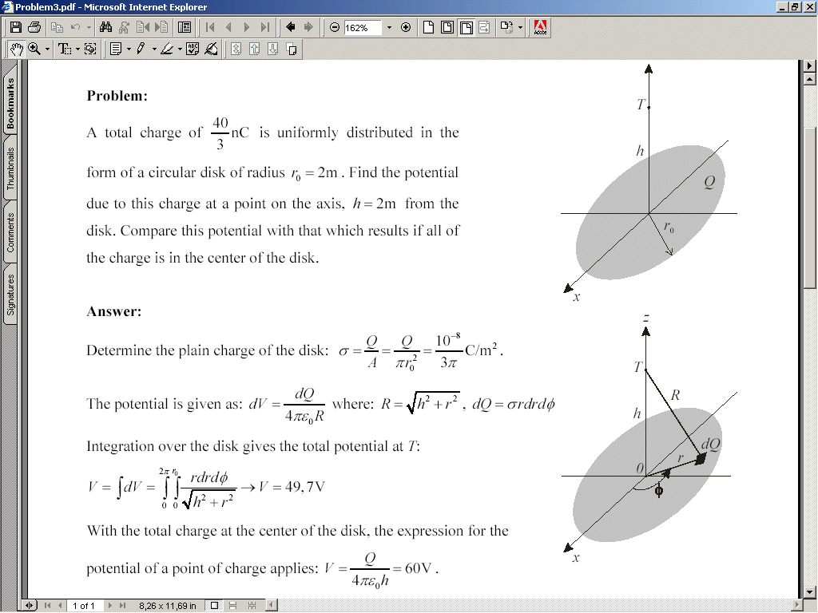
Figure 1: Sketches and notations presented using HTML & GIF (left) and PDF (right)

- E-MATERIALS FOR SECONDARY EDUCATION OF FoEE
The result of three projects (eOET-1, eOET-1plus, eELEplus) co-financed by European social fund between years 2006 and 2010 is a web-based educational material providing the fundamental background in the field of electromagnetic and electrical circuits. Using two-level material structure, it is designed for secondary education as well as it is a good introductory for the courses of FoEE in the first year of undergraduate study at universities and vocational colleges. In contrast to traditional study materials, the web-based approach provides dynamic and interactive animations, synchronized with mathematical equation derivation, and multimedia elements, such as sketches, pictures, sound and video, step-by-step problem-based learning as well as user tracking and online examination. The open platform, used in the projects, allows for further improvements, extensions and corrections of the material. The goal of this plenary presentation is to improve the awareness of this freely available educational material among the members of Slovenian EE society. We would suggest the target teachers to use the web-based material at their work and encourage their colleges to do likewise. We believe the web-based educational material is an excellent tool for stimulating and engaging students, requiring new, pleasurable and state-of-the-art teaching methods.

  - Building blocks of e-materials

The sections that make up the web material and their distribution by project are given in Table 1. The main part is the manuscript, most of which is written in a comprehensive and in-depth preparation of the contents of the material from the above areas. Technical material cannot be imagined without technical sketches. In electromagnetics, we are confronted with concepts that are often abstract and difficult to imagine, therefore, for example, we help by drawing field lines, traverses, flows, or equipotentials. As we get to know each other, a good sketch of objects and fields in the space is half way to conquering the substance. Learning without a lot of examples cannot be imagined. Some more difficult examples require a streamlined and structured approach to the delivery of a substance, which allows the student to become independent in their resolution, independent of the guidance.
The main advantage of online material is the ability to use multimedia elements. From Table 1 it is evident that we supported the material with photographs, animations and videos. Both animations and videos are fully supported by sound.
Table 1: Web building materials: quantitative breakdown by project

  - Level structure and target population

The material is divided according to the level of difficulty. This does not just mean that individual chapters are excluded from the baseline and collected at a higher level, but most chapters are designed in parallel. At the basic level they provide knowledge using simple mathematical tools, and at a higher level using complex tools such as complex, differential and integral calculus. The basic level of material is primarily intended to support the teaching of electrical engineering in secondary vocational schools, the lowest level educated in the field of electrical engineering in our school system. The basic level can also be used by the graduates of professional gymnasiums, of which better students will undoubtedly already reach higher level skills. The higher level is primarily aimed at facilitating the transition from secondary schools to upper and lower secondary schools, since - especially the latter - they address the subject of electromagnetics at a more demanding level using complex mathematical tools, which gives students a difficult leap. We want them to additionally stimulate them to study online, and enable easier and quicker conquer of concepts and knowledge in this field.

  - Procedures for the preparation and implementation of the material

The draft educational content had to be adapted in both volume and depth. An appropriate subset of content was needed, which, in sufficient, but comprehensive scope, covers the subject matter. The content had to be structured in two levels according to complexity. When the basic level content was selected, chapters and the upgrade method were selected at the higher level. At the same time, we created other building blocks (images, video, animations and sounds) and prepare background materials for them (scripts, materials for experiments, etc.).
(Solved) tasks require the selection of an appropriate number of tasks, which must be of different difficulty levels. We decided that the tasks will be performed in three forms, that is, as guided solved examples, interactive examples that require the learner to engage in their own engagement and enable it to verify the results, and offer guidance to the correct resolution, as well as the problems of independent training that are equivalent to the classical approach performing exercises on a board or paper. To this end, it is necessary to prepare tasks, solve them, and break them down to the steps that are successively shown to the learner in guided rescue.
Knowledge and theory, however, involve knowledge testing. In addition to the tools brought up by modern distance education systems (e-cho), we have also developed some of our own methods for checking students' knowledge, ranging from the answers offered to verifying the correctness of the results entered in solving the tasks.
In order to prepare animations, it is first necessary to develop scenarios, based on which the screenplay is described. The implementation of this is followed by an overview with the simultaneous preparation of a text for a sound that usually complements the animation. The text is recorded first and edited later.
Pictorial and video materials require a careful selection of experimental equipment and exhibits. Large picture materials were created in the field, some of which were contributed by some of the authors from their own long-standing repositories. Also, in the process of preparing the video construct, it is first necessary to prepare a scenario with a description of the ideas, a list of necessary equipment and any special features in the recording process. Experiments are based on both commercial and self-made equipment. There have been some experiments from previous training, but they needed to be adapted to the specifications of the recording environment. Most of the experiments needed to be re-created. The recording of the scenarios follows the recording of the experiments carried out by the LTFE MMC team. When viewing images, the authors prepare a draft text in writing, which is then read and recorded. This is followed by video editing.
Due to the large amount of material, it is one of the most painstaking implementation procedures - encoding material. First, you need to put a page template, and then all the entries in the template are manually passed to the appropriate format. It continues with entries of badges for other widgets (technical sketches, animations, videos) and links. At the end, the levels are corrected and the corresponding indexes are produced.

  - Platform for publishing e-materials

As a central platform for the implementation of the material, (in the last eELEplus project), an open approach was chosen - MediaWiki [6]. This open source platform (php, MySQL) offers many advantages. It allows you to view and edit content across the site. It enables the uploading and integration of multimedia widgets, images, videos (also publicly accessible - for example, YouTube). All changes are stored in the archive. Thus, several co-authors (teachers) can co-create and complement the content, and if necessary (promptly), correct the errors. In case of abuse, the material can be returned to one of the previous states, not least originally. The latter was the central shortcoming of the past system (eOET-1, eOET-1plus), since it was necessary to reach the level of page encoding to correct the error.
The platform also allows for custom shaping and insertion of new widgets. Thus, for the needs of our project, we have upgraded the display of images, animations and video with the appropriate controls for playback and visual borders for visibility. The eternal hard nut for the representation of mathematical equations was solved by introducing the equations into the system in the form of a TeX record (they can also be translated from the MathML format) and displayed in vector graphic form, allowing broad compatibility between the browsers.
The entire material is available in the form SCORM [7], which makes it easy to integrate material into e-learning systems, such as Moodle [8]. In this way, teachers can transfer material to their institution (faster access) and adapt it to their needs and learning preparations.

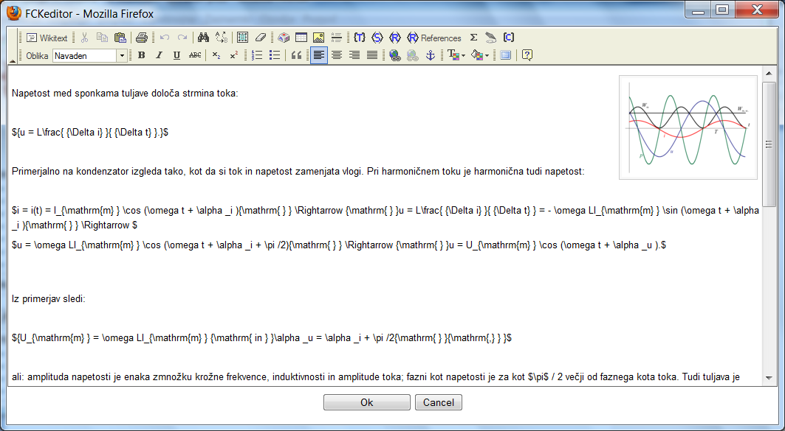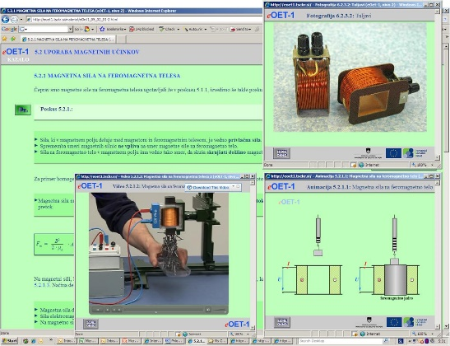
Figure 2: Sketches and notations presented using HTML & GIF (left) and PDF (right)

The material is available in appendix [10] and [11], where we were obliged to maintain it under the contract for 5 years, but it has been maintained at our own expense for over 10 years due to the demonstrated interest of the secondary schools used in the pedagogical process.

- VIDEO TEXTBOOKS FOR HIGHER EDUCATION FoEE
In order to take a step forward in the field of development of e-textbooks, in 2011 we started to record lectures in the basic professional subjects of the FoEE in the first year of the first Bologna level of university studies at the Faculty of Electrical Engineering at the University of Lubljana. The core motivation stems from the following objectives (1) to combine the benefits of living words and printed materials to enhance the effectiveness of studies; (2) offer students the possibility of repeated playback, fast forward or pause, offering rethinking, reviewing the outputs and making extracts; (3) offer students the opportunity to quickly access content - this allows cutting of lectures by subject; (4) give students the opportunity to pre-prepare for lectures or to monitor missed lectures; (5) to assist the lecturer in directing live lectures into discussion, comments and illustrative examples; (6) motivate "generation Z" with online and video education approaches.

  - Recording, cutting, editing, recording formats

When recording, we set ourselves the goal of taking lectures in a way that is done in a regular pedagogical process - that is, delivering content with a chalkboard. Unlike much more established recording of lecturers using pre-prepared transparencies, this was an additional challenge for us, since it was necessary to readily cover the content created by chalkboard after the board while at the same time taking the speaker's speech.
Depending on the financial and personnel capabilities, we could not afford a large team (for example, three) of cameramen and mixers, so we decided to record a lecture by a single cameraman from our projection room at our largest lecture room (P1), where we put a JVC GY-HM100E camera on the stand, which was not conspicuous and not disruptive for the lecturer and students. Due to the long distance, we had a slight problem with light. The board, which is much larger in width than the video format, was divided it into three parts, among which we performed crossings, and the lecturers were disciplined to write down the table linearly downwards and from the left to the right, without taking any unnecessary transfers to the already listed parts of the table. We made sure (also for the purpose of ensuring the protection of personal data) that students were left out of work.
As part of the recording, we captured approximately 2.5 TB of the XDCAM EX 1080i50 (35 Mb / s VBR) format, which was further processed on three Apple iMacs 27'' i7 2.93 GHz with Final Cut Pro 7.0 software.
The materials were cut into lectures (60 lectures lasting 90 minutes) and themes (250 themes of different timigs from a few minutes to an hour), intended for connection with the emerging e-tutorial. The cutting was followed by assembly where we extracted unnecessary content (for example, lecturers' comments intended for the organization of students' work), merged videos or topics that were interrupted with a break, and connected them with appropriate passages. We have encoded two formats (full/uncompressed: 1.3 TB and compressed H.264 - MOV in size 1280 x 720: 200 GB, which allows you to play back on different devices: PC, PDA, phone.
In addition to two lecturers (acting and coordinator), two cameramen (approximately 150 hours) and two students (approx. 250 hours) were involved at the video processing.

  - Content

Initially, in 2011/12, we began to record lectures on the subjects of FoEE I and II (2 x 60 school hours) covering the following topics: (1) electrons and electrical current, (2) electrostatic field and capacitor circuits, (3) current field and DC circuits, (4) magneto-static field and magnetic circuits, (5) induced electric field, (6) transients, (7) alternating circuits, (8) three-phase systems. On the basis of very positive experiences, two objects were started in the following years: Electromagnetics (30 hours), which emphasizes the physic-mathematical model of electromagnetism, which relies on vector analysis, partial differential equations, complex functions, integral equations, variational calculus and numerical methods and covers the following topics: (1) electromagnetic field equations, (2) classes of electromagnetic fields, (3) numerical solving of engineering electromagnetic problems. Applied electromagnetics (30 hours), which emphasizes the numerical solution of engineering problems: electrical and magnetic field shielding, skin effect analysis, impedance conductors, induction heating, field analysis in cables, lightning conductors, porosity resistance, particle in the electromagnetic field, Hall phenomenon, field in an anisotropic substance.

  - Accessibility of materials

Since 2012, the material was made publicly available at the address, using progressive download instead of streaming. This year we are moving to the platform http://efeplusmm.fe.uni-lj.si, which enables the registration of users (recording of activities and keeping statistics of individual users), and coding in 6 different forms (accessibility at different terminals / platforms, accessibility at different bit rates of the access connection).
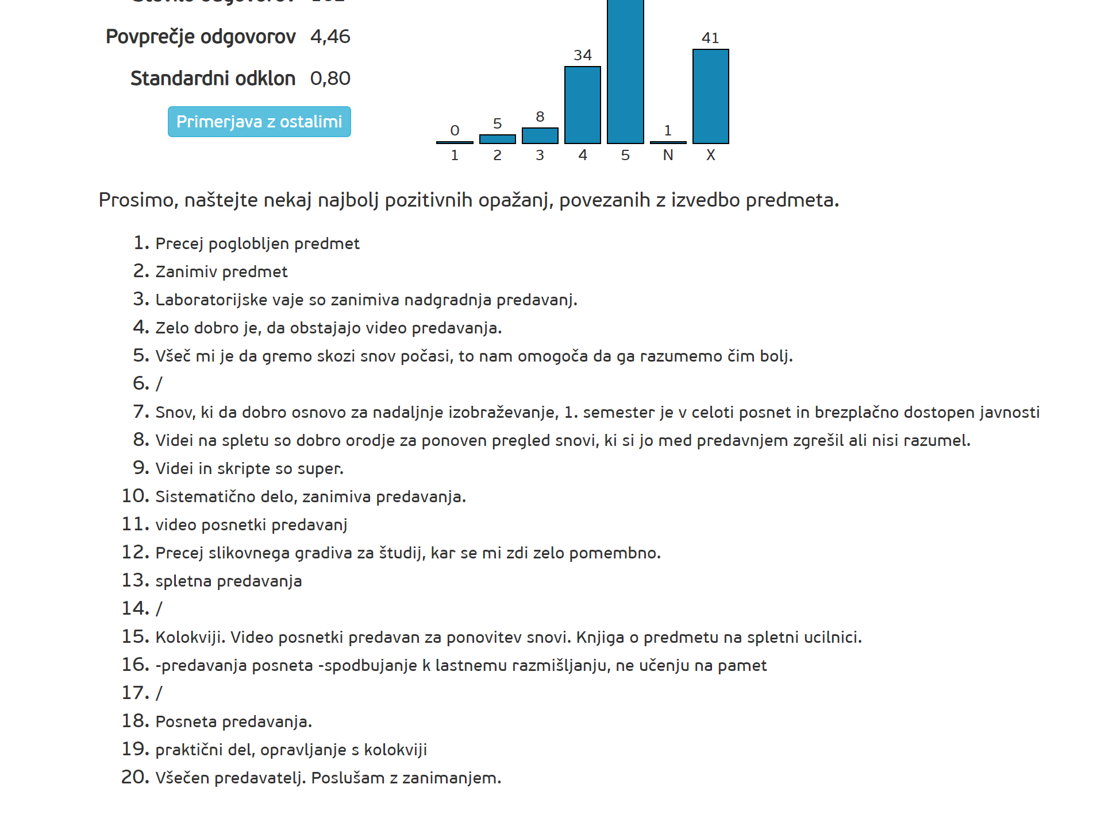
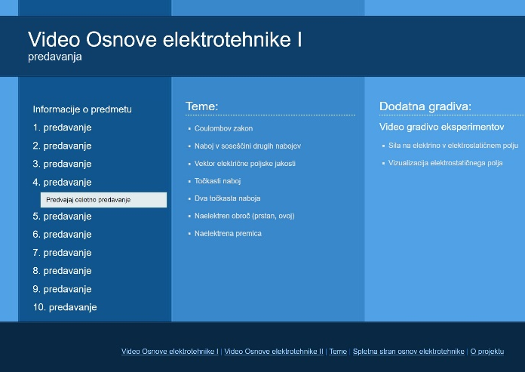
Figure 3: Access page for video lectures (left) and evaluation/opinion page (right)
  - Acquisitions, Evaluation
In the early period, we measured using Google Analytics and found that out of 180 students, approximately 100 students occasionally used the videos. Interestingly, over the years video lectures have become increasingly active among students, which is attributed to various factors, the popularization of video in lectures, the popularization of video among students themselves, the advancement of technology (some students did not have enough fast access to the Internet, and today video can simply be viewed on smartphones.) After seven years of video materials, they show their place in general surveys carried out by UL FE, as students respond to a question about positive observations in the FoEE subject in eight out of 20 responses.

- MULTILINGUAL MATERIALS FOR FOREIGN STUDENTS - INTERNATIONALIZATION

In regards to internationalization, which we have done in the UL FE Mission in recent years, we have first undergone a thorough reflection on the subjects of FoEE, with which the materials deal with multilingualism. The textbooks and solved examples are already available in English and it is quite difficult to compete some of good authors. In addition, Erasmus students who come from different countries like to use textbooks for domestic authors in their mother tongue. Students from the Balkans usually learn some of the Slovene language until the first examination period and therefore they can already begin using the Slovenian language.
We decided to start internationalization with laboratory exercises for two reasons: (1) laboratory work is unique to our faculty, which means that students can not use alternative literature in order to be able to prepare them correctly; (2) We begin with laboratory exercises early in the first semester, when foreign students are still missing the Slovene language, and their help in foreign languages ​​is especially welcome. Within the framework of laboratory exercises, we decided to address the internationalization of two issues: (1) a set of 15 videos (total of 2 hours of video), which are, as preparation, linked to experiments carried out by students in the laboratory, and (2) a revised textbook "FoEE through computationalally supported laboratory experiments", which combines instructions with laboratory exercises with explanations and integrates them with the corresponding calculations, which are prepared for students (also in multilingual form) for the web and videos with multilingual subtitles through QR codes.
Based on the analysis of the enrollment, we find that most foreign students are enrolled from Macedonia, Serbia, Bosnia. Therefore, we decided to use Macedonian, Serbian and English as the target languages ​​for internationalization.

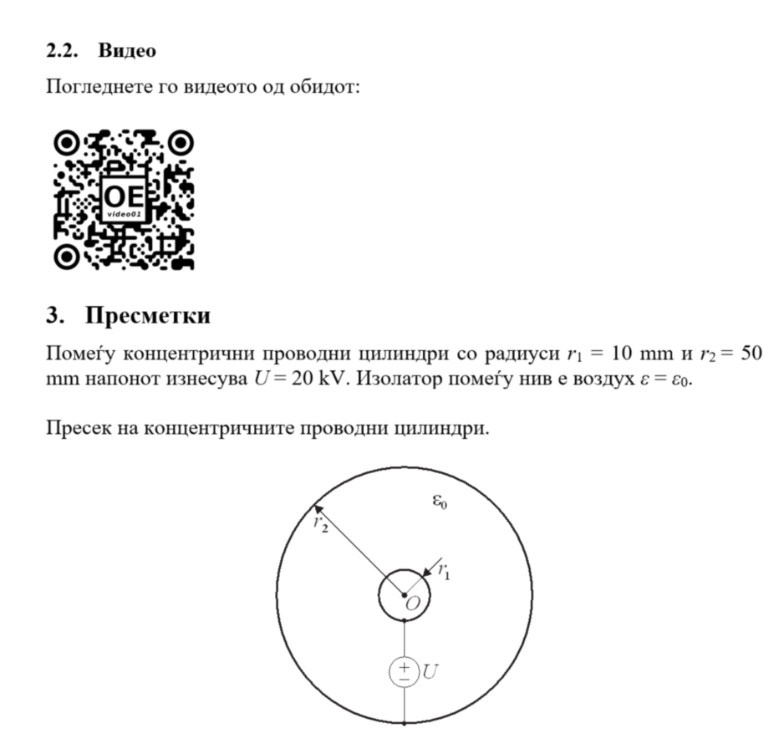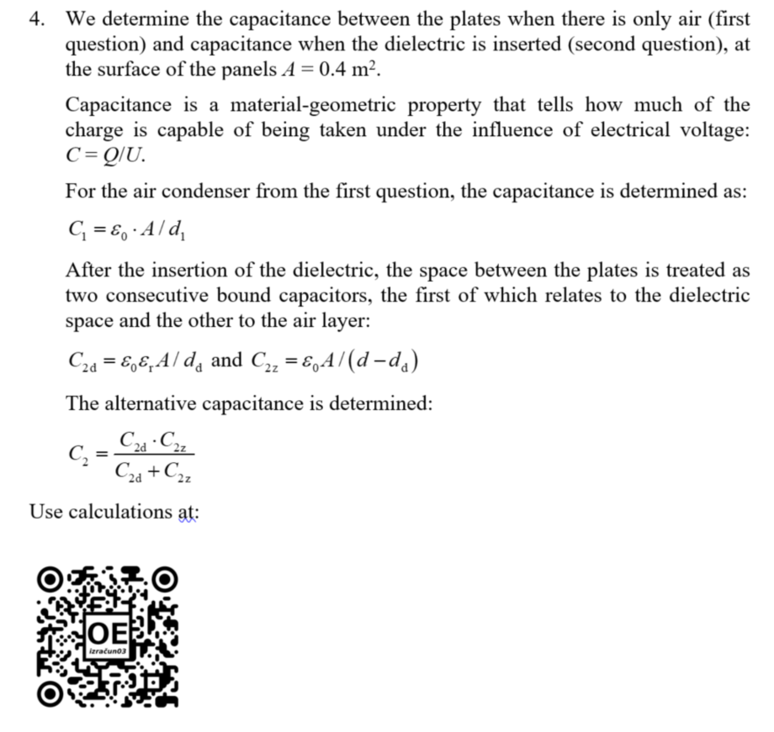
Figure 4: QR-code integration of video and calculation in multilingual learning material
  - Multilingual subtitles for video clips
In order to be able to make subtitles for the videos in several different foreign languages, we first made a transcript of videos in the Slovenian language. We did have a draft text that we used to record video sounds, but at the time of the performance we usually had slight deviations. The full text of 15 videos includes 11000 words. With the help of students coming from different language areas, we translated them into different foreign languages. For translating into Macedonian, for example, two extremely effective students (Tabakovski and Deleva), and four students who carried out proofreading for them, participated.
Since our video-streaming platforms do not currently allow the use of subtitles, we have used Youtube for the purpose, which, besides using subtitles, also allows you to change the language and thus adjust the video to the target language of the user.

- CONCLUSION

In the chronological overview, we presented activities in the field of preparation of video materials, which are being prepared at UL FE (higher education) in cooperation with the Kranj School Center (secondary education) and many other individuals and institutions. In the past projects, the production of materials, e-materials, video lectures, experiments was at the forefront.
With the current activities we address two aspects. The first is internationalization, with which we want to achieve two things: (1) to offer our materials to foreign students who come to study at UL FE or. possibly also enrolling in our secondary education; (2) given that, according to the new Erasmus students at UL FE, they can only choose between subjects of the 2nd Bologna level, the developed material has also been decided to offer wider in the regions, which dictates the language adaptation of materials. We initially started with the subtitles, and we do not shy away from the possibility that in the subsequent process we will perform voice synchronization, perhaps with sound synthesizers, which have recently become very effective.

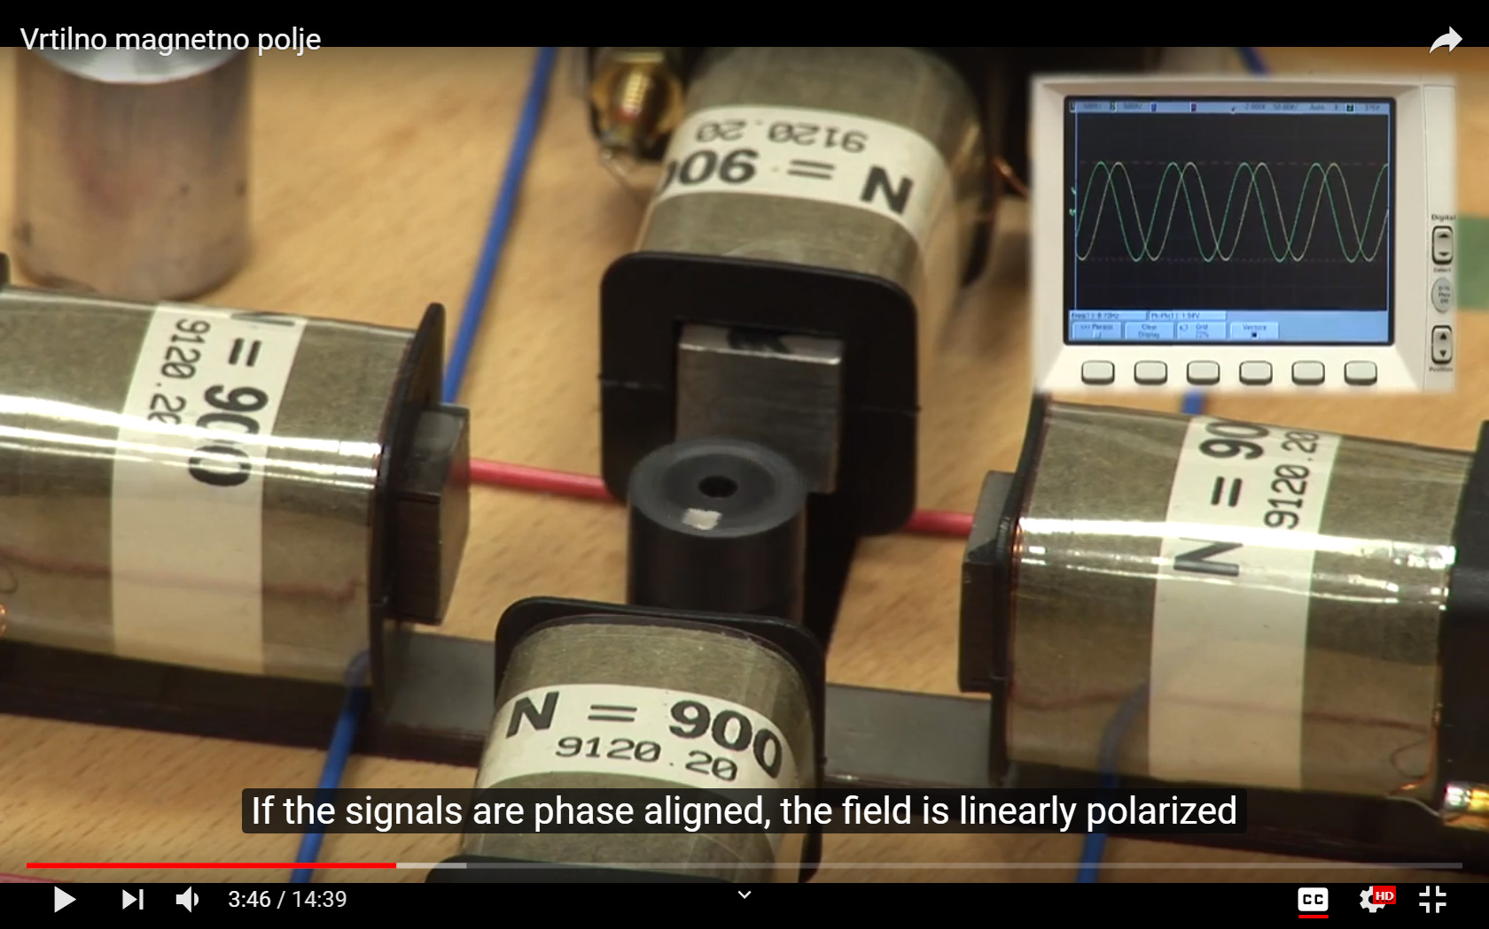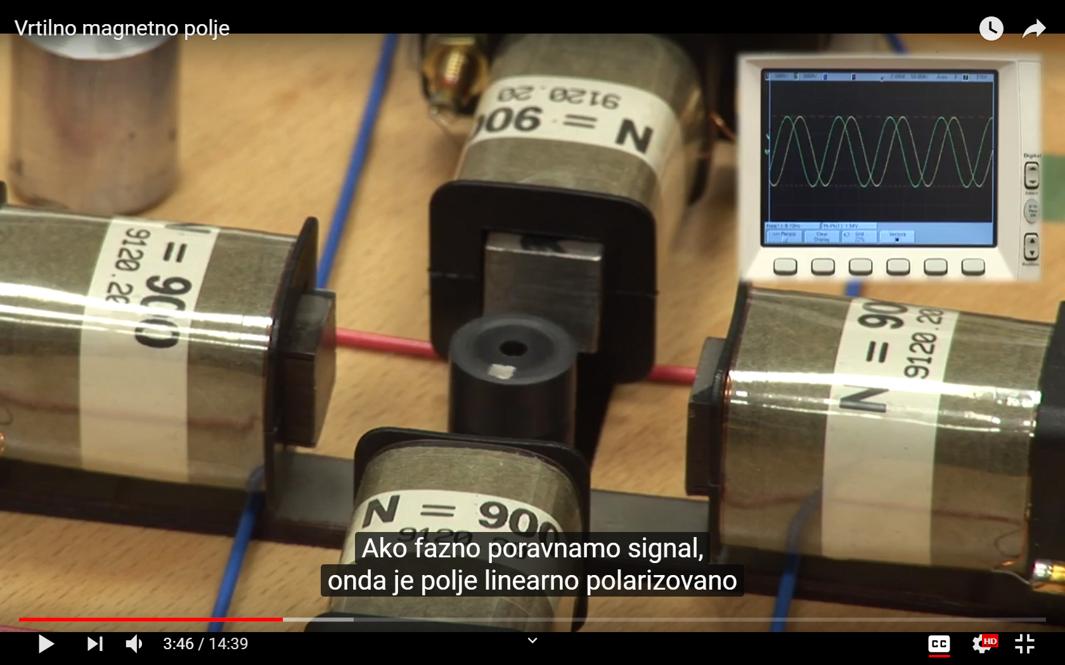
Figure 5: An example of video with subtitles of an experiment in EE: English (left) and Serbian (right)

The second aspect is the augmentation of the use of (already) prepared e-materials, which we address in the context of two ongoing projects. The first project relates to the use of advanced pedagogical approaches in secondary education in electrical engineering (napELE) with the following objectives (1) to develop strategies for integrating e-materials into the pedagogical process at secondary technical schools and technical gymnasiums; (2) to help teachers who want to, but because of different barriers, do not have access to the use of modern learning approaches; (3) upgrade teacher training sessions that we will develop with them; (4) to build building blocks to carry out advanced education in one place; (5) help the teacher to establish a modern learning environment; (6) of the teacher - so equipped - accompany the classroom at the first steps with an updated mode of education; (7) capturing and processing results, and knowledge and user satisfaction; (8) to introduce / excite young people for the profession of a teacher.
The second project relates to the implementation of a pilot update on the didactic use of ICT in the pedagogical study process, which will be held in 2020 within the framework of the Digital UL project with the desire to introduce and use: (1) reverse learning (the materials will include video lectures; ) of combined learning (hybrid of traditional direct and online learning - classes will take place both in the lecture room and online (natural extension of traditional learning); (3) problem / project learning - problem: deeper introductory skills with little application in the context of life situations (4) Learning through research (getting new information through research); (5) Collaborative learning (forms of interaction triggering learning mechanisms, involving students in groups with the aim of achieving a common learning experience; goal, group presentations); (6) digital storytelling (more understanding of the experiment, a better knowledge of the equipment used in the experiment).

REFERENCES
- I. Humar, A.R. Sinigoj, E. Bulić: Pregled metod za objavljanje rešenih izpitnih nalog iz predmeta Osnove elektrotehnike na spletu. Proceedings of 12th International Electrotehnical and computer science conference ERK, 25.-26. Sep. 2003, Ljubljana, Slovenia, pp. 537-540.
- I. Humar, E. Bulić, A.R. Sinigoj: Načini objavljanja rešenih nalog iz predmeta Osnove elektrotehnike na spletu in vrednotenje uporabe. Elektrotechnical review, 2004, vol. 71, no. 1-2, pp. 76-81.
- I. Humar, A.R. Sinigoj, E. Bulić: Dynamic educational material of electromagnetics with integrated mathematical notation for the Web. Proceedinge of 4th conference on Information Technology based Higher Education and Training, 7.-9. Jul. 2003, Marrakech, Morocco, pp. 450-455.
- I. Humar, A.R. Sinigoj, J. Bešter, M. O. Hagler: Integrated component web-based interactive learning systems for engineering. IEEE Transsactions on Education, Nov. 2005, let. 48, št. 4, str. 664-675.
- I. Humar, A.R. Sinigoj, M. O. Hagler: Mathematical tools for supporting web-based education of electromagnetics. 5th conference on Information Technology based Higher Education and Training, 31. Maj – 2. Jun. 2004, Istanbul, Turkey.
- MediaWiki: http://www.mediawiki.org/wiki/MediaWiki
- SCORM: http://www.adlnet.gov/Pages/Default.aspx
- Moodle: http://www.moodle.si/moodle
- eOET-1, 2008: http://eoet1.sckr.si
- eELEplus, 2010: http://eele.fe.uni-lj.si
- Video - Fundamentals of Electrical Engineering, 2012: http://video.fe.uni-lj.si/osnove_elektrotehnike
- Multilingual subtitled video of experiments, 2018: Youtube channel Osnove elektrotehnike UL FE https://www.youtube.com/channel/UClM_Qj7xvs61OO846FjQVPQ

