INTERNET OF VEHICLES

Miloš Stanišić¹; Jasmin Delić²
¹University of East Sarajevo - Faculty of Transportation Doboj, Bjeljina, Bosnia i Herzegovina, milosstanisic093@hotmail.com
²University of East Sarajevo - Faculty of Transportation Doboj,East Doboj, Bosnia i Herzegovina, jasmin_dj@outlook.com

Summary: This paper presents the technology of interconnecting vehicles with road infrastructure and other vehicles. This accomplishment is achieved through the application of an integrated distribution network of the Internet vehicle. The paper includes an overview of IoV technologies (Internet of Vehicle), as well as the development of the Internet of Things IoT and VANET networks that served as the basis for its development. The IoV applications that are applied in intelligent transport systems are also presented.

Keywords: Internet vehicles, VANET, Internet of Things, intelligent transport systems.

1. INTRODUCTION

Every day, the need for using cars and motor vehicles is becoming more and more demanding. The biggest problem that arises as a consequence of this demand is the increasing number of traffic accidents with a fatal outcome. Hence, the dangers and costs arising from this are identified as a serious problem facing modern society. There are various types of equipment for the needs of the vehicle network. Internet vehicles or the Internet of Vehicle (IoV) is one type of such equipment. Such equipment differs from standard intelligent transport systems, paying more attention to information about interactions between people and vehicles. Its goal is to provide real-time users with easily accessible information on the status of road traffic.

2. INTELLIGENT TRANSPORT SYSTEMS

Intelligent Transport Systems (ITS) implies any system or service that provides more efficient and rational movement of people and goods. Intelligent transport systems represent the application of new technologies in order to reduce congestion, material savings, increase safety and reduce environmental impacts in all modes of transport. These systems are composed of a large number of physical components, such as different types of sensors, cameras and signaling elements, whose work is supported by various management and telecommunication technologies, with the basic function of providing operational management and control of the functioning of the traffic system.
Intelligent transport systems allow the traffic system to function more efficiently and rationally. These systems integrate users at different levels, traffic systems of different countries and vehicles using communication technologies that make real-time information transfer. ITS integrates telecommunications, electronics, IT with traffic engineering in terms of design planning and traffic management systems. This integration increases the efficiency and safety of the traffic system and has a positive impact on the environment. In order to achieve this ITS requires procedures, systems and equipment that allow data collection, communication, analysis and distribution of data and information to the users of the traffic system.
The first ITS applications were aimed at improving the conditions in the traffic flow and the operation of light signals in real time. According to the sources given in the PIARC ITS manual from 2004, among the first ITS applications were SCOOT (Split, Cycle and Offset Optimization Techniques) and SCATS (Sydney Coordinated Adaptive Traffic System). Today, the number of applications is much larger and wider. It is difficult to underline a clear boundary between individual applications because they often overlap in individual parts.

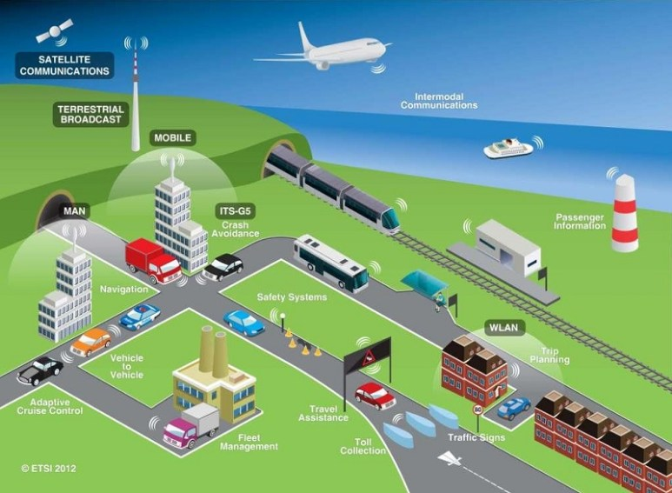
Figure 1: Application of Intelligent Transport Systems.

3. INTERNET OF THINGS

The concept of Internet of Things or IoT allows data collection and management of physical objects from a distance using the existing network infrastructure, thus achieving better integration of the physical world and computer systems. This approach achieves increased efficiency, precision and cost reduction. The advantages of using Internet facilities in the field of maintenance are obvious because they eliminate the need for physical sightseeing and equipment control, but all the necessary information is obtained in a timely manner at the place where the decisions are made. This saves time and money, especially in the case of equipment that is located in a geographically wide area. Also, a large amount of data collected from different objects enables their processing by data mining methods, enabling the prediction of the behavior of individual parts of the equipment.
Figure 2 shows the model of the vehicle connected to the IoT Gateway as well as the dedicated short range communication (DSRC) or dedicated short-range communication that represents the technology that is implemented in the IEEE 802.11p standards for vehicle networks. With DSRC, vehicles can communicate effectively with other vehicles moving on the same or adjacent part of the road or at intersections to ensure driver safety. Internet objects relate to physical objects connected via built-in sensors and other devices that can collect and transmit information about objects over the Internet.

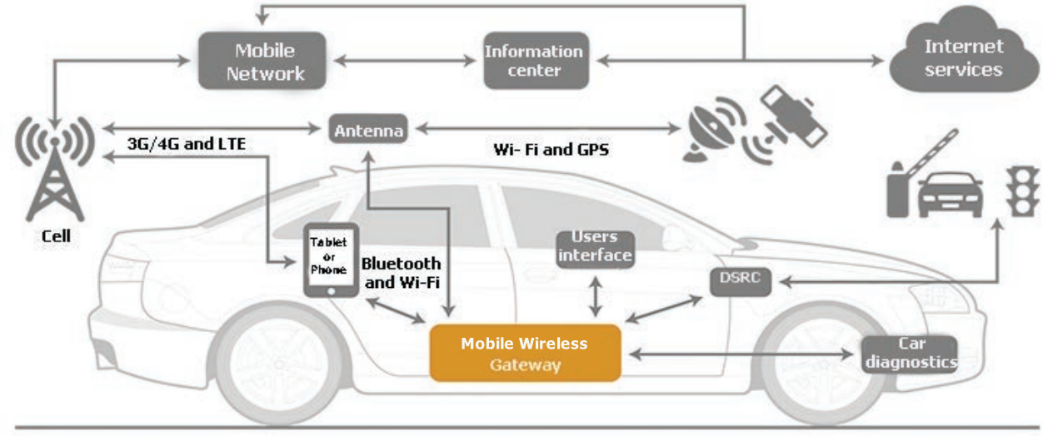
Figure 2: Displaying Vehicle Connectivity with IoT Gateway.

The data collected by these devices can then be analyzed to optimize products, services, and operations. One of the earliest and most famous applications of this technology was in the area of optimization of electricity production. Where sensors are deployed within the electrical network, they can help to monitor the use of energy from the distance, and adjust their production and distribution for the highest or lowest consumption. A great example is the electric current in households and the provider of electricity. This technology is also applied in many other industries. In some countries, such as Russia, the law requires that everyone installs a sensor in his car, which makes it possible to detect the real cause of the accident and is based on real driving behavior rather than on the projections.
Examples of using Internet of Things can be found in everyday life. The so-called "smart houses" are increasingly becoming more and more frequent, say that the alarm wakes up at 7 am and then informs the coffee maker to start cooking, or say that the refrigerator knows that the milk is running out and tells us to our terminal device. In other words, in the future, everything that can be connected will be linked. This includes mobile devices, coffee machines, washing machines, headphones, clothing devices and almost everything else. In fact, the number of possible applications of this technology is so great that Internet of Things have the potential to replace people in some specific activities, and it is considered that this new technology could make life easier and simpler.

4. INTERNET OF VEHICLES

Internet vehicles represent the integration of three networks: the in-vehicle network, the outer vehicle network and the mobile Internet vehicle. Based on this concept of integrating these three networks into one, we can define Internet vehicles as a wide-spread distribution system for wireless communication and information exchange between vehicles2X (X: vehicle, person, path and internet) all according to the agreed communication protocols and data interaction standards. It is an integrated network that supports intelligent traffic management, intelligent dynamic information service and intelligent vehicle control, presenting itself as a typical application of IoT (Internet of Things) technology in intelligent transport systems.
Technology convergence includes information communication, environmental protection, energy saving and security. In order to succeed in the upcoming market, acquiring basic technologies and standards will be key to ensuring strategic advantage. However, the integration of Internet vehicles (IoV) with other infrastructures should be as important as the development of IoV technologies themselves. As a result, the Internet vehicle will become an integral part of the largest IoT infrastructure after its completion. Here, it must be emphasized that the cooperation and the connection between the transport sector and other sectors (such as: energy, health care, environment, production and agro-culture ...) will be the next step in the development of IoV.

4.1. Vanet as the basis for the development of IoV

VANET or the Ad-hoc network of vehicles converts each individual vehicle into a wireless router or mobile node, enabling vehicles to interconnect, thereby creating a wide bandwidth. As certain vehicles leave the signal range and exit the network, other vehicles can join by connecting each other to create a mobile Internet. VANET covers a very small mobile network that is subject to mobility restrictions and the number of connected vehicles. Several characteristics of large cities such as traffic jams, high buildings, inadvertent behavior of traffic participants and complex road networks cause further disturbance of its work. As far as VANET is concerned, the facilities involved in the operation of its network are temporary random and unstable, and the scope of services is local and discrete. VANET can not provide global and sustainable services and applications for its users.

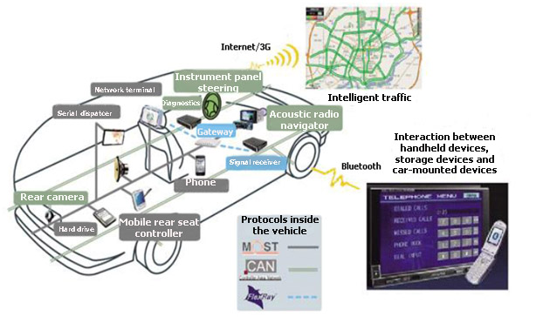
Figure 3: Vehicle communication with VANET.

In Figure 3, we can see the communication that takes place inside the vehicle. In-vehicle communication systems can detect vehicle performance and fatigue and drowsiness of drivers, which is of great importance to public and driver safety. In contrast to VANET, IoV has two main lines of technology: vehicle networking and vehicle intelligence. Vehicle networking consists of VANET, Telematics vehicles and mobile internet. Vehicle intelligence represents the integration of vehicles and drivers into one unit that is more intelligent by using network technologies such as "deep" learning, cognitive computing, computer computing and uncertain artificial intelligence. IoV focuses on the intelligent integration of people, vehicles, objects, and environments and represents a huge network that provides services to large cities or even the whole country.
Based on the collaboration between computing and communication, that is, common vehicle and driver awareness, or intelligent computing and cognition, IoV can deliver, manage and count huge complex dynamic data of people, vehicles, objects, environments to improve the compatibility, distribution and sustainability of complex network systems and information services.
The ideal goal of IoV is to finally provide deep integration of the man-vehicle-facility-environment, reduce social costs, promote transport efficiency, improve the city level of services and ensure that people are satisfied and enjoy their vehicles. With this, it is clear that VANET is a subnet of IoV. Due to all the shortcomings and increasing numbers of users, as well as more demanding and more complex requirements, VANET and Telematics vehicles had to evolve into IoV.

4.2. IoV activation

There are many steps in IoV activation, but the most important step is to connect vehicles with an integrated IoV network using wireless access technology. Today, there are many wireless access technologies such as WLANs, WiMAX, Cellular Wireless and satellite communications. Most of these technologies are used to connect vehicles to IoV.
WLAN as one of the aforementioned wireless access technologies uses IEEE 802.11 standards that are well accepted on the market due to its relatively high data transfer speeds. The latest version of this standard (802.11n) has achieved a maximum transfer rate of 100 Mgps (Megabits per second). IEEE 802.11p is a new communication standard that is designed for wireless access around the vehicle to support intelligent transport system applications. WiMAX's IEEE 802.16 standards in theory can cover a huge geographic area of ​​up to 50 kilometers of distance and can provide end-users with a significant bandwidth of up to 72 Mgps. While IEEE 802.16 only supports fixed broadband wireless communications IEEE 802.16e / mobile WiMAX standard supports different types of service quality speeds up to 160 km / h, even in poor optical visibility conditions. The key advantage of WiMAX in relation to WLAN is that the method of accessing the connection channel in WiMAX uses a planned algorithm in which a subscriber station should only compete once for the initial network entry. Mobile wireless technology consists of 3G, 4G and LTE networks. The current 3G network delivers data at a speed of 384 kbps (kilobits per second) to vehicles on the move, and for fixed nodes, this speed can move up to 2 Mgps. Due to high costs, satellite communication for vehicles is poorly used, with the exception of using GPS. It is only a substitute for temporary and emergency cases, when other technologies are not available or are defective. Summarizing the aforementioned wireless access technologies, we come to the conclusion that 4G or LTE technologies would be most effective for establishing an internal network of vehicles and activating IoV. The reasons for such conclusions are the following. First, 4G or LTE are the most used communication standards, and most countries use exactly these standards to provide access to services. As obviously, every vehicle can use them to connect with IoV. Secondly, in the environment of high-rise buildings and complex city environments, 4G or LTEs are included among the best wireless access technologies. And finally, in the past 10 years, the development of VANET was very slow, and hardly had a serious application in the real world. The main reason for this is that related vehicles were not able to maintain VANET on city roads because their goals were random and different. To maintain VANET, all vehicles must be able to access the IoV's integrated network in order to activate it and enable them to access customer services.

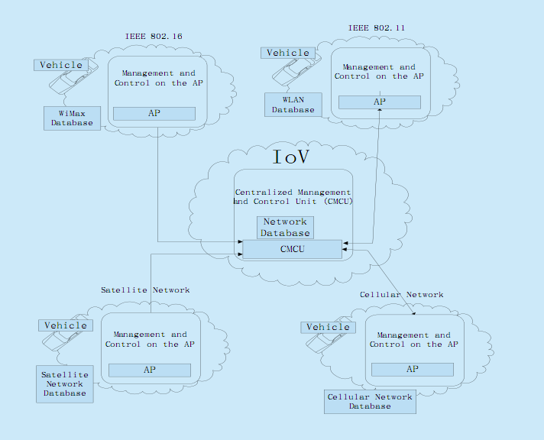
Figure 4: Wireless access technologies in IoV

5. IoV APPLICATIONS

The rapid development of numerical information technology and network technologies has contributed to further automation of vehicles. This has allowed the development of many applications that combine safe driving with service provision. Applications in IoV can be divided into two groups: user applications and security applications. Applications that enhance vehicle safety and improve travel safety by informing their vehicles about dangerous situations in their environment are called security applications. Apps provided by additional services are called user applications.
Technologies that increase the safety of vehicles and passengers are of great importance and one of the most important applications that help avoid collisions. Today collision avoidance technologies are mostly systems based on vehicles provided by the manufacturer as autonomous packages that generally have two functions, a collision alert and driver assistance. The first function warns the driver when the collision appears inevitable, while the second function partially takes control of the vehicle for standby or emergency intervening on the road. Collision alerts include notifications of a road crash, road conditions such as a slippery carriageway, and upcoming emergency vehicles. On the other hand, collision alerts can be used to alert vehicles about an accident that occurred in the later part of August, thus achieving preventing the creation of huge columns of cars. They can also alert the driver to the danger of the road in order to avoid accidents. Driving near or through intersections is one of the most complicated problems that drivers must face because two or more traffic flows are crossed and therefore the possibility of a collision is high.
User applications vary from those for real-time multimedia viewing, interactive applications such as video conferencing, weather information or Internet access, including information transfer, Internet browsing, downloading music and interactive games to travel service applications such as locations and restaurant prices and gas stations. Generally speaking, user applications provide two classic types of services: cooperative local services and global internet services. Cooperative local services are applications that focus on providing broadcasting information and entertainment programs that can be accessed through local services such as local electronic advertisements and downloading of media content. Typical examples of global Internet services are social services, such as financial and insurance services, fleet management services and parking zones, which focus on software and data upgrades.
User applications include three types of usage. The first type gives the vehicle or driver the ability to access any information available on the Internet. The second type allows access to local businesses, tourist attractions or other events. In this case, the travel units transmit information about this event, such as its location, the time of the start of that event and its price. The third type allows the autoservice to access the vehicle condition without having to physically connect to that vehicle. When a vehicle approaches an area close to the car service, it can send a query to the vehicle asking for its information in order to perform a diagnosis of the problem reported by the user. As long as the vehicle approaches user information and vehicle history, it can be retrieved from the database and displayed to the technician for use.

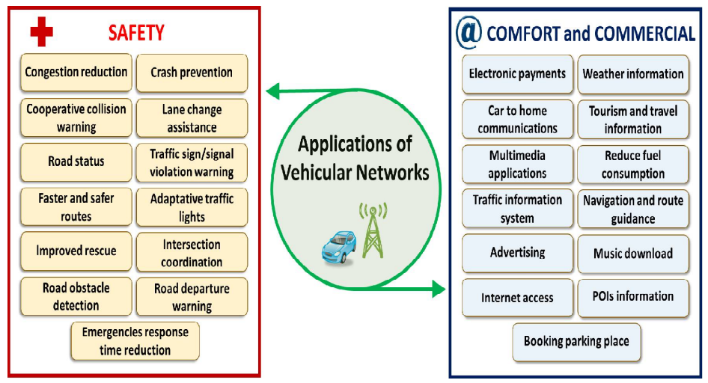
Figure 5: Usage of IoV applications in traffic

6. FURTHER DEVELOPMENT OF IoV

The goal of IoV is to integrate many users, vehicles and networks to provide the best possible connected communications that are sustainable, operational, credible and controlled. Such a network system is not currently available, but it is desirable to improve the capabilities of the bugging IoV applications to achieve that goal. Efficient wireless access solutions will be crucial for a sustainable and credible IoV. These solutions should consider the limits of coverage of communication in complex cities. Complex solutions can be developed in such a way as to enhance the ability to communicate using a variety of IoV technologies.
The transfer of a large amount of data, especially video data, through IoV, can make the network load more difficult. Efficient methods will have to be developed to maintain service delivery because vehicles become mobile nodes in the global network. Integrating a man with a vehicle as end users creates new network and service models that are very different from existing models. These new models can interfere with operations within IoV. New methods will be needed to ensure good IoV quality.
Although many of the future challenges proposed most of them relate to VANET or vehicle telematics while only a small portion of the researchers propose the challenges of IoV from prospective numerous users, vehicles, networks. Obviously, there are many unique challenges associated with IoV, but we will focus on four challenges to which particular attention should be paid, such as:

• What is a network and service model between a man and a vehicle in IoV?

• How to increase the ability to communicate in IoV?

• How to collaborate between virtual vehicles?

• How to ensure the sustainability of the provision of services in IoV?

Network and service model between man and vehicle. We know that the network model of the user originates from the Internet and that the network model of the Internet comes from VANET. Both of these models have been studied for years and many complex models have been published on the basis of these studies. Still, the realization of an efficient network model between man and vehicle is still an open problem. In IoV, the network model between man and vehicle should be focused on maximizing resource use, robustness and network stability. Although the problem is still open, some approaches to solving this problem can include deep knowledge of matter and cognitive computing along with the exchange of data about the network line through the use of large amount of data technologies. The problem with this solution is focusing on finding the service and its time-space distribution characteristics by creating a quantitative system for evaluating the requirements of a typical network service. The next question is whether the service model between the person and the vehicle would be the same as the service model of the Internet or mobile wireless network. There is almost no research on this topic. The study of service characteristics during the process of coordination with services and the network through a user-specific regimen or service, its development mechanisms and trends, and the creation of a cognitive learning model represent basic research problems. The data obtained from such research can help establish a user behavior service in terms of a cognitive learning model by combining people, vehicles and services to enhance their ability to cope with complex time-space changes in service requirements in IoV.
Increasing the ability to communicate in IoV. Although existing communication systems provide the ability to support network features, there is a so-called "bottleneck network" that is related to parts of wireless access. Shared optimization among all layers of the network can be challenging because the solution to the "bottleneck" requires the modification of many communication layers. Most of the work on network optimization was derived from heuristics and simulations. It would be desirable to have a mathematical framework that would characterize interactions between layers of the network. There is a lot of work to be done to increase the communication capability of each network layer. Difficulties arise here due to:
- dramatic changes in connection channels, network elements, mobility and resources
- and inconsistent optimization goals in terms of users, services and networks.
In order to deal with these problems, several modifications for the network layers of the network have been suggested. However, these modifications could not significantly improve the ability to communicate in IoV. Realizing a stable volume bandwidth supply for IoV traffic in the presence of congestion is a required task. We can use some intelligent technologies to increase the ability to communicate, and as a result, reduce the redundancy of network traffic.
Cooperative technologies of virtual vehicles with drivers. With the popularity of operating systems found in vehicles such as Carplay, Google Auto Link, QNX Car and more and more vehicles will be connected to the IoV network. Then in IoV's computer platform, a huge number of virtual vehicles can interact with a huge number of drivers. This achieves a better network experience for vehicles and drivers using co-operative technologies. Collaboration between virtual vehicles and drivers consists of two phases. The first step is to observe information gathering physical vehicles with drivers, including finding time-space distribution characteristics and vehicle behavior characteristics, creating a quantitative system for assessing the quality of service services. The second phase involves the assessment and interaction between virtual vehicles and drivers that should answer the following questions: what is the model of mixed networks and service, how its mechanisms and trends evolve, how to deal with complex spatial and temporal changes in services? Based on these two phases, although physically two vehicles are not connected and are not even within the same range, they exchange information via virtual drivers with drivers. Or even when one vehicle is absent from the network or stopped, its virtual vehicle can continue to fulfill its role and provide data or services to other virtual vehicles.
Sustainability of service provision. Ensuring the sustainability of services in IOV-in is a demanding task, which requires a use of intelligent methods and design friendly network mechanism. For vehicles in IOV-in such as "smart" vehicles, "average" vehicles and "idiot" vehicles can not expect the same kind of services. These vehicles were together for at least 30 years. There are challenges in adapting to all vehicle service to provide sustainable services across heterogeneous networks in real time, providing limited network bandwidth, mixed wireless access, lower service platforms and complex urban environments. Other factors of importance are: mobility, network sharing and routing errors, changes in channel quality and speed of data transfer and network load. Some of these factors need to be referred to intelligent computing at the service stage. To ensure sustainability of the services provided to the IOV-u need to understand the limitations of these services in conditions of extreme demands for bandwidth in real time, ensuring adequate network resources using the lack of data, large size and limited bandwidth of wireless networks. Previous services and computing platforms are approximately set to "average" vehicles and are not suitable for all vehicles in IOV-in.

7. CONCLUSION

IoV has an increasingly prominent role in traffic and the use of this network contributes not only to safe driving, but also provides users with information that may be of importance to their journey. If we look at what we get by introducing IoV into our vehicles, the benefits would be numerous. The very information we receive through this network can not only help us greatly but also greatly influence the driver's behavior. All the benefits provided by IoV make our ride safe and reliable, and therefore driving conditions are improving and the driving time is shortened. With the increasing needs of society, technology faces increasingly complex requirements in terms of providing services and information to its users. In order to be able to respond to all these demands, she must develop as well .

REFERENCES

[1] Asia-Pacific Economic Cooperation (IoV), 50th Telecommunications and Information Working Group Meeting Brisbane, Australia, 2014
[2] Boris Radišić, Network Infrastructure in the IoT Concept, Faculty of Traffic Science, Zagreb, 2016
[3] Filip Tsvetanov, Challenges and future trends of VANETs sensor networks, University of Telecommunications and Post Faculty of Telecommunication, Bulgaria, 2016.
[4] Smiljan Vukanović, Intelligent Transport Systems in Road Traffic, Belgrade, February 2014.
[5] Yang Fangchung, WANG Shangguang, LI Jinglin, LIU Zhihan, SUN Qibo, An Overview of Internet of Vehicles, State Key Laboratory of Networking and Switching Technology, Beijing University of Posts and Telecommunications, Beijin China, 2014.

