OVERVIEW OF THE OBLIGATION OF THE EMPLOYER ACCORDING TO THE RULES FROM THE SECURITY AND HEALTH ACT

Jasmina Obradović¹; Dr Vesna Marjanović²
¹ALUMINIUM INDUSTRY IMPOL SEVAL, Uzice, Republic of Serbia
²COLLEGE OF APPLIED SCIENCES, Uzice, Republic of Serbia

Abstract: The paper presents the obligaions of employers according to certain regulations deriving from the Law on Health and Safety at Work. The aim of this paper is to promote the Health and Safey System at Work, as well as to improve and preserve th helath of employees, all of his in order to prevent injuries at work and occurance of occupational diseases and diseases related to work. In order to implement the requirements related to occupational safety and health, which arise from the Law, it is necessary to conduct overall and constant education of both employers and employees, as well as all other participants who have influence in making decisions in this area and the dissemination of the culture of work in that improves this area.

Key words: Law on Health and Safety at Work, obligations of the employer

- INRODUCTION

In the past few years, security and workplace issues have been addressed with considerable attention and a number of regulations have been regulated in this area. Safety and health at work is an integral part of every worker's life, a part of the general culture and what is happening in every company and society in general. Safety and safety at work depends on the level of engagement of all factors in the enterprise. It can not be expected that one person or even one service in a larger company, regardless of knowledge of the problem, expertise and competence, will be able to create safe and healthy working conditions if the entire system of occupational safety and health is not functioning properly. Unfortunately, many employers are not aware of the importance of establishing a safety and health system at work and they consider it to be unnecessary cost, not an investment for the future. Under the Occupational Health and Safety Act, the employer is a domestic or foreign legal entity or a natural person that employs, that is engages persons for work, with the exception of the person who provides the job in the household and the holder of the family farm households who perform business with members of the family farm household, an employer is also a natural person who carries out business or other activity with the members of his family household. The general obligations of the employer, in the sense of this Law, at the same time represent the rights of employees in relation to the implementation of safety and health measures at work.

- JOINT OBLIGATIONS OF THE EMPLOYER ACCORDING TO THE RULES MADE BY THE LAW ON SAFETY AND HEALTH AT WORK

- provide employees with work in the workplace where the measures for safe and healthy work are implemented;
- improve the risk assessment for all workplaces;
- determine measures to prevent, eliminate or reduce occupational hazards and risks in the workplace by the risk assessment act;
- make partial amendments and supplements to the risk assessment act in the event of significant changes in the work process or when the results of the monitoring of the health status of the employee show that this is necessary;
- at the request of the competent labor inspection, provide the information used in the risk assessment;
- minimize the risk of injury and / or damage to the health of an employee in a workplace that can not be prevented or eliminated;
- execute the training of an employee for safe and healthy work;
- familiarize employees with all types of risks that can occur in the workplace, in the work environment, in the use of equipment for work and means and equipment for personal protection;
- when the risk assessment establishes that there is a danger to the life and health of employees, prevent the exposure of employees;
- the implementation of measures for safe and healthy work must not cause financial obligations for employees;
- engage a legal entity with a license for carrying out preventive and periodical examinations and checking of equipment for work, means and equipment for personal protection at work and working conditions;
- provide employees and / or their representatives with information about the measures taken to achieve safe and healthy working conditions in the workplace;
- ensure co-operation with employees or their representatives in relation to issues related to safety and health at the workplace. [1,2,3,4,5,6,7,8,9]

- THE OBLIGATIONS OF THE EMPLOYER ACCORDING TO THE RULES ON PREVENTIVE MEASURES FOR SECURITY AND HEALTH WORK IN THE WORKPLACE (“OFFICIAL GAZETTE OF RS”, No. 21/09)

- traffic surfaces intended for moving towards escape routes, as well as the exits themselves, must always be free;
- technical maintenance of the workplace and equipment for work, and all observed defects are removed immediately;
- regularly clean and maintain the workplace and equipment for work;
- regular maintenance and checking the correctness of equipment and devices intended to prevent or eliminate hazards and / or hazards. [1]

- THE OBLIGATIONS OF THE EMPLOYER ACCORDING TO THE RULES ON PREVENTIVE MEASURES FOR SAFETY AND HEALTH WORK IN THE USE OF THE EQUIPMENT FOR THE WORK ("“OFFICIAL GAZETTE OF RS”, No. 23/09, 123/12 and 102/15)

- in the choice of equipment, take into account the specificities, existing hazards and damages that may arise in the use of equipment;
- only the employee who is professionally trained can use the equipment;
- working, maintenance, servicing and specific cleaning of equipment must be performed by employees designated for that purpose;
- the appropriate equipment for work must be used in accordance with the purpose and with the safety data specified in the manufacturer's documentation;
- provide the user's manual of the equipment. [2]

- OBLIGATIONS OF THE EMPLOYER ACCORDING TO THE RULES ON PREVENTIVE MEASURES FOR SAFETY AND HEALTH WORK ON USE OF MEANS OF EQUIPMENT AND EQUIPMENT FOR PERSONAL PROTECTION ON WORK (“OFFICIAL GAZETTE OF RS”, No. 92/08)

- assess whether the means and equipment for personal protection at work meet the requirements, before selecting it;
- train employees theoretically and practically for proper use of personal protective equipment and / or equipment for personal protection at work;
- only the proper means and / or equipment for personal protection at work can be given to the employees;
- means and / or equipment for personal protection at work must be designed in accordance with regulations, meet labor conditions, not increase existing or produce new risks, and be so designed that employees can properly and conveniently use them;
- assets and equipment must be mutually adaptable and effective to protect the employee;
- undertake all that is necessary in order not to endanger the health and hygiene of employees, when circumstances require that a certain agent and / or equipment for personal protection at work use more employees. [3]
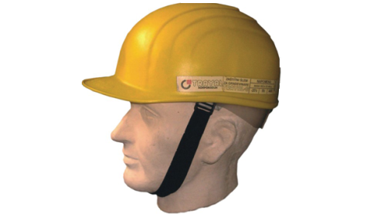
Picture 1: Personal protective equipment [12]

THE OBLIGATIONS OF THE EMPLOYER TO THE RULES ON THE PROVISION OF SECURING THE SAFETY AND / OR HEALTH AT WORK (“OFFICIAL GAZETTE OF RS”, No. 95/10 and 108/17)

- make sure and point out appropriate safety and health labels in accordance with regulations where there is any risk;
- the signs must be placed at the appropriate height in the viewline and in a well-lit, accessible and visible place;
- use of fluorescent and reflective materials or additional artificial lighting is mandatory in cases of poor natural lighting;
- in the course of training for the safe and healthy work of employees, provide manuals or instructions in written form regarding the manner of treatment and the meaning of the safety and health labels;
- the signs must be removed when there are no longer circumstances for which they are placed. [4]

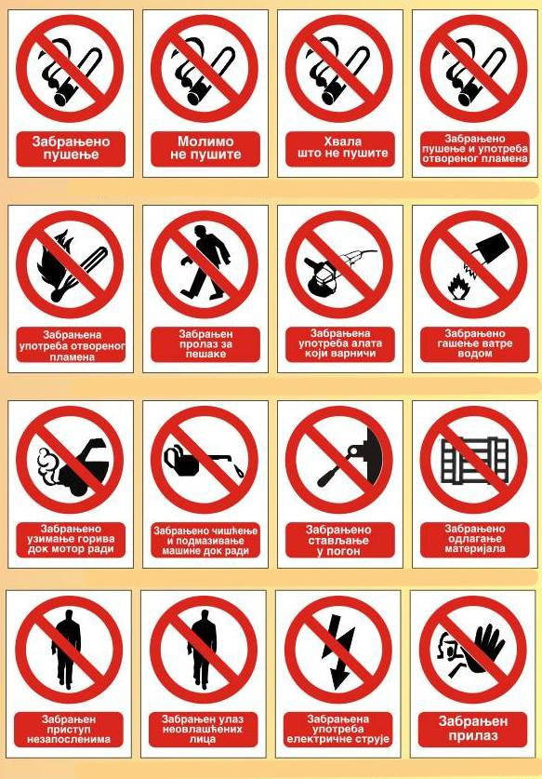
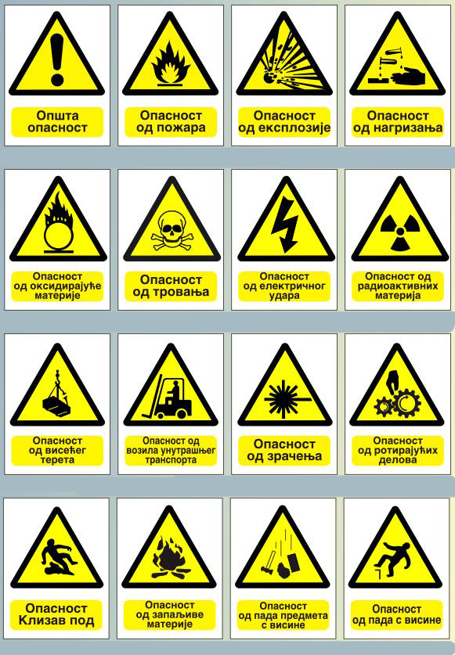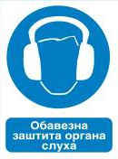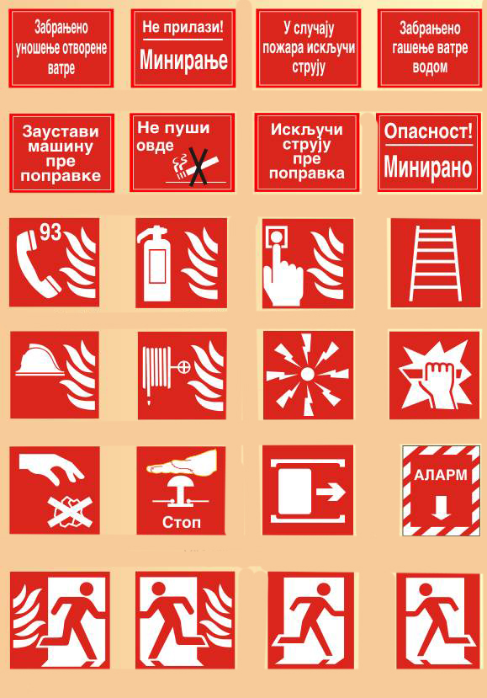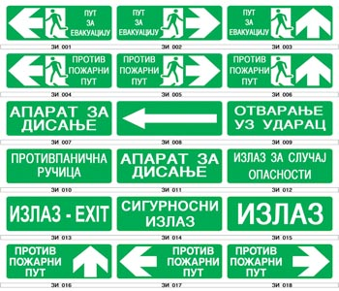
Picture 2: Examples of prohibitions, warnings, obligations, fire extinguishing equipment and emergency exits or first aid [10]

- THE OBLIGATIONS OF THE EMPLOYER ACCORDING TO THE RULES ON PREVENTIVE MEASURES FOR SAFETY AND HEALTH WORK IN THE EXHIBITION OF CHEMICAL MATERIALS (“OFFICIAL GAZETTE OF RS”, No. 106/09 and 117/17)

- ensure that any new workplace activity involving hazardous chemicals begins only after a risk assessment has been carried out and all preventive measures for safe and healthy work have been carried out;
- avoid the use of dangerous chemical substances or its exchange with chemical matter or a process that is not hazardous or that is less hazardous;
- provide monitoring of the health status of employees;
- ensure that the contents in containers and pipelines, as well as the types of materials, are marked in accordance with the regulations;
- provide adequate storage, handling and separation of chemical substances;
- when exceeding the exposure limit value, immediately take all measures to ensure that the exposure to the employed chemical substance is within the allowed limits;
- provide adequate means and equipment for personal protection at work for employees who are allowed to work in an endangered area;
- prevent the presence of a person in an endangered area that is not protected by appropriate means and equipment for personal protection;
- provide warning and communication systems to signal increased danger, to undertake remediation, evacuation and rescue measures;
- ensure that employees and their representatives for safety and healthcare are informed about dangerous chemical substances, their characteristics, exposure limit values and be informed where all the safety data sheets are delivered from the supplier. [5]

- THE OBLIGATIONS OF THE EMPLOYER ACCORDING TO THE RULES ON PREVENTIVE MEASURES FOR SAFETY AND HEALTH WORK IN THE USE OF EQUIPMENT FOR EQUIPMENT (“OFFICIAL GAZETTE OF RS”, No. 106/09 and 93/13)

- improve the assessment of the risk of the occurrence of visual impairment damage and physical and psychophysiological damage to health;
- provide suitable breaks or changes in work activities to the occupants in order to reduce psychophysiological efforts;
- provide employees with visual examinations to be performed by the occupational medicine or ophthalmologist and which are carried out periodically at intervals of no more than three years or when the employee experiences visual problems that may arise as a result of the use of screen display equipment;
- an employee who uses screen display equipment to provide targeted ophthalmological examination, if the results of the show that this is necessary; provide a targeted ophthalmological examination to an employee who uses screen display equipment, if the results of the examination show that this is necessary;
- if the usual corrective means can not be used, provide the use of special corrective measures that correspond to the work being done. [6]
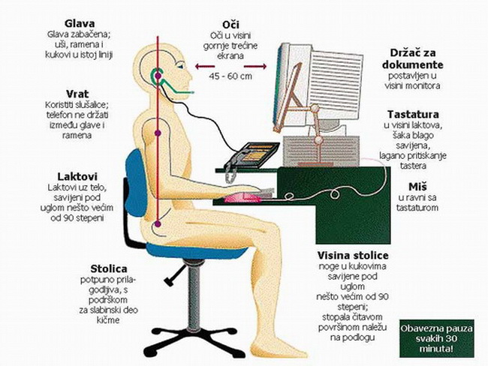
Picture 3: The correct position when working on a computer [11]

- THE OBLIGATIONS OF THE EMPLOYER ACCORDING TO THE RULES ON PREVENTIVE MEASURES FOR SAFETY AND HEALTHY WORK IN THE EXPOSURE OF BIOLOGICAL DAMAGES (“OFFICIAL GAZETTE OF RS”, No. 96/10)

- avoid performing work where there is a possibility of exposure of workers to hazardous biological harmfulness, by replacing and performing jobs in which exposure to biological harm is not dangerous or less dangerous;
- prevent the exposure of employees to biological harmfulness when based on risk assessment it is determined that there is a risk to the safety or health of employees;
- indicate notifications containing procedures to be followed in case of work-related injury and handling of biological harmfulness;
- ensure that the means and equipment for personal protection at work, or protective clothing and work clothes, are decontaminated and cleaned or, if necessary, destroyed;
- ensure that employees do not consume food or liquid in the workplace where there is a risk of contamination;
- provide rooms with showers and sinks in which there are antiseptic agents for washing eyes and / or skin;
- determine in detail the procedures for the collection, handling and processing of samples of human and animal origin;
- advise the health status of employees and, when necessary, provide effective vaccines for those employees who are not yet immune to biological harm. [7]
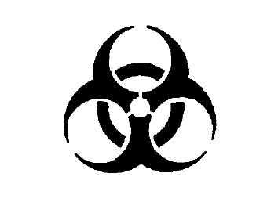
Picture 4: Biological Hazard Pictogram [7]

- THE OBLIGATIONS OF THE EMPLOYER ACCORDING TO THE RULES ON PREVENTIVE MEASURES FOR SAFETY AND HEALTH WORK FOR EXPRESSION OF CARCINOGENES OR MUTAGENES (“OFFICIAL GAZETTE OF RS”, No. 96/11 and 117/17)

- inform employees about containers and pipelines containing carcinogens or mutagens, mark them clearly and comprehensibly and place warning signs on them;
- provide monitoring of the health status of employees;
- consider separately the consequences for the safety and health of the housemaid between the age of 18 and 21, the employed woman during pregnancy, mothers who are breastfeeding and the employee with reduced ability to work, and consider the possibility of moving to other workplaces;
- develop a plan for dealing with emergencies;
- carry out the replacement of carcinogens or mutagens with a substance, mixture or process that are not dangerous or that are less dangerous;
- ensure that carcinogens or mutagenic products are produced and used in a closed system, and if technically not possible, minimize the exposure of employees;
- ensure the safe removal of carcinogens or mutagens through ventilation;
- when there is an unforeseen high exposure, allow work in a endangered area only for employees who are necessary for performing repairs and other necessary work and provide them with means and equipment for personal protection;
- ensure that employees do not consume food, liquids or smokes in the workplace where there is a risk of contamination,
- provide rooms with showers, washbasins and toilets. [8]

- THE OBLIGATIONS OF THE EMPLOYER, ACCORDING TO THE REGULATION ON EQUIPMENT AND PROCEDURE FOR FIRST AID AND THE ORGANIZATION OF THE SAFETY SERVICE SERVICE (“OFFICIAL GAZETTE OF SFRJ”, No. 21/71)

- injured workers must be immediately given the first aid at the nearest suitable place;
- first aid is provided by trained persons, but also workers working in workplaces with increased risk of injury and health damage who must be trained to help themselves if they are in danger;
- for each organization, for every 50 employees, there must be a cabinet provided with medical supplies and first aid;
- have at least a double amount of medical supplies in the reserve, and if the organization is more than 50 km away from the nearest place of supply with medical supplies - at least a triple amount;
- in cases where there is a possibility of gas poisoning, the possibility of strangulation and similar accidents, there must be devices and equipment with oxygen and complete equipment (stretcher, inhalator, antidotes);
- where there is an increased risk of injuries and damage to health, there must be suitable bearings for transmitting injured persons and a means of transport for the transport of an injured person must be provided;
- in each work shift, a sufficient number of qualified persons must be provided for first aid;
- managers, masters, managers, and supervisors must be trained, as well as at least 2% of the total number of employees who are employed in one work shift.

  - Rescue station

It is used for fitting the equipment both as a conference venue and in case of an emergency. The rooms must be spacious, dry, bright, fire-proof and dustproof, and the entrance door must be clearly marked. It should, as a rule, have a number of insulating breathing apparatus with complete equipment, an appropriate number of safety accumulator lamps, at least one inhaler, devices for microclimate and other measurements, necessary devices, tools, accessories and emergency response materials, and this is especially a sweeping, necessary number of bags with medical supplies, an appropriate communication tool during a rescue operation. Breathing apparatus must be located in a suitable place protected from sun and dust, and unusable apparatus and their parts must be disposed of at a particular point. Only those appliances that meet the prescribed requirements can be used and it is convenient for everyone to be of the same type. The used ones must be well cleaned and prepared for future use before being stored in the rescue station. Oxygen bottles must be periodically tested and the chemical purity of the oxygen in the bottles must be at least 98%. It is necessary to determine the professional who will maintain the respirators, devices and other accessories and equipment of the rescue station in the correct condition and examine their correctness.

Rescue unit

Workers are voluntarily attached to the rescue unit, and supervisory and technical staff are ex officio. Professional rescue teams can be designated in larger rescue stations. The unit consists of the head of the unit (head of the unit), his deputy and members. Members can only be persons up to 45 years of age who are physically examined to be able to perform the rescue work. Training of members is done through courses, which include theoretical instruction and practical exercises. The unit is divided into teams with at least three members, and if only one team participates in the action, it must have at least five members. At least twice a year it is necessary to carry out exercises and at least once a year to give an alert signal. The members of the unit are obliged to immediately arrive at the rescue station as soon as they hear an alert signal and appropriate protective means must be provided to them. [9]

- CONCLUSION

According to the International Labor Organization 2.2 million people die annually from the consequences of poor working conditions, or one person every 15 seconds. To compensate for the consequences of job-related injuries, 2-4% of national gross domestic product is spent, or about 25 billion euros. In Serbia, for every fatal fatal injury, 70 serious and 700 injuries are registered with some characteristics of disability and 7,000 minor injuries. These data are sufficient reason for introducing a system of safety and health at work, which, in addition to caring for the life and health of employees, has an economic significance. The aim of this paper is to promote the safety and health system at work, as well as to improve and preserve the health of employees, all of this in order to prevent injuries at work and the occurrence of occupational diseases and diseases related to work. In order to implement the requirements related to safety and health at work, which arise from the Law, it is necessary to conduct overall and constant education both employers and employees, as well as all other participants who have influence in decision making in this area and the expansion of the culture of work in this field improves.

LITERATURE
1] Rulebook on Preventive Measures for Safe and Healthy Work at Work ("Official Gazette of RS", No. 21/09)
[2] Rulebook on preventive measures for safe and healthy work in the use of equipment for work ("Official Gazette of RS", No. 23/09, 123/12 and 102/15)
[3] Rulebook on preventive measures for safe and healthy work in the use of personal protective equipment and equipment ("Official Gazette of RS", No. 92/08)
[4] Ordinance on the provision of safety and / or health at work labels ("Official Gazette of RS", No. 95/10 and 108/17)
[5] Ordinance on Preventive Measures for Safe and Sound Work for the Exposure to Chemical Substances ("Official Gazette of the Republic of Serbia", No. 106/09 and 117/17)
[6] Ordinance on Preventive Measures for Safe and Sound Work for the Use of Display Equipments ("Official Gazette of the Republic of Serbia", No. 106/09 and 93/13)
[7] Ordinance on Preventive Measures for Safe and Sound Work for the Exposure to Biological Hazards ("Official Gazette of RS", No. 96/10)
[8] Ordinance on Preventive Measures for the Safe and Healthy Work of Carcinogens or Mutagenes ("Official Gazette of RS", No. 96/11 and 117/17)
[9] Rulebook on equipment and procedure for first aid and organization of rescue service in case of accidents at work (Official Gazette SFRY, No. 21/71)
[10]http://www.vatroival.com/portfolio/znakovi-i-nalepnice/
[11]https://sites.google.com/site/virtualnicas/racunarski-sistem/ergonomija
[12]https://www.vatrosprem.rs/proizvodi/zastita-i-bezbednost.html

