INNOVATION SOURCES OF KNOWLEDGE FOR IT STANDARDIZATION INITIATIVES

Vesna Ružičić, PhD
Faculty of Technical Sciences in Čačak, University of Kragujevac, Serbia, vesna.ruzicic@ftn.kg.ac.rs

Abstract: This paper presents a comparative analysis of global (ISO/IEC) and local (SRPS) sources of knowledge in PDCA (Plan–Do–Check–Act) loop quality, with the ability to monitor innovation intensity in the standardized fields Information Technology (IT). The study refers to standardized fields of the first level of International Classification for Standards (ICS) grouped in clusters of innovation. The paper focuses on the latest trends in the sources of knowledge and trend lines of certain standardized fields of higher (daily) intensity of innovation in the fields: ICS1 = 25 Manufacturing engineering, ICS1 = 33 Telecommunication and ICS1 = 35 Information technology. The aim is to monitor the intensity of knowledge innovation, trends, sources of knowledge for IT standardization initiatives and update the Knowledge Base (KB) for quality improvement on standardization platform.

Keywords: Sources of Knowledge, Information Technology (IT), Knowledge Base (KB), Innovation, Standardization

INTRODUCTION

The paper deals with a comparative analysis of local (SRPS – label for standards in Serbia, [1]) and international (ISO/IEC, [2]) sources of knowledge in the fields classified according to ICS (International Classification for Standards). A comparative analysis of the fields which has the highest (daily) intensity of innovation was presented for first level classification (ICS1). The starting point for monitoring sources of knowledge innovation is archiving information on quantity and value of the sources of knowledge in all fields of creativity at the ICS1 classification. A comparative analysis of the some field which has the highest (daily) intensity of innovation was presented for ICS1: 25 Manufacturing engineering, 33 Telecommunication, 35 Information Technology (IT).
Knowledge in education process often requires significant expenses. Therefore, establishing the mechanism or model of knowledge which will be applied in complex processes bears particular significance. However, the observation and implementation of international (ISO/IEC) and local standards (SRPS) are necessary both in education and business processes. Creation of Knowledge Base (KB) provides automation solutions to the problem. The aim is to monitor the intensity of knowledge innovation, trends, sources of knowledge for IT standardization initiatives and update the knowledge base for quality improvement on standardization platform, in the PDCA [3] quality loop.

1.1 Research Objectives and Initial Hypotheses

The research gives insight into creation of sources of knowledge and knowledge base in the standardized fields, according to the influencing factors for knowledge innovation, viewed from various perspectives. Planning KB can be realized from various perspectives with the purpose to develop and apply IES, starting from knowledge source. On the basis of the defined comparative indicators, such as index of quality (Iq) and index of value (Iv), innovations are set in the observed level ICS. The activities in the PDCA are analyzed.
The initial hypotheses have been summarized, identified and quantified in PDCA [4] concept, through the following questions:
- Plan phase (P) – Is it possible to plan resources for daily knowledge innovation in the specific fields on the IT standardization platform according to original trend lines starting from knowledge sources?
- Do phase (D) – Is it possible to define comparative indicators (indices) for all fields of creativity, in order to update data base and knowledge base in IT fields?
- Check phase (C) – Is it possible to define clustering indices of innovation intensity at the same time in all fields of creativity?
- Act phase (A) – Is it possible to monitor knowledge source trends of IT fields on the standardization platform? Compared to previous studies, according to [5], the annual sample of sources of knowledge (on the ICS platform) is increased every year.

METHODOLOGY AND FRAME OF RESEARCH OF STANDARDIZED FIELD OF CREATIVITY

Methods Web research, statistical methods, multicriteria analysis and clastering have been used in the paper. Data were collected from the website of the International Organization for Standardization and the National Institute for Standardization [1]. The selection and analysis of data have been completed in the form of clustering and determining level of innovation. Creating trends [6] of knowledge source is followed by mathematical lines/ trend relations.
Based on the frequent innovations [7] expressed by quantities and values of KB units, grouping/clustering is performed according to standardization fields. According to the International Classification of Standards (ICS), all standardized fields of creativity are observed (ICS1 = 01, 03 to 97). Intensity of innovation is viewed according to the relation (1).

Ii_{/t} = Iqu_{/ISO/t} + Iqp_{/srps/t-1} (1)

If:
Ii_{/t} > 250, innovations are daily – daily cluster of innovation (2.1)
50< Ii_{/t} ≤ 250 − cluster weekly innovation (2.2)
12< Ii_{/t} ≤ 50 − cluster monthly innovation (2.3)
0 < Ii_{/t} ≤ 12 − cluster yearly innovation (2.4)
Ii_{/t} = 0 − no innovation (2.5)

RESULTS AND DISCUSSION

This section gives the results of the research related to local and global sources of knowledge in fields: Manufacturing engineering (ICS = 25) and Information technology (ICS1 = 35), fields with the greatest (daily) intensity of innovation ICS1 (Relation 2.1, Figure 1). Telecommunications on the ground (ICS1 = 33) belonged to the daily cluster of innovations January 2015. Statistical analyses were done on samples using the frame specified by the research fields: (ICS1 = 25), (ICS1 = 33), (ICS1 = 35) and ICS1 = 01 to 97, for the January of calendar year of the 21st century. In this paper, samples for the years of the first and second decade of the 21st century are separated. Indices quantities Iq_{/ICS/ISO±SRPS/year} and indices values Iv_{/year} provide numerous further comparisons, analyses and reasoning towards improvement.
The Innovation Index was determined by a set of indexes of development ISO projects (Iqu_{/ISO/year}) and SRPS publications in the previous year (Iqu_{/SRPS/year}), Figure 1.

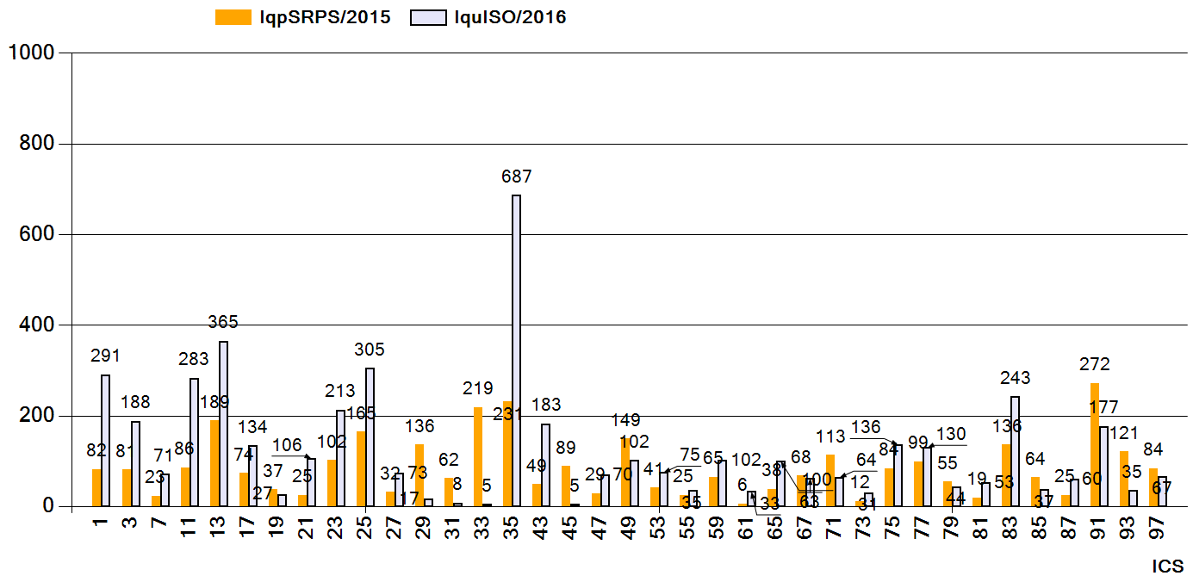
Figure 1: Comparable amounts of innovation ISO – SRPS population standards, January 2016
Quantity indices (Iq), defined and determined for both ISO and SRPS, refer to the following sources of knowledge: samples (Iqs), published standards (Iqp), standards under development (Iqu), standards withdrawn from use (Iqw), new projects (Iqd), innovations in various stages of development (Iqi ≥ Iqu_{/year}) for the entire previous calendar year. In general, equation (3) applies:

$\text{Iqs}(\text{KS})=\text{Iqp}+\text{Iqw}+\text{Iqd}+\text{Iqu}$ (3)

3.1 Results Knowledge Innovation for Standardized Fields ICT

Results of the analysis of IT standardization sources of knowledge in ISO/IEC documents and SRPS standards are presented by comparative indices and charts for most of the subfields, except in cases where the statistical sample is insufficient for proper analysis of the tree fields: ICS1 = 25 Manufacturing engineering, ICS1 = 33 Telecommunication and ICS1 = 35 Information technology. The sample contained over Iqs_{/ICS1=25/ISO+SRPS/2016} ≈ 6050, Iqs_{/ICS1=33/ISO+SRPS/2016} ≈ 4300, Iqs_{/ICS1=35/ISO+SRPS/2016} ≈ 8550 standards [9] and related subfields of the international [1] and local aspects of standardization [2]. The trend lines of some standardized fields of technics and informatics with daily innovation intensity have been selected from the cluster of daily innovation intensity and they have been presented: ICS1 = 25 Manufacturing engineering and ICS1 = 35 Information technology. A number of important details and the results of comparison of knowledge trends have been shown. Observed were parameters of local (SRPS) and global (ISO) sources of knowledge.
ICS1 = 25 Manufacturing engineering – The cumulative results of the field ICS1 = 25, for ISO and SRPS standards have been graphically presented both through the review and trends of standardization, Figure 2.

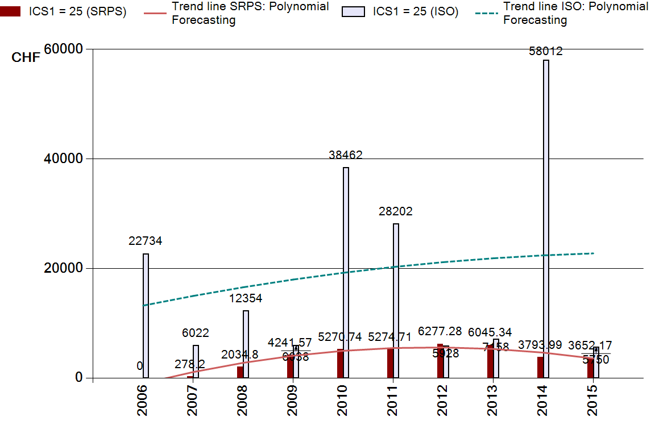
Figure 2: Comparative analysis sources of knowledge (ISO – SRPS) for ICS1 = 25, 1.1.2016

ICS1 = 33 Telecommunication – The cumulative results of the field ICS1 = 33, for ISO and SRPS standards have been graphically presented both through the review and trends of standardization, Figure 3. In this area, the parameters of global sources of knowledge and innovation are analyzed, and the aggregate results are graphically presented through the cross-sections and trends of standardization, including:
  - the temporal aspect of the research period (according to the year of publication) since 1980, with new projects at different stages of development (Iqu), (Figure 3a) and
  - the trend line according to data from the nine years shown (research period at the beginning of the first and second decade of the 21st century) and according to the established relations Iv/ ICS1 (Figure 3b).
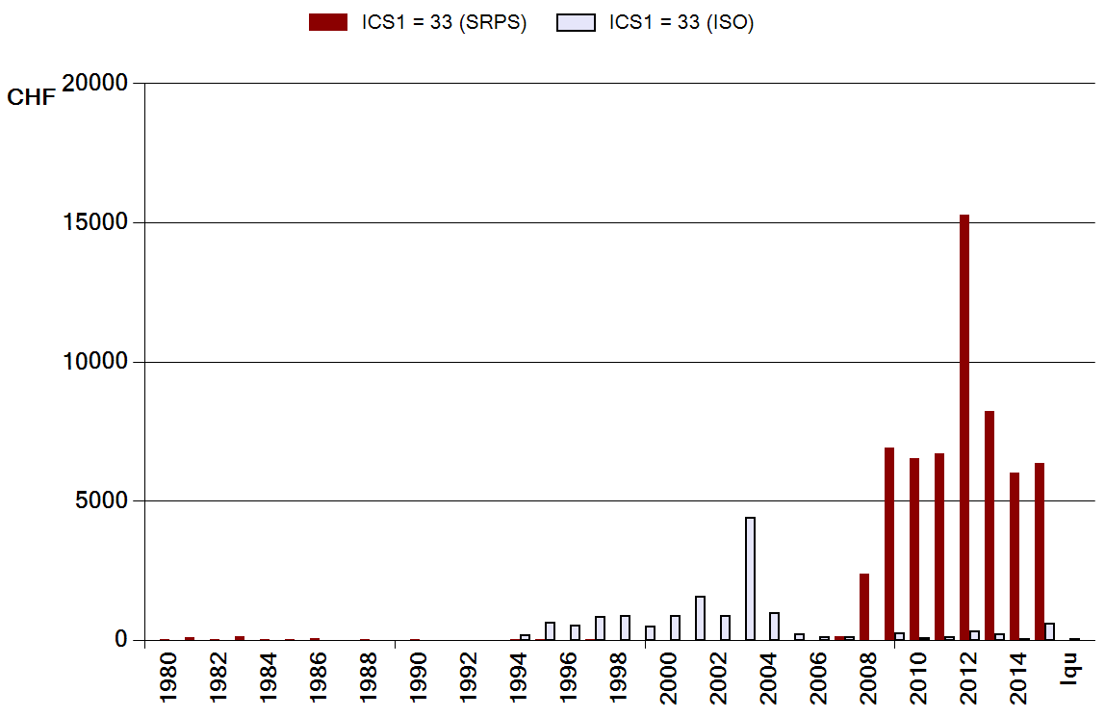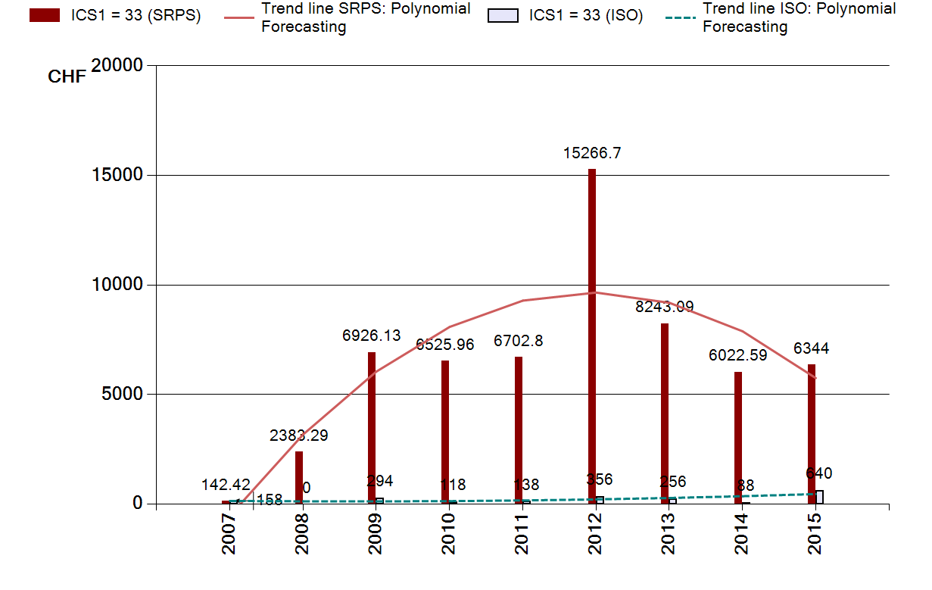
a) | b)
Figure 3: Comparative analysis sources of knowledge (ISO – SRPS) for ICS1 = 33, 1.1.2016:
a) temporal aspects, b) regression trend lines
Independent variable (Iv_{/y/33/SRPS}) takes control variable values (according to concrete year Ix = 2007, 2008, to 2016, respectively) so that the values of the function are expressed in CHF.
ICS1 = 35 Information technology – The cumulative results analysis of the field ICS1 = 35, for ISO and SRPS standards have been graphically presented through the review and trends of standardization, Figure 4.

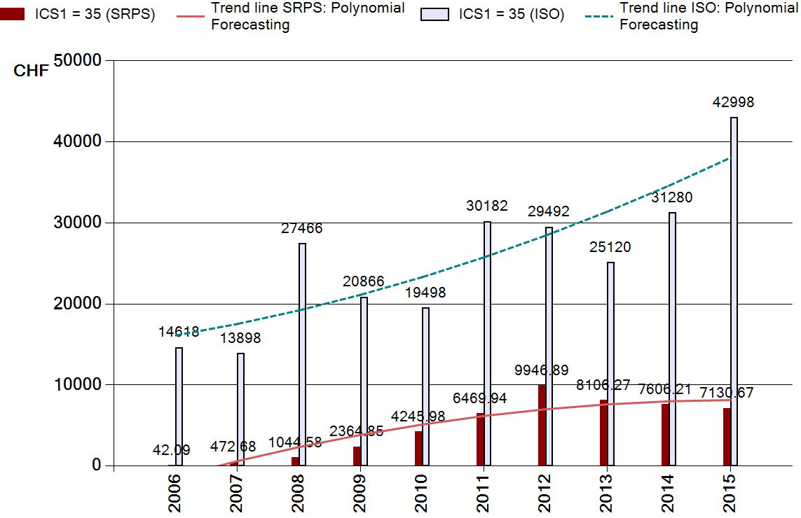
Figure 4: Comparative analysis sources of knowledge (ISO – SRPS) for ICS1 = 35, 1.1.2016

Although the trend lines (mathematically observed) give similar results in resource planning, this can be discussed from several aspects:
- the comparison and deviations of the planned resources based on the mathematical trend line in relation to the actual realization (which is particularly relevant for the planning and realization of ISO projects);
- the comparison of innovations on local (SRPS) and global (ISO) platforms;
- the necessary experience of planners (managers), etc.
Figure 2 and Figure 3 show significant quantitative quantities/ quantities of innovation (numerical and value) in fields ICS1=25 and ICS1=35 in 2016. At the same time, the number and value of liabilities in previous years are also reduced.
The cumulative results of the field ICS1 = 35, for ISO and SRPS standards have been graphically presented both through the review and trends of standardization (1.1.2015), Figure 5.

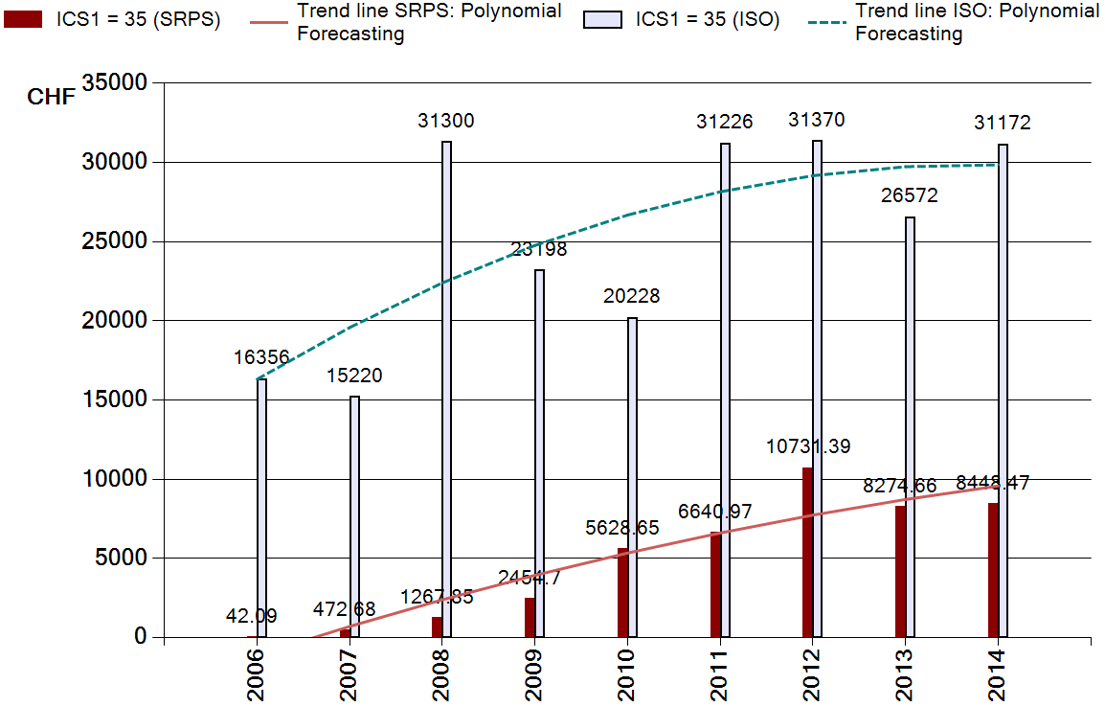
Figure 5: Comparative analysis sources of knowledge (ISO – SRPS) for ICS1 = 35, 1.1.2015

Iv’ = Iv_{/SRPS/35(2014)/1.1.2015}=8448.47 (Figure 5) (4)

Iv” = Iv_{/SRPS/35(2014)/1.1.2016}=7606.21 (Figure 4) (5)

Difference in innovation value, in the case of the IT field for SRPS standards (ICS1 = 35), for one calendar year is determined according to the following relationship:

Iv’- Iv” = ΔIv (6)

It's necessary is to monitor the intensity of knowledge innovation, trends, sources of knowledge for IT standardization initiatives and update the KB for quality improvement on standardization platform.

3.2 Discussion of the Results of the PDCA

The selected relevant results have been analyzed and joined together with the other factors that affect PDCA spiral of quality improvement. The followings goals have been achieved: presentation of methodology development, research results, proof of hypotheses 1 to hypotheses 4, and implementation of comparative analyses of the standardized sources of knowledge (according all ICS1 fields):
(P) Resourses planning for knowledge innovation – daily, weekly or monthly, (Ii_{/t});
(D) Update of database and knowledge base in ICS1 fields (ICS1 = 01, 03, ..., 97);
(C) Defining clustering indices, according to innovation intensity (Iv’, Iv”, …);
(A) Monitoring innovation trends for knowledge improvement on the standardization platform (ΔIv).
The correlations between the process of IT standardization and clusters of innovativeness require a special attention. On one hand, the standards provide a legal safety and a basis for innovativeness [8], create a huge market and build trust among the users. According to the models of the innovation processes [9], the standardization in companies can affect all the stages starting from a basic research to a product design, manufacture and introduction into the market. On the other hand, all the above mentioned influential aspects are disputable when the standardization process does not encourage the innovativeness of final products. However, in this paper, direct correlations of the IT standardization process and innovativeness are given.

CONCLUSION

According to the aforementioned structures of the displayed, the original concept of the „sources of knowledge towards the KB for expert system in the domain fields for IT standardization initiatives” will have more success in those areas in which it is adequately supported by the state institutions. This implies collective quality assurance and resources: organization system, personnel, software and the knowledge in the hardware fields, and other end-products. In the fields with a greater intensity of innovation, the application of expert systems is more justified and has better results. Based on the presented hypotheses and results, what follows are the conclusions reached through the PDCA methodology:
- (Plan) The methodology and model development starts from an overall statistical sample Iqs (sources of knowledge) in ICS fields in various phases of product development. On the basis of Iqu_{/ISO} and Iqp_{/SRPS} and innovativeness intensity it is determined to which innovativeness cluster a field belongs. The realization of the objectives of planning, collecting and updating of knowledge from the sources of knowledge to the system and its applications in the field of innovation is beyond the capabilities of individuals [10];
- (Do) Knowledge innovation in the time dimension of Do-phase of the PDCA concept (presented in the example of the knowledge base in the domain field), is the base for outstanding performance results/ products (on examples ICS1=25, ICS1=33 and ICS1=35). Knowledge innovativeness intensity in high education [11] falls significantly behind standardization intensity (Iqs_{/ISO+SRPS}); the reasons for this should be the subject of future research;
- (Check) System checking focuses on the target fields and subfields of creativity along with the daily innovation intensity. The knowledge base system is dynamic, which implies both systematic innovation and mandatory checking (Iv’, Iv”, ….);
- (Act) By the use of software for resource availability is improved in the fields of high innovativeness (difference in innovation value – ΔIv). It is necessary to systematically and continuously monitor knowledge innovation trends in product innovations [12] on standardization platforms. The results of the analysis of innovation and roads model [13] the KB system to local (SRPS) platform utilizing the PDCA_{/t} concept, leading to the achievement of the objectives of excellence in practice.
It's necessary is to monitor the intensity of knowledge innovation, trends, sources of knowledge for IT standardization initiatives and update the KB for quality improvement on standardization platform, particularly in the process of knowledge acquisition – innovation sources of knowledge for IT standardization initiatives.
Future research would relate to the next level of contribution, both for areas of creativity as a whole, as well as for other individual ICS areas, and for their detailed analysis and application. Continue further research may include the elaboration of the impact of new parameters and elements, conditioned by the needs of users, by including the requirements of new standards.

REFERENCES

- ISO/IEC, International Standards for Business, Government and Society, List of ICS fields, http://www.iso.org/iso/iso_catalogue/catalogue_ics/catalogue_ics_browse.htm, (accessed: 16. 03. 2019)
- Institute for Standardization of Serbia, Available. Advanced search: http://www.iss.rs/standard/advance_search.php (accessed: 16. 03. 2019)
- ASQ (© American Society for Quality), „Plan–Do–Check–Act (PDCA) Cycle”, available at: http://asq.org/learn-about-quality/project-plannin, 2015, (accessed 16. 03. 2019).
- PSU (2004), „Cluster Analysis, Ward’s Method, © 2004” Pennsylvania State University, Pennsylvania, available at: http://sites.stat.psu.edu/~ajw13/stat505/fa06/19_cluster/09_cluster_wards.html (accessed 1 February, 2017)
- Ružičić S. V. and Micić M. Ž., „Creating a strategic national knowledge architecture: A comparative analysis of knowledge source innovation in the ICS subfields of multimedia and IT security”, Computers & Security, Vol. 70, pp. 455-466, 2017
- Micić, Ž. and Ružičić, V., „Trends knowledge innovation standardized authorities in one of creativity with a focus on quality subfield”, in 10th International symposium Research and design for industry – IIPP, Faculty of Mechanical Engineering, Belgrade, 1-13. December, pp. 201–208, http://doi.org/ISBN 978-86-84231-35-4, 2014
- Maruta, R. „Transforming knowledge workers into innovation workers to improve corporate productivity”, Knowledge – Based Systems, Vol. 30, June 2012, pp. 35-47
- Ružičić, V. and Micić, Ž., „Continuous monitoring the trends of knowledge sources per cluster innovation intensity”, in 11th International symposium Research and design for industry – IIPP, Faculty of Mechanical Engineering, Belgrade, 22-23. 12. 2017 (pp. 114–123). http://doi.org/ISBN 978-86-84231-38-5, 2015
- Ružičić, V., „Modelling Knowledge for Development and Application of Information-Expert System”, Doctoral dissertation, Faculty of Technical Sciences in Čačak, University of Kragujevac, 2018.
- Ružičić V., „Application of some tools and methods aimed at advancement of project management”, 6th International Conference Science and higher education in fuction ofsustainable development - SED 2013, Užice, Oktober 2013, ISBN 978-86-83573-39-4
- ISO/IEC, „2382-36:2008 Information technology – Vocabulary – Part 36: Learning, education and training (14 pages)”, in Switzerland, Geneva, 2008
- Micić, Ž., Micić, M. and Blagojević, M., „ICT innovations at the platform of standardization for knowledge quality in PDCA”, Computer Standards & Interfaces, Vol. 36 No. 1, pp. 231-243, 2013
- Micić, Ž. and Ružičić, V., „Innovation sources of knowledge for clustering standardized field of creativity”, in Technics and Informatics in Education – TIO 2016, University of Kragujevac, Faculty of Technical Sciences, Čačak, 28-29 May, pp. 250–257, 2016

