RESTRUCTUREDTEXT INTEGRATOR OF TEACHING MATERIAL
Dr Petar Marić¹; Dr Srđan Popov²
¹ Faculty of Technical Science, University of Novi Sad, Novi Sad, Serbia, petarmaric@uns.ac.rs
² Faculty of Technical Science, University of Novi Sad, Novi Sad, Serbia, srdjanpopov@uns.ac.rs

Abstract—The integration of teaching materials and transformations into presentation forms is a problem that we face every day. We noticed that the material made for the teaching units, we often have to transform into a suitable presentation form. Preservation, correction and updating of materials, when the material in the presentation format is not suitable. Therefore, the content is generated and updated in the text format, and reStructuredText markups are responsible for generating different presentation forms.

Keywords— reStructuredText, ASCII txt, pdf, html, data index .

- INTRODUCTION

reStructuredText and corresponding tools are very useful for generating teaching materials into different formats which can be: HTML (including Windows HTML Help), LaTeX (for printable PDF version), ePub, Texinfo, manual pages and plain text. Among these formats we can find adequate format in all cases the use of materials, which can be found during the teaching process. One of the most important is to generate a book from teaching materials. All required tasks during lecture preparation are covered and materials for a particular teaching unit areperformed within a plain text formatted file.
On the basis of this formed material, materials for the classes are generated. This approach has a particularly interesting ability to generate HTML presentation based on the same source code, that is intended for online usage.

- RELATED WORKS

In article [1] authors present how free and open source software can be incorporated into geospatial education to promote open and reproducible science. Their motive primary is to generate and share source material for courses. They chose HTML but are also usingautomated scripts to ensure that everything published on the website is also kept in sync with a publicly hosted code repository and allows to transform in reStructuredText, in the future. In our opinion, the transformation of the material into the reStructuredText should be done beforehand to automate the generation of the HTML.
Miller and Ranum [2] generate an interactive eTextbook that incorporates video, code editing,execution and visualization. They were motivated by drawbacks of the classic, typically static electronic book formats. In addition their eTextbook should be created with an open source authoring system. In their implementation all prose is written in restructuredText,including figures, images, and other necessary visual effects.

- RESULTS AND DISCUSSION

To build our book we're using the reStructuredText markup language [3] in conjunction with the Sphinxdocumentation framework [4]. Thanks to Sphinx and its builders we're able to build our book in multipleformats, currently supported:
- HTML (web site)
- HTML (single page)
- plain text
- LaTeX
- camera-ready PDF, derived from LaTeX
Sphinx itself supports a lot more output formats, but we found these to be particularly useful. Sphinx implements a pluggable software architecture, making it easy to extend its features by adding new Sphinx builders, or even adapting the existing builders.
With Fabric [5] we're able to automatically compile the entire book (Figure 1) (in all of our supported formats) and upload its HTML version to the book's site [6] with a single command (please note that most of the original program output has been snipped for brevity).

Figure 1:Compiling the entire book, in all of its supported output formats

Once compiled, the book is accessible either online, through its site [6] as showed on Figure 2 or offline, via a camera-ready PDF like on Figure 3.

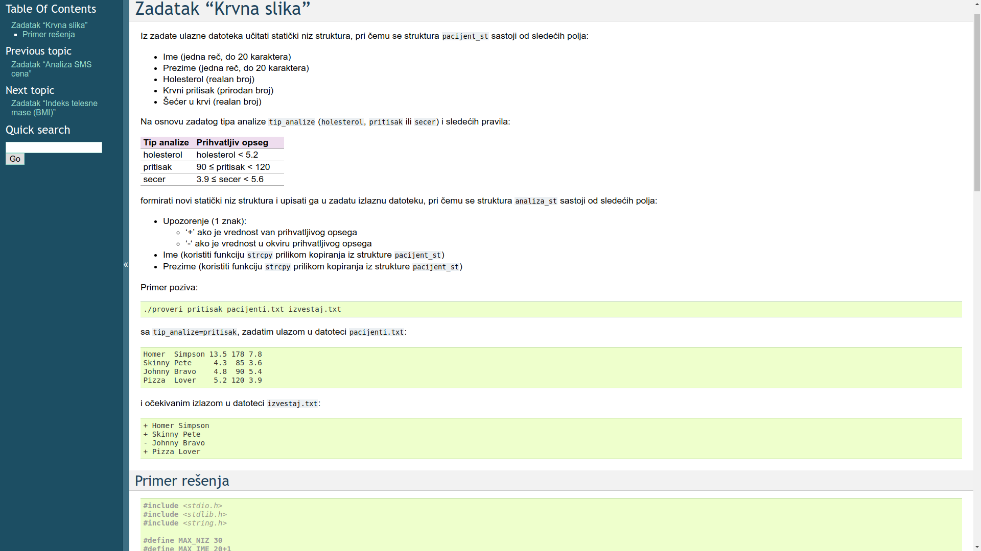
Figure 2: Bookwebsite [6]

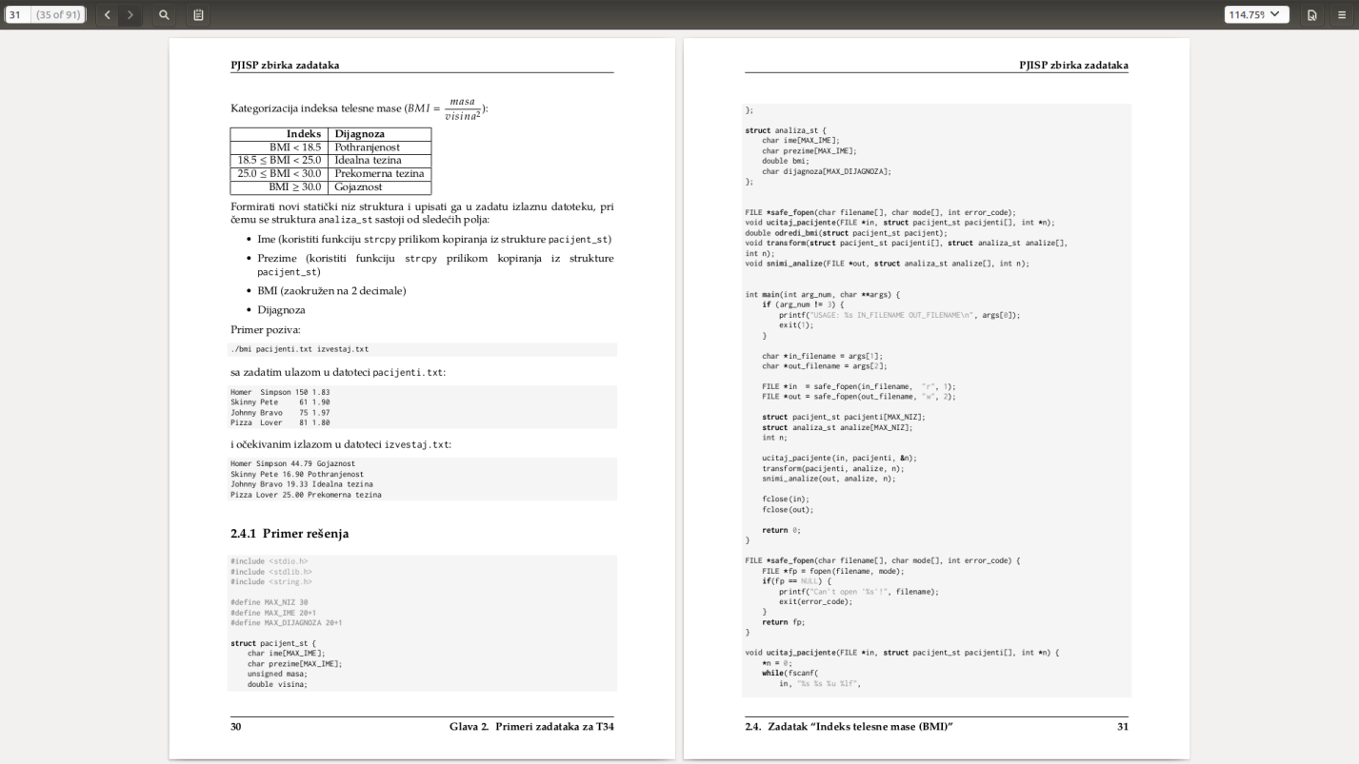
Figure 3: Camera-ready PDF

One useful feature we found missing in many similar books is a thematic index of programming assignments,
which we've created by extending Sphinx (Figure 4).
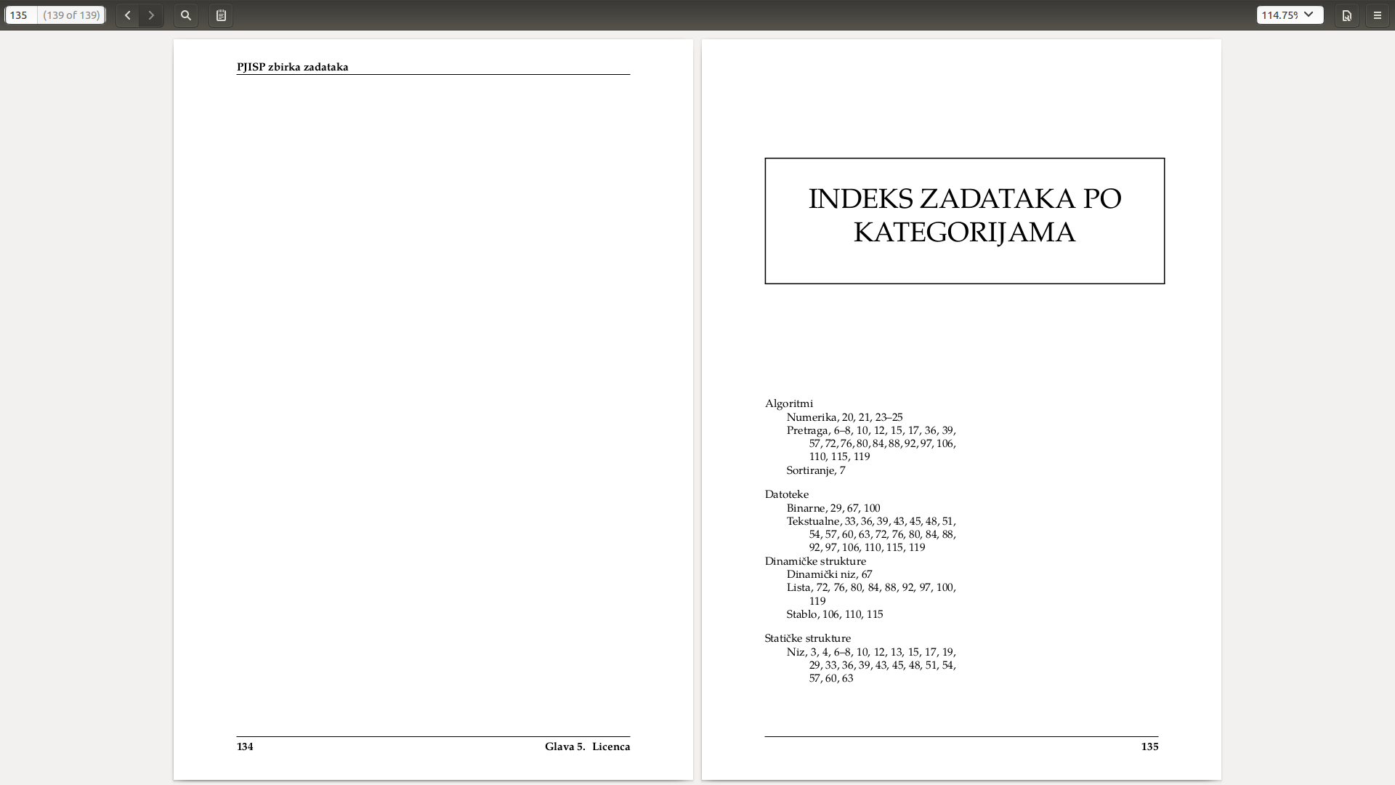
Figure 4: Thematic index
We're already beta-testing the book with our students and in the last school year alone (October 2, 2017 - September 10, 2018) we've had 3,603 users (across all the different devices they use [7]) visit the book's site, where an average user had:
- 4.94 independent sessions with the site
- 3.78 pages per session
- 5:08 minutes session duration
This demonstrates substantial engagement from both our students and the external users, as we taught 4 different courses in the last school year - totaling at about 800 students who we've told about the book.

- CONCLUSIONS AND FUTURE WORK

We're currently in the process of evaluating different eBook formats and their existing Sphinx builders, aiming to create a platform-neutral paper-free offline version of our book.
In the same time we're integrating the book publishing process into our existing continuous integration infrastructure, which would enable us to automatically publish the book (in all of its formats) whenever a change has been made to its source code repository.
This book and its source code are publicly available, under the Creative Commons Attribution-NonCommercial-ShareAlike 4.0 International Public License (CC BY-NC-SA 4.0)[8].

REFERENCES

[1] Vaclav Petras , Anna Petrasova , Brendan Harmon , Ross K. Meentemeyer and Helena Mitasova, Integrating Free and Open Source Solutions into Geospatial Science Education, ISPRS INTERNATIONAL JOURNAL OF GEO-INFORMATION, ISSN 2220-9964 Published by MDPI AG, Basel, Switzerland
[2] B.N. Miller and D.L. Ranum. Beyond PDF and ePub: toward an interactive textbook. Proceedings of the 17th ACM Annual Conference on Innovation and Technology in Computer Science Education (ITiSE’12), pages 150–155, New York, NY, USA, 2012.ACM.

[3] D. Goodger, "An Introduction to reStructuredText" http://docutils.sourceforge.net/docs/ref/rst/introduction.html
[4] G. Brandl, "Sphinx - Python documentation generator" http://www.sphinx-doc.org/
[5] J. Forcier, "Welcome to Fabric!" http://www.fabfile.org/
[6] P. Marić and S. Popov, "PJISP zbirkazadataka" http://pjisp.petarmaric.com/zbirka-zadataka
[7] Google, "How users are identified for users metrics - Analytics Help"
https://support.google.com/analytics/answer/2992042?hl=en
[8] Creative Commons Corporation, "Creative Commons:
Attribution-NonCommercial-ShareAlike 4.0 International (CC BY-NC-SA 4.0)"
https://creativecommons.org/licenses/by-nc-sa/4.0/

