COMPARISON OF JPEG PERFORMANCES USING REGULAR AND MODIFIED QUANTIZATION TABLES

Milovan Milivojević, Ph.D.¹, Mikloš Pot, M.Sc.², Željen Trpovski, Ph.D.³
¹Business Technical College of Vocational Studies, Užice, Serbia, milovan.milivojevic@vtps.edu.rs
²Polytechnical Engineering College, Subotica, Serbia, pmiki@vts.su.ac.rs
³Faculty of Technical Sciences, Novi Sad, Serbia, zeljen@uns.ac.rs

Abstract: The JPEG image compression standard is based on the Discrete Cosine Transform (DCT) and coefficient quantization. In this paper we’ll discuss only grayscale image compression, and we’ll only mention the case of color images. We’ll also suppose that the test images are quadratic (256x256 pixels) and each pixel is represented using 8 bits (256 shades of gray). Compression starts by dividing the digital image into 8x8 blocks, and further operations are performed on these 8x8 blocks. The contribution of this paper is that different quantization matrices are used to determine the measure of degradation. In the end, after reconstruction, the degradation is evaluated using the most common measures: the Peak Signal to Noise Ratio (PSNR).

Keywords: digital image compression, discrete cosine transform, quantization, peak signal-to-noise ratio

1. INTRODUCTION

Compression of a digital image is a mean to save memory space. Basic classification of compression methods is to compression without losses and compression with losses. In the case of lossless compression the original signal (in this case image) can be reconstructed without loss of quality. On the other hand, in the case of lossy compression after reconstruction degradation occurs. The degree of degradation depends on the compression factor, and on image content also. Typical value of the compression ratio for the lossless case is 3:1, and in the case of lossy compression the ratio is 15:1. The JPEG standard that was first announced in 1992 refers to the family of lossy compressions. The standard defines several types of JPEG compressions: sequential, hierarchical, progressive and lossless. When talking about JPEG, most often we think of the sequential type that is mostly used in practical implementations [1], [2].
The importance of digital image compression is justified because of huge storage space requirement: without compression, a single 512x512 pixel color image would require 768kB of space, while only one second of full HD 1080x1920 video would require around 200MB of storage space.

2. THE JPEG PROCESS

The JPEG process consists of several steps: 1) Breaking the digital image into 8x8 pixel blocks, 2) Level shift: 128 is subtracted from each pixel value, now the block range concerning pixel intensities will be between -128 and +127, 3) DCT transform on each block, 4) Quantization, 5) Zig-zag scanning of the 8x8 image block, 6) Run-length coding and entropy coding [3]. The flowchart of the algorithm is shown is Figure 1.
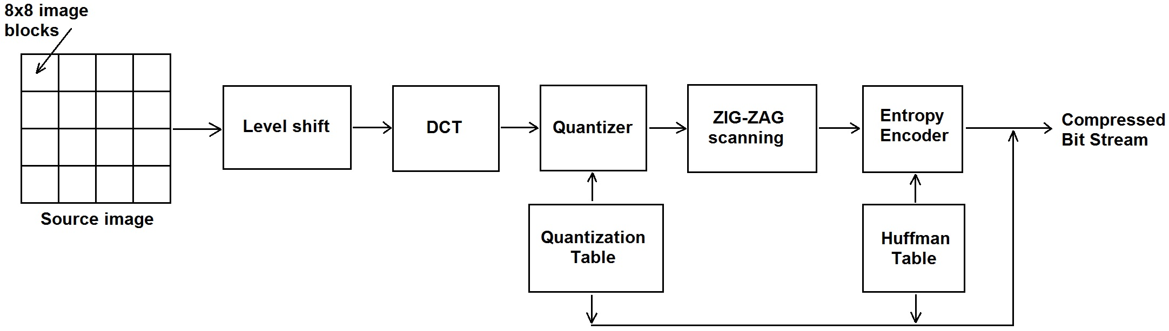
Figure 1: Flowchart of the JPEG process
2.1. Quantization

From the steps listed above, quantization is the only step that introduces irreversible information loss, all other steps are invertible. Different levels of compression and quality are possible by selecting a specific quantization matrix. The exact quantization matrix is not a part of the JPEG standard, so the user can decide on quality levels between 1 and 100. Quality 1 gives the highest compression ratio and worst image quality, while quality 100 gives perfect quality and lowest compression level. Empirical research that included the human visual system resulted in the JPEG Q₅₀ standard quantization matrix. The Q₅₀ is a good trade-off between compression ratio and reconstructed image quality. If different quality level is needed, the Q₅₀ is multiplied with a scalar factor. For a quality level greater than 50 (higher image quality), the Q50 is multiplied by (100-quality level)/50. For quality level less than 50 (lower quality, smaller file size) the Q₅₀ is multiplied by 50/quality level. In both cases the scaled quantization matrix is rounded to contain only positive integers and limited to values between 0 and 255 [4]. Examples matrices Q₁₀, Q₅₀ and Q₉₀ are shown in Figure 2.

$Q_{\text{10}}=\left[\begin{matrix}\text{80} & \text{60} & \text{50} & \text{80} & \text{120} & \text{200} & \text{255} & \text{255} \\ \text{55} & \text{60} & \text{70} & \text{95} & \text{130} & \text{255} & \text{255} & \text{255} \\ \text{70} & \text{65} & \text{80} & \text{120} & \text{200} & \text{255} & \text{255} & \text{255} \\ \text{70} & \text{85} & \text{110} & \text{145} & \text{255} & \text{255} & \text{255} & \text{255} \\ \text{90} & \text{110} & \text{185} & \text{255} & \text{255} & \text{255} & \text{255} & \text{255} \\ \text{120} & \text{175} & \text{255} & \text{255} & \text{255} & \text{255} & \text{255} & \text{255} \\ \text{245} & \text{255} & \text{255} & \text{255} & \text{255} & \text{255} & \text{255} & \text{255} \\ \text{255} & \text{255} & \text{255} & \text{255} & \text{255} & \text{255} & \text{255} & \text{255}\end{matrix}\right]$ $Q_{\text{90}}=\left[\begin{matrix}3 & 2 & 2 & 3 & 5 & 8 & \text{10} & \text{12} \\ 2 & 2 & 3 & 4 & 5 & \text{12} & \text{12} & \text{11} \\ 3 & 3 & 3 & 5 & 8 & \text{11} & \text{14} & \text{11} \\ 3 & 3 & 4 & 6 & \text{10} & \text{17} & \text{16} & \text{12} \\ 4 & 4 & 7 & \text{11} & \text{14} & \text{22} & \text{21} & \text{15} \\ 5 & 7 & \text{11} & \text{13} & \text{16} & \text{12} & \text{23} & \text{18} \\ \text{10} & \text{13} & \text{16} & \text{17} & \text{21} & \text{24} & 2 & \text{21} \\ \text{14} & \text{18} & \text{19} & \text{20} & \text{22} & \text{20} & \text{20} & \text{20}\end{matrix}\right]$ $Q_{\text{50}}=\left[\begin{matrix}\text{16} & \text{11} & \text{10} & \text{16} & \text{24} & \text{40} & \text{51} & \text{61} \\ \text{12} & \text{12} & \text{14} & \text{19} & \text{26} & \text{58} & \text{60} & \text{55} \\ \text{14} & \text{13} & \text{16} & \text{24} & \text{40} & \text{57} & \text{69} & \text{56} \\ \text{14} & \text{17} & \text{22} & \text{29} & \text{51} & \text{87} & \text{80} & \text{62} \\ \text{18} & \text{22} & \text{37} & \text{56} & \text{68} & \text{109} & \text{103} & \text{77} \\ \text{24} & \text{35} & \text{55} & \text{64} & \text{81} & \text{104} & \text{113} & \text{92} \\ \text{49} & \text{64} & \text{78} & \text{87} & \text{103} & \text{121} & \text{120} & \text{101} \\ \text{72} & \text{92} & \text{95} & \text{98} & \text{112} & \text{100} & \text{103} & \text{99}\end{matrix}\right]$
Figure 2: Quantization matrices Q₁₀, Q₉₀ and Q₅₀

The DCT compacts the energy of the image block into only few coefficients in the upper left part of the block. That is the reason why these low frequency components are quantized lightly, while high frequency components are quantized rather heavily [5]. A typical DCT transformed image block before and after quantization is showed in Figure 3.

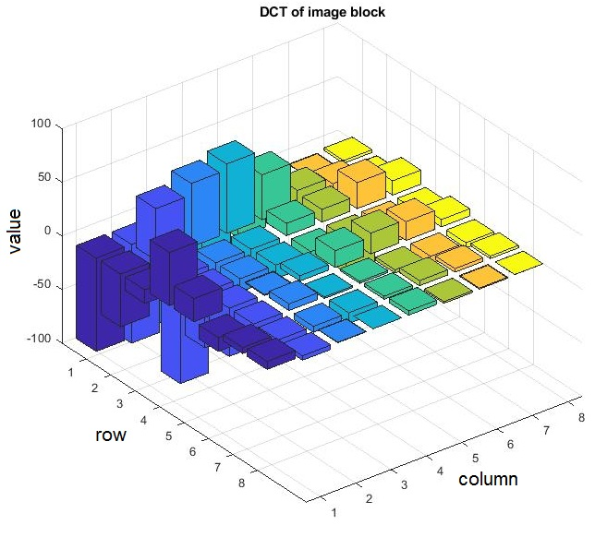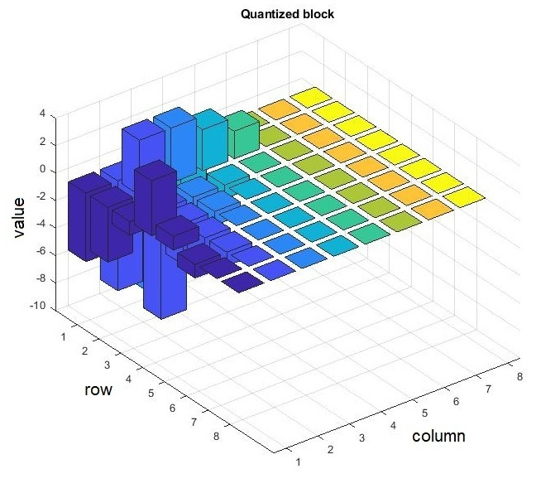
Figure 3: Image block after DCT transformation (left), and after quantization (right)

3. TEST IMAGES

In the first stage of the research the authors examined the influence of the quantization matrix on peak signal-to-noise ratio (PSNR), structural similarity (SS) and compression ratio (CR). Thumbnails of 11 256x256 8-bit test images used are shown in Figure 4.

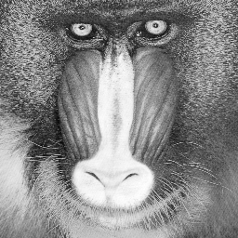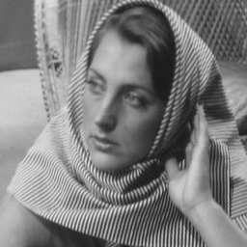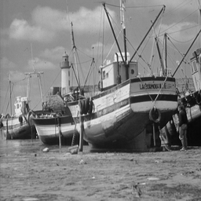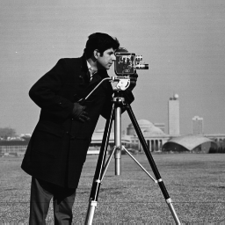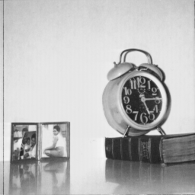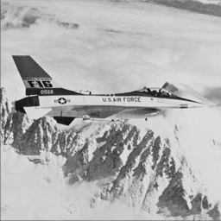

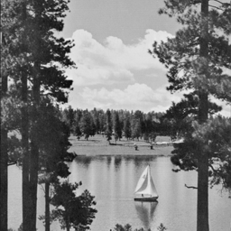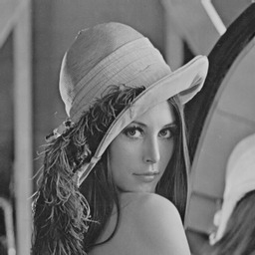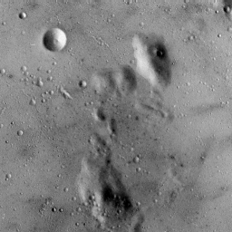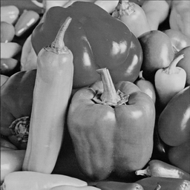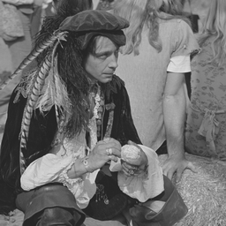
Figure 4: Test images used in the research: Baboon, Barbara, Boat, Cameraman, Clock, F16 (top row), Lake, Lena, Moon, Peppers and Pirate (bottom row)

4. EXPERIMENTAL RESULTS

In the experimental phase all test images were compressed and decompressed, and several objective quality parameters were measured between the original and the reconstruction digital images. Peak signal-to-noise ratio (PSNR) and structural similarity index (SSIM) were used to evaluate the quality of the compression. The results are summarized in Table 1. For each test image the Q₅₀ quantization matrix was used.

Table 1: Experimental results of image compression for quantization matrix Q₅₀
 | Bitstream (bits) | CR | PSNR | SSIM
Baboon | 59250 | 8.85 | 29.35 | 0.66
Barbara | 63303 | 8.28 | 33.37 | 0.86
Boat | 66067 | 7.94 | 31.86 | 0.81
Cameraman | 54223 | 9.67 | 31.50 | 0.58
Clock | 40943 | 12.81 | 34.69 | 0.56
F16 | 58458 | 8.97 | 32.61 | 0.72
Lake | 74022 | 7.08 | 31.09 | 0.80
Lena | 52342 | 10.02 | 33.58 | 0.79
Moon | 50787 | 10.32 | 32.13 | 0.64
Peppers | 56106 | 9.34 | 34.14 | 0.81
Pirate | 68076 | 7.70 | 31.59 | 0.81

By modifying the quantization matrix, the results also change. Table 2 shows the results for the same process when using quantization matrices Q₁₀ (high compression, low image quality) and Q₉₀ (excellent quality, low compression rate). It is on the user to adapt the quantization matrix to his needs.

Table 2: Experimental results for quantization matrices Q₁₀ and Q₉₀
 | Quantization with Q₁₀ |  |  |  | Quantization with Q₉₀
 | Bitstream (bits) | CR | PSNR | SSIM | Bitstream (bits) | CR | PSNR | SSIM
Baboon | 12713 | 41.24 | 2658. | 0.32 | 172218 | 3.04 | 37.45 | 0.91
Barbara | 20972 | 25.00 | 26.26 | 0.64 | 138730 | 3.78 | 40.64 | 0.94
Boat | 20195 | 25.96 | 26.33 | 0.56 | 155884 | 3.36 | 39.69 | 0.93
Cameraman | 17782 | 29.48 | 26.22 | 0.35 | 133019 | 3.94 | 39.90 | 0.80
Clock | 15724 | 33.34 | 28.63 | 0.37 | 98356 | 5.33 | 41.72 | 0.80
F16 | 20044 | 26.16 | 27.00 | 0.48 | 136878 | 3.83 | 40.29 | 0.87
Lake | 24340 | 21.54 | 25.73 | 0.58 | 171558 | 3.06 | 38.90 | 0.92
Lena | 17218 | 30.45 | 28.36 | 0.54 | 128034 | 4.09 | 47.25 | 0.98
Moon | 11562 | 45.35 | 28.64 | 0.31 | 155348 | 3.37 | 37.72 | 0.90
Peppers | 18710 | 28.02 | 28.41 | 0.60 | 128690 | 4.07 | 41.15 | 0.92
Pirate | 20062 | 26.13 | 26.71 | 0.56 | 164441 | 3.19 | 39.02 | 0.94

So far only grayscale images were analyzed. For the color case there is a slight difference. The JPEG standard requires to transform the RGB color image to the YCbCr color plane. This transformation is done using the following equation:
$\begin{aligned}\left[Y | \right]\left[\text{Cb} | \right] \\ \end{aligned}$ (1)

Since the human eye is not as sensitive to color degradation as to luminance degradation, the chrominance planes can be further subsampled for extra space savings. The subsampling can be done using either 4:4:0, 4:2:2 or 4:2:0 method. In this paper 4:2:0 is used what means that the spatial resolution of both the horizontal and the vertical planes are halved. In our case the original test image is composed of 256 rows and 256 columns [6]. After the transformation the luminance component (Y) still has the same resolution, but the chrominance components are halved to 128x128 by averaging each 2x2 image block. This on purpose degradation is hardly visible for the human eye, so the subjective quality remains almost the same. A typical RGB to YCbCr color transform of a test image (with and without subsampling) is shown in Figure 5.
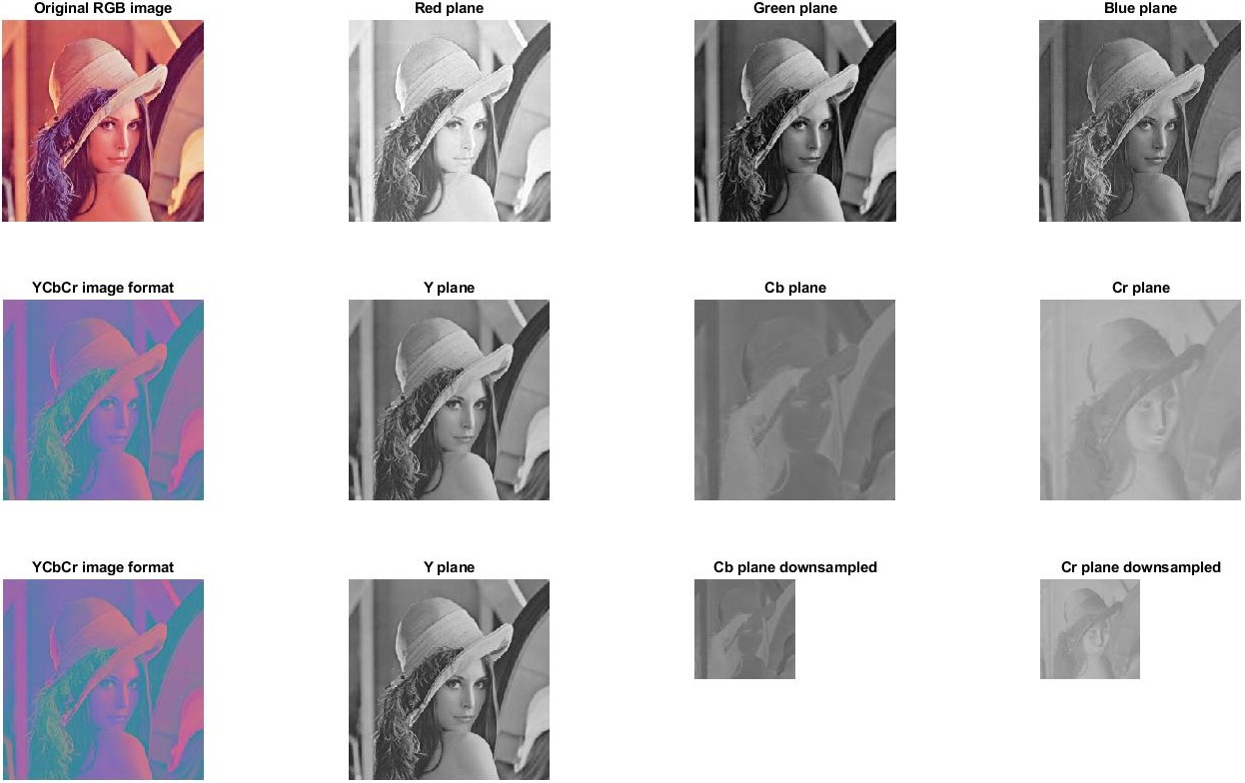
Figure 5: Color test image decomposed to color planes. Top row: Original test image decomposed to Red, Green and Blue components. Middle row: Test image transformed to YCbCr color plane, decomposition to Y (luminance), Cb and Cr (chrominance). Bottom row: YCbCr color image format, color planes subsampled by factor 2.

It would be logical to expect the compression ratio does not change for the color images in comparison to grayscale (if same quantization matrices are used). But because eyes are less sensitive to color, it is possible to quantize the color components more heavily. A typical chroma quantization matrix is shown in Figure 6. As it can be observed, numbers are quite high in comparison to the luminance Q-matrix which means bigger degradation. The other reason the compression ratio increases for color images is the fact that Cb and Cr components were subsampled to 128x128 ,so they occupy 4 times less space than their original version. After all calculations are done, it can be easily calculated that we ended up with 1.5 256x256 digital image (256x256 luminance image plus 2 times 128x128 chrominance images).

$$Q_{\text{90}}=\left[\begin{matrix}\text{17} & \text{18} & \text{24} & \text{47} & \text{99} & \text{99} & \text{99} & \text{99} \\ \text{18} & \text{21} & \text{26} & \text{66} & \text{99} & \text{99} & \text{99} & \text{99} \\ \text{24} & \text{26} & \text{56} & \text{99} & \text{99} & \text{99} & \text{99} & \text{99} \\ \text{47} & \text{66} & \text{99} & \text{99} & \text{99} & \text{99} & \text{99} & \text{99} \\ \text{99} & \text{99} & \text{99} & \text{99} & \text{99} & \text{99} & \text{99} & \text{99} \\ \text{99} & \text{99} & \text{99} & \text{99} & \text{99} & \text{99} & \text{99} & \text{99} \\ \text{99} & \text{99} & \text{99} & \text{99} & \text{99} & \text{99} & \text{99} & \text{99} \\ \text{99} & \text{99} & \text{99} & \text{99} & \text{99} & \text{99} & \text{99} & \text{99}\end{matrix}\right]$$
Figure 6: Chrominance quantization matrix

Table 3 shows the stream length (number of bits) to represent each color plane. It can be observed that the Y plane needs 7-10 time more space than the color components [7]. There are two main reasons for this: the first is that the color components (Cb, Cr) are four times smaller than the Y component (128x128 compared to 256x256), and the second is that the color components were quantized rather heavily.

Table 3: Number of bits needed to represent the Y, Cb and Cr color planes in bits
 | Y (bits) | Cb (bits) | Cr (bits) | Total (bits) | Compression ratio
Baboon | 72040 | 8157 | 7652 | 87849 | 17.90
Barbara | 77496 | 4498 | 4965 | 86959 | 18.09
F16 | 47403 | 5718 | 4145 | 57266 | 27.47
Lena | 44228 | 5703 | 5519 | 55450 | 28.37
Peppers | 44351 | 7441 | 9505 | 61297 | 25.66
Finally, Figure 7 shows the original test image Lena along with 3 more images that were obtained after compression and decompression using quantization matrices Q₁₀, Q₅₀ and Q₉₀.

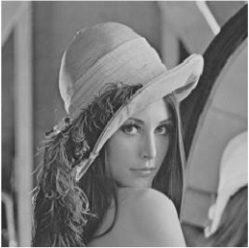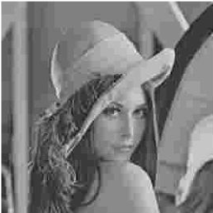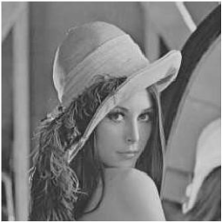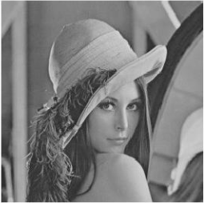
- (b) (c) (d)
Figure 7: Test image Lena compressed with different quantization matrices. (a) Original test image, (b) Test image quantized with Q₁₀, (c) Test image quantized with Q₅₀, (d) Test image quantized with Q₉₀

5. CONCLUSION

In this paper we investigated different quantization for 11 test images in the process of JPEG compression. We proved that quantization has a considerable impact on the resulting image quality and on the compression ratio. Quantization is a mean to make a trade-off between image quality and compression ratio. Color images were also investigated, and we showed why color images can achieve higher compression ratios. It would be worth investigating how would the JPEG compression perform if the digital image is not broken to 8x8, but bigger pixel blocks. Also better results might be achieved if different quantization matrices would be applied to different blocks based on their content [8].

6. ACKNOWLEDGEMENT

This paper is partially supported by Serbian Ministry of Education, Science and Technological Development, under Grant No. III 47020.

REFERENCES

[1] W. B. Pennebaker, J. L. Mitchell: JPEG Still Image Ddata Compression Standard. Springer Science & Business Media, New York, 1992.
[2] Joint Photographic Expert Group (JPEG). Information technology – digital compression and coding of continuous-tone still images – part 1: requirements and guidelines. ISO/IEC 10918-1, ITU/CCITT Rec. T.81, 1992.
[3] N. Ahmed, T. Natarajan, K. R. Rao: Discrete Cosine Transform, IEEE Trans. on Computers, 23, pp. 90-93, 1974.
[4] K. S. Thyagarajan: Still Image and Video Compression with Matlab, John Wiley & Sons, 2011, ISBN 978-0-47048416-6.
[5] G. K. Wallace: The JPEG still picture compression standard, IEEE Transactions on Consumer Electronics, 38(1), 1992.
[6] Douak, Benzid, Benoudjit: Color Image Compression Algorithm Based on the DCT Transform Combined to an Adaptive Block Scanning, Int. J. Electron. Commun. 65, 2011, pp. 16-26.
[7] Wang, Lee, Chang: Designing JPEG quantization tables based on human visual system, Elsevier, 2001, signal Processing: Image communication 16, pp. 501-506.
[8] S. Alireza Golestaneh, Damon M. Chandler: Algorithm for JPEG Artifact Reduction Via Local Edge Regeneration, Journal of electronic Imaging 23(1), 013018 (Jan-Feb 2014).

