AN ICT-BASED PLATFORM FOR INTERACTIVE TRAINING AND TEACHING BASED ON PI REGULATOR

¹Dr Dejan Blagojevic; Dr Stojanče Nusev; ¹Dr Aleksandra Boričić;
¹ Visoka Tehnička Škola Strukovnih Studija Niš, Republika Srbija, dejan.blagojević@vtsnis.edu.rs (TNR 10 pt, centrirano)
² University SV.Kliment Ohridski,Fakultet, Faculty of Technical Science Bitola, Macedonia, imejl adresa

- Abstract: The concept of virtual laboratories is becoming more and more applicable in the first place due to its efficiency. A virtual experiment is an experiment with the mathematical model of the system. This eliminates the need for a real laboratory. However, it is necessary to construct a precise mathematical model and an appropriate platform for an experiment. The proposed solution consists of three functional units: the teaching management system, the central PID system and the laboratory equipment integrated with the subject software and hardware. The central PID system consists of a software package that acts as a PID controller that ensures that each student has his / her login account in the central PID system. The software package offers the possibility of expanding the number of potential exercises on demand. The developed application is compatible with the teaching management software package and provides the opportunity to demonstrate the software and work in it without interruption to students through a group presentation. This model have been developed through the realization of the Erasmus+ project, WamPPP 561821-EPP-1-2015-1-RS-EPPKA2-CBHE-JP and practically is involved in the teaching process

Key word: virtual lab, mathematical model, central PID system, application, software

(tri prazna reda)

1. INTRODUCTION

The demands for faster network and availability of advanced services (voice, data, and video) with an appropriate QoS (quality of service), today present a serious challenge in the development of the modern teaching and researching process. Trend of globalization and competition are just some of the challenges we face every day. In addition to technology, this market also requires qualified personnel, whose education takes time, as well as contemporary teaching methods and environment [1]. Higher education in Europe has undergone major changes through the Bologna Process. The higher education faces with inevitable trend of globalization as well as our society generally. Today's information and communication technologies contribute greatly to the advancement of the educational system through introducing of innovative methodologies into the teaching process, such as distance learning, learning on processes in real time, etc. This last presents a good basis for further development of the application of ICT technologies in higher education, through the application of various network and wireless systems in effort to improve the quality of the teaching process [2]. From viewpoint of qualification framework/knowledge, the necessary skills, abilities and attitudes/, the necessity for implementation of integrated systems in the teaching process is necessary almost inevitable step. This step have to ensure the acquisition of knowledge, skills and habits. The integrated models should contain all elements of contemporary "learning", such as ``General Learning``, ``Everywhere Learning``, ``Enhanced Learning``, ``Extended Learning`` [3].
Also, integrated model have to be in line with the requirements of traditional classroom teaching, laboratories, face-to-face (f2f), hybrid or mixed teaching as a combination of teaching in classroom and teaching with the help of various technology as well as on-line lessons [4].
Today, the concept of a virtual lab is increasingly more applicable in the first place due to its efficiency. A virtual experiment is an experiment with the mathematical model of the system. This eliminates the need for a real laboratory. However, it is necessary to construct a precise mathematical model and an appropriate platform for the experiment [5, 6]. The application of virtual laboratories has special advantages if we focus on a wider circle of users. The advantages are numerous and range from the possibility of remote access to resources, the unlimited number of repetitions of the experiment and the simulation of process to the possibility of realizing rapid analyzes and processing the results of the performed experiments, to the possibility of transferring practical knowledge at a distance [7, 8].
Our solution comprises three functional units: a) Teaching process management system b) The central PID system c). Laboratory equipment integrated with a course software and hardware controlled by Nucleo F411 RE board (fig.1) [9]. .
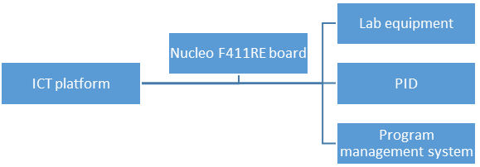
Figure 1. Block schema of ICT platform

2. TECHNICAL REQUIREMENTS (FUNCTIONAL DESCRIPTION OF THE SYSTEM

2.1. HARDWARE PLATFORM

As we already mentioned, our integrated system, consists of three functional units: a) teaching management system, b) central PID system and c) laboratory equipment integrated with the subject software and hardware. All this is controlled by Nucleo F411RE board [10]. The teaching management software package should support the operating systems Windows, Linux, Android, IOS, Mac, with the stated functionality being understood as the Windows operating system, where some of the functionality does not need to be supported on other operating systems. Management software must generally support work from both subsystems (central PID system and lab work).
In general, interactive learning provides the following opportunities: Transferring a work screen by teachers to student computers, transferring voice from teachers to student computers, demonstrating specific content to a specific student, networking video content for all students, networking the camera's content for all students, an interactive board where all students can participate.
From the point of view of control and assistance to students, interactive learning should provide: student computer monitoring and control, internet access control, media access control (CD, USB Disk), application control, printer control, screen control (screen darkening during lectures). Furthermore, it is often necessary to provide remote commands on a student computer such as running applications, opening a remote site on a student's computer, and remotely starting a computer.
The management of open-circuit systems is based on the set algorithms. These algorithm are based on knowledge of the functioning of a managed system and do not affect it changes in output variables or interference. The algorithm of such functional management is usually defined in the design of the system, and then the corresponding device is implemented.

The PID controller, is the part of the automatic control system that performs the control function (fig.2). The essential task of the controller is to generate a measurable output size by generating the control signal to the reference value given by the signal [10-11]
.
Figure 2. Automatic feedback control system with controller.

For a feedback system, the input signal in the controller is an error signal obtained as the difference between the reference and the output signal. The controller is characterized by a transfer function H (s) which should enable the generation of an output signal that will provide the desired behavior of the system [12].
In the case of the displayed system, the central PID system consists of a software and hardware part. The software part represents a software package that acts as a PID controller that ensures that each student has his / her login account in the central PID system. The hardware is conceived so that it can be accessed from any computer through the network access and manage the PID parameters. This conceptualized system allows the simulation of the appropriate industrial and production processes in real time.
Hardware is a set of several parts of which the air hose is made of plastic. The effective tube length should be at least one meter and transparent to allow students to see sensors and other elements in the tube. The fan creates a flow of air through the tube and can be controlled by a potentiometer (manual) or programmable. The fan speed is measured by the voltage of the signal ranging between 0V and 5V. The normal fan speed will be defined as the maximum speed. (It is not necessary to know the volumetric airflow). The air is heated by electric heaters. Heater supply is controlled by a voltage in the range between 0V and 5V that connect and disconnect the main voltage on the heater via PWM. The presence of a PWM signal is indicated by a light indicator. The PWM device requires a 24 VDC power supply from the AC / DC converter. Two temperature sensors are built into the system
Both sensors must be equally calibrated. Sensor signals must be voltage in the range 1V - 5V. This voltage range must correspond to a temperature range of 20-60 °C with a linear relationship between the ranges. An analog I / O device must be able to accept the above voltage ranges [9-13]..

2.2 NUCLEO F411RE DEVELOPMENT BOARD
Generally solution is based on the NUCLEO F411RE development board which is programmed to enable the acquisition and installation of digital and analogue signals from a specially developed application on a PC. A microcontroller is programmed to function as a slave, i.e. to react to the commands obtained from a PC application via serial port. The setting of an electric motor reference speed value has been enabled, as well as that of the PID controller parameters via the application programmed in the MATLAB. The application was developed in MATLAB GUI so that one can enable easier data processing in the course of work. One of the suggestions was to develop application in Python, so as to reduce software cost. From the beginning the good sides of creating an acquisition board are a great input and output organization flexibility, a larger number of inputs/outputs, as well as the price (the material for the realization of one platform cca 100 e + energy electronics + apparatus). Likewise, the possibility of further system upgrade is large, but it implies a vast knowledge of embedded programming, of electronic board development, as well as of programming and working with MATLAB software. The bad sides of this approach are reflected in the time and cost necessary to develop MATLAB software (unless one uses Python). Also, the speed, as well as the precision of a signal acquisition would be smaller than using commercial solutions specialized for this purpose [10].
The presented solution is based on the NI USB-6008 acquisition card (which was available at the time). One of the remarks was that the card is out of date and that one should use the more recent NI USB-6001 card, which is cheaper and has better performance. The card enables the acquisition and installation of digital and analogue signals from a specially developed application at a PC. The application is developed in the LabVIEW software. A card is simply attached to a computer and other peripherals. The setting of an electric motor reference speed value has been enabled, as well as that of the PID controller parameters via the application programmed in LabVIEW. The good sides of this approach are reflected in a shorter time necessary for its development, so one can dedicate more time to develop different apparatus. The possibilities of a further system upgrade are greater than with the previously described solution, since one does not need the knowledge of embedded programming, and the software is more intuitive for the beginners. The bad sides are the price, fewer inputs/outputs, as well as the price of the LabVIEW package.

3. DESCRIPTION OF THE SYSTEM FOR THE CONTROL OF THE TEMPERATURE AND APPLICATION OF THE P-I METHOD OF SETTING

The subject of management is a system where it is necessary to regulate the temperature. The system consists of a chamber representing an interior in which temperature control is performed, an air-heater heater, a fan that allows the air flow through the chamber and the sensor for measuring the temperature and air flow [10-13].
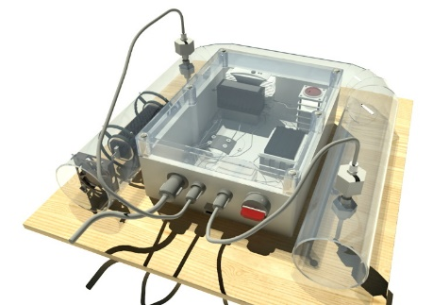

Figure 3. The temperature control system
1. The chamber is made of transparent plastic tube length of 1 meter.
2. The heater serves to heat the air in the chamber. The supply of heaters is controlled by a control voltage signal in the range of 0-5V. The control signal values ​​in a given range are obtained using pulse width modulation (Pulse Width Modulation - PWM).
3. The fan allows the movement of air through the chamber.

The temperature sensor is used to monitor the current temperature and the education of the control system. The measuring range of the sensor is from 20-60 ° C, and this measuring range with linear dependence corresponds to a voltage value of 1-5V. According to the nature of the process, the most appropriate structure of the regulator is PI. There is a simple method that allows adjustment of PI controller parameters, without bringing the system into oscillations. This method consists from following 4 steps:
- Bring the system to a nominal or other desired state by setting the voltage U_{o} in manual mode.
- Set the initial parameters K_{p} = 0, T_{i} = ∞, T_{d} = 0, and switch the system to the automatic mode. Increase the Kp value until the response image of the system achieves the desired stability in a sudden change in the reference value or by setting the disorder (if possible). It is considered that the system is sufficiently tuned if, when changing the reference, the new set value is achieved with a slight leap, but also with good damping.
- Set the parameter T_{i} to be equal to 1.5 · T_{ou}, where T_{ou} is the time between the first two extremes of the skip (one positive and the other negative) when controlling with the P regulator.
- With the set PI controller, observe the system's response to a jump start or change of reference. Due to the nature of the integral effect, the response of the system may be more unstable than with P effect. If it is noticeable that the system is too unstable, it is necessary to reduce K_{p} to 80% of the initial value

4. DETERMINATION OF PARAMETERS AND TESTING OF SYSTEMS WITH PI REGULATOR

Before the setting of the parameters of regulator, we have make a choice of selection period with Ts=0.1s. and system filtration is set by averaging measurement with 10 samples. System is set in nominal mode. In this mode, manual control is set on zero. In order to determine the parameters of the PI controller, it is necessary, initially, to select the P type of the regulator and set the K_{p} value to ensure that the system has a leap and a good damping, after skipping, without too much oscillations. In order to determine the parameters of the PI controller, it is necessary, at first, to select the P type of the controller, after that we have set the K_{p} value of the action in order to ensure that the system has a leap and a good damping, after skipping, without too much oscillations. In this case, we decide to set value K_{p} = 3. After entering values ​​for K_{p} and set reference temperatures to 32 ° C (the current temperature was 27 ° C), the system was switched to automatic mode. After a time of 1:12 min, the system had a leap (Fig. 4) and at the time of 1:42 min, the system reached the first value of the extreme - positive (Fig.5).
At 3:11 min, the system reached the second value of the extreme - negative (Fig. 6). In the further work, the system has shown that it has good damping, without too much oscillation, indicating that the value of the parameter K_{p} = 3 have been well selected. Based on the knowledge of the time of the first and second extremes, the T_{i} parameter was determined by the product of the time T_{ou} = 89s and the coefficient 1.5, so that T_{i} = 133.5.
Based on predetermined parameters of K_{p} and T_{i,} PI regulators, the system was tested by setting up a jumpy reference change, that is, the system response to the change in the reference temperature was monitored. After entering the parameters of the PI controller and switching to the automatic mode, the desired is set, i.e. a reference temperature of 35 ° C, while the current temperature was 28 °C. By monitoring the operation of the system, it was determined that the system had a good response and that the reference value of the temperature was reached relatively fast, at a time of 1:19 minutes, with a smaller leap of about 14% (1°C) of the value of the reference change (Fig 7).
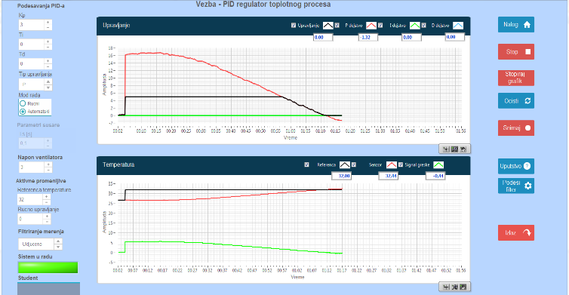  Figure 5. A leap of system in t=1:12 min | 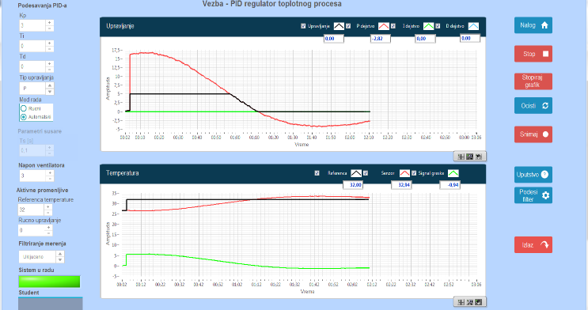  Figure 5. System reaceh the first positve extremum
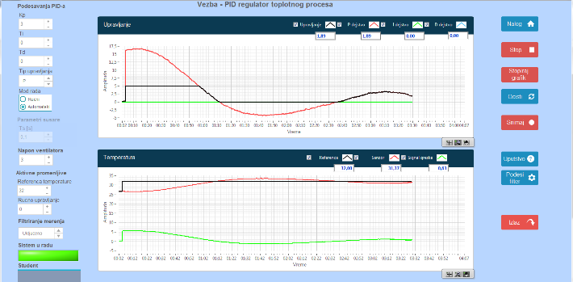  Figure 6. The system reached the second value of the extreme. | 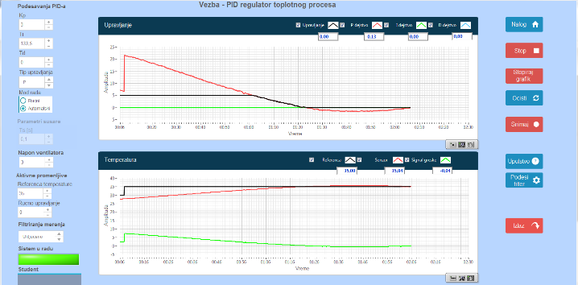Figure 7. Response of system on spring change and overlap
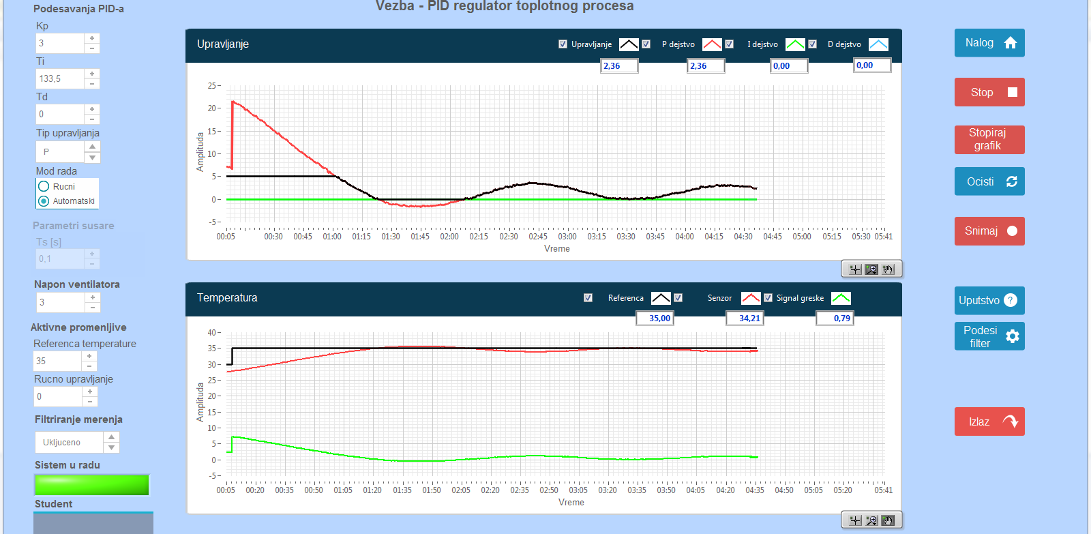
Figure 8 . Stationary state of system.

In stationary state, the system monitors the set temperature with deviations of less than 1 °C, which is satisfactory, given the nature of the sensor's measurement and the entire system (Fig. 8).
Take into account a small oscillations that the system shows in the stationary state, it is easy to conclude that control shows good results and indicates that the parameters K_{p} and T_{i} are well defined, and the regulator PI meets set requirements for temperature

4. CONCLUSION

Today, information and communication technologies are a key factor in the development of the education system, by introducing innovative methodologies into the teaching process, such as distance learning or, more generally, electronic learning. The concept of virtual laboratories is becoming more and more applicable in the first place due to its efficiency. A virtual experiment is an experiment with a mathematical model of the system, which eliminates the need for a real laboratory.
The presented solution consists of three functional units: the teaching management system, the central PID system and the laboratory equipment integrated with the subject software and hardware. The teaching management software package should support Windows, Linux, Android, IOS, Mac operating systems, with the aforementioned functionality implied on the Windows operating system, where some of the functionality does not need to be supported on other operating systems. With this model, interactive learning provides the following possibilities: Transferring a work screen by teachers to student computers, transferring voice from teachers to student computers, demonstrating specific content to a specific student, networking video content for all students, networking the content of the camera to all students, interactive whiteboard where all students can take part.
On the other hand, from the point of view of control and assistance to students, interactive learning should provide: student computer monitoring and control, Internet access control, media access control (CD, USB Disk), application control, printer control, screen control (screen darkening in during the lecture). Furthermore, it is often necessary to provide remote commands on a student computer such as running applications, opening a remote site on a student's computer, and remotely starting a computer.
The complex system thus constructed, ultimately allows students to work and manage the appropriate systems in real time, which has been a major drawback so far. Also, the work of the student is under the supervision of the subject professor or assistant, which enables the student's independence on the one hand, and on the other hand, safe work.

BIBLIOGRAPHY

- „Ključni podaci o učenju i inovacijama kroz ICT u školama u Evropi 2011,” © Education, Audiovisual and Culture Executive Agency, 2011, ISBN 978-92-9201-501-5.
- Schmidgen, Henning; Evans, Rand B.: The Virtual Laboratory: A New On-Line Resource for the History of Psychology. History of Psychology, 6 (2), p. 208-213, 2003
- V. Marković, D. Vučković and Z. Marinković, „Trendovi u ICT industriji kao podsticaj reformi u visokom obrazovanju,” XXVIII Simpozijum o novim tehnologijama u poštanskom i telekomunikacionom saobraćaju – PosTel 2010, Beograd, 14-15. decembar 2010.
- “Report on defined WM-related knowledge, skills and competencies,” WamPPP, 2016.
- N. Đelošević, LMS u E-učenju Univerzitet u Kragujevcu 145010-TEMPUS-2008-RS-JPHES-ETF-JP-00059-2008, 2010.
- V. Vasiljević, B. Pavić i I. Kostić, Komunikacioni sistemi – Priručnik za labaratorijske vežbe, VISER, Beograd, 2010.
- M. Živković, S. Tešanović, Ž. Gavrić i Boris Slijepčević, „Upotreba virtuelne laboratorije u obrazovanju: korišćene programskih alata LTSPICE i FILTER DESIGN u sticanju znanja iz predmeta Osnovi telekomunikacija,“ INFOTEH-JAHORINA Vol. 10, Ref. F-17, pp. 976-979, March 2011.
- Development of a methodological approach to the curricula implementation in the waste management field on the basis of a modern-day information and communications technology – WamPPP 561821-EPP-1-2015-1-RS-EPPKA2-CBHE-JP.
- A novel ICT-based learning platform for practical education and training WamPPP 561821-EPP-1-2015-1-RS-EPPKA2-CBHE-JP.
- Nucelo F411 RE https://www.st.com/en/evaluation-tools/nucleo-f411re.html
- Dejan Blagojević, Milan Pavlović, Đorđe Karić, ‘’Karakteristike p-i metode podešavanja pid regulatora sistema za regulaciju temperature’’, Zbornik radova VTS Niš, 2017, god, pp 25-29,
- M. Naumović, „Inženjersko obrazovanje u upravljanju - izazov savremenih informacionih tehnologija,“ Zbornik radova Infoteh Jahorina 2001, pp. 31-35, mart 2001.
- N. Popović i M. Naumović, „Primjena virtuelnih okruženja za učenje u automatskom upravljanju,” INFOTEH-JAHORINA Vol. 7, Ref. E-III-12, p. 518-523, March 2008.

