MULTIMEDIA APPLICATIONS FOR BUS ARRIVAL TIME PREDICTION USING KALMAN FILTER AND WEB SERVICE

Aleksandar Stjepanovic, PhD; Gordana Jotanovic, PhD; Mirko Stojcic, MSc; Emir Peco, BSc;
1 University of East Sarajevo, Faculty of Transport and Traffic Engineering Doboj, aleksandar.stjepanovic@sf.ues.rs.ba,gordana.jotanovic@sf.ues.rs.ba mirko.stojcic@sf.ues.rs.ba

Abstract: The use of multimedia applications in transport is closely related to the rapid development of information and communication technologies and their versatile application in different areas of human life. Interactive multimedia applications in the analysis and efficient monitoring of various transport situations provides wide opportunities for timely decision-making, which affects the safety and efficiency of transport processes with increased participants' satisfaction. Research in this paper focused on theme bus arrival time prediction (BATP). The paper analyzes two approaches to this complex problem, model based approach-with Kalman filter and in real time approach with web service. For experimental analysis it is designed distributed multimedia information system (DMIS) which purpose is to monitor and manage public bus traffic on a selected section. Under the proposed system, designed several multimedia interactive applications that are installed on distributed multimedia bus stops.

Keywords: Intelligent Transportation System, Multimedia application, Bus Stops, Multimodal interactive interfejs,BATP;

INTRODUCTION

The term multimedia comes from the Latin words multus and medium, where the medium is a physical carrier or data transducer. The definition of multimedia says that is the ability to handle various types of presentation media that make up the data type with the task of defining information in its encoded form. Due to the rapid development of computer and digital technologies in the early 1990s, multimedia began to appear as a multidisciplinary research area, and it relates to the study and development of an effective and efficient multimedia system that targets a specific application. Interactive multimedia provides the ability to control users over the application, if it adds a hyperlink structure - hypermedia to achieve the application dynamics [1].
Hypermedia is created when images, animations, sounds, videos are added to hypertext. Hypertext is a text displayed on a computer that contains links to other text documents. It represents a structure that consists of interconnected units of information displayed on an electronic device. Unlike a simple traditional text, hypertext does not have a single sequence of readings, but is read by the reader dynamically, that is, it determines it during reading.
The goal of multimedia is to capture as many human sensations as possible so that the experience of the transmitted message is as complete as possible. From the point of view of the implementation of multimedia applications in intelligent transportation systems (ITS), multimedia applications must be scalable in view of the availability of resources. The multimedia communication model uses mostly two types of communication, user interface - transport - user interface and processing, storing, searching - transport - user interface [2] .
Intelligent Transport System can be defined as an information and communications and management upgrade of a conventional transport system that achieves a significant improvement in performance, more efficient passenger and goods transport, improved traffic safety, more comfort and protection of passengers, and the provision of cleaner environment. Many research in the field of intelligent transport systems, carried out over the last thirty years, are focused on increasing the possibilities for application of information and communication technologies in transport systems, which enable optimum use of roads, traffic and travel data, and constant monitoring and monitoring of services, road safety and security of applications.
ITS integrates not only different modules, but also pedestrians, vehicles, road infrastructure, traffic management centers, sensors and satellite navigation systems [3]. With distributed intelligence, ITS clearly impose stringent requirements for the exchange of information among all ITS entities in terms of availability, reliability, fidelity and promptness [4]. An increasing number of ITS applications are now available in different transport modes.
It is estimated that by 2020 the European market for these applications will reach 30 billion euros. To ensure maximum benefit, these applications must be compatible, which means that their implementation must be based on a strategic framework. The purpose of the system architecture for ITS, or ITS architecture, is to provide this framework. Architecture represents the basic organization of the system and contains all the key components, taking into account their connections and relationships with the environment. It incorporates the principles of their design and development by observing the entire life cycle of the system.

BASIC HYPOTHESIS

The use of multimedia applications in transport is closely related to the rapid development of information and communication technologies and their versatile application in different areas of human life. The use of interactive multimedia applications in the analysis and efficient monitoring of various transport situations provides wide opportunities for timely decision-making, which affects the safety and efficiency of transport processes with increased participants satisfaction.
As a good example of the use of multimedia applications in transport, the application for bus and train traffic monitoring in Chicago (USA) is available on the website (www.ctabustracker.com) [5].
For the purposes of research and experiments in this paper was selected experimental section of main road Prnjavor-Doboj, Bosnia and Herzegovina-Republic of Srpska and proposed model with CCMS (Central Control Multimedia System) with separate model for monitoring and control of intercity bus transportation. Structure (CCMS) is a modular (Figure 1). The idea is to design first implemented ITS service for bus arrival time prediction (BATP), in the territory of BiH, because currently there is not any application for traffic monitoring and managing [1].

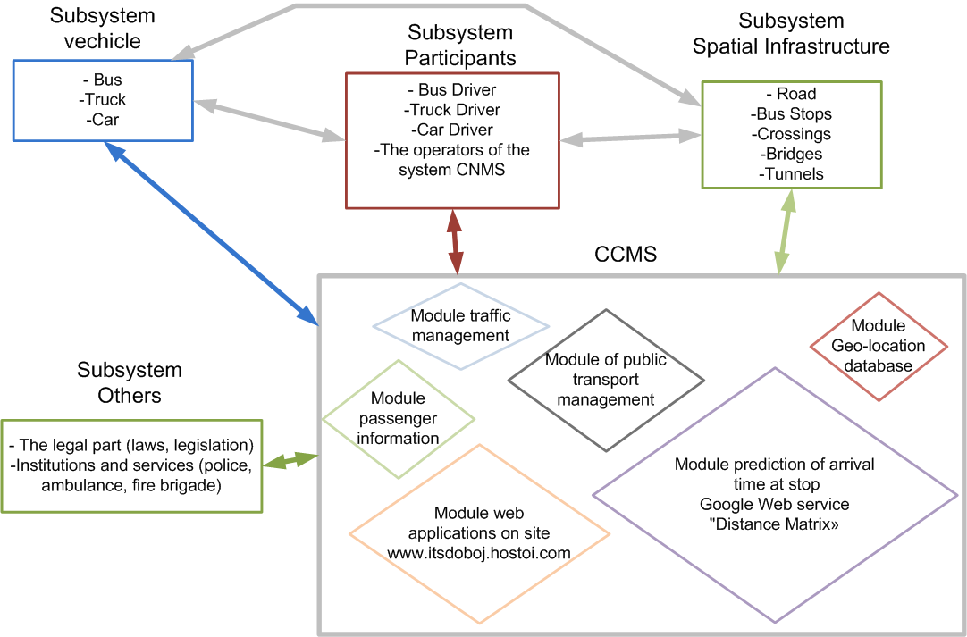

Figure 1: Structure of the system for monitoring and managing of bus transport

The concept of the proposed architecture is based on the recommendations of the European architecture for ITS (FRAME European ITS Framework Architecture) and is in line with the international standard ISO 14813-1 by which is made identification service and the domain of ITS in eleven groups. The emphasis of work is on the analysis of a possible segment of the system that refers to the estimated time of arrival of the bus at the bus stop (Bus arrival Time Prediction).
The Bus Arrival Time Prediction (BATP) in real time is a very actual but at the same time a very complex problem, which Zaki, Ashour, Zorkany and Hesham [2] dealt with in detail in their research. An example service developed for the city of Chicago, using an algorithm for estimating bus arrival time, was developed by Cleverdevices [6]. A similar service was developed for the United Kingdom area available at the address (http://www.arrivabus.co.uk/timetables).
Several different mathematical methods have been used to estimate the time of arrival of the bus in the previous research [3]. In general, all methods can be divided into several groups:
1) Istorian Approach- Includes methods that estimate the arrival time of the bus based on the mean time needed to pass the given stocks, based on the data available for the same period in several different previous days, which was processed in the works of Altinkaya, Zontal [3].
2) Real time – approach, the estimated time of arrival at the next time interval is the same as the current interval estimation. This approach implies that the arrival time has fluctuations in a narrow range, and does not take into account unplanned interruptions in traffic, such as congestion, traffic accidents and other unforeseen circumstances.
3) Statistic model - predicts the time of arrival based on the formed function with a group of independent variables,
4) Model based approach - The Kalman filter outperforms all other developed models in terms of accuracy, demonstrating the dynamic ability to update on the basis of newly obtained data reflecting changing environmental characteristics. This algorithm was used to update the variable (travel time) [3],
5) Machine Learning Techniques - Artificial Neural Network (ANN) is one of the most widely used techniques for estimating traffic and their ability to solve complex non-linear relations [7].
In the next chapter will analyze two approaches, based on the model and on the real time approach.

2.1. Model based approach - The Kalman filter

The principle of the Kalman filter operation is the calculation of the estimated states x _k, based on the measurements of the burden burdened by y_k, for the random process x_k, which is described by the linear discrete model in the state space. The Kalman filter is an optimal estimator and predictor of an unknown size and has found a great application in the prediction of the bus arrival time [2,3,4,6,7], navigation, tracking and predicting the path of the object. The process is described by a linear model with state variables (1) and (2).
(1) (2)
The Kalman filter's task is to estimate this value. The filter works in two steps:
- - a priori (prediction) - based on the last known state k-1, the following condition k is predicted; this estimate contains some error due to noise in a system which is not taken into account at the time, therefore, an estimate is carried out without known measurement;
- - a posteriori (korekcija) - after the situation really changes to the next, the output of the system y(k) is measured, and on the basis of this jammed result, the matrix describing the behavior of the process and the noise data corrects the condition estimate x.
After that, the entire cycle repeats: the next state is predicted, the output is measured, the assessment of the next condition is corrected and the cycle is repeated. The measurement divides the algorithm of the realization of the Kalman filter in two parts: a part before the measurement (a priori estimation) and after the measurement (assessment of the condition with known measurement, and posteriori). The first step of the algorithm can be described by the following equations [3,7]:
(3) (4)
The difference between the real and a priori estimated state is the priori estimation error:
(5)
It is possible to define the covariance error of the apriori estimation:
(6)
In the first step of the recursive algorithm of the discrete Kalman filter, a priori value of the system state variable is estimated based on the deterministic equation of the state of the system - the prediction, and the calculation is attributed to a priori covariance error estimation. Step of the prediction:
(7)
(8)
The second step contains the following equations [3,7]:
(9)
(10)
(11)

2.2.In real time approach

The Google's "Distance Matrix API" is a service that provides feedback on the distance between two points on the selected route path and the time of travel on a particular section, based on the user's query. The entry and query parameters are the starting and endpoints that can be in the form of names or as geocordinates of the desired locations. Of the other parameters, the mode of transport is chosen, the units in which the output values will be displayed. For users of the free API, there are limitations in the number of queries per day to 2500/ 24h. An example request to a web service: https://maps.googleapis.com/maps/api/distancematrix/output?parameters
In response to a query, there may be two document formats in XML and JSON (JavaScript Object Notation) form.
The following code represents the function for calling a web service with a response in JSON format [1]:

Program code:
function curl_request($sURL,$sQueryString=null)
{
$cURL=curl_init();
curl_setopt($cURL,CURLOPT_URL,$sURL.'?'.$sQueryString);
curl_setopt($cURL,CURLOPT_RETURNTRANSFER, TRUE);
$cResponse=trim(curl_exec($cURL));
curl_close($cURL);
return $cResponse;
}
$sResponse=curl_request('http://maps.googleapis.com/maps/api/distancematrix/json',
origins='.$originslat.','.$originslon.'&destinations='.$destlat.','.$destlon.'&mode=
driving&units=metric&sensor=false');
$oJSON=json_decode($sResponse);
if ($oJSON->status=='OK')
$fDurationInMin=(float)preg_replace('/[^\d\.]/','',$oJSON->rows[0]->elements[0]->
duration->text);
else $fDurationInMin=0;
echo "<br>",'Time arrival for_'.$fDurationInMin.PHP_EOL .'_min';

The algorithm is based on monitoring of the geolocation the vehicle through the installed device in the vehicle. The coordinates of the last position of the bus are read from the database in which the weather and geographic coordinates of the location of the vehicle are preserved.

THE PROPOSED SYSTEM FOR EXPERIMENT PURPOSES

The proposed system consists of an acquisition part in the field and a control part in the monitoring and monitoring center. The acquisition part consists of a certain number of sensors that constantly monitor the given parameters. Within the acquisition part of the experiment, two cameras were set up for monitoring critical sections of the route, a multimedia device at the bus stop and a speed monitoring and monitoring system equipped with a webcam, computer and speed calculator for the detected video signal [9]. The system is divided into two parts, and the part that processes the subsystem on a multimedia stand, the traffic monitoring part closely linked to the central control multimedia system, fig 2.

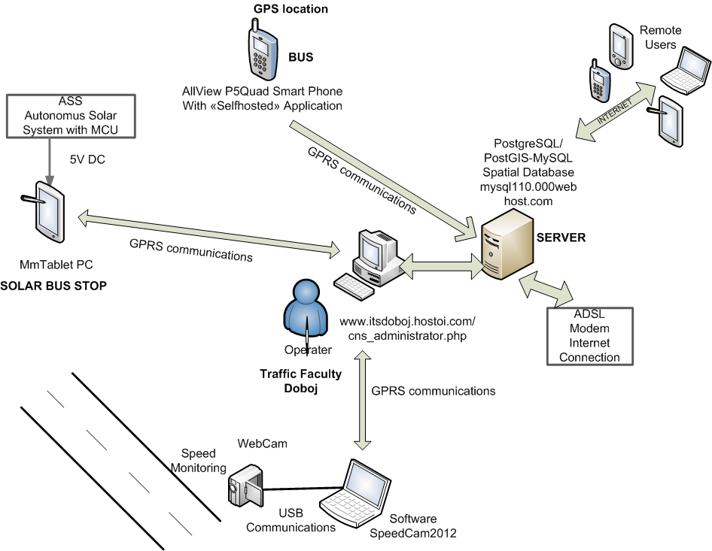

Figure 2: Structure of the DMIS system

The proposed DMIS model has a modular structure, which consists of the following hardware modules:
1. CMMS – Central monitoring multimedia system located at one of the outlying organizational units of the University of East Sarajevo – namely, the Faculty of Transport and Traffic Engineering in Doboj,
2. MmPC – Multimedia tablet computer embedded at a stationary facility (i.e. at the bus stop located in Stanari) on the surveyed section of the regional road Doboj-Prnjavor,
3. MmPh – Multimedia cell phone embedded on a monitored non-stationary object (i.e. on the bus),
4. LWC – Laptop computer with a web camera used for vehicle speed detection on the selected road segment,
5. ASS – Autonomous solar system for power supply of the devices –a stationary object embedded at the bus stop, located in Stanari [9],
6. SDB – Server with an installed spatial database (PostgreSQL/PostGIS) [1], located at the Faculty of Transport and Traffic Engineering in Doboj.
The software components of DMIS, which are installed on the selected hardware devices, consist of a variety of applications involved in continuous interaction. They are installed on a server, tablet PC, and smartphone [1,8].
The application used for tracking the geolocation of the bus as well as enabling communication between a bus driver and DMIS is installed on a cell phone mounted inside the bus.
The second application, which is installed on a tablet computer, enables the interaction with bus users at bus stops. The interface of this application allows users to access a variety of options such as timetables [2,3,4] estimated time of arrival of the bus at the bus stop, and other service information closely related to road conditions and weather forecast [4].
The third application is installed on a server and is intended to be used by both, distant customers and a DMIS operator. This application can be accessed by a DMIS operator and by the customers via their electronic devices (cell phones, PADs, etc.). Figure 3. illustrates the software architecture of the system [9].

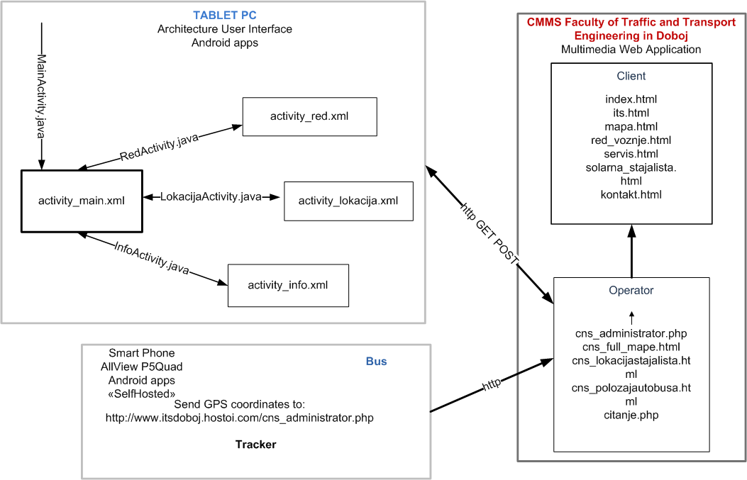
Figure 3: Proposed system activity

Currently, the design of the proposed DMIS is supported by a rapid development of the applications that can be created using a variety of open source technologies such as HTML5, CSS (Cascading Style Sheet), JavaScript, PHP (Hypertext Preprocessor), Android, and GoogleMaps. For the experimental purposes, we used the Google Distance Matrix API [10], which had been proposed as an example of a web service that could be employed for the realization of the forementioned task.
The algorithm for both, the applications and the system, is based on the vehicle location tracking via an MmPh device installed in the vehicle [1].
MmPH is an ALLVIEW P5Quad smartphone that runs on an Android operating system. A Self-hosted application, which was installed on the device, enabled us to monitor the vehicle geolocation and to send the data streams every 30 seconds in the form of text files ("GPS -position.txt "), via the HTTP protocol.
The text file data are read by using PHP scripts and are stored in a database specifically designed for this purpose.
The estimation of the bus arrival time at the desired bus stop was made on the basis of the dwell time and the passenger service time; therefore, the obtained data represent the total trip time.

The experimental data are obtained from on-site measurements at the locations shown in Table 1.

SEG. | Hospital output-Plocnik | Plocnik-Rudanka | Rudanka-Stanovi | Stanovi-Ljeskove Vode | Ljeskove Vode-Ostruznja | Ostruznja-Stanari | Stanari-Kulasi | Kulasi-Vucijak | Vucijak-Cross M16.1
GPS.  COORD. | 1. (44.7491, 18.0825)  2. (44.7562, 18.0552) | 1. (44.7562, 18.0552)  2. (44.7600, 18.0423) | 1. (44.7600, 18.0423)  2. (44.7559, 18.0022) | 1. (44.7559, 18.0022)  2. (44.7626, 17.9188) | 1. (44.7626, 17.9188)  2. (44.7517, 17.8848) | 1. (44.7517, 17.8848)  2. (44.7528, 17.8326) | 1. (44.7528, 17.8326)  2. (44.7766, 17.7497) | 1. (44.7766, 17.7497)  2. (44.8315, 17.7013) | 1. (44.8315, 17.7013)  2. (44.8522,  17.7000)
LENGHT | 5,0km | 650m | 3,5km | 7,7km | 3,5km | 4,2km | 8,1km | 7,9km | 3,2km
TIME  ARRIVAL | 8.5min | 1.5min | 5.75min | 9.5min | 6min | 6.5min | 11min | 8.75min | 5min

Estimation of the arrival time (using the Kalman filter) of the bus was done based on the forms given in the previous chapter. The Table 2. shows the calculated arrival times for an arbitrarily selected Ostružnja share (i = 6) - Stanari (i = 7).

Table 2. Estimation of the arrival time of the bus at the stop using the Kalman filter
Start  Time | art3 | art2 | art1 | Sred. | ∆3 | ∆2 | ∆1 | VAR[local] | g(k+1) | a(k+1) | e(k+1) | P(k+1) | M
11:19 | 6m  45s | 6m  20s | 5m  45s | 6m  16s | 13m  20s | 11s | 16m  45s | 10m  5s | 0,51 | 0,49 | 5m  9s | 5m  52s | 6m  5s
14:19 | 5m  20s | 6m  10s | 5m  55s | 5m  48s | 13m  4s | 8m  4s | 49s | 7m  19s | 0,63 | 0,37 | 4m  36s | 5m  58s | 6m

It is visible from the obtained results of the prediction P (k + 1) and the measured results (M) that there is a certain error (ε) of the Kalman filter's prediction. Based on the following form, the mean relative error ε_{sr} can be calculated:
(12)
where: X_{tac} (t) is the exact value obtained by the measurement, X_{proc} (t) is the estimated value, N is the number of measurements.
A comparative overview of the obtained results of the mean error ε_{sr} for the Ostružnja-Stanari section is shown in Table 3.
Table 3. Comparison of the results of the prediction error using the web service and the Kalman’s filter

„Distance Matrix API“  ε_{sr} | 0,106
Kalman's Filter  ε_{sr} | 0,0211

The obtained results indicate that the method of predicting the arrival of the bus to the stop with the Kalman filter results with a lower mean error than the method with the web service.
Based on the analysis of the experimental data obtained from this research, we designed a platform for the optimization of the bus schedule and the total trip time on the observed section of the road. The graph (Figure 4.) illustrates a comparative overview of the difference between the arrival time of a bus running on schedule and the arrival time of a bus using the proposed system.

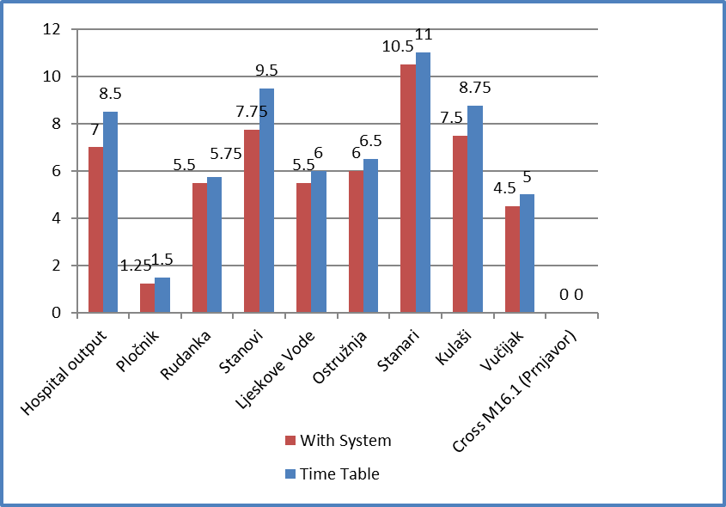

Figure 4: Display time obtained using the system and on the basis of the timetable

4. DISCUSSION

The total trip time of the timetabled bus is 62.5 minutes, while the total trip time of the bus using the proposed system is 55.5 minutes. It has been found that the usage of the proposed system results in a more reliable total trip time optimization which in turn has an impact on the improvement of the performances.
The improvements in performance are reflected in shorter total trip times and shorter passenger service times at bus stops, improved passenger satisfaction and increased passenger confidence in public transport services. Comparison of the results of the prediction error using the web service and the Kalman filter shows that best results of using Kalman filter.
The mean relative error ε_{sr} is 0.0211 for Kalman filter and 0.106 with web service “Distance Matrix API”. Within the proposed DMIS, we designed several interactive multimedia applications that were installed at various points of interest (i.e. multimedia solar bus stops, sophisticated vehicles, and central monitoring module of DMIS) with the aim to enable interaction between the system and the users of public transport services.
One of the important features of the proposed DMIS model resides in its capability for open-ended developmental improvements to meet the needs of the public transport users.

CONCLUSION

The paper presents the results of the research on the interoperability and interactions between ITS and multimedia applications (MMA), which was undertaken with the aim to design DMIS for monitoring and managing the transport processes in the sector of intercity bus transport. The DMIS has a modular structure, and it was employed for the management of the collaborative interactions between ITS and MMA, which were used to monitor and control transport processes closely related to the intercity bus transport on the surveyed section of the regional road Doboj-Prnjavor. This road section was selected as a field study sample in order to conduct a field experiment that would investigate the total trip time of the bus as well as the possibilities for its optimization. One of the important features of the proposed DMIS model resides in its capability for open-ended developmental improvements to meet the needs of the public transport users. Second features of DMIS is a real-time estimation of the bus arrival time at a desired bus stop use two different model of prediction. This is a very topical, but at the same time highly complex issue that receives plenty of attention from IT and transport experts.

REFERENCES

- Aleksandar Stjepanovic, Milorad Banjanin: „Distributed Multimedia Information System for Traffic Monitoring and Managing” , International Conference on Intelligent Data Engineering and Automated Learning“ IDEAL 2014, University of Salamanca, Salamanca, Spain, September 2014. LNCS 8669 „Lecture Notes in Computer Science“ Springer, ISBN 978-3-319-10839-1, ISSN 0302-9743, DOI 10.1007/978-3-319-10840-7, p.475-483, 2014.
- M. Zaki, I. Ashour, M. Zorkany, B. Hesham. (2013). Online Bus Arrival Time Prediction Using Hybrid Neural Network and Kalman filter Techniques, International Journal of Modern Engineering Research, (IJMER), Vol. 3, Issue 4, Jul-Avg. 2013. ISSN:2249-6645, pp-2035-2041.
- Mehmet Altinkaya, Metin Zontal. (2013). Urban Bus Arrival Time Prediction: A Rewiev of Computational Models, International Journal of Recent Technology and Engineering (IJRTE), ISSN: 2277-3878, Vol. 2, Issue 4, September 2013.
- Mohammed Alreshoodi, John Woods. (2013). Survey on QoE/QoS Correlation Models for Multimedia Services, International Journal of Distributed and Parallel Systems (IJDPS), Vol. 4, No.3, May 2013.
- BusTime.[online]. Source: http://www.ctabustracker.com/bustime/home.jsp-12.07.2017.
- RTBA.[online]. Izvor: http:// www.cleverdevices.com/clever-devices-products- passenger-
information-real-time-bus-arrival.htm –12.07.2013.
[7] Dr. Ranjana Dinkar Raut, Vineet Kumar Goyal. (2012). Public transport Bus Arrival Time Prediction with Seasonal and Special Emphasis on Weather Compensation changes using RNN, International Journal of advanced Research in Computer and Communication Engineering, Vol. 1, Issue 6, Avgust 2012, ISSN:2278-1021.
[8] Amer Shalaby, Ali Farhan. (2004). Prediction Model of Bus Arrival and Departure Times Using AVL and APC data, Journal of Public Transportation, Vol. 7, No. 1, 2004.
[9] Aleksandar Stjepanovic, Milorad Banjanin, Ferid Softic, Zlatko Bundalo, Miroslav Kostadinovic. (2014). Implementation of autonomus solar system for power supply of transport facilities, 18th International Research/Expert Conference „Trends in the Development of Machinery and Associated Technology“, TMT 2014, Budapest, Hungary ,Year 18, No.1, pp. 217-220, ISSN1840-4944, 10-12. September, 2014.
[10] Aleksandar Stjepanovic, Ferid Softic, Zlatko Bundalo, Suzana Miladic, „EFFECTS OF TEMPERATURE ON POWER MODULE THE INTEGRATED SOLAR POWER BUS STOPS“, Zbornik radova, SAOBRAĆAJNICE I OPTIMIZACIJA TRANSPORTA, Naučno-stručni skup, Doboj, ISBN 978-99955-36-6. Novembar, 2012.

