INFLUENCE OF EMBODIMENT ON EMERGENCE OF SUBJECTIVE DATA MODELS IN EVOLUTIONARY AGENTS

Marko Tot¹, MSc; Aleksandar Kupusinac¹, PhD; Igor Balaž², PhD;
¹ University of Novi Sad, Faculty of Technical Sciences, Novi Sad, Serbia, markotot@uns.ac.rs
² University of Novi Sad, Faculty of Technical Sciences, Novi Sad, Serbia, sasak@uns.ac.rs
³ University of Novi Sad, Faculty of Agriculture, Laboratory of Meteorology, Biophysics and Physics, Novi Sad, Serbia, igor.balaz@df.uns.ac.rs

Abstract: We investigated the elementary properties the embodied system should have to be able to spontaneously build and evolve subjective and functional representation of the environment. We show that embodied integration of perception with bodily actions can emerge from a rather simple basic setting of (i) existence of a set of bodily actions and (ii) ability to randomly chose actions and execute them with variable probabilities. In simulations, agents were able to successfully discriminate between beneficial and harmful external objects. Even more interestingly, agents who evolve in the mixed environment, with both food and poison, became much more efficient and lived longer compared to agents that reside in the environment without harmful influences. Finally, we shortly elaborated on possible application in medicine.

Keywords: Agent-based modeling, environment, interface, embodiment.

1. INTRODUCTION

A concept of embodied cognition postulates that properties of an agent's cognition do not solely depends on agent's brain but are also deeply interconnected with properties of his body. Arguments in favor of embodied cognition in humans are overwhelming [1] [2] [3]. However, in this article we are interested in the minimal model of embodied perception. Such problem gained significant theoretical treatment, mostly in dealing with the origin of life question [4] [5] [6] [7]. Our goal here is not so ambitious. Instead, we intent to take only visual perception and to investigate what are the elementary properties the system should have to be able to spontaneously build and evolve subjective and functional representation of environment. Here, by ”functional” we mean any traits of agent's organization that can increase his survival rate. To investigate these basic properties of embodied cognition we will use a minimal model without relying on complexities of brain-imitating approaches. Also, we will use vision as an minimal example since it is the easiest concept-building process to demonstrate.
Our aim is to show that embodied integration of perception with bodily actions can emerge from a rather simple basic setting of 1) existence of a set of bodily actions and 2) ability to randomly chose actions and execute them with variable probabilities. We will show that during evolution agents favor development of internal functional structures organized to acquire information, analyze them and make decisions based on performed analysis. Our findings are in line with the sensorimotor contingency theory which postulates that vision is a mode of exploration of the world that is mediated by perceiver’s subjective rules integrated with various motor actions [8].
In our previous work we demonstrated that evolvable agents, even without provided objective metrics according to which elements of environment should be compared and grouped, can spontaneously build subjective data models [9]. In that work agents started with no executable functional structures nor with the inherent ability to recognize other elements in their environment, like in this article. However, their internal structure relied on building internal decision trees. In this work we are taking a step back to investigate minimal necessary architecture of agents so they could spontaneously develop subjective models of environment and refine them based on their own empirical evidences. With that we can test the entire possible state-space of developing subjective data-models and thus open possibility for further systemic investigation of evolvability in more complex settings.

2. MODEL DESCRIPTION

As a modeling framework we will use agent-based approach since it offers ability to construct bottom-up systems where only elementary boundaries are set [10]. In our model, the environment is two-dimensional grid populated by agents and resources (Figure 1). Resources store certain amount of energy and at the beginning of each simulation they are randomly distributed within the grid.

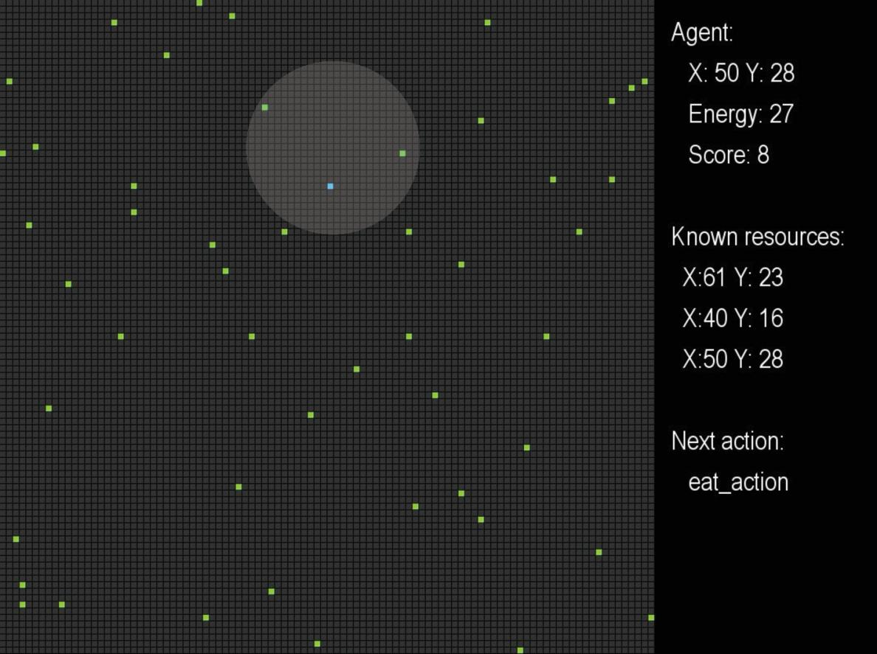

Figure 1. Snapshot of the running simulation. Left part is the simulation grid where agent is blue rectangle, while resources are green. Right part of the simulation screen shows agent's current location, energy level, score, known resources (resources that agent discovered so far) and what will be his next action. Gray circle shows agent's perspective. Here he discovered three resources, but since he is currently eating one of them, only two remaining ones are visible.

Since the influence of direct competition on the evolutionary dynamic and on the patterns of adaptation is highly nonlinear and depends on a large number of factors [11] [12] we deliberately excluded possibility of direct competition. Therefore, we run each simulation with a single agent randomly placed within the grid. To account for random noise effects, each data point for each value of tested simulation parameters is obtained as an average of 10.000 repeated simulations. For the overview of simulation parameters see Table 1.

Table 1. Simulation parameters

Name | Value
Grid width | 100
Grid height | 100
Number of resources | 50
Energy stored in each resource | 5
Cost of performing any action | 1
Number of repeated simulations | 10.000
Initial agent’s energy | 30
Extent of tested movement speeds | 1-30
Extent of tested sense ranges | 1-30

At the beginning, agents do not know what should they seek in the environment nor how they should act. They only have a set of embodied actions (Table 2). Agents start with a given amount of energy which they spend by performing actions. If an agents energy reaches 0, the simulation ends. At each time step agents try to execute one action. Probabilities of executions of actions can be: 0.1, 0.25, 0.5, 0.75 and 1. At each time step an agent generate random number and determine whether certain action can be executed or not. If in a time steps an action is skipped, then the next available action goes through the same procedure. In short, agent's strategy is defined via action-probability pairing.

Table 2. Embodied actions that an agent can perform

Action name | Description
Explore | Move to a random location on the map
Sense | Perceive the location of nearby resources
Sense poison | Check if nearby resources are poisonous
Move to resource | Move towards the closest visible resource
Eat | Eat anything that is on the current location

In the model, explicitly defined fitness function does not exist. Therefore, agents are free to test any individual strategy within the boundaries of embodiment. To agents the only way to extend their survival is to make sure that their energy level is above 0. Agents can do it by consuming resources and thus increasing their own energy level. The simulation ends if the agents maximum life duration is reached, which is set at 301 time steps.
In summary, each agent has multiple parameters that determine its success: (i) Movement speed which determines what distance can agent move per 1 point of energy, (ii) Sense range which determines how far can an agent see while doing the sense action, (iii) Energy level which specifies the agent's current energy and (iv) Strategy which specifies the probabilities that a specific action will be skipped.
To identify statistical outliers, for each set of obtained results we calculated $T^{2}$ distance which is the square of Mahalanobis distance $d_{i}=\sqrt{(Y_{i}−\overline{Y})^{T}S^{−1}(Y_{i}−\overline{Y})}$, where $Y_{i}$ is an object vector of tested variables (move speed and sense range) for each simulated case, $\overline{Y}$ is corresponding arithmetic mean vector and $S$ is sample covariance matrix. Upper control limit ($\text{UCL}$) is calculated as $\text{UCL}=((n−1{)^{2}}/n)β(α,p/2,(n−p−1)/2)$, where $n$ is the sample size, $p$ is the number of variables, $α$ is the level of significance and $β(α,p/2,(n−p−1)/2)$ followed a beta distribution [13].
To asses relative importance of the speed of movement and sense range on agent's survival time, we calculated their importance index using method described in [14]. In brief, let denote predictive model by $f$ and if $x_{1}$ and $x_{2}$ are move speed and sense range, then let $y=f(x_{1},x_{2})$. The expected value of $y$, $E(y)$, is defined by integrating $y$ with respect to the joint distribution of $x_{1}$ and $x_{2}$. Also, the variance of $y$, $\text{Var}(y)$, is defined by integrating $(y−E(y))^{2}$ with respect to the joint distribution of $x_{1}$ and $x_{2}$. Then the impact of the factor $x_{j}$ on the effect $y$ can be described by $\text{Var}(E(y|x_{j}))$. From that we can derive the Importance index as the ratio $I_{i}=\text{Var}(E(y|x_{j}))/{\text{Var}}(y)$ which gives a measure of the sensitivity of $y$ to the factor $x_{j}$ that reflects the relative contribution of single factor alone, not in combination with other factor.

3. EMBODIMENT AND EMERGENCE OF SUBJECTIVE DATA MODELS

First, we compared success of “normal” agents with blind agents whose sense function is impaired so they can perform sensing but cannot identify resources. As expected, there is a huge difference in average life duration between blind and non-blind agents (Figure 2). For blind agents, Figire 2a imply that the longest living agents are those with the minimal spatial range of sensing environment. Although the difference between life spans in this group of agents is small, we tested it by calculating $T^{2}$ distance. It showed that this group of agents is indeed a proper outlier cluster, located above the $\text{UCL}$. The strategy of survival they applied is quite interesting. As explained in the model description, performing each action cost fixed amount of energy. Since they were not able to recognize food source they adopted strategy we called blind foraging. In blind foraging agents completely abandoned attempts to sense anything in their environment because it will cost them energy and reduce their life span. Instead, they use all the available energy to randomly move and blindly try to eat something. By using such strategy this cluster of outliers even managed to reach average lifespan equivalent of agents with sense range = 6.
For agents that made correct identification of resources, to analyze relative importance of move speed and sense range as determinants of their average life span we applied recursive partitioning method. In short, we created a decision tree to classify pairs of agent's properties that enables his longest survival. The split of nodes is based on the largest logworth:

$\text{LogWorth}=−{\text{log}}_{\text{10}}(p−\text{det})$,

where det is the value of the determinant (move speed and sense range) while $p$ is calculated using Monte Carlo calibration method [15]. To determine number of recursions we calculated $R^{2}$ value after each split. $R^{2}$ reaches maximum of 0.86 after three splits. However, since further splits only partitioned move speed, here we opted to analyze only 2-step iteration with R²=0.8 (Figure 3). General trend is expected: coupling high movement rate with increased distance of vision lead to higher survival rate (Figure 2b and Figure 3). However, somewhat unexpectedly the Pearson correlation coefficient show that relative influence of the movement speed on the average life duration of agents is much higher than the sense range (0.76 and 0.38 respectively).

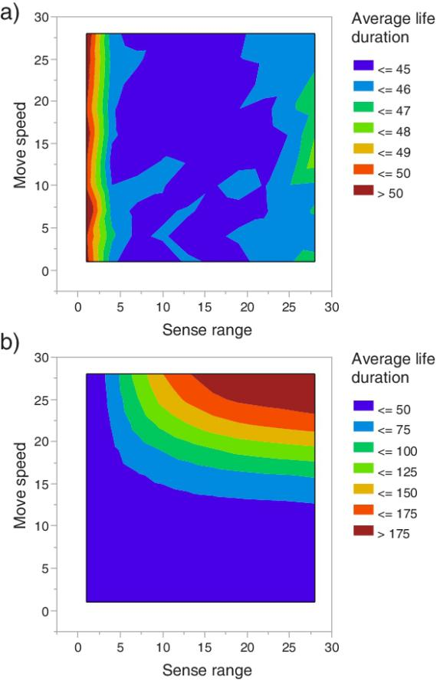

Figure 2. Contour plot of distribution average life duration of agents. a) Case for agents that are unable to properly identify food source. b) Agents that properly identified food source.

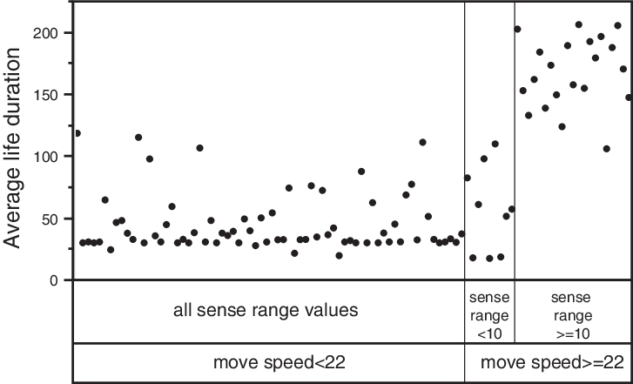

Figure 3. Partition for average life duration: Each black point represents average life duration of 10.000 agents after performed max. 300 time steps. For each partitioned subgroup we calculated mean of these data points so the subgroup of agents where move speed < 22 and any value of sense range is composed of 70 data points (=700.000 agents) and the average life duration of all of them is 44.9. Subgroup move speed >= 22 and sense range < 10 consists of 9 cases (=90.000 agents) with total average life duration =57.2, while move speed >= 22 and sense range >= 10 subgroup is composed of 21 cases (210.000 agents) with average life duration =167.4.

To test that further, we trained a simple fully connected neural network with one layer (Figure 4a), using tanh activation function. Tanh function, $\text{Tanh}=(e^{2x}−1)/(e^{2x}−1)$, is the centered and scaled version of the logistic function that normalize all input values to the range [-1,1]. For validation we used Holdback method (with proportion 0.333) where the original data are randomly divided into the training and validation sets. Obtained R²=0.98 for training data and R²=0.97 for validation data, as well as comparing measured and predicted life duration of agents (Figure 4b), signify that the model is predicting very well on both data sets. Therefore we used it as a starting point to get more general understanding of the relative importance of speed of movement and sense range on life duration of agents. First, we calculated the importance index ($I_{i}$) to precisely measure the importance of speed and range in a way that is independent of the model type and fitting method (see methods for details). For the move speed I_{i} = 0.7 while for sense range I_{i} = 0.14 which basically confirms what correlation coefficient indicated: the move speed is significantly more important for agent's survival than its sense range. Looking at the slopes of the mean response of the agent's survival value (Figure 5a) and cross-section profile of the modeled response surface (Figure 6a) further support that conclusion. Distribution histogram under the added noise (Figure 5a) shows that the speed of movement is not only more important but that it also influence life duration over the much broader set of parameter values.

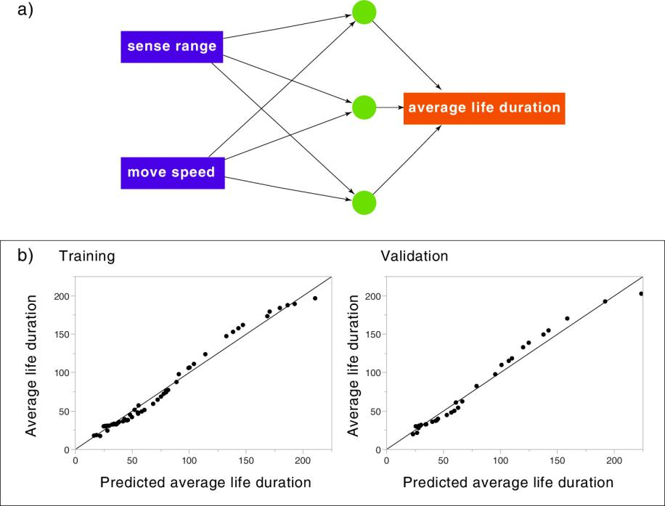

Figure 4. Neural network model of agent's behavior. a) diagram of the applied fully connected neural network. b) Plots of the actual versus predicted average life duration. Left plot shows model fit using training data set, while the right plot shows fit for validation data set.

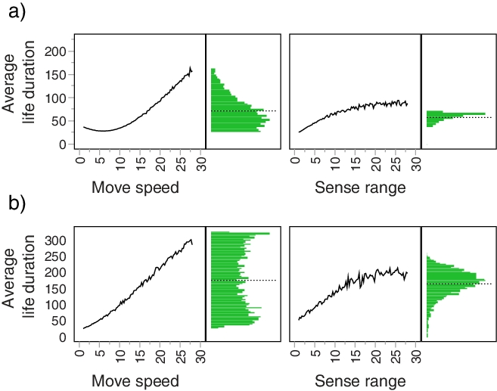

Figure 5. Mean response of the average life duration across a uniform distribution of factors: move speed and sense range. The plots are created by fixing one of the factors and then varying other factor by drawing 5000 Monte Carlo samples from a uniform distribution defined by the minimum and maximum values of the varying factor. For example, upper and lower left plots show how the average life duration changes by going across move speed while the sense range is fixed. Similarly, both plots on the right side show reverse situation: fixed move speed and varying sense range. Histogram to the right of each mean response plot shows how distribution of average life duration would change under added normally distributed random noise (mean=14.5, standard deviation=5.4) over 5000 iterations. Two scenarios are shown: a) without and b) with presence of poisonous resources.

The only outliers identified by calculating $T^{2}$ distance are agents where the minimal sense range (=1) is combined with high speed of movement (>22). In these cases average life duration unexpectedly decreases. Most probable explanation is that in these cases narrow vision coupled with very high mobility leads to nonproportionally high waste of energy spent on fast random movement.

4. PERCEPTUAL DISCRIMINATION OF ENVIRONMENT

In nature, living organisms evolved to successfully navigate highly multidimensional space of both beneficial and harmful environmental factors. To test whether agents in our simple settings are able to develop mechanisms to discriminate between positive and negative influences we introduced poisonous food sources. In the set of initial experiments (data not shown), where the negative influence of poison was just inverse of the food value (food energy gain =5, poison energy loss =-5) most of the agents adopted strategy of indiscriminately eating everything. Instead of spending valuable resources on developing new perceptive ability, they adapted by slightly increasing average movement so they can reach more food (and poison) sources. However, things became significantly different when we set the energy loss caused by poison to be 5 times higher than the value of food energy gain (food energy gain =5, poison energy loss =-25). In that case agents readily adopt new strategy of recognizing both food and poison and in fact they became much more efficient compared to agents that live in the environment without harmful influences (Figure 7). Their average life span reached 200 time steps, double compared to life span of agents who lived in the “ideal” environment. Comparison of distribution histograms under the added noise (Figure 5) for no-poison and poison scenarios show that in the later case distribution of the effect of noise on survival span is much broader. In other words, it seems that our results indicate that under the more complex environment (noisy, with presence of both poisonous and beneficial resources) expected evolutionary success rate, measured as an average life span, increases. However to make such conclusion we would need to run a series of additional tests which would fall outside of the scope of this paper.

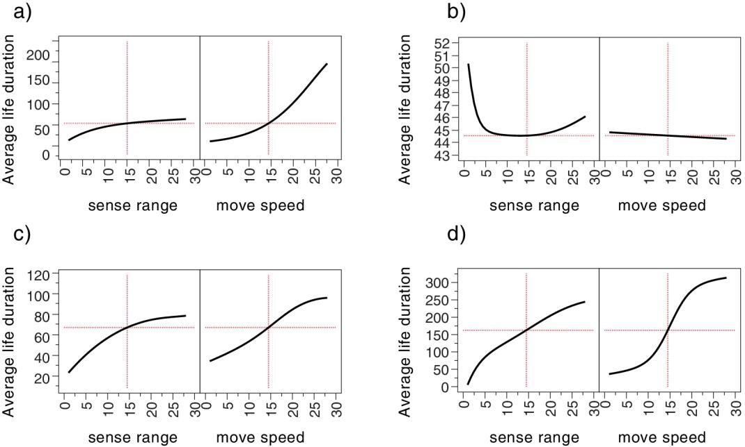

Figure 6. Cross section profiles of average life duration surfaces for trained neural network model. Scenarios are: a) Environment without poison, agents can sense food. b) Environment without poison, agents cannot sense food. c) Environment with poison, agents cannot sense it. d) Environment with poison, agents can sense it. For each scenario, black line represents cross-section profile of average life duration response surface of trained neural network model. Value of cross-section is indicated by red lines. For all scenarios, vertical cross-sections are set to be the median value of variables, so for both move speed and sense range are 14.5. Horizontal cross-section is then just coresponding value of average life duration for the fixed vertical cross-section.

To analyze the relative importance of the agent's sense range and move speed on their survival in this scenario, we compare slopes of predicted responses of trained neural network models for different scenarios (Figure 6). Once the agents are faced with the environment with both beneficial and harmful influences (Figures 6c and 6d) the relative importance of spatial range of sensing environment increases but the ability to move fast still remains the main factor in extending survival.

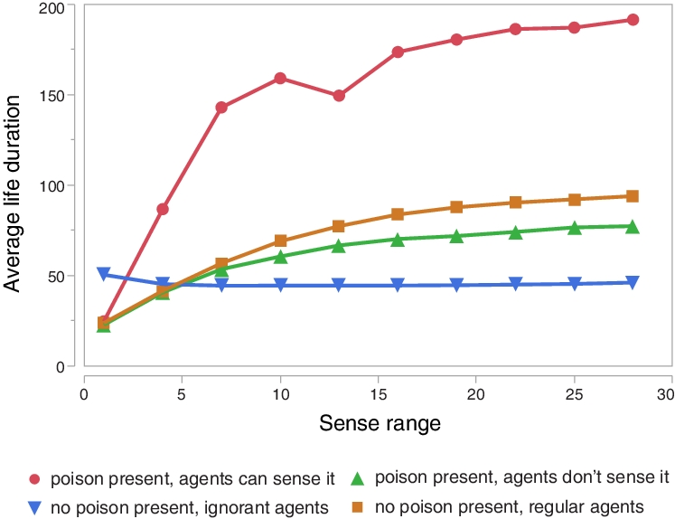

Figure 7. Average life duration of agents in different environments as a function of different ranges of sense.

5. CONCLUSIONS

We demonstrated that in the simplest evolutionary game, embodied agents can discover subjectively “correct” way of sensing and acting within the given environment through random search. As expected they are by far more successful in surviving than ignorant agents. What is more interesting is that they were able to successfully discriminate between beneficial and harmful external objects. So, even without complex underlying structures agents were able to build subjective data models and use them for their own purpose. According to Nicholson [16] crucial difference between organisms and machines is their purposiveness. Machines operate towards an end that is external to itself so they are extrinsically purposive. In contrast, organisms act on their own behalf so they are intrinsically purposive. In organisms purpose arrives from within and serves no purpose other than toward organism's survival. In our model we demonstrated that even in the very basic setting of embodied agents, they can develop functional structures in the form of subjectively appropriate data models. By developing such structures agents created their own bottom-up purpose and maintain it by analyzing environment and acting upon it by using subjectively purposeful data structures. Because the sensorimotor contingencies within different sensory domains (vision, audition, smell, etc.) are subject to different (in)variance properties, the structure of the rules that govern perception in these different modalities is expected to be different in each modality [8]. Therefore we cannot directly extrapolate our findings to other modes of perceiving environment, but we believe that our basic finding, namely that the development of subjective data models rely on a rather simple process of randomly pairing and testing available embodied properties also holds for other perception channels.
Obvious next research step is to include direct competition and reproduction of agents. We believe that careful comparison of the “ideal” case (this paper) and more realistic cases will reveal much about the cost/benefit ratio of taking certain evolutionary paths, especially related to novelty selection. For example, to what extent agents will be able to reach ideal strategies under various levels of selective pressures? Also, given that functional properties of living organisms are often weakly coupled, one of the important yet poorly investigated questions is how various strengths of internal interactions influence ability of these properties to evolve? On top of that: how introduction of functionally novel structures change configuration of existing evolutionary constraints?
Finally, immediate potential application of the approach tested here could be in designing (semi)autonomous agents that should operate in a highly complex and not properly mapped environment. For example, a significant obstacle in creating efficient drug delivery systems (DDS) is existence of a number of complex biological barriers in human organism. A real challenge is to design DDS optimized for penetrating those barriers. This issue became even more prominent with the recent development in nanomedicine where nanoparticles have the potential to modulate both the pharmacokinetic and pharmacodynamic profiles of drugs, thereby changing their therapeutic index [17]. However, despite potentially high benefits, state-of-the art of nanoparticle-based treatments have shown rather low efficacy, with the delivery rate to targeted sites of only 0.7% of the total injected dose [18]. Potentially promising strategy for dealing with such problem could be to first model possible chemical and physical properties of nanoparticles as embodied parameters of agents and then let those agents to freely test individual strategies within the boundaries of embodiment, as in this paper, until they reach the desired location and deliver drugs there. Profile of the “winning” agents in simulations could then be used as a template for the synthesis and later in vitro / in vivo testing.

ACKNOWLEDGEMENTS
This project has received funding from the European Union's Horizon 2020 research and innovation programme under grant agreement No. 800983, and from the Ministry of Education, Science and Technological Development of the Republic of Serbia within the projects: III 43007, III 044006 and ON 174026, and by the Provincial Secretariat for Science and Technological Development of the Autonomous Province of Vojvodina within the project 114-451-2856/2016-02).

REFERENCES

[1] Aizawa, K. (2007). Understanding the embodiment of perception. The Journal of Philosophy, 104:5–25.
[2] Rupert, R. (2009). Cognitive Systems and the Extended Mind. Oxford University Press.
[3] Shapiro, L. (2011). Embodied Cognition. Routledge, New York.
[4] Bich, L. and Moreno, A. (2015). The role of regulation in the origin and synthetic modelling of minimal cognition. Biosystems, 148:12–21.
[5] Bitbol, M. and Luisi, P. (2004). Autopoiesis with and without cognition: defining life at its edge. Journal of the Royal Society, Interface, 1:99–107.
[6] Bourgine, P. and Stewart, J. (2004). Autopoiesis and cognition. Artificial Life, 10:327–345.
[7] Maturana, H. and Varela, F. (1980). Autopoiesis and Cognition: The Realization of the Living. Reidel Publishing.
[8] ORegan, J. and Noe, A. (2001). A sensorimotor account of vision and visual consciousness. Behavioral and Brain Sciences, 24:939–1031.
[9] Balaz, I. and Schneider-Kitamura, E. (2018). Making sense of nonsense: Evolutionary emergence of perceptual assimilation of environment in agent based system. In Ikegami, T., Virgo, N., Witkowski, O., Oka, M., Suzuki, R., and Iizuka, H., editors, The 2018 Conference on Artificial Life: A Hybrid of the European Conference on Artificial Life (ECAL) and the International Conference on the Synthesis and Simulation of Living Systems (ALIFE), pages 428–435. MIT Press, Cambridge, MA.
[10] Russell, S. and Norvig, P. (2003). Artificial Intelligence: A Modern Approach (2nd ed.). Upper Saddle River, New Jersey: Prentice Hall.
[11] Osmond, M. and de Mazancourt, C. (2013). How competition affects evolutionary rescue. Philosophical Transactions of the Royal Society B, 368:20120085.
[12] Pekkonen, M., Ketola, T., and Laakso, J. (2013). Resource availability and competition shape the evolution of survival and growth ability in a bacterial community. PLoS ONE, 8:e76471.
[13] Jayakumar, D. and Thomas, B. (2013). A new procedure of clustering based on multivariate outlierdetection. Journal of Data Science, 11:69–84.
[14] Saltelli, A. (2002). Making best use of model evaluations to compute sensitivity indices. Computer Physics Communications, 145:280–297.
[15] Sall, J. (2002). Monte carlo calibration of distributions of partition statistics. In Adami (1998), White Paper by SAS Institute.
[16] Nicholson, D. (2013). Organism 6= machines. Studies in History and Philosophy of Biological and Biomedical Sciences, 44:669–678.
[17] Wicki, A., Witzigmann, D., Balasubramanian, V., and Huwyler, J. (2015). Nanomedicine in cancer therapy: Challenges, opportunities, and clinical applications. Journal of Controlled Release, 200:138–157.
[18] Wilhelm, S., Tavares, A., Dai, Q., Ohta, S., Audet, J., Dvorak, H., and Chan, W. (2016). Analysis of nanoparticle delivery to tumours. Nature Reviews Materials, 1:16014.

