THe INTELLIGENt information TECHNOLOGIES AND modern Business
Ljubica Dikovic1, Ph.D.; Zorica Sagic2, Ph.D.; Ph.D.; Ljiljana Trumbulovic3, Ph.D.; Slavoljub Vujovic4, Ph.D.
¹ ² ³ College of Applied Studies Uzice, Sveti Sava Square 34, Uzice, Serbia
⁴Economics Institute Belgrade, 16 Kralja Milana Street, Belgrade, Serbia

Abstract: The purpose of this paper is to present the significance of intellectual capital and information technology for modern business today. The intellectual capital of an organisation is part of its total value based on modern technology, modern knowledge as a part of learning organisation. The paper discusses the latest trends in intelligent information technology and business of modern company. The latest computer trends such as Big data, Internet of Things, machine learning, cyber intelligence, robotic process automation, emotion recognition, speech recognition, images recognition, marketing automation, peer-to-peer networks, blockchain technology and biometrics technology show a great expansion of artificial intelligence in all segments of society, especially in business. Finally, the authors conclude that will be a growing interest in the future for the development of intelligent technologies that enable customers to realize complex tasks in web-focused environments, distributed computing in different environments, and computer supported collaborative work.

Keywords: Intellectual capital, learning organization, information technology

- INTRODUCTION

Technological development is directly related to the intellectual capital i.e., the human factor, because it is the most important development resource nowadays. Investing in the intellectual capital development is a global tendency, because the 'civilisation of knowledge' is important for all countries, regardless of their development level.
The power of a modern, global company is increasingly contained in the intellectual and cultural performance of the company, rather than in traditional, tangible assets. So it's true that the future belongs to those who have knowledge. The purpose of learning is to increase knowledge or to achieve a higher level of existing skill. In this regard, learning relates to a relatively constant change in behaviour that arises as a result of experience or practice.
The progression of knowledge in terms of intellectual learning is achieved through a social process that is largely focused on maximising the collective know-how. In this regard, the current concepts are 'knowledge-creating company' and 'learning organisation'.

- The Learning Organisation and intellectual capital

Learning is a basic premise for developing the organisation's core competences. Some authors suggest three strategies for improving the organisation's ability to learn: improve learning orientations; improve facilitating factors; change both learning orientations and facilitating factors [1].
The learning organisation is a company which purposefully creates a structure and strategies and improves and maximises the learning of an organisation. The focus is on integral thinking and actions at all levels in the organisational structure of the company [2].

Learning also involves taking time for reflection and analysis, for reviewing strategic options, exploring consumer needs, assessing the existing work system, and finding new products. In this learning process, it is necessary to stimulate the exchange of ideas through project teams and meeting with consumers (suppliers).
Learning is actually investing in human resources as a part of intellectual capital i.e., intangible assets and can be incorporated into the 'goodwill' item in the balance sheet. It becomes the most important factor of achieving a relatively permanent competitive advantage in the global economy. However, it is necessary to distinguish concepts of 'organisational learning' and 'learning organisation'. In the first case it is about training employees in the company to acquire knowledge about interpersonal relations, above all. In the learning organisation, people acquire knowledge and expertise in their day-to-day work. In such an organisation, individuals continuously expand their capacity in order to achieve the desired results; it builds a new, more flexible way of thinking; collective aspirations are freely defined; and people continually learn how to learn together.
The learning organisation has processes for knowledge diffusion through the organisation where it is needed and for knowledge transformation into a new way of business operating [3, p. 94]. In such organisations the emphasis is on systems thinking. Systems thinking are necessary when people want to create common vision, mental models and teamwork and to enhance personal abilities. The personal influence of each individual is very important [3, p. 59].
Although the learning organisation takes place through employees, it is not just a sum of knowledge of existing employees. Learning is considered to be neither deterministic nor random. One part of learning is based on the experiment and the other one is based on the understanding of existing knowledge [4, p. 94]. In today's economy you have to learn faster than your competitors.
Peter Senge (1947) is an American scientist, teacher and director of the Center for Organizational Learning at de MIT Sloan School of Management. The Senge’s five disciplines of learning organizations or Senge’s learning organisation describes how to manage the success and development of an organization and how employees give the extra mile that goes beyond the expectations of the company. What are the five disciplines of learning organizations?(see Figure 1)[17]

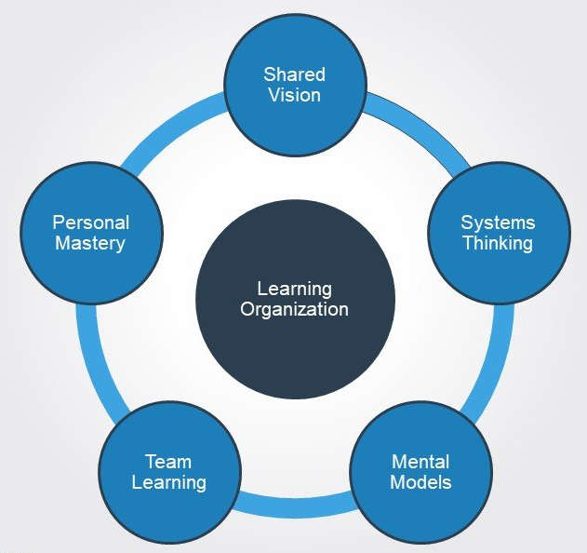
Figure 1.Senge’s five disciplines of learning organizations

Intellectual Capital is defined as all knowledge within an organisation which has the potential to create value when applied in line with the mission, vision and goals of the organisation. Intellectual capital is focused on company's functioning in the changed future conditions and on seizing the external opportunities. People generate capital for the companies through their competences, attitudes and intellectual engagement. Competences as a component of human capital include: knowledge, skills, talents, and know-how of managers and employees. Particular attention should be paid to core competences development as critical and recognised strengths.
Intellectual Capital Management links scientific and technology, innovation and intellectual property rights in a holistic management concept. Another view of intellectual capital towards innovation is shown on the Figure 2:
- Intellectual Capital: Knowledge that can be used to create value.
- Intellectual Assets: Codified knowledge that can be used to create value.
- Intellectual Property: Legally protected intellectual capital. [18]

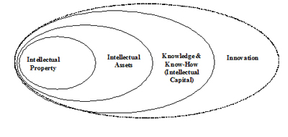
Figure 2. Another View of Intellectual Capital Towards Innovation

In order to survive and be competitive in the knowledge society, the economies need to learn how to manage their intellectual capital. Innovative companies form knowledge management teams and professional organisers hold workshops and conferences on knowledge management. 'An information society' and 'the knowledge economy' are the long-anticipated phenomena and now they are a reality.
Techniques and tools for managing the traditional factors of production (labour, capital and land) have been progressively improved. In terms of professional tools for managing intellectual capital, virtually no progress has been made. As a consequence, companies often insufficiently use their intellectual resources. Knowledge is structurally very complex in environment in which companies operate today. The following trends are responsible for this: extremely high knowledge growth rate; the extent to which knowledge has become fragmented; and increasing globalisation of knowledge.
Many companies perceive the increasing complexity of knowledge in the environment as a threat. However, there are many ways in which dynamic knowledge development can create new chances for the competition. In order to survive in a volatile market, a company must keep up with information technology (IT) trends.
Social learning theory has progressed from the initial achievement of bringing the language and data of learning theory to bear on an understanding of complex human functioning to a sophisticated application of modern information-processing concept [5, p.776].
The success of organisations depends on their ability to design themselves as social learning systems and also to participate in broader learning systems such as an industry, a region, or a consortium [6, p.225].
Especially when trying to understand human interactions or to predict behaviours, we shouldn't look for answers only in large volumes of data. Big Data, small data and more traditional data handling approaches can become trustworthy companions [7, p.981].
In most organisations, social learning or informal learning is carried out through eLearning. Social learning can also be realised through collaboration tools or externally on social media networks like LinkedIn, even Facebook. Social learning is expected to become the most common form of learning. It is also expected that there will be traditional forms of learning in combination with different forms of social learning. As part of social learning, many organisations have introduced new trends: the trend of self-directed learning and self-evaluation via e-learning in 2018.[8]

- INTELLIGENCE information TECHNOLOGIES TO LOOK FOR IN 2019

„62% of enterprises will use AI technology by 2018.” Narrative Science

2.1. Artificial Intelligence

Artificial Intelligence (AI) is the field of computer science designed to solve cognitive problems commonly associated with human intelligence, such as learning, problem solving, and pattern recognition. AI is defined as a system's ability to correctly interpret external data, to learn from such data, and to use learning to achieve specific goals and tasks through flexible adaptation [9].
Applications of AI in business management include: fraud detection, spam filters and prevention for online transactions, smart searches, smart business decision-making, content personalisation as a service, smart virtual personal assistants to provide real-time support to users, smart devices to predict customer, predictive customer service, estimating customer profile, data analysis and customer segmentation, dynamic price optimisation, process automation by integrating industrial robots into workflow or automatically route service requests, sales and business forecasting, social semantics, etc.[10]
Results of a recent survey indicate that artificial intelligence can assist businesses in areas ranging from customer support to personalization ( Sorce:Forrester/IDC/NarrativeScience,2018): [11]
- 300% (3x) increase investment in AI methodology this year across all business;
- 57% of business expect it to help improve customer experience and support;
- 20% of all workers use automated assistance technologies to make decisions and get work done;
- 80% of executives say AI boosts productivity and creates new positions.
There are many applications and approaches to digital transformation, but in the end, it's about businesses transforming their supply chains with data - gaining better access to data, making sense of data, and using that data in a fundamentally different way to drive profitability.

2.2. Machine Learning

Machine Learning (ML) is concerned with the development of algorithms and techniques that allow computers to learn and discern patterns and predict future outcomes based on historical data. Machine learning platforms develop techniques that allow computers to learn. Machine learning is a part of artificial intelligence and a subfield of computer science.
Machine learning platforms are gaining ground every day by providing APIs, algorithms, big data, development and training tools along with designing and deploying models into applications and other machines. These platforms are currently being used in various business activities, mostly for the classification or prediction.

2.3. INTERNET OF THINGS

The Internet of Things (IoT) is the network of physical objects that contain embedded technology to communicate and sense or interact with their internal states or the external environment.
According to Cisco (https://www.cisco.com), 500 billion devices are expected to be connected to the Internet by 2030. Each device includes sensors that collect data, interact with the environment, and communicate over a network. The Internet of Things (IoT) is the network of these connected devices. These smart, connected devices generate data that IoT applications use to aggregate, analyze, and deliver insight, which helps drive more informed decisions and actions. The IoT is a critical part of business strategies going forward.
Cisco has predicted the explosion of connected devices across all sectors by 2020 (see Figure 3). [13]

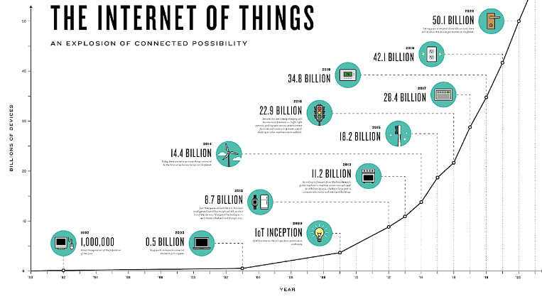
Figure 3. The prediction by CISCO, An Explosion of Connected Possibility

New insights from IoT connected device data enable organizations to create new business models and new business services. Sensors can detect location, environment, presence, and more and provide raw data and analytics to applications, which transform that insight into action that can provide competitive advantage.

2.4. Robotic Process Automation

Robotic Process Automation (RPA) is software that uses scripts and other methods (such as machine learning, speech and imagee recognition, and natural language processing, automating higher-order tasks) to automate human tasks or processes to support standard business processes. It is used to execute specific tasks or process where it is too costly or humans are inefficient to perform. Robotic Process Automation provides organizations with the ability to reduce staffing costs and human error.
2.5. Cyber defence and cyber intelligence

Cyber defence is a computer network defense mechanism which includes response to actions and critical infrastructure protection and information assurance for organizations, government entities and other possible networks. With the growth in volume as well as complexity of cyber attacks, cyber defense is essential for most entities in order to protect sensitive business information.
Breach Level Index detected a total of over 2 billion breached records during 2017. Data records were lost or stolen with the following frequency: Every second 82, every minute 4,949, every hour 296,914, every day 7,125,940 2,600,968,280. A data breaches incident by source over time is shown below (see Figure 4 ): [14]
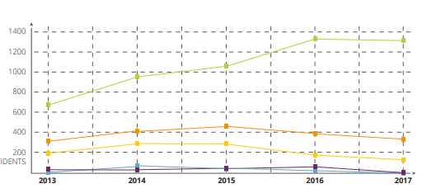
Figure 4. Data breaches incident by source over time, Source: Breach Level Index, 2017

Cyber intelligence contains recurrent neural networks, which are capable of processing sequences of inputs, and can be used in combination with ML techniques to create supervised learning technologies, in order to uncover suspicious user activity and detect up to 85% of all cyber-attacks.

2.6. PEER-TO-PEER NETWORKS and blockchain technology

Peer-to-peer networks are created when two or more PCs connect and share resources without the data going through a server computer. Peer-to-peer networks are also used by cryptocurrencies, and have the potential to even solve some of the world’s most challenging problems, by collecting and analyzing large amounts of data.
Blockchain technologies provide the infrastructure for cryptocurrencies and the basis of crypto economy. Blockchain technology has enabled digital information to be distributed rather than copied, thereby creating a platform for a revolutionary new version of the Internet. This technology has enormous potential in many industries especially in the financial sector, as a support of efficiency and transparency in global money transactions.

2.7. Marketing automation

Marketing automation allows companies to improve engagement and increase efficiency to grow revenue faster. It uses software to automate customer segmentation, customer data integration, and campaign management, and streamlines repetitive tasks, allowing strategic minds to get back to doing what they do best.
For example, Adext (https://www.adext.ai) uses 100% real AI. Through its Machine Learning models, Adext runs thousands of simulations to discover the best performing audience and automatically update customer’s ads budget with amazing results from 30% up to 500% uplift.

2.8. Biometrics technology

Biometrics technology deals with the measurement, analysis, and identification of people’s biological information. Types of biometric identifiers include: Fingerprints, Walking gait, Facial recognition, Iris / eye scan, Ear shape, Speech patterns. Currently, this technology is widely used in market research. Biometrics can provide businesses with heightened security and customers with a more personal experience. With advances in biometric technologies and improvements in IT infrastructure, there is a growing acceptance of biometric recognition technologies in our daily lives, and this acceptance will grow further with time. [16]

2.10. EMOTION RECOGNITION and image recognition

This technology allows software to “read” the emotions on a human face using advanced image processing or audio data processing. Emotion AI is used in the gaming, automotive, robotics, education, healthcare industries, and other fields, to apply facial coding and emotion analytics from face and voice data.
Image recognition is the process of identifying and detecting an object or feature in a digital image or video, and AI is increasingly being stacked on top of this technology to great effect.
Image recognition technology can also be used to detect license plates, diagnose disease, analyze clients and their opinions and verify users based on their face. [16]
Based on Forrester’s analysis, there is graphic of the most demanding technology : [18]

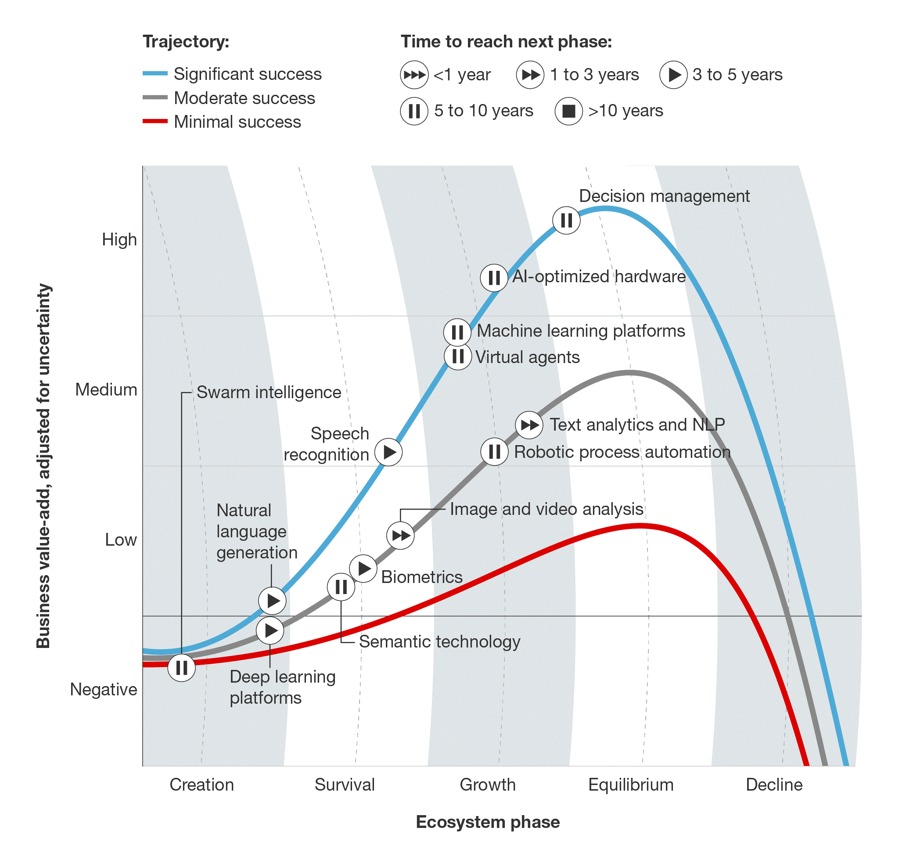
Figure 5. Source: Forrester Research,2017. [18]

Conclusion
A learning organization is an organization skilled at creating, acquiring, and transferring knowledge, and at modifying its behavior to reflect new knowledge and insights. Intellectual capital is one of the most important resources for economic and social organisations. Artificial intelligence technologies today show a huge impact on business activities across the globe. It is not only made available for large enterprises but also for small businesses that want to have remarkable appearance on the internet. Many types of AI have become available to companies of all sizes. This is thanks to factors like continuing hardware price/performance improvements, cloud computing, and advances in AI techniques. The intelligent information technologies are being used by a large number of organizations for improving productivity in many roles of complex systems thanks to the latest computer trends such as Big data, Internet of Things, machine learning, cyber intelligence, robotic process automation, emotion recognition, speech recognition, images recognition, marketing automation, peer-to-peer networks, blockchain technology and biometrics technology.
Finally, we could conclude that will be a growing interest in the future for the development of intelligent technologies that enable customers to realize complex tasks in web-focused environments, distributed computing in different environments, and computer supported collaborative work.

LITERATURE
[1] Nevis, E. C., DiBella, A. J., & Gould, J. M. (1995, January). Understanding Organization as Learning System. Sloan Management Review, 213.
[2] Dougson, M. (1993). Organizational Learning: A Review of Some Literatures. Organizational Studies, 14(3), 112.
[3] Senge, M. P. (1994). The Fifth Discipline Fieldbook: Strategies and Tools for Building a Learning Organization (p. 94). New York, NY: Doubleday.
[4] Mahony, T. J. (1995). The Management of Resources and the Resource of Management. Journal of Business Research, 33(2), 94.
[5] Grusec, J. (1992). Social Learning Theory and Developmental Psychology: The Legacies of Robert Sears and Albert Bandura. Developmental Psychology, 28(5), 776-786.
[6] Wenger, E. (2000). Communities of Practice and Social Learning Systems. Organization, 7(2), 225–246.
[7] Diaconita, V. (2015). Processing unstructured documents and social media using Big Data techniques. Economic Research, 28(1), 981-993.
[8] Kaplan, A., & Haenlein, M. (2010). Users of the world, unite! The challenges and opportunities of Social Media. Business Horizons, 53(1), 59-68.
[9] Kaplan, A., & Haenlein, M. (2018). Siri, Siri, in my hand: Who's the fairest in the land? On the interpretations, illustrations, and implications of artificial intelligence. Business Horizons. Advance online publication. doi:/10.1016/j.bushor.2018.08.004
[10] https://www.nibusinessinfo.co.uk/content/how-are-businesses-using-artificial-intelligence/
[11] https://www.datamation.com/artificial-intelligence/artificial-intelligence-in-business.html
[12] www.zeolearn.com/magazine/10-latest-artificial-intelligence-technologies-for-enterprises-to-consider Internet of things (IoT)
[13] https://medium.com/pragmatic-idealism/how-should-businesses-think-about-integrating-their-strategy-with-internet-of-things-iot-a7f261025625
[14] https://breachlevelindex.com/assets/Breach-Level-Index-Report-2017-Gemalto.pdf
[15] Chen, H., Chiang, R., & Storey, V. (2012). Business Intelligence and Analytics: From Big Data to Big Impact. MIS Quarterly, 36(4), 1165-1188.
[16] www.scnsoft.com/blog/biometric-technology-advanced-technologies-are-making-their-way-into-the-workplace
[17] www.toolshero.com/management/five-disciplines-learning-organizations/
[18] http://www.apicc.asia/?page_id=60
[18] https://www.forbes.com

