THE INTEROPERABILITY OF COMMAND AND INFORMATION SYSTEMS

Marija Krstić¹, MSc; Lazar Krstić², Spec.; Valentina Stanković³, MSc;
¹ Higher Business School of Professional Studies, Leskovac, SERBIA, krstic.marija@vpsle.edu.rs
² Higher Business School of Professional Studies, Leskovac, SERBIA, krstic.lazar@vpsle.edu.rs
³ Higher Business School of Professional Studies, Leskovac, SERBIA, stankovic.valentina@vpsle.edu.rs

Summary: The age of information we live in imposes the need for the use of modern information and communication technologies in all aspects of life and work - including the field of military operations. Information has always been one of the parameters of power, but in recent decades, rapid advances in information and communication technologies have made it a key factor in winning battles and wars. If the general history of war is considered more closely, it is easy to understand how important is the timely and valid information about the state of the opposing forces in each conflict. In this respect, successful interoperability is vital, that is, mutual communication of units of all branches of the armed forces of different countries.

Keywords: interoperability, command and information system

1. INTRODUCTION

The pathways of command and information flow during the decision-making process are part of the command and control systems and have different forms that are dependent on the type and complexity of the task. During the military decision-making process, a path of information flow is chosen which is currently in accordance with the needs or the importance of the message that is supposed to be transferred and used. This leads to the need for the selection of information, especially by the commands of the authority that provide essential information for decision-making purposes, which is primarily set up by the command and information system (CIS).
Today's warfare and combat operations require the need to use, as much as it is possible, the concept of network-centric warfare in the phases of design and implementation of the command and information system. The network-centric warfare aims at creating greater combat power, efficient networking of spatially separated elements of combat units, achieving a higher level of common knowledge of the situation on the battlefield and a better synchronization.

2. INTEROPERABILITY CONCEPT AND CHARACTERISTICS

The term „interoperability“ comes from the Latin word opera, which means „work“ and the words inter, which means „between“. The term „I14y“ is often used instead of the term interoperability, in which number 14 indicates the number of missing letters „i(14 = nteroperabilit)y“.
This term must be precisely defined, since it can have various interpretations in different contexts, and therefore different meanings for different experts - depending on the areas they deal with. The term is often used in terms of technical systems engineering, or alternatively, in a broader sense, while taking into account the social, political and organizational factors that affect the system and its performance. For this reason, there are numerous definitions of interoperability in the literature, including the following:
- In a general context, interoperability is the ability of some products, systems, or processes to function together during the implementation of a specific joint task [1].
- The ability of heterogeneous software systems or units to provide or accept services of other systems or units and to enable efficient joint operation, without altering and degrading the exchanged information [2].
- Interoperability is the ability of heterogeneous systems to work together in best possible way so that information can be exchanged, that is, so that it is made available to the user without the need for additional communication operations between the two systems [3].
- In the context of the telecommunication-information system, interoperability represents the ability to communicate directly, exchange information and perform functions between the information and communication systems and/or their elements in order to achieve an efficient and united operation by them and/or their users in a way that the user is not required to posses a detailed knowledge of the characteristics of all individual elements of the system [4].
- The IEEE (Institute of Electrical and Electronics Engineers) lists interoperability as the ability of two or more systems or components to exchange and use information [5].
- In a broader sense, the term interoperability implies the ability of the system, units or forces to provide direct communication, information exchange and performance of functions (service delivery) in order to provide effective unified action [6].
In accordance with the above-mentioned definitions, interoperability:
- includes two or more entities (systems, components, units, organizations);
- enables communication (information exchange, services); and
- aims to fulfill a specific goal (to ensure efficient joint operation and to improve modus operandi) [7].
Interoperability requires a certain degree of compatibility between systems that exchange information, in order to minimize the transformations required for the exchange of data and for obtaining the preconditions for its correct interpretation. The approach to connecting different systems based on interoperability relies on the exchange of meaningful data between autonomous systems, that is, on the exchange of functionality of data that have a context and meaning.
Interoperability is considered a very important element in many areas such as information technology, telecommunications or medicine. Also, transport and traffic systems, automated techniques and E-Government are largely dependent on interoperability. Interoperability is very important for the state, while governments support and require interoperability of the market since lack of interoperability is a source of monopoly and unnecessary costs.
Levels of interoperability, in terms of comparing its different types and aspects, is often discussed in literature. In order for a comparison to be made, different types of interoperability are positioned at different levels of the interoperability scale, where a higher position on the scale actually indicates a higher degree of achieved interoperability.
Figure 1 gives an overview of the level of interoperability by the Semantic Interoperability Center Europe (SEMIC.EU), which states that interoperability can be achieved on a technical, syntax and semantic level.

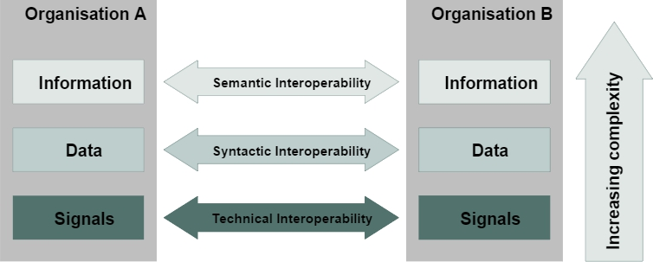
Figure 1: Interoperability levels according to the European Interoperability Center [8]

- Technical interoperability - (signals) - includes technical aspects of integration of information systems, i.e. communication protocols and infrastructure of data exchange between systems, where basic networks and protocols are unambiguously defined.
- Syntax interoperability - (data) - the ability of two or more systems to communicate and exchange data, where defined data formats are located at its base. In principle, XML and SQL standards provide syntax interoperability. This level of interoperability is a prerequisite for ensuring the next level of interoperability.
- Semantic interoperability - (information) - the ability of two or more systems to automatically and meaningfully interpret the shared data and accurately form results - as defined by the end users. In order to achieve semantic interoperability, when exchanging information both parties must respect the reference model. The content that is exchanged must be clearly defined, which means that the set of sent information, in terms of meaning, must be recognized and mapped into a set of received information.

3. CIS INTEROPERABILITY

There is a command system in all armed forces which functions as a subsystem of the entire combat structure. Bearing in mind that the requirements from the command of the armed forces are getting greater, the possibility of making the optimal decision by using the current methods is decreasing. For this reason, the introduction of the command and information system significantly increases the possibility of making optimal decisions.
The command and information system (CIS) represented at the level of the tactical units of the army has the basic purpose to functionally and structurally integrate all technical-technological elements into one functional entity whose task is to facilitate the decision-making and command process by using the obtained data and by distributing information [9].

3.1. CIS concept and characteristics

The command and information system is the information system of the commander (command-headquarters) or an information system that supports the command of the armed forces. It is a system for command, control, communication and computerization, or the C4 system. The command and information systems have recently started becoming systems for command, control, communication, computerization, intelligence reconnaissance, surveillance and combat reconnaissance or the C4ISR systems. In technical terms, it represents a system for the collection, transmission and distribution, processing and display, and protection of data and information. Figure 2 shows a block diagram of command and information systems.

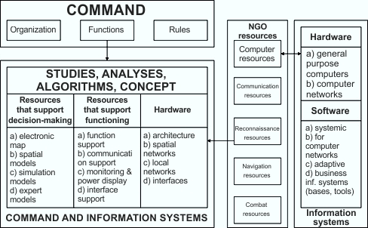
Figure 2: Block diagram of command and information systems

The command-information system is a very complex multidisciplinary system. It requires the application of the methodology of its own prototype development, because, due to the importance, complexity and sensitivity of the system, its development must be realized in a country with the competent research and development institutions, which have the necessary knowledge and capacities. Also, CIS is a dynamic system that constantly needs to monitor user needs and technical and technological changes. For this reason, CIS is not closed and defined system but a system which is continuously evolving, upgrading and implementing. Fast and so-called ad hoc solutions in this area are unacceptable both from the military, professional, and economic side, as they bring great security risks.

3.2. CIS functions and role

The basic functions that are achieved by the realization of command and information systems include:
- Collection of information,
- Information transfer,
- Processing and analysis of information,
- Sending and distribution of information and
- Information protection.
The role of command and information systems is reflected in providing assistance to commanders and headquarters with:
- Decision-making,
- Monitoring the current situation through a common operational image,
- Integration and synchronization of operations and combat operating systems,
- Coordination of the efforts of subordinated, superior and adjacent commands,
- Coordination of support,
- Connecting sensors with armed systems,
- Creating an information environment through attack and defense information operations.

3.3. CIS principles

Taking into account the fact that the command and information system is a very complex multidisciplinary system, and in order to ensure its continuous operation, as well as continuous flow and process of information, it must be based on the following basic principles:
- Interoperability - implies the possibility of interconnection and operation of CIS in a broader environment than the basic one for which it is intended. In order to achieve interoperability, certain conditions must be met: unification, compatibility, standardization and communication connection.
- Flexibility - refers to the ability to adapt to changeable and unpredictable situations, in which rapid redirection to new tasks is required with minimal interruptions and losses of available time.
- Availability - represents a quick response of the system and feedback. In order to talk about the availability of the system, it must be reliable, redundant and timely.
- Mobility - represents the full spatial mobility of the elements, as well as the ability to monitor and provide all the necessary services to mobile forces and individuals during combat operations.
- Order - implies a well-organized, disciplined and optimal work of all participants and ensures full control of resources, information flows and processes. It relates to control and management activities, electromagnetic spectrum control and information priority management.
- Tenacity - refers to the probability of survival in all conditions of action, both combat and non-combat, which is achieved by proper application of techniques (proper layout of key elements of the system, application of parallel mode of transmission of information...). System security, information protection, protection against system attacks are key factors of this principle.
- Sustainability - refers to the continuity of CIS support for all defined missions and operations in all conditions.

3.4. Concept and characteristics of CIS interoperability

Interoperability is the ability to operate certain systems, units or forces, to effectively accept the active operation of other systems, units or forces, as well as to exchange a number of activity parameters in a combined operation. Interoperability is the principle that enables the command and information system to perform functions and tasks in combined and joint operations, that is, the ability to connect and operate in a wider environment than the one that it is intended for [10].
Interoperability is most easily achieved through the use of modern data transmission systems, and it is expressed through:
- Compatibility - the possibility of joint use of different products, processes or services;
- Interchangeability - the ability of the product, process or service to be used instead of others, in order to meet certain requirements;
- Unity - a state that arises through the use of common doctrines, procedures and equipment.
The basic means for achieving interoperability is the standardization of procedures, actions and equipment used by allies and partners. Standardization implies the development and implementation of Standardization documents through which the required level of compatibility, interchangeability or unity in the operational, material and administrative fields - in order to achieve interoperability - is ensured and maintained.

3.5. Conditions for achieving CIS interoperability

In order to achieve CIS interoperability, the following conditions must be fulfilled:
- Unification - of the means and systems is realized if mutual compatibility, ease of handling and training, replacement of spare parts, modularity of blocks and devices, interchangeability of consumables and parts are achieved...
- Compatibility - the ability of two or more elements, resources, and subsystems to function within the same system or environment without mutual interference (negative impact).
- Standardization - essential for any system. It primarily refers to all technical systems, assets, hardware, and software. In the course of development, national standards are primarily respected, but international standards are used for non-defined segments. Part of the CIS that should be interoperable with supranational systems (peacekeeping, military alliances, etc.), in addition to certain technical standards, needs to comply with the standards in the field of procedures and methodology of work. Standardization includes aspects of interoperability, compatibility, and ease of handling and basic maintenance, and must ensure the adaptability of all essential tactical and technical requirements.
- Communication connection - a key functional segment that implies the connection between all elements of the CIS system in all conditions. The connection of system elements must be present at all levels and directions.

3.6. CIS interoperability levels

The Army strives for collective multinational land forces interoperability with the level of interoperability dependent on national and/or Department of Defense (DOD) objectives for the partner nation, the expected missions the partner is likely to perform in multinational operations, the partner’s current and projected military capabilities, and the partner’s own objectives. The Army recognizes four levels of interoperability (interoperability = I below) with partner Armies as outlined in Table 1.

Table 1: Levels of interoperability [11]
I-0: Partner Army has no demonstrated interoperability with Army; command and control (C2) interface with the Army is only at the national level; has no regular engagement with the Army.
I-1: Partner Army shares information or situational awareness through liaison teams with U.S. systems (analog to digital conversion required); requires alignment of capabilities and procedures to establish operational norms; has some routine engagement with Army.
I-2: Partner Army has digital C2 capabilities; actively participates in interoperability solutions with the Army; routinely exercises or operates with the Army.
I-3: Partner Army’s interoperability is network-enabled through: shared situational awareness; command and control on-the-move; collaborative planning; networked fires; combat identification; and information collection.

3.7. CIS for artillery support „AFATDS“

The Advanced Field Artillery Tactical Data System (AFATDS) (Figure 3) is a component of the fire support of the Army Battle Command Systems (ABCS). It is interoperable and integrated into the CIS Air Force - the USAF TBMCS (Theater Battle Management Core System) and into the CIS Navy - the Global Command and Control System - Maritime (USN GCCS-M). AFATDS is a multipurpose C2 system (US Army and full-fledged armies of NATO member states) designed to monitor the situation and manage integrated battlefields, to plan and implement (air, land and maritime) fire support by the use of indirect fire in real time. It is designed to be compatible with different systems and subsystems and to facilitate the exchange of information with other systems. The hardware configuration of the AFATDS system monitors the continuous development of computer technology and is continually upgraded. The interoperability of the AFATDS system ensures its hierarchical binding to higher and lower CIS USA Army, Air Force and Navy, the connection and the united collaboration of the fire support forces of the United States and NATO countries (full members), as well as their mutual communication [12]. AFATDS functions with all existing and planned systems of the US military, as well as all other allied artillery C2 systems, such as British "BATES", German "ADLER", French "ATLAS" and Italian "SIR" [13].

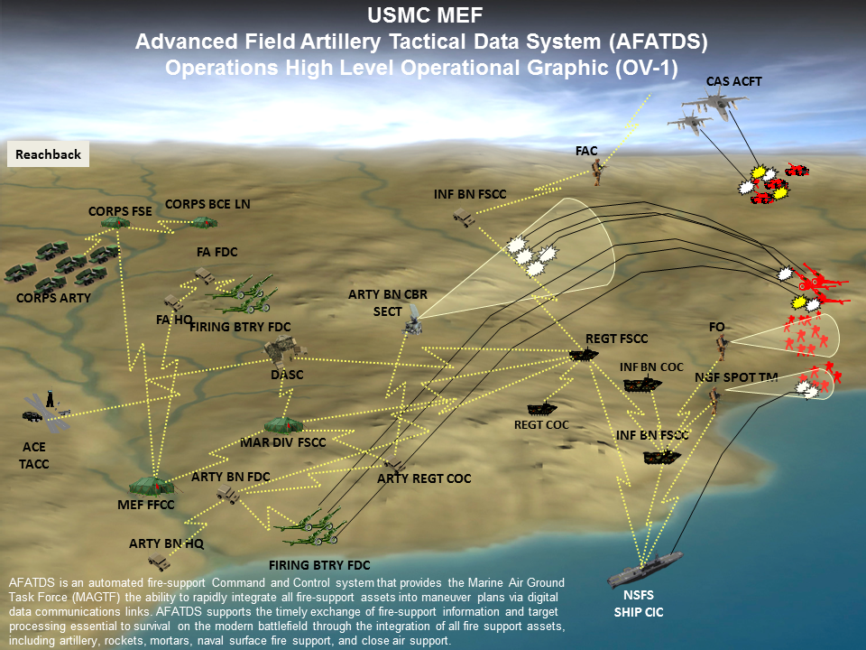
Figure 3: AFATDS - Interoperable multipurpose C2 user system [14]

4. CONCLUSION

Conflicts in recent history are characterized by the fact that there are not just two warring sides. The lack of quantity and quality of mutual communication, or the combined operation of forces, leads to the fact that the defined information cannot be transmitted within a short period of time or forwarded in a safe and reliable manner to the command centers of the armed forces, which should continue to act according to the defined tactical procedures. In that regard, successful interoperability, i.e. mutual communication between units of all armed service branches of different countries is of vital importance.
Depending on the specific requirements a large number of combat tactical data connections have been developed, in a wide range of areas, to transmit information in a timely manner at all levels. However, the interconnection of various military computer systems, especially between combat platforms, represents a very big challenge because of the great reliance on wireless communications, the high demands for security of transmission, and the need for resistance to hostile interference in situations where networks have different technological levels.

REFERENCES

- Subotić M., Banjanin M., Miletić B. Interoperability of LIKS-a in Traffic and Transport: INFOTEH-JAHORINA, Volume 8, Ref. C-6; 2009: 272-276.
- Njeguš A. Informacioni sistemi. Beograd: Univerzitet Singidunum; 2016.
- https://sr.wikipedia.org/sr-el/Интероперабилност [accessed 21.10.2018.]
- Gligorijević M., Mogućnosti upotrebe funkcionalnih sistema veza Republike Srbije u odbrani zemlje, doktorska disertacija, Beograd, Univerzitet u Beogradu, 2012.
- Milojković J., Interoperabilnost u elektronskom poslovanju statističkih sistema, doktorska disertacija, Beograd, Fakultet organizacionih nauka, 2012.
- Gligorijević M., opt. cit.
- Popović S., Model interoperabilnosti sistema elektronskog poslovanja zasnovan na servisno orijentisanom razvoju softvera, doktorska disertacija, Beograd, Univerzitet Singidunum, 2012.
- Reusing and Sharing of Semantic Interoperability Assets, available at https://slideplayer.com/slide/741472/ [accessed 07.11.2018.]
- Miletić S., Kokelj T., Manjak M. Metodologija projektovanja integrisane telekomunikacione i računarske mreže komandno-informacionog sistema artiljerijskog diviziona za vatrenu podršku: Vojnotehnički glasnik, Vol. 60, No. 2; 2012: 258-274.
- Manjak M., Miletić S. Predlog koncepta komandno-informacionog sistema brigade KoV Vojske Srbije: Vojnotehnički glasnik, Vol. 59, No. 2; 2011: 78-93.
- Odierno R. Multinational Force Interoperability, Army Regulation 34-1, Headquarters, Department of the Army, Washington, DC; 2015: 2.
- JOINT FIRE SUPPORT IN 2020: Development of a Future Joint Fires Systems Architecture for Immediate, Unplanned Targets, available at https://apps.dtic.mil/dtic/tr/fulltext/u2/a459793.pdf [accessed 29.04.2019.]
- https://www.raytheon.com/capabilities/products/afatds [accessed 29.04.2019.]
- https://www.defence-point.gr/news/προσφυγή-raytheon-κατά-της-leidos-για-το-afatds [accessed 28.02.2019.]

