PROPOSED MODEL FOR AUTOMATIC LEARNING STYLE
DETECTING BASED ON ARTIFICIAL INTELLIGENCE

Marko Bursać¹, MSc; Danijela Milošević², PhD; Katarina Mitrović³, MSc
¹ High railway school of vocational studies, Belgrade, SERBIA, marko.bursac@vzs.edu.rs
² University of Kragujevac, Faculty of Technical Sciences, Čačak, SERBIA, danijela.milosevic@ftn.kg.ac.rs
³ University of Kragujevac, Faculty of Technical Sciences, Čačak, SERBIA, katarina.mitrovic@ftn.kg.ac.rs

Abstract: The aim of this paper is to introduce an model for the automatic prediction of learning style based on artificial intelligence methods. The proposed model has three phases: student data collection; the cluster phase and the phase of prediction learning style for new users who are not yet defined. In this work, the methods of clustering (Fuzzi c-Means alhorithm) were used to define eight Felder-Solomon learning styles. By using artificial neural networks based on clustered data, the model defines a learning style for new users. The results presented in the paper give the possibility to use models with the aim of reducing the error in determining the style of learning.

Keywords: Artificial neural network, Fuzzy c-Means, Felder-Silverman learning style, Adaptive learning

1. INTRODUCTION

By defining the learning style for the students, it is possible to improve learning processes. Contribution to the personalization of learning, according to the available literature, is reflected in the personalization of learning objects, based on defined learning styles. One of the most prevalent learning styles is Felder-Solomon, which defines eight learning styles. Reporting an error in discovering the style of learning by the classical method (questionnaire) can be avoided through the process of process automation, using artificial intelligence methods.
This paper presents a model for the prediction of learning styles based on artificial intelligence methods. Based on the behavior of users on the system, or access to learning objects, it is possible to create sequences of the Fuzzy c-Means algorithm that belong to one of the eight clusters - learning style according to the Felder-Solomon model. By using artificial neural networks, it is possible to classify a new user (a new sequence) into one of eight clusters, or assign a learning style to it. The structure of the paper includes a literature review, theoretical explanations in which the Felder-Solomon model of learning is represented, the Fuzzy c-Means algorithm used for clustering and the artificial neural network model used in the learning style prediction. By using this model, it is possible to reduce the error in defining the learning style for the new user, which can improve the process of acquiring knowledge.

2. RELATED WORK

Based on the research, the authors in [1] argue that precision in determining learning styles using questionnaires is between 66% and 77%, which leaves room for improving the reliability of learning style learning. One of the aims of the research is to improve the accuracy of the automatic definition of learning style in which authors define four approaches: using artificial neural networks, genetic algorithms, ants colony and practical optimization of the swarm.
The authors based on literature review to determine the definition of learning styles based on Felder-Solomon model for several reasons. In the Felder-Silverman model, elements of Kolb's, Pasko's and Myers-Briggs models are included, so Felder-Silverman model defines four dimensions: active and reflexive learning style (A / R), sensory and intuitive learning style (S / I) , Visual and Verbal Learning Style (V / V), and Sequential and Global Learning Style (S / G).
Evaluation of the four approaches for the automatic detection of learning styles was carried out by a sample of 127 students of basic studies in an object-oriented modeling course at the University of Austria. Evaluation of automatic learning styles detection was done on the Moodle system.
The basic data set was obtained by testing students who filled in the questionnaire. In order to ensure the reliability of the data, the authors elucidated all students who completed the questionnaire in less than 5 minutes. After the elimination, the final set of students who left the data consisted of 75 students, which the authors note that the researchers in similar works used the same or a small number of respondents.
The results of the research are presented by the authors through the presentation of a comparative analysis of all four approaches in the automatic determination of learning styles and works that have been studied by similar research. For each of the four performance indicators, a table view is given. On the basis of the obtained results, the authors conclude that the best results in automatic decision-making of the learning style give an approach in which artificial neural networks are used, with an accuracy of 80.7%.
In the paper [2], they present research aimed at learning lessons based on the discovery of learning styles using artificial intelligence methods. In addition to the review of the existing literature, the authors give a theoretical overview of the existing learning styles (Felder & Silverman's, Kolb's, Honey & Mumford's and VARK models).
Based on the previous literature, the authors choose the two most commonly used learning styles (Felder & Silverman and Kolb's), provide a comparative analysis of learning styles using artificial intelligence (artificial neural networks and decision trees). In order to present a comparative analysis, authors develop software (Java programming language) based on artificial intelligence. Developed software provides the user with the ability to define the student's attribute of user behavior, using the artificial intelligence technique, on the e-learning system, to determine the student's learning style.
The results of testing the observed learning styles defined by the artificial neural network and decision table indicate an extremely minor secondary square error when it comes to determining the style of learning, and thus, when determining the two observed learning styles, authors give preference to artificial neural networks.
The authors [3] present the architecture of the system for identifying learning styles based on user behavior on the e-learning system. The authors based on the Fuzzy C-Means algorithm clustered user behavior into eight Felder-Silverman models, clustered by objects that users access to the e-learning system (text data, multimedia data, video, presentations, exercises, etc.). Authors based on the logs of the defined e-learning system create the sequences of all users (id sequence, id session, user id, id and time spent on the observed page expressed in minutes). The clustered data (eight clusters) are used by authors as one of the input data into the neural network, along with the newly created sequence, which leads to a particular category that represents the learning style for the trainee. The authors give the architecture of created artificial neural networks (input / output data, number of hidden neurons, etc.).
In the paper [4], an overview of the research based on the previous work of authors that proposed systems for the automatic detection of learning styles is presented. After theoretical considerations in the introductory part, the authors give an overview of the learning styles that are most commonly used. The results of analyzing the papers, ie the proposed models, suggest that many of the models presented during the detection are good results, that is, the precision of learning style learning for the observed students is over 61%. The authors analyzed 27 published papers, of which five (19%) dealt with the theoretical frameworks of the research, while 22 (81%) had an experimental part in the research.
The authors [5] present a new approach in identifying learning styles using artificial neural networks. During the research, the authors are based on the detection of Felder & Silverman's model as one of the most prevalent.
When creating an artificial neural network, authors present optimized network parameters based on a literature review. The result of the error of learning style detection is determined by the authors as the difference between the results achieved by the artificial neural network and the standard questionnaire for learning style learning.
In order to detect the learning style, the authors [6] give an overview of the Bayesian-network based research. Authors in the research, they define the automatic detection of Kolb's learning style based on the questionnaire.
The results of the research presented in this paper are related to the accuracy of automatic learning style learning. The accuracy shown in the frames is from 66.67% to 75%, depending on the study style of learning.
The authors [7] provide an overview of learning styles based on artificial neural networks to provide and adapt the resources and activities of the e-learning system. The aim of the research is to integrate the system's adapting in terms of learning style in the MOOC environment. The stages of the proposed system can be defined in six steps: data collection, data processing, defining basic characteristics, classifying data, defining the learning style and adapting (if needed).
In the paper [8], authors define the architecture of a system for classifying learning styles based on Elman's neural networks trained with the help of an artificial bee colony. Data collection was performed using a questionnaire based on objects and learning methods.
The authors give an overview of the proposed model, bee colony consisting of three main steps: employees of bees, observers and scouts involved in the process of searching the ABC algorithm. Elman's artificial neural networks, structure, description and algorithm for searching are presented in this paper. The aim of the study study is to classify learning styles based on predefined learning objects and the way of teaching. The accuracy of the obtained results based on the defined model is 97.12%. In the paper [9], the authors give an overview of the architecture of a system based on in-depth learning and artificial intelligence. The proposed architecture of the e-learning system is defined through four stages that have the task of determining the user's learning style. The authors suggest the collection of data based on records from the records of students and logs of the e-learning system they approach (behavior of users on the system). The second stage of the system involves the use of data mining techniques with the aim of defining key data related to determining the learning style - the input nodes of the artificial neural network. The third phase of the system is based on an artificial neural network that, based on input data, defines the user's style of learning according to Felder & Silverman's model. Based on the style of learning, the content of the learning is distibuted to users.

3. THEORETICAL BACKGROUND

3.1. Felder & Silverman stil učenja

Based on previous research, determining the differences between students based on the way of learning and the presentation of the teaching material gives the best effects. Differences between students are achieved by defining learning styles. By identifying learning styles optimal learning is achieved, by defining the style of learning style and by adapting instructions to learners based on established styles [10].
Research in the field of automatic detection of learning style showed that the largest number of scientific papers was based on the discovery of styles that defined Felder & Silverman, and thus it can be concluded that this is one of the most common styles in use. Felder & Silverman provides [11] an overview of a group of learning styles and a description for each of them, or for each of the participants. According to the developed model, learning styles differ according to the way perception, processing, input and understanding of information. Each participant is characterized by preferences for each of the four bipolar dimensions.
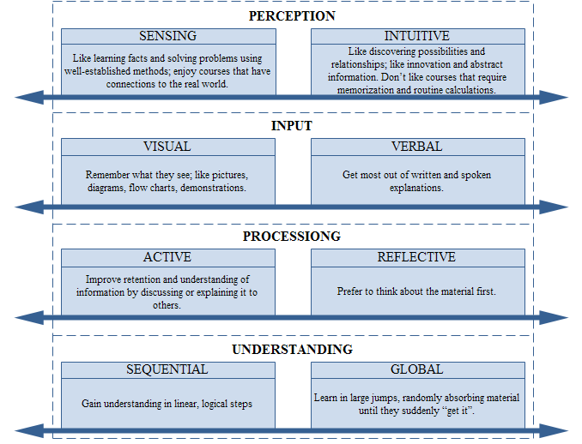
Figure 1: Characteristics of students of different learning styles according to the Felder-Silverman model [12]

Learning style recognition in a classic way involves testing users with a questionnaire. The questionnaire for determining learning styles [13] consists of 44 questions. Based on the answer, it is possible to determine the learner's learning style.

3.2. Fuzzy c-Means clustering algorithm

Cluster analysis is a way of assigning a set of objects in a group (clusters) so that they are similar in cluster to each other than objects in other clusters. Cluster analysis is a method that determines the structural characteristics of the measured properties on a strict mathematical, but not statistical basis. In order for the obtained results of the cluster analysis to be meaningful, it is necessary to determine the assumptions concerning the representativeness of the sample and the multicolarity of the variables. The reliability of the results of the cluster analysis depends on the representativeness of the sample [14].
Fuzzy c-means is a data aggregation technique where each part of the data belongs to a cluster to a certain level that is specifically determined by the fact that the parts themselves can be grouped into one or more levels and where the levels differ from one another.
Fuzzy c-Means clustering algorithm is an iterative algorithm for fuzzy clustering of data based on the k-means algorithm. The algorithm fuzzy c-means, as well as the k-means algorithm, is based on centroids, and therefore is sensitive to elements that jump from others. The parameters of the fuzzy c-means algorithm are the set of elements to be grouped, the number of groups in which the elements should be distributed, the initial values of the centroid and the exponent of the weight [15]. The function has the following form [16]:
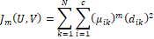 | (1)
 | (2)
 | (3)
The algorithm consists of the following steps:
1. step: Choose c
Choose
Initialize
2. step: Calculate centers of groups (clusters) using and equation:
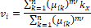 | (4)
3. step: Recalculation using next equation:
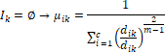 | (5)
i | (6)
gde je | (7)
4. step: Comparison and
If stop iteration, otherwise go back to step 2

3.3. Artificial neural networks

Artificial neural networks represent mathematical models for information processing, can be successfully used for identification problems, mapping input data to output data, grouping, classifying and optimizing data [17].
The neuron model consists of three basic elements:
- a set of synaptic weights (w_{ij}),
- collector - forms the weight sum of the input and
- activation function - limits the amplitude of the neuron output signal (functions can be grouped into several common groups: linear, binary, sigmoidal, competitive, and gauses [18]).
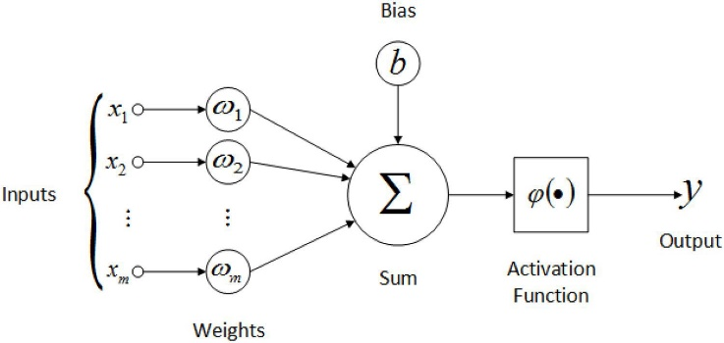
Figure 2: Artificial neuron [19]

The neuron's output is based on a combination of a series of inputs multiplied by the corresponding weights. A neural network consists of a series of neurons that are interconnected. When designing a neural network, it is necessary to determine the structure (the number of neurons and their interconnections). In order to create a prediction model using neural networks, it is necessary to define the severity of certain connections. This is achieved by training a neural network. It gives test data and then corrects the answer that it gives, if it is incorrect. The neural network will then correct the severity of certain neuronal connections. If the previous neuron gave the correct answer to the link to it, the weight will increase, while otherwise it will decrease. Over time, the neural network learns, and as the number of training increases, it gives more accurate results [20]. According to [21], artificial neural networks represent a collection of mathematical models that can simulate some of the properties of biological nervous systems and draw similarities to adaptive biological learning. They are made up of a large number of interconnected neurons (processing elements), which, similarly to biological neurons, are linked to their links containing permeable coefficients, which are similar to synapses. Neurons are organized on three levels: the input layer, one or more hidden layers, and the output layer. The appearance of a single neural network model is shown in the following figure. The number of neurons in hidden layers can be determined in many ways. The exact number of neurons used in hidden layers can be determined according to [18]:
- two-thirds of the sum of the number of inputs and number of outputs,
- two times less than the number of inputs and
- square root of the products of the number of inputs and outputs.
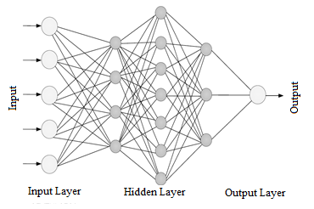
Figure 3: Example of the neural network [21]

Artificial neural networks process information on the biological neural networks, with the ability to memorize, learn, and correct errors, with a high speed of reaching solutions, and neural networks can be used to solve complex problems, such as classification or prediction. Artificial neural networks can be used in different disciplines for modeling complex and real problems.

4. MODEL ZA PREPOZNAVANJE STILA UČENJA

The proposed model aims to based on user behavior on a system of one of the eight Felder and Silverman learning styles. The model consists of three important steps to make the learning style successfully defined:
- creating sequences,
- clustering sequences and
- learning style prediction.
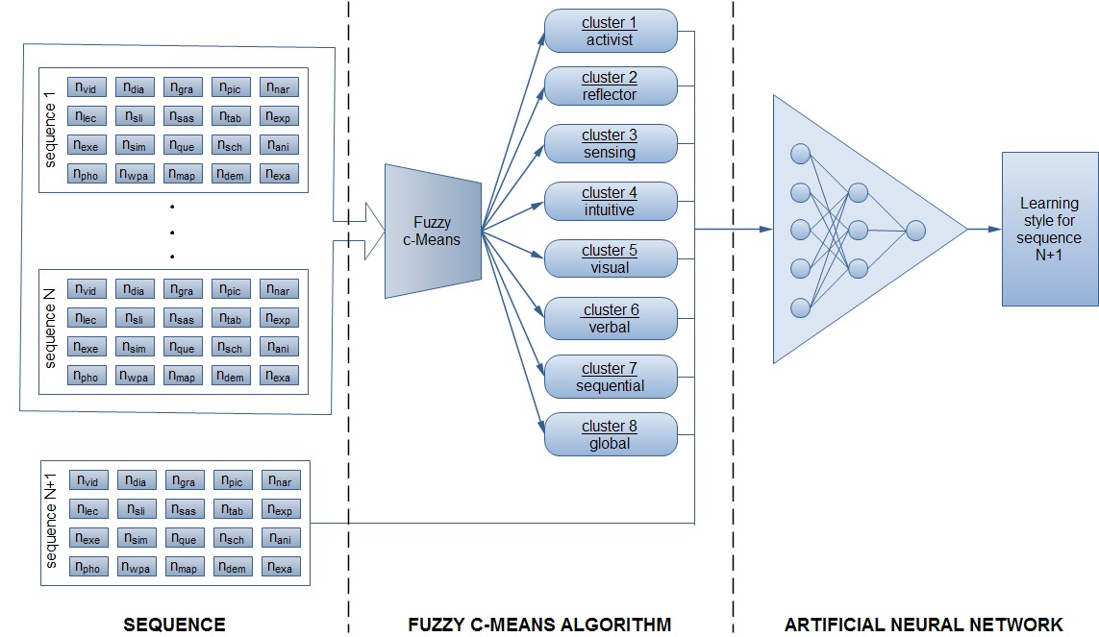
Figure 4: Proposed model for the detection of learning styles

4.1. Creating sequences

One of the types of web mining according to [22] is processing the log of data from the server in order to obtain user behavior patterns on the system. By using some of the web usage mining techniques it is possible to create sequences for each user.
In the paper [23], the authors define the belonging of learning objects (resources) to each of the eight learning styles defined by Felder & Silverman. Observed resources by the author are: video - vid; diagram - dia; graph - gra; picture - pic; narration - nar; lecture - lec; slides - sli; self-assessment - sas; table - tab; experiment - exp; exercise - exe; simulation - sim; questionnaire - que; scheme - sch; animation - ani; photo - pho; web page - wpa; map - map; demonstration - demo and example - exa.
The following table gives an overview of learning styles with resource resemblance.

Table 1: Affiliation of resources with learning styles
Learning Style | Resource
Activist | vid, dia, gra, pic, sas, exe, sim, sch, wpa, map, exa
Reflector | dia, gra, lec, sli, sas, tab, exe, sim, sch, ani, wpa, dem, exa
Sensing | vid, dia, gra, pic, sli, sas, tab, exp, exe, sim, ani, wpa, map, dem, exa
Intuitive | dia, nar, lec, sli, sas, tab, exe, que, wpa, dem, exa
Visual | dia, gra, pic, sli, sas, exp, exe, sch, wpa, map, exa
Verbal | dia, gra, pic, nar, lec, sli, sas, exe, sim, que, sch, ani, wpa, dem, exa
Sequential | vid, gra, nar, sli, sas, tab, exp, exe, que, wpa, map, dem, exa
Global | gra, pic, nar, lec, sli, sas, exe, sim, que, ani, pho, exa

Using web usage mining techniques it is possible to create a sequence in the following form:
Nvid | Ndia | Ngra | Npic | Nnar | Nlec | Nsli | Nsas | Ntab | Nexp | Nexe | Nsim | Nque | Nsch | Nani | Npho | Nwpa | Nmap | Ndem | Nexa
where Nvid represents the number of accesses of the user to the video material, Ndia number of access to diagrams, etc. According to sequence form, the sequences for the eight users could look as in the following table.

Table 2: Example sequence
u1 | 19 | 17 | 14 | 12 | 0 | 0 | 0 | 10 | 0 | 0 | 8 | 7 | 0 | 6 | 0 | 0 | 5 | 3 | 0 | 2
u2 | 0 | 20 | 16 | 0 | 0 | 14 | 13 | 12 | 9 | 0 | 7 | 6 | 0 | 6 | 3 | 0 | 2 | 0 | 2 | 0
u3 | 19 | 18 | 14 | 13 | 0 | 0 | 12 | 8 | 8 | 6 | 5 | 3 | 0 | 0 | 2 | 0 | 2 | 1 | 1 | 0
u4 | 0 | 19 | 0 | 0 | 16 | 16 | 12 | 10 | 8 | 0 | 7 | 0 | 7 | 0 | 0 | 0 | 6 | 0 | 3 | 3
u5 | 0 | 19 | 17 | 14 | 0 | 0 | 12 | 12 | 0 | 9 | 8 | 0 | 0 | 7 | 0 | 0 | 6 | 3 | 0 | 2
u6 | 0 | 20 | 16 | 15 | 14 | 10 | 9 | 8 | 0 | 0 | 6 | 6 | 4 | 2 | 2 | 0 | 0 | 0 | 1 | 1
u7 | 18 | 0 | 18 | 0 | 15 | 0 | 13 | 11 | 9 | 7 | 7 | 0 | 6 | 0 | 0 | 0 | 4 | 2 | 2 | 1
u8 | 18 | 0 | 0 | 17 | 14 | 14 | 12 | 9 | 0 | 0 | 7 | 7 | 5 | 0 | 3 | 2 | 0 | 0 | 0 | 1

Learning style according to the number of accessing resources can be defined for users: u1 - activist; u2 - reflector; u3 - sensing; u4 - intuitive; u5 - visual; u6 - verbal; u7 - sequential; u8 - global.

4.2. Sequence clustering

A set of sequences can be clustered with the Fuzzy c-Means algorithm described in the previous exposition. For eight users, clustering can confirm the learning style that is listed. The following tables are obtained by clustering.

Table 3: Clustering sequences according to learning style
 | aktivni | refleksivni | osećajni | intuitivni | vizuelni | verbalni | sekvencijalni | globalni
 | u1 | u2 | u3 | u4 | u5 | u6 | u7 | u8
Reflector | 0.00382 | 0.96105 | 0.00629 | 0.00952 | 0.00324 | 0.00936 | 0.00240 | 0.00305
Sequential | 0.00341 | 0.00350 | 0.00673 | 0.00482 | 0.00159 | 0.00416 | 0.98037 | 0.00476
Global | 0.00325 | 0.00278 | 0.00480 | 0.00549 | 0.00124 | 0.00522 | 0.00308 | 0.97175
Activist | 0.96438 | 0.00458 | 0.01500 | 0.00395 | 0.00326 | 0.00647 | 0.00275 | 0.00411
Visual | 0.00564 | 0.00721 | 0.00984 | 0.00507 | 0.98117 | 0.01027 | 0.00243 | 0.00299
Intuitive | 0.00234 | 0.00674 | 0.00390 | 0.95742 | 0.00163 | 0.00755 | 0.00243 | 0.00410
Sensing | 0.01246 | 0.00551 | 0.94669 | 0.00449 | 0.00377 | 0.00671 | 0.00401 | 0.00447
Verbal | 0.00470 | 0.00864 | 0.00676 | 0.00925 | 0.00410 | 0.95028 | 0.00253 | 0.00477

In the previous table it is possible to conclude that the sum of all numbers in the column is equal to number 1, and the largest number is the membership of a particular cluster.

5. RESULTS AND DISCUSSION

The prediction of learning style can be defined using artificial neural networks. The artificial neural network model was created in the Matlab program. Below is a table of sequences for users who are not defined learning style.

Table 4: Example sequences for users whose learning style is not defined
u_{n} | 15 | 20 | 18 | 15 | 10 | 1 | 13 | 12 | 2 | 10 | 8 | 4 | 3 | 7 | 2 | 4 | 5 | 3 | 1 | 3 | 5
u_{n+1} | 19 | 0 | 16 | 0 | 15 | 0 | 14 | 11 | 10 | 7 | 7 | 0 | 5 | 0 | 0 | 0 | 3 | 3 | 2 | 0 | 7
u_{n+2} | 20 | 17 | 14 | 13 | 10 | 9 | 7 | 10 | 0 | 4 | 10 | 8 | 0 | 7 | 0 | 0 | 5 | 3 | 0 | 3 | 1

The created artificial neural network model consists of:
- 20 input variables (sequence),
- 10 neurons in the hidden layer and
- one output.

For defining the learning styles for unknown users (u_{n}, u_{n+1}, u_{n+2}) is used to set 56 of known sequences, or sequences for which is well known style of learning. Learning styles are numbered from 1 to 8 (1 - activist, 2 - reflector, 3 - sensing, 4 - intuitive, 5 - visual, 6 - verbal, 7 - sequential, 8 - global).

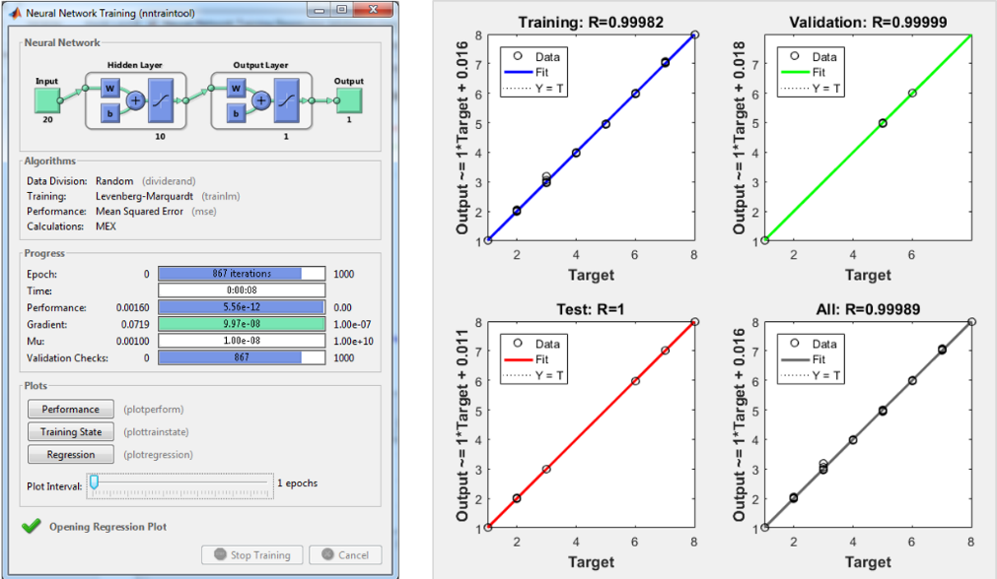
Figure 6: Training of artificial neural network (left) and graphic representation of regression (right)

After creating and defining an artificial neural network model, the network is trained in 10 iterations. As a result of training, the acceptable values of the coefficient of correlation R were obtained, for training R = 0.99982; for validation R = 0.99999; for testing R = 1. The first three graphs represent the data of the transitions, validation and testing (Figure 6 - right). The dotted line on the charts represents the perfect results, the result - output = goals. The full line represents the best linear linear regression line between input and target data. The value of R represents an inductance of the relationship between input and target data. If R values 1, it is concluded that there is an accurate linear relationship between the line relationship between input and target data [24].
The obtained results for the observed users who have not defined the learning style (u_{n}, u_{n+1}, u_{n+2}) are shown in the following table.
Table 5: Results of learning style prediction for new users
New user | Learning style obtained by using artificial neural networks
u_{n} | 7.522084011 | Global
u_{n+1} | 6.998565208 | Sequential
u_{n+2} | 1.870605353 | Reflector

6. CONCLUSION

This paper presents the proposed model of automatic detection of learning styles based on students behavior in learning management systems, using artificial intelligence. Defined test data gives a defined learning style according to Felder-Silverman learning style model. Sequence obtained based on the performance of students it is possible to clusterized in one of the eight learning styles (reflector, sequential, global, activist, visual, intuitive, sensing, verbal) using the Fuzzy c-means algorithm. After clustering using artificial neural networks, it is possible to determine the learning style for new students. During tests of the model was used Matlab. In model testing, a set of 56 sequences created by random selection of numbers ranged from 0 to 20.
Implementation of such a system (model) in the e-learning system to enhance the learning process. Learning style determined by artificial intelligence methods would enable system users (students, students) to use materials adapted to their style of learning. This way of working for the e-learning system would improve the learning process and thus influence better learning.
As one of the possibilities for further work it is possible to define a real set of data on the basis of which it would be possible to define real sequences, taking into account a greater time period in order for the sequence to be more comprehensive and complete. To create a sequence, it would be necessary for a user to spend some time, or to access learning materials.

REFERENCE

[1] Jason Bernard, Ting-Wen Chang, Elvira Popescu, Sabine Graf, "Learning style Identifier: Improving the precision of learning style identification through computational intelligence algorithms," Expert Systems With Applications, vol. 75, pp. 94-108, 2017.
[2] Richa Bajaj, Vidushi Sharma, "Smart Education with artificial intelligence based determination of learning styles," Procedia Computer Science, vol. 132, pp. 834-842, 2018.
[3] Sucheta Kolekar, Radhika Pai, Manohara Pai, "Prediction of Learners Profile Based on Learning Styles in Adaptive e-Learning System," International Journal of Emerging Technologies in Learning, vol. 12, no. 6, pp. 31-51, 2017.
[4] Juan Feldman, Ariel Monteserin and Analía Amandi, "Automatic detection of learning styles: state of the art," Artificial Intelligence Review, vol. 44, no. 2, pp. 157-186, 2015.
[5] Jason Bernard, Ting-Wen Chang, Elvira Popescu, Sabine Graf, "Using Artificial Neural Networks to Identify Learning Styles," Artificial Intelligence in Education, vol. 9112, pp. 541-544, 2015.
[6] Samina Rajper, "Automatic Detection of Learning Styles on Learning Management Systems using Data Mining Technique," Journal of Science and Technology, vol. 9, no. 15, pp. 1-5, 2016.
[7] Brahim Hmedna, Ali El Mezouary, Omar Baz, Driss Mammass, "Identifying and tracking learning styles in MOOCs: A neural networks approach," International Journal of Innovation and Applied Studies, vol. 19, no. 2, pp. 267-275, 2017.
[8] Nor Liyana Mohd Shuib, Ahmad Shukri Mohd Noor, Haruna Chiroma, Tutut Herawan, "Elman Neural Network Trained by using Artificial Bee Colony for the Classification of Learning Style based on Students Preferences," Applied Mathematics & Information Sciences, vol. 11, no. 5, pp. 1269-1278, 2017.
[9] Subitha Sivakumar, Sivakumar Venkataraman, "A User-Intelligent Adaptive Learning Model For Learning Management System Using Data Mining And Artificial Intelligence," International Journal for Innovative Research in Science & Technology, vol. 1, no. 10, pp. 78-81, 2015.
[10] Boban Vesin, Personalizacija procesa elektronskog učenja u tutorskom sistemu primenom tehnologija semantičkog veba - doktorska disertacija, Novi Sad: Prirodno matematički fakultet Univerziteta u Novom Sadu, 2014.
[11] Richard Felder, Linda Silverman, "Learning and Teaching Styles In Engineering Education," Engreeng Education, vol. 7, no. 78, pp. 674-681, 1988.
[12] Stanislava Olić, Motivacija i uvažavanje stilova učenja kao determinante učeničkog postignuća u hemiji - doktorska disertacija, Novi Sad: Prirodno-matematički fakultet Univerzuteta u Novom Sadu, 2016.
[13] Index of Learning Styles (ILS) Learning Style Questionnaire, [Online]. Available: https://www.bradford.ac.uk/academic-skills/media/learnerdevelopmentunit/documents/academicskillsresources/effectivelearningstrategies/media-99185-en..pdf. [Accessed 10 01 2019].
[14] Vera Lazarević, "Metode klaster analize u matematičkoj takonomiji," in LLL–Seminari u okviru TEMPUS projekta - seminar 3, Novi Sad, Departman za matematiku i informatiku.
[15] Luka Loina, Usporedba algoritama čvrstog i neizrazitog grupiranja podataka za segmentaciju slike, Osijek: Elektrotehnički fakultet Sveučilišta Josipa Jurija Strossmayera, 2018.
[16] Ida Žokalj, Zvonimir Szorsen, Cluster Analysis - fuzzy clustering, Zagreb: Fakultet elektrothenike i računarstva Sveučilišta u Zagrebu, 2002.
[17] Dušan Teodorović, Milica Šelmić, Računarska inteligencija u saobraćaju, Beograd: Saobraćajni fakultet Univerziteta u Beogradu, 2012.
[18] Zoran Miljković, Dragan Aleksendrić, Veštačke neuronske mreže, Beograd: Mašinski fakultet Univerziteta u Beogradu, 2009.
[19] Marko Koprivica, Supervizni algoritmi za učenje neuronskih mreža sa prostiranjem signala unapred - diplomski rad, Beograd: Fakultet organizacionih nauka Univerziteta u Beogradu, 2010.
[20] Velida Kijevčanin, Šaban Gračanin, Data mining (samostalni istraživački rad), Kragujevac: Univerzitet u Kragujevcu, 2009.
[21] Milan Vukićević, Sonja Išljamović, Miloš Jovanović, Boris Dlibašić, Milija Suknović, "Primena neuronskih mreža za predviđanje uspeha studenata," in YUinfo, Kopaonik, 2012.
[22] Aldekhail M., "Application and Significance of Web Usage Mining in the 21st Century: A Literature Review," International Journal of Computer Theory and Engineering, vol. 8, no. 1, pp. 41-47, 2016.
[23] Zenaide Carvalho da Silva, Leandro Rodrigues Ferreira and Andrey Ricardo Pimentel, "Adaptation of Learning Object Interface based on Learning Style," International Conference on Enterprise Information Systems (ICEIS 2017), vol. 3, pp. 119-126, 2017.
[24] Analyze Shallow Neural Network Performance After Training, [Online]. Available: https://www.mathworks.com/help/nnet/ug/analyze-neural-network-performance-after-training.html. [Accessed 14 03 2018].

