INFORMATION SYSTEM FOR RECIVING REPORT ABOUT LIBRARY OF TECHNICAL COLLEGE OF APPLIED SCIENCES
FROM UROŠEVAC IN LEPOSAVIĆ

Dejan Živković¹; Filip Marković²; PhD Nenad Marković
¹ Technical College of Applied Sciences from Uroševac in Leposavić, Leposavić, the Republic of Serbia, zile028@gmail.com
² Faculty of Technical Sciences, Kosovska Mitrovica, the Republic of Serbia, ridjikm@gmail.com
³ Technical College of Applied Sciences from Uroševac in Leposavić, Leposavić, the Republic of Serbia, nen.mark74@yahoo.com

Abstract: The subject of the this paper is the way of realizing information system of library in the Technical College of Applied Sciences from Uroševac in Leposavić using the MS Office Access software package. Information system of library is a separate base of data which is conected with infornmation system of student service which ensures that members of the library can only be students of this higher education institution. The information system created in this way provides the opportunity to access availability of books, as the state of published books. It also provides an opportunity for the student service to have an access whether the student has settle obligations to the library when issuing a certificate of graduation, as and getting a necessary report whose can serve for a statistical analysis of library which latter could be used in process of self-evaluation.

Key words: library, information system, MS Office Access, report.

1. INTRODUCTION

Information system of Technical College of Applied Sciences from Uroševac in Leposavić (TCAS from Uroševac in Leposavić) should promote the work of the library, for example to provide more efficient usage of search data on books and library members with significant decrease of time used for finding them, saving the space, time, etc. In the library information system of the TCAS from Uroševac in Leposavić following processes exists:
- data entry of new member and membership check,
- modification of data on members and their deletion,
- checking (control) of returned books,
- records of all books that are in the library and check of their status,
- records of borrowing and returning books, etc.
In order to achieve this successfully, it is first of all necessary to get to know and understand functioning of the work itself of this way achieved information system of the TCAS library from Uroševac in Leposavić.
The work of the information system of TCAS library from Uroševac in Leposavić does not differ much from the work of classical libraries. Namely, it is based on renting books for a limited period of time, exclusively for school students, in keeping records of each book, its name and author, as well as on each library member and its index number, ID, name, surname, address and other necessary data. Therefore, it was necessary to design the Information system of TCAS library from Uroševac in Leposavić. [1]
All designing processes require that several stages or steps are used in the creation, because it is unrealistic to expect that anything can be projected in 1 minute or in one step. The process of realization of information system of TCAS library from Uroševac in Leposavić is divided in three steps:
- system analyze,
- data base projecting,
- creation of application. [2,3]

2. STRUCTURE OF THE INFORMATION SYSTEM OF LIBRARY AND ITS RELATION MODEL

For the purpose of more efficient project management, i.e. realization of the information system of TCAS library from Uroševac in Leposavić, it is necessary to define its organization. The organization (diagram) of the TCAS library from Uroševac in Leposavić is given on Pic. 1.
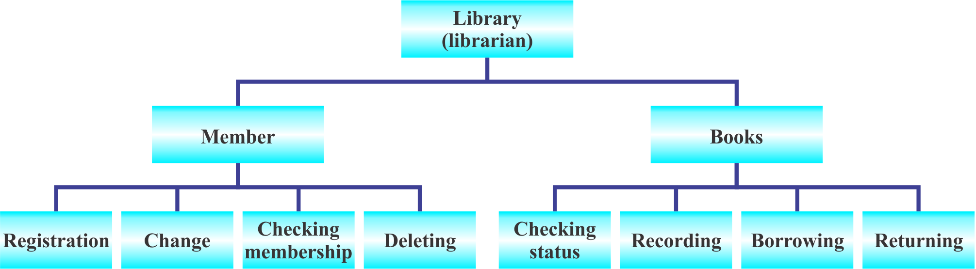
Picture 1: Organizational structure of the information system of TCAS library from Uroševac in Leposavić

As shown in Pic. 1, the user manipulates with information about library members and their books, as follows:
- Manipulation with data on members:
- Entry of data for new member of the library – entry of new library member into records based on the personal data contained in the school archive i.e. information system of the student service that this information system is connected.
- Modification of data on library members – it is possible to modify data about library members.
- Checking library members – based on student ID (index) checks of library members if necessary.
- Deletion of members of the library – members of the library who have finished the school are deleted, only in case there are no active reminders, that is, that the books have not been returned.
- Manipulating data on books:
- Book Recording – strict records are kept for each book located in the library.
- Checking the status – checking whether the book about which member was given information is in the library fund and whether it is currently in the library or maybe rented.
- Borrowing and returning books – if a book is not a rented member gets a book. Data on the book and data on the member in the records of rented books are entered.
- Returning books – based on a membership card, first checking the student's membership and then releasing a member from the records of leased books is done first.
The information system of the TCAS library from Uroševac in Leposavić consists of 13 tables in which the necessary data on the members and books of the library are stored, three of which are imported from the information system of the student service (MB Student, MB Places, MB State), which enables import information about the members of the library where it is ensured that library members can only be students of TCAS from Uroševac in Leposavić, Pic. 2.

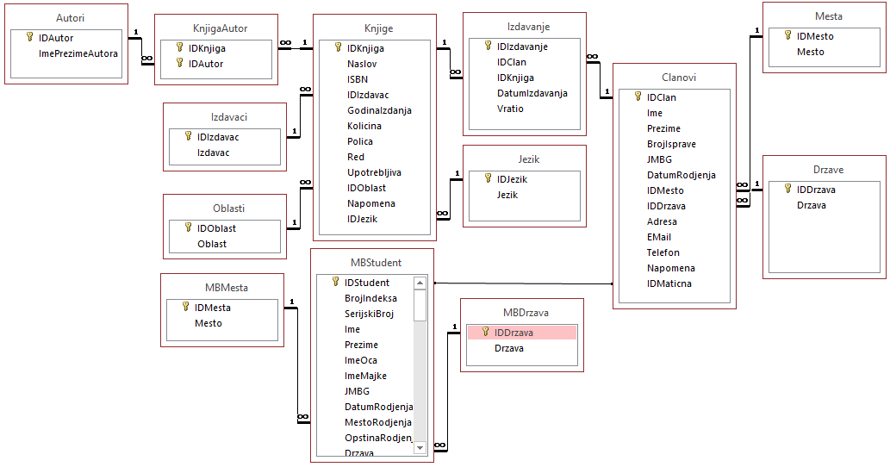
Picture 2: Relational model of information system of the library TCAS from Uroševac in Leposavić

3. STARTING AND WORKING WITH APPLICATION

The program is implemented in development environment of MS Office Access, part of the MS Office software package. [4,5] Numerous benefits of MS Office Access have greatly facilitated the development of this application. What is characterized by MS Office Access are many ways to view and manipulate the database in the form of objects.
Most frequently used objects are: [6,7,8]
- Tables,
- Queries,
- Forms,
- Reports,
- Macros.
Purpose of these objects is as follows:
- The tables contain all data necessary for the operation of information system of TCAS library from Uroševac in Leposavić.
- The query is question asked in the table or tables of database, and on the basis of which we get the required result. In development of information system of the TCAS library from Uroševac in Leposavić, numerous query were used, most of which make select inquiries, although the update was also used. The query response can appear in the form of a separate table or tables.
- Reports are used to get and summarize information from one or more tables in the database. From the query they differ by being an extremely good way to display information in a legible form.
- Macros represent the most complex object that can be created in the database. They are created using Visual Basic code to automate certain repetitive tasks.
- Forms are a great way to view, enter and edit table data.
In the continuation of this work, special attention will be paid to the presentation of forms and reports of the information system of the TCAS library from Uroševac in Leposavić.

3.1. Title form

After starting of the program, the title form opens on which the user can decide for some of the „superior“ jobs: THE MEMBERSHIP, THE BOOK ENTRY, THE ISSUE OF THE REPORT, etc., Pic. 3. We call the jobs that are covered by them as „subordinates“. Each of these jobs has its own separate form in which it is implemented.
Each of the forms has a certain level of protection that is reflected in the fact that all data must be entered in the same form that is predefined by the Input mask.

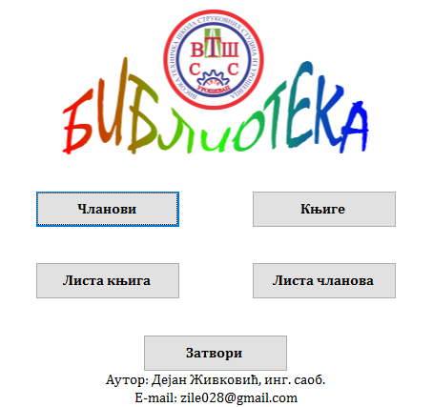
Picture 3: The title form of the information system of the library TCAS from Uroševac in Leposavić

3.2. Records of members and debt books

In the form Members are information about the member: index number, name, surname, ID, contact telephone... and data on issued books, Pic. 4. Through this form, the user can enter data for new member or import data from an existing student database. Also, through this form, the user has the option of borrowing a library member from one of the books or extending it, as well as to print out a report on all the books in charge and those that he had previously borrowed.

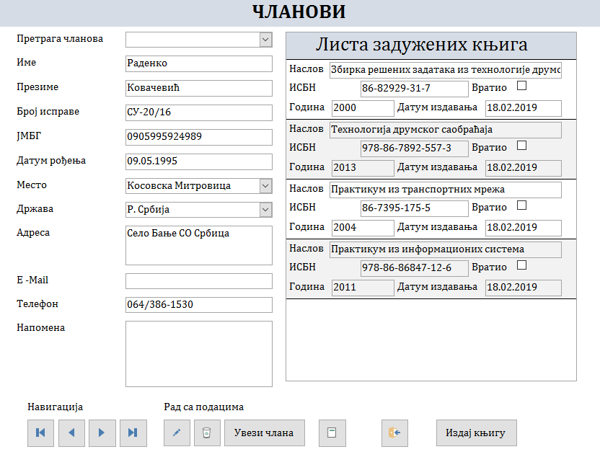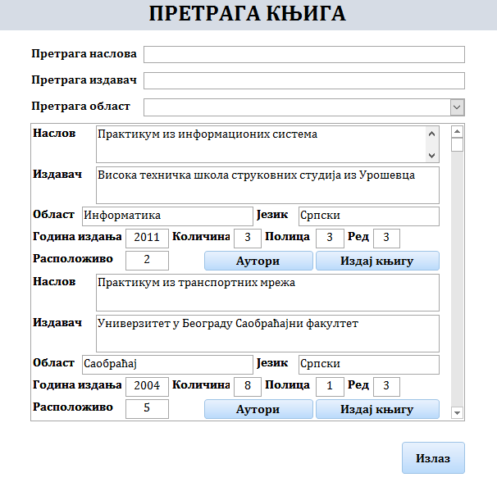
Picture 4: Enter card of members and search for books

Book borrowing is done by clicking on the „Release Book“ button, then opening a book search form that can check the availability of the book and on which book shelf is located. Reducing books is done very easily; it is necessary for a user to select appropriate member in the member search field and to check/click on the „Return“ box on the list of debited books for the book that the member wishes to return; it is removed from the list of debited books.

3.3. Book records

Entering new books or removing existing ones from the database is done through the „Book“ form that contains information about each book located in the library, such as: Title, ISBN, Publisher, Year Edition, Authors..., Pic. 5. With this form we fill in the table Book. The data in this table are all books available to the library.

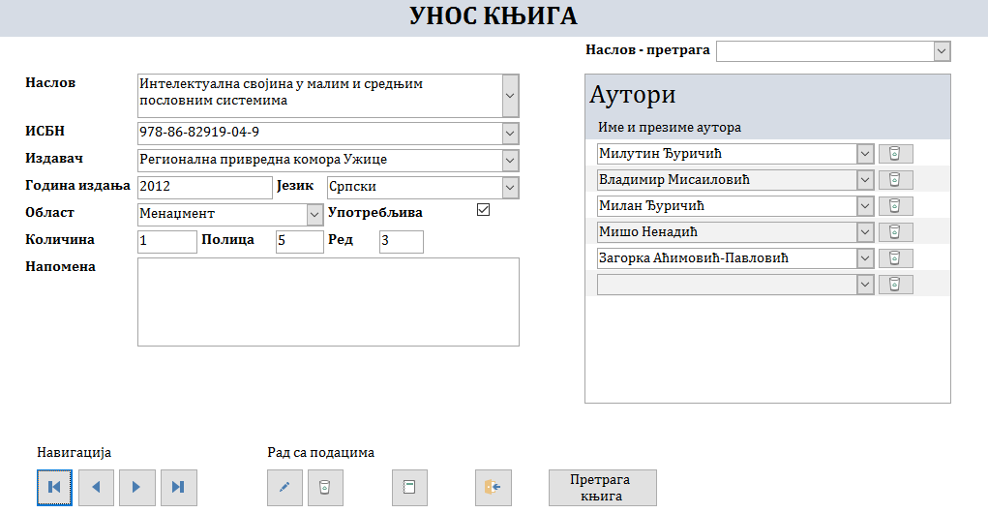
Picture 5: Book card

Within this form, we provide the user with information about whether a book is in the library's fund, and whether there is a free copy of this book. Using the „Book Search“ option makes navigation through the book's fund easier.
Also, through this form, a user can get a report on which books are located in a library sorted in alphabetical order.

3.4. Report

Reports are specialized database objects, such as forms and queries. Therefore, we can prepare as many reports as we want and we can keep them at hand as long as we need them. However, it is very difficult to work exclusively with tabular displays. In this case, we do not have the flexibility needed to work with large data blocks, we can not finer format the individual fields, and we do not have tools available such as clustering tools and calculating aggregate data that facilitate data understanding.
In order to get tabular preview from printing the first to print another list, we would have to manually shift and hide columns each time. With reports, this problem does not exist because each report is kept in the database as a separate object. When we want to print out a list of books, we'll launch the Book List report. If we need information about members, we will start a report Member List, Pic. 6.

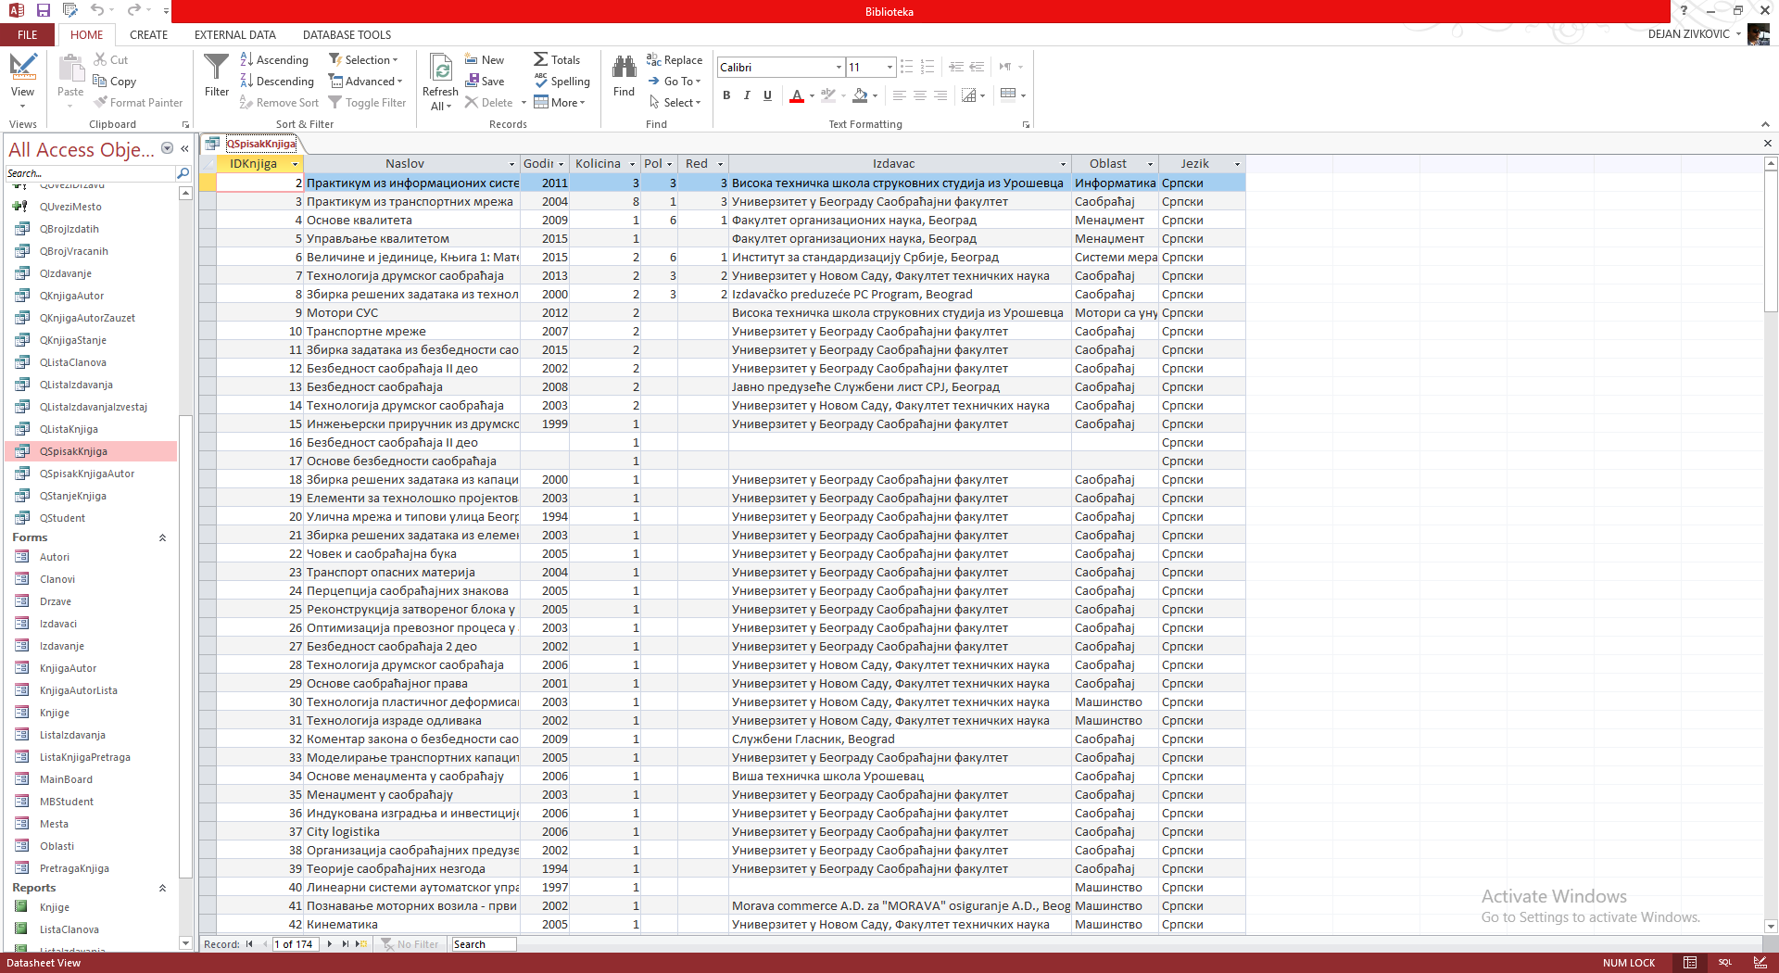
Picture 6: Basic query printing

The concept of the report is the same as the concept of query. Instead of freezing a set of sorting and filtering options, queries allow us to compose every combination we want and then save it as a separate object in a database.
In order to see one of the arguments for claiming that the queries are incomparably better than plain printing of the tabular display, compare Pic. 6 (which shows printed version of table display) of Pic. 7 (which displays the same data in a simple report). Please note that in the table view there is simultaneously unused space and missing data.

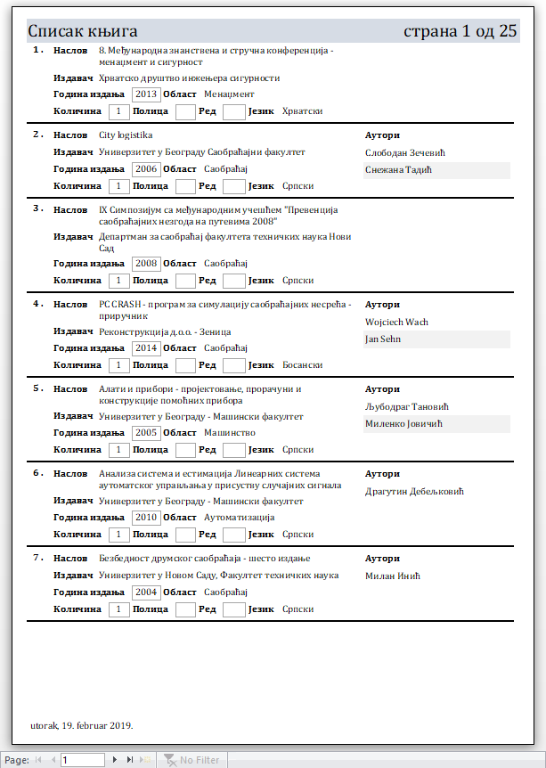
Picture 7: The list of books shown as a report

There are a lot of reasons for us to make a printed sample of data we maintain. Well printed copy provides:
- we take data with us without obligation to carry computer as well,
- we show data to people that are not users of MS Office Access,
- we study details outside office.

4. CONCLUSION

The paper presents and explains information system of the TCAS library from Uroševac in Leposavić, which has a record of members, books and authors in a fully automated process of issuing and returning books. The creation of this information system has been done in a few steps.
The reality in all information systems is that they can be done differently, that is, instead of the base in MS Office Access, it uses the SQL database or another program for creating interfaces and coding like Visual Studio, but all of these elements affect the value of the project itself i.e. the value of the information system, so it is necessary to pay a lot of attention (calculate) what is „profitable“ i.e. what will bring optimal work for the optimal period in front of us and in accordance with optimal costs. In the existing program, certain improvements can be made if necessary, i.e. if users request individual changes to the tools they are working with to be in line with the information system capabilities.

REFERENCES

[1] Marković N., Živković D., Marković F. Information sistem for obtaining reports on students of the High Technical School of Vocational Studies from Urosevac in Leposavic, Professional paper, TIE Cacak, 2018: 203–207.
[2] Feddema H. Access 2007 VBA Bible: For Data-Centric Microsoft Office Applications, John Wiley & Sons; 2007.
[3] MacDonald M. Access 2007: the missing guide, Belgrade, Microbook; 2008.
[4] Cox J., Lambert J. Step by Step Microsoft Access 2013, USA Microsoft Press; 2013.
[5] MacDonald M. Access 2013: the missing manual, USA: O’Reilly Media; 2013.
[6] Hennig T., Cooper R., Griffith G.L., Stein A. Access 2007 VBA Programmer's Reference, John Wiley & Sons; 2011.
[7] Teresa H., Rob C., Geoffrey G. Armen S. Access 2007 VBA Programmer’s Reference, Wiley Publishing, USA; 2007.
[8] Joseph C.S., Alan S. Access 2007 VBA Programming For Dummies, Wiley Publishing, USA; 2007.

