POSSIBILITIES OF CONSERVATION AND REVITALISATION OF BUILDINGS OF RESIDENTIAL ARCHITECTURE OF THE INTERWAR PERIOD IN UZICE
Gordana Lazić, PhD¹;
¹The College of Applied Sciences, Užice, Srbija

Abstract: Despite many difficulties in the period between the First World War and the Second World War, such as bad roads, lack of capital, unemployment, a decline in purchasing power, many significant and diverse residential buildings were built in Užice: The house of merchant Stojan Krčevinac from 1925, (according to the plans of engineer Dobrivoje Mojović), the house of David Novaković from 1931 and the house of Mališa Atanacković from 1934. When it comes to the protection and revitalization of the building heritage in Užice, the results are very uneven. A number of buildings in today's urban core of the city are preserved, some facades are renovated, but most of them require rehabilitation and proper interpretation. A positive example is the house of David Novakovic, which in 2018 received a new facade and decorative lighting, and along with the expected arrangement of the parterre, will represent an example of dedication to the preservation of the architectural heritage, a more beautiful urbanistic image of Uzice as well as a more substantial tourist offer.

Keywords: the residential architecture, Uzice, post-secession, expressionism, modernism, conservation and revitalization

- INTRODUCTION

The panoramic view of the city of Uzice leaves the observers in the belief that it is a young town whose history does not reach beyond seventy years ago, more precisely from the time of Solitary construction. Still, a little more careful view will discover, cluttered among skyscrapers, the medieval city, tower churches and some interesting, rarely preserved buildings that somehow survived the mass destruction especially after the Second World War.
Starting from the oldest (such as the famous Jokanović house, the house of Andre Stanić at the Rakijska marketplace or the house in Sarajevska Street 16, all from the second half of the 19th century), through the buildings built before the First World War (the house in Miladin Popović Street 1, Zlatiborska Street 6 - known as "Zlatan Prag", houses in Zicka Street, then a number of houses in Dimitrija Tucovic Street from the Square of Partisans to the Aleksic Bridge, finally Milos Trifunovic's house from 1912 with the features of the secession style), to the objects from the interwar period which will be considered in this paper, the impression of significant and diverse construction of Užice from the mid 19th to the half of the 20th century is gained, that is, at the time of the development of civil society and the creation of a modern state.
Between the two world wars begins the accelerated development of a devastated city in which the poor traffic communications, the lack of investment capital and especially the fact that during the wars of 1912-1918, the number of inhabitants decreased by 20%, were a major problem.. The economic recovery plan included the improvement of the road network, the renewal of energy resources, the development of industry and crafts, the establishment of banks. The initial successes were diminished by the outbreak of the major economic crisis in 1928, causing a decline in modest purchasing power, a stagnation of trade and high unemployment. In spite of these unfavorable circumstances, Užice has built up significant and stylishly diverse residential buildings between the two world wars, some of which will be represented by this work.

- HOUSE OF STOJAN KRČEVINAC
The house of Stojan Krčevinac was erected in 1925 according to the plans of engineer Dobrivoje Mojović (who, a few years later, will design the building of the Homeland War Orphanage), which shows the documentation in the possession of the heir. It is located on the corner of Dimitrija Tucović Street and Lipa Street, and it is a family house, one-storied, business-residential building with the stores on the ground floor and on the apartments on the first floor. In the urban position, this is an angular object on street regulation. In the decorative sense, the corner is especially emphasized by a balcony with a wrought-iron enclosure and a balcony door with rounded windows between the glass windows (secession manners that are rarely applied in Serbia, for the first time on the Milan Jovanovic photo studio in Belgrade in 1902, architect Milan Antonovic) and richly decorated attic. In the lateral layout of the building, three-sided windows are distinguished as a typical feature of the interwar postsecession as well as the rectangular fields beneath the roof wreath where women's maskerons are placed in a stylized leaf frame. They are identical to the masquerones applied on the second floor of the Upper Gymnasium building from the period 1924-25 year which fits with the year of construction of this house.

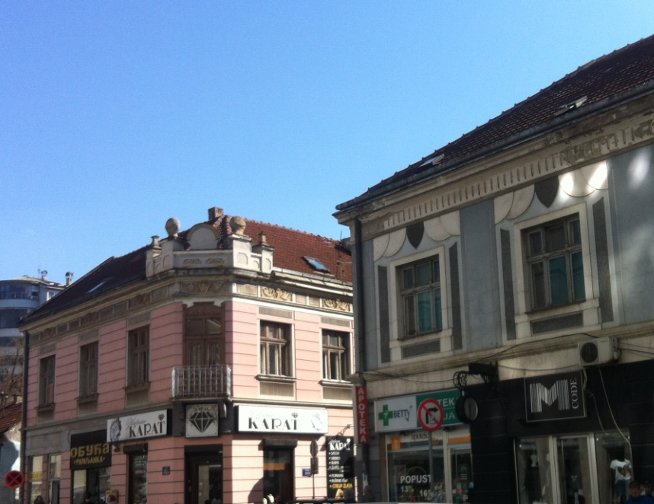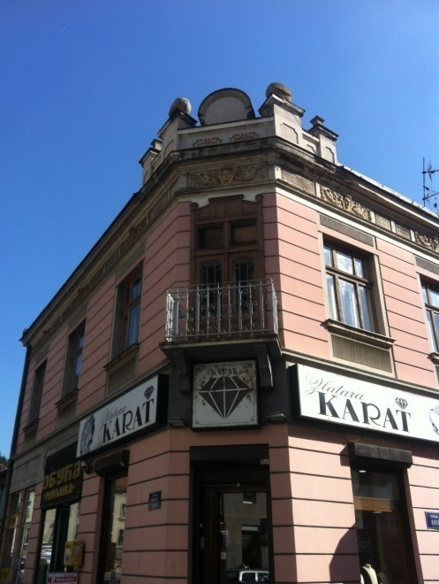
Figure 1,2: House of Stojan Krčevinac (left and detail of the angle) and house of Pavle Ljubisavljević
Across the house of the merchant Stojan Krcevinac there is a house of pharmacist Pavle Ljubisavljevic with unusual motifs of folded semicircles. Both façade buildings were renovated in the late 1980s.

- HOUSE OF DAVID NOVAKOVIĆ
The house of David Novakovic was erected in 1931 and is located in Obilićeva Street number 6. Despite careful quest for the name of the designer, this information could not be obtained either by insight into the legacy of the heirs, nor in the documents of the Historical Archive, the National Museum or the Directorate of Construction (where the data of the Institute for the Conservation of Cultural Monuments in Kraljevo are in use). According to the heirs, the house was erected in 1931-33 and this is confirmed by the panoramic footage of Uzice in the book by Milorad Iskrin "Uzice koga više nema" on page 43 where you can see the newly built house of David Novakovic but not the hotel "Palas", built since 1933. Also from the successor Dusko Novakovic, he informs that the original color of the building was a combination of bordeaux and white, and that at a high angle of attic there was a sculpture of the eagle that was removed after the Second World War.
And this one-storey, business-residential house has one floor and a courtyard wing. It used to be on street regulation and is now withdrawn from that line because of the changes caused by the demolition of Subotic's house and the construction of the Department Store "Belgrade". It has an angular position with a high attic and lateral rhizalates. It preserves original entrance door, authentic triple windows and shallowly profiled ring decorations that discreetly point to the possible influences of the architectural style of Momir Korunović, according to whose plans it was precisely during this period 1931-36, the Sokolana was erected. And the eagle's motive is associated with the figures of hawks that stood on the perimeter of the Sokolana roof. During 2018, the facade was rehabilitated according to the Conditions of the Institute for the conservation of Cultural Monuments in Kraljevo, and based on the Planning Document of the Directorate of the Construction of Uzice, under the supervision of the architect Ruža Penezić. The house belongs to the category of buildings of the 3rd degree of protection that is carried out on objects of architectural, urban and ambient values ​​and which have the status of prior protection. The original bordeaux color was replaced by a smaller intensity color due to its incorporation into the surrounding ambient.

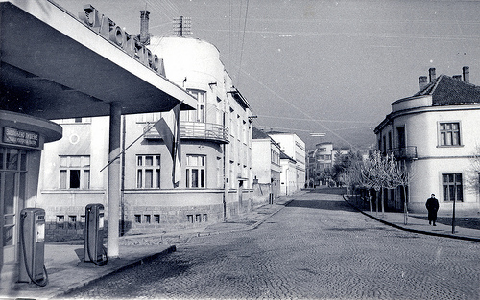
Figure 3: House of David Novaković (1956) and the house Subotić
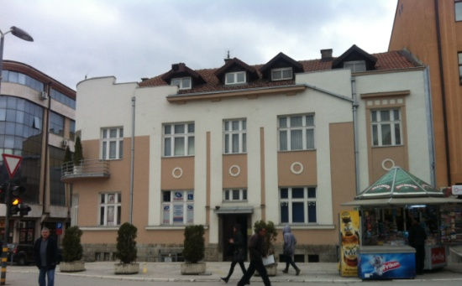
Figure 4: House of David Novaković (in present days)
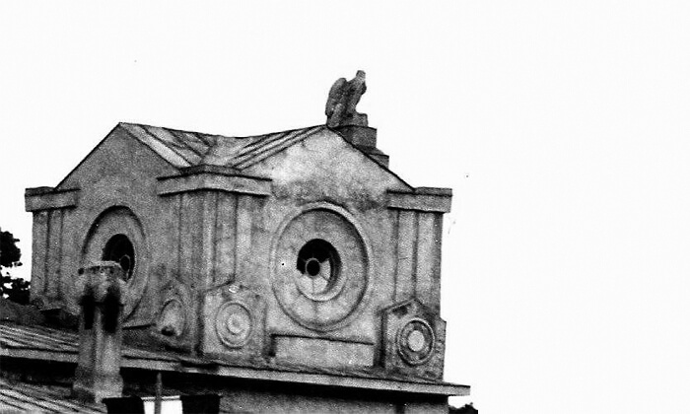
Figure 5: Detail of decoration of Sokolana

- HOUSE OF MALIŠA STEFANOVIĆ
House of Mališa Stefanović was erected in 1934-36. It is located on the former Trg Svetog Đorđa, today's Trg Svetog Save. The designer is the famous Serbian architect Miladin Prljević (born in Užice), who is also the author of project the hotel "Palas" from 1933, as well as his own house on the former Žitna marketplace. It is typologically similar to the previous objects, therefore, it is a single-storey, family house with an emphasized angle. It is laid freely in space, it has a simple, cubic mass with an original step-like look of roof coverings (in today's look, only the indication of this step-by-step is preserved). Smooth surfaces, with elegant details in the form of profiling and contrasting colors. As with previous buildings, the angle is emphasized by the balcony, but the stylistic concept is completely different. In the first two cases, the angle is rounded and the balcony is a decorative addition, while in the project of the Prljević architect we see that the balcony retains a strict, rectangular shape and that, thanks to the direction and color of the decorative tape, the impression of structural unity with the whole is given. The house of Mališa Stefanović emphasizes Prljević's rational and functional understanding of architecture, modeled on the aesthetics of the Group of Modern Artists who worked in Belgrade from November 1929 to February 1934.
The fate of this object is an example where all the ways of different circumstances affect the survival of the architectural heritage. In this house, in 1941, there was a seat of the Main National Liberation Committee of Serbia, and for that reason, the house has been under state protection since 1949, and since 1979 it has been proclaimed as immovable property of exceptional importance. Although the plan for the construction of a shopping center in the basement of newly-built solitaire foreseen the demolition of this building for an access approach to supply, it was abandoned precisely because of its historical significance, not because of artistic qualities. The foundations were restored and the facade renovated, and in this house is settled the Music School.

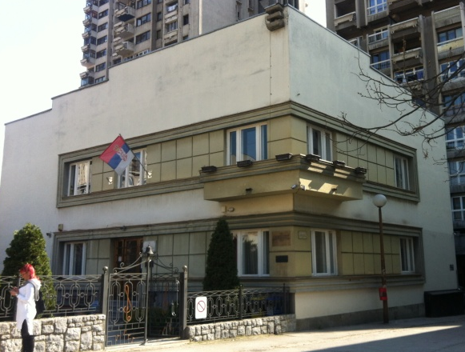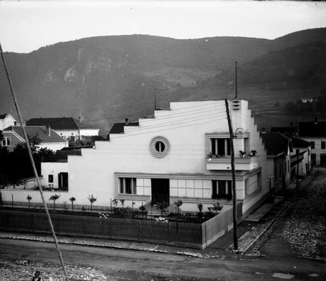
Figure 6,7 : House of Mališa Stefanovića (today and earlier)

In addition to the mentioned objects, many other examples of housing construction in the period between the two world wars, they deserve attention and effort to be preserved and adequately presented as a memorial of the development of the civil society in Uzice. These include the Railway Home (formerly called the Railway Barracks) in Omladinska Street 22, built in the 1920s, with a geometric decoration that owes its origin to the secession, which, despite the restored façade, is now in a rather neglected state, then Djeric's house, in the row of block "C", also single-storey, family house with balconyon the corner, as well as the house on the corner of King Peter and Streets 2. Proleterske brigade, with iron balcony, Vasovic house with oval okulus at the corner near the SUP, houses in Klisura, houses in Street Dimitrije Tucovic to Aleksic Bridge, Old Pharmacy in Dimitrije Tucovic Street, house with clinker brick facade in Koštica, houses in Žička Street and many others.

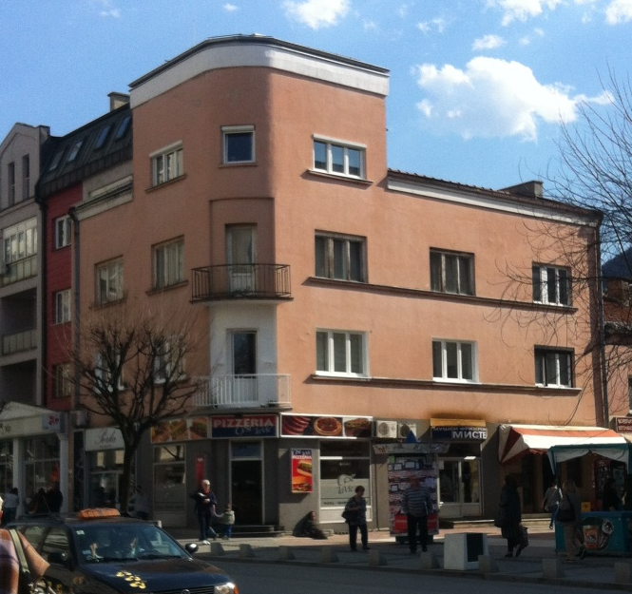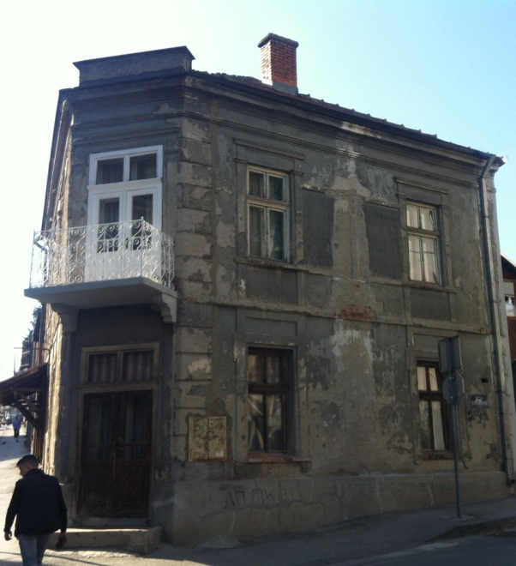
Figure 8,9: House Đerić and house on the corner King Petar Street i 2. Proleterske brigade
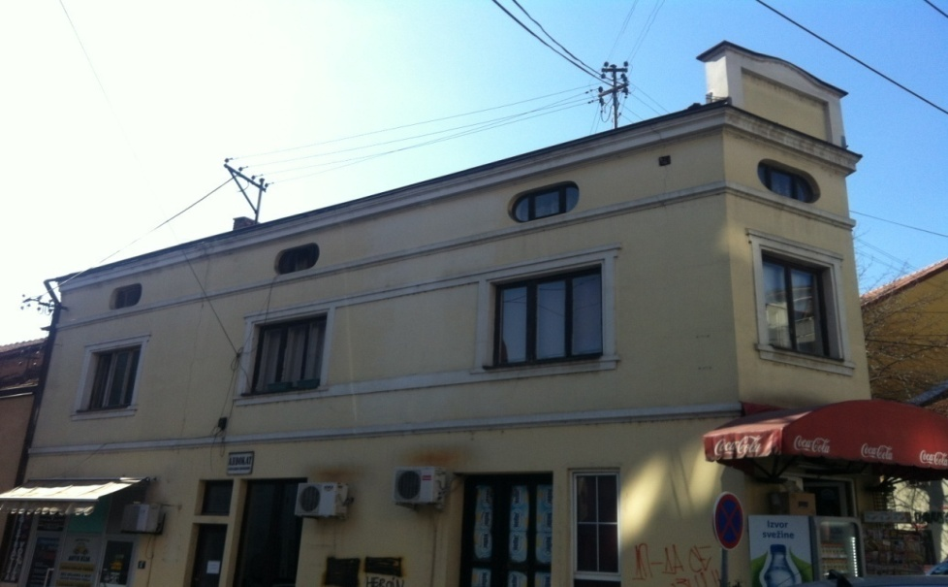

Figure 10: House Vasović, Slanuša
- CONCLUSION
The problems of protecting cultural heritage are a complex social phenomenon which implies many economic, political, historical, artistic, sociological, psychological, technological and other factors crucial in defining the notion of a cultural property and determining the necessary protection measures. The word "spomenik" in the Serbian language was first mentioned in 1844 in the first Order of the protection of antiquities. Later terms such as cultural good and cultural heritage relate both to material and spiritual values. In addition to the documentary, historical and artistic aspects, there is a component of idea, that is, a way of interpreting a cultural good, which contributes to positive action on the consciousness of the community.
Artwork is the unity of the whole, it is a non-renewable resource of the environment in which it originated. To preserve its authenticity is the most important task of the conservator. The center of attention should be preventive restoration because it prevents the restoration of extreme urgency. The specificity of the protection of the architectural works is the inseparability of its historical location, space and ambience, taking into account the material integrity of the building, the preservation or removal of newly added supplements, the problem of patina, the risks of the method of analogy, the preservation of the integrity of adjacent spaces in order not to disturb artistic values ​​such as lighting, proportions, viewing angles ... It should also be taken into account that today's measures of protection do not make it difficult or impossible for measures to be taken in the future.
Previous activities on the coservation and revitalization of the architectural heritage in Uzice show disagreements and uneven results. Some objects, for example, Jokanovic's house, represent a triumph of profession and deliberate action of the community. The works of coservation and reconstruction started at this object in 1989. According the order of the Municipal Assembly of Uzice, the National Museum reconstructed and renovated the house. The conservation conditions were granted by the competent Institute for the Conservation of Monuments of Culture from Kraljevo, while "Projektbiro" from Uzice made the project. These concerted efforts have led to the ultimate goal, and this is the survival of a valuable example of urban architecture, which today represents a significant part of the city's tourist offer, and we hope, as part of the Užice citizens' awareness of the continuity of the city's development from the Turkish hinterland to the modern town. Some other examples were not that lucky and what happened to them did not serve for pride. Some objects are gone forever and we only know about them from saved photos and documentation. But what remains is not a bit and should, in agreement with the owners, take at least the most necessary protection measures. Reconstruction of facades, along with instructions for preserving authenticity and stylistic unity of buildings, could be the first steps, and the house of David Novakovic, who left an unpleasant first impression on all who arrived in Uzice from the direction of the Bus and Railway Station earlier, today is the decoration of this part of the city. Unfortunately, the house of Miloš Trifunović, with the most prominent features of secession as a European artistic style at the transition from the 19th to the 20th centuries (in Uzice's architecture), despite the decades-long writings of the authors of these lines, is increasingly suffering from worse interventions on the facade year after year. With the restored façade, adequate carpentry and respect for the stylistic unity of the same, we would get another preserved architectural jewel that would influence the general picture of the development of the city of Uzice.
Awareness of the preservation of cultural heritage is the civilization context of the environment in which it was created, a task that links the past and the future and defines the character of a particular community. The protection of cultural heritage is connected with numerous social circumstances in terms of integration with the strategy of sustainable development, development of cultural tourism and overall progress of the region and the state. Regardless of the degree of importance, richness and diversity of this heritage, it is the duty of the community to preserve what has been found and the greatest responsibility rests on those individuals and institutions that are most concerned about its value.

REFERENCES
[1] Tomić,S. Spomenici kulture njihova svojstva i vrednosti. Beograd; Narodna biblioteka Srbije; 1983; 59-65.
[2] Marković,Ž-Stanimirović,A. Kulturno-istorijsko spomeničko nasledje Titovog Užica. Užice:Užički zbornik 19; 1990; 53-105.
[3] Lazić, G. Arhitekt Milan Antonović (1868-1929). Novi Sad: Zbornik Matice srpske za likovne umetnosti br.27-28; 1991-1992; 20-21.
[4] Istorija Užica (1918-1975). Institut za savremenu istoriju Beograd. Užice;1992; 89-161.
[5] Đajić, M.-Ristović, D. Jokanovića kuća, Užice: Narodni muzej; 1992; 23-25.
[6] Iskrin, M. Užice koga više nema.Užice: 1993;43
[7] Lazić,G. Istorija i arhitektura objekata na Trgu Svetog Đorđa u Užicu. Užice: Užički zbornik 24; 1995; 165-176.
. [8] Kadijević, A. Momir Korunović.Beograd. 1996,88-90.
[9] Roter-Blagojević,M. Stambena arhitektura Beograda u 19. i početkom 20. veka. Beograd: Orion art; 2006; 101-445.
[10] Brandi, Č. Teorija restauracije. Beograd: Publikum; 2007; 68-79.
[11] Kadijević,A. Ekspresionizam u beogradskoj arhitekturi (1918-1941).Beograd, Nasleđe 13;2012; 61-71.
[12] Putnik, V. Prilog proučavanju razvojnih tokova međuratne stambene arhitekture Beograda. Beograd, Nasleđe 13;2012; 153-166.
[13] Kuzović,D.-Stojnić,N.Architecture in Užice from 1918-1941 – From Architecture of Historical Styles Towards Modern in:Facta Universitatis, Series: Architecture and Civil Engineering, Vol.12, broj3;2014; 287-298.
[14] Dimitrijević-Marković,S. Problemsko polje oblikovanja u planovima urbane obnove, Beograd, Nasleđe 17;2016;151-161.

