VISUAL COMPLEXITY OF FRACTAL RHYTHM

Đorđe Đorđević, PhD¹; Ivana Ćirović, PhD²
¹ University of Belgrade Faculty of Architecture, djordje@arh.bg.ac.rs
² Business-Technical College of Vocational Studies in Užice, Republic of Serbia, ivana.cirovic1@gmail.com

Abstract: In architectural and urbanistic compositions, fractal rhythm is the rhythm generated through objects of fractal geometry observed as though they were mathematical models of natural rhythm. Due to the presence of a component of randomness, fractal rhythm is classified among nonexact rhythms. This paper will attempt to prove that fractal rhythm is assessed as visually more complex than exact rhythms. In addition, it will also show how the selection of a fractal as a model of rhythm with particular mathematical properties may influence visual complexity of the generated rhythm, and presumably, aesthetic perception of such rhythm.

Keywords: fractal rhythm, random fractals, fractal dimension, visual complexity, aesthetic measure

1. INTRODUCTION

Relevant scientific research in the field of experimental aesthetics has determined there is a correlation between aesthetic preferences toward objects of fractal geometry and their fractal dimension which is a mathematical property of fractals observed as an objective parameter of their complexity. Moreover, results analysis of scientific descriptions of objects existing in nature by means of fractal geometry and measurements of their fractal dimension have shown there is a correlation between aesthetic preferences toward particular values of the fractal dimension on one hand, and a prevalent value of the fractal dimension when it comes to objects from nature on the other. Fractal dimension is accepted as an objective parameter of complexity of fractals, and research shows it is in correlation with the perceived complexity. Results of the studies conducted before the appearance of fractal geometry show a correlation between aesthetic preferences toward visual objects, and their objective and perceived complexity.
In addition, there is also a relationship between values of the fractal dimension of an object and its visual properties, such as: detail and richness of structure, curve, roughness, jaggedness, etc, which are directly related to the judgements of visual complexity of visual objects, and to aesthetic preferences toward such objects. Thus, according to a group of authors [1], the value of the fractal dimension of a fractal has a strong effect on its visual appearance in such a way as to make a visual object with a low fractal dimension look like a “very flat, sparse shape”, whereas a visual object with a high fractal dimension on the other hand appears as a “shape with a complex and intricate structure” [1: p.57]. The authors describe a fractal curve as a line that “begins to occupy space” and where increasing its fractal dimension also increases its ''complexity'' and ''richness of the repeating structure'' [1: p.57]. Similarly, Voss [2] writes that fractal dimension determines a relative level of detail of fractals, so in the case of Brownian curves, or one-dimensional Brownian functions for example, it occurs as a quantifiable parameter of their ''wiggliness'' [2: p.71], whereas in Brownian surfaces or two-dimensional Brownian functions, it occurs as a measure of “roughness”, meaning that surfaces with a higher fractal dimension appear “rougher” [2: p.31]. Describing Brownian surfaces, Pentland [3] observes that the fractal dimension roughly corresponds to our intuitive impression of “jaggedness” [3: p.974] ''roughness'' [3: p.975].
The previous observations of different authors about how the value of the fractal dimension of fractals influence their appearance, or more precisely certain properties with a clear visual manifestation of their own, leads us to the following assumption – that by using these objects of fractal geometry for the design of architectural and urbanistic compositions, provided we adopted their mathematical or geometric properties, we may replicate their visual properties. This allows us to manipulate the desired visual impression of our architectural and urbanistic compositions as more or less unstable, variable, etc, which, as it turns out, is recognised and evaluated as more or less visually complex, by manipulating and adjusting the appropriate values of this parameter.

2. FRACTAL RHYTHM

In architectural and urbanistic compositions, a nonexact rhythm may be determined using objects of fractal geometry from the class of random fractals observed as though they were mathematical models of natural rhythm, which was initially proposed by Bovill [4] who identified rhythm determined like this as fractal rhythm.
The author analysed two types of fractals, both from the class of random fractals: fractional Brownian functions and random curds. Scientific literature [5] [6] [7] [8] [9]) shows the latter may be acceptable mathematical models for many natural shapes and processes, namely: fractional Brownian functions as a mathematical model of change over time of a random variable from nature, and as a model of a number of natural shapes and surfaces, e.g. terrain, clouds, bodies of water, plants, etc, and random curds as a mathematical model of random clustering of matter in nature, e.g. clustering of stars or galaxies. It was Bovill who identified the possibility of determining rhythm in architectural and urbanistic compositions with the aforementioned objects of fractal geometry, observing them as mathematical models of natural rhythm of element change or natural distribution. He described a potential procedure for transferring rhythm from a model to rhythm in architecture that can be used to achieve rhythm in architectural and urbanistic compositions similar to natural rhythm, and this is how the author justifies the proposed concept. Figures 1 and 2 show compositions of architectural elements (fence comprising metal rods and a wall surface covered with multi-coloured panelling) generated with the use of fractal objects mentioned above and procedures proposed by Bovill, as well as two examples from architectural practice where element rhythm may have been generated this way.

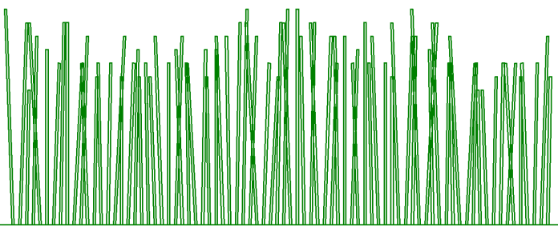 | 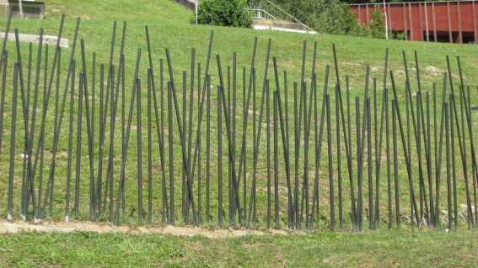
Figure 1a: Fence generated with the use of two fractional Brownian functions
Figure 1b: Terme Olimia, Kranjska Gora, designed by ENOTA, photographer Đorđe Đorđević, PhD

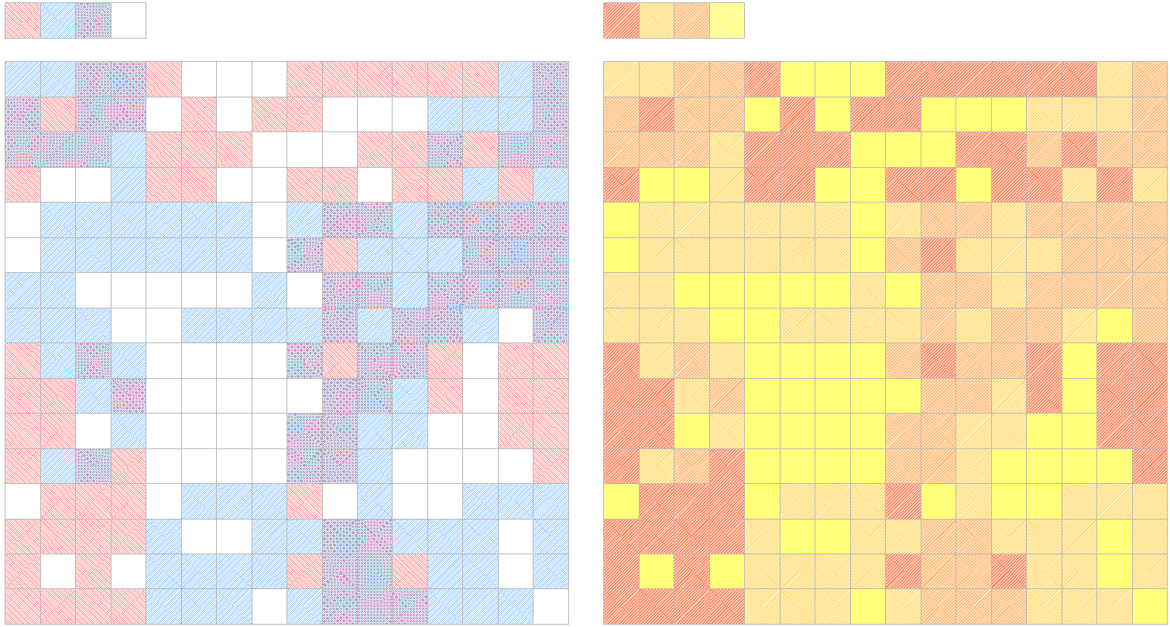 | 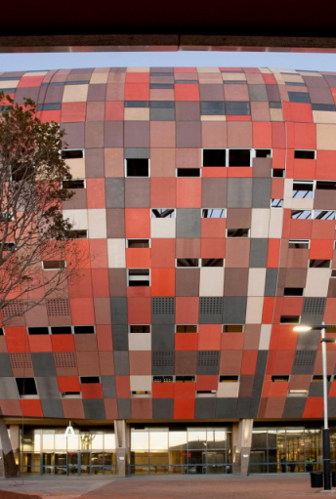
Figure 2a: Pattern for floor or wall surface generated with two random curds;
Figure 2b: Soccer City Stadium, Johannesburg, 2007-2010, Boogertman, http://www.domusweb.it

3. VISUL PROPERTIES OF FRACTAL OBJECTS

Several authors have expressed their observations about visual properties of fractal objects, all of which point out to a certain irregularity while simultaneously emphasising a direct connection between the observed visual properties and the value of their fractal dimension. For example, Saupe [10] notices that fractional Brownian functions with a higher fractal dimension oscillate more erratically [10: p.84], and that the N parameter indicates “roughness” of the function [10: p.83]. Similarly, a group of authors [11] describe a curve with a higher fractal dimension as “rougher”, underlining its higher ''point-to-point fluctuation'' [11: p.465].
More than one author classifies visual properties mentioned above under a more general definition – visual complexity. Thus, a group of authors [1] describe fractal objects (thus emphasising their difference from objects in Euclidian geometry) as objects of “immense complexity” [1: p.53]. They also say that visual impression of complexity is related to the value of the fractal dimension, and that by increasing the value of the fractal dimension, we will increase the complexity of a structure [1: p.57]. Such a direct connection has led some authors to assume that visual complexity of different visual objects can be measured, and thus compared by means of the fractal dimension. For example, Mitina and Abraham [12] represent the fractal dimension as an “objective parameter of fractal complexity” [12: p.1047], whereas Vaughan and Ostwald [13] measure and compare the ''visual complexity'' [13: стр.323] of a built and natural environment, measuring and comparing numerical values of their fractal dimensions.
The assumed connection between visual complexity of fractals and their mathematical properties is significant in this paper as one of the potential parameters in the selection of an appropriate fractal object for the determined rhythm, because visual complexity represents an important correlate in aesthetic judgement of visual objects, which has been confirmed by research in the field of psychology of perception and experimental aesthetics conducted before and after the appearance of fractal geometry.

3.1. Perception of Fractal Objects

To demonstrate the connection between mathematical properties of fractal objects and their visual appearance, the paper will review the results of experimental research in the field of psychology of perception about discrimination sensitivity and complexity judgements of fractal objects with regard to some of their mathematical properties, e.g. in terms of fractal dimension value where such a connection has been confirmed.
Research [11] [14] shows that the numerical value of the fractal dimension, which is a mathematical property of a fractal, is also reflected on the visual appearance of the fractal (specifically for examined objects, it manifests as roughness), because even differences as small as 0.2 or 0.15 in the value of the fractal dimension have been visually recognised; discrimination sensitivity for both fractal curves and fractal surfaces is highest for “medium” values, i.e. around 1.5 for curves and 2.5 for surfaces (authors explain this by the fact these values correspond to the measured value of the fractal dimension of most objects in our natural environment, hence our visual system has adapted to those particular characteristics of the environment), as well as that fractal objects with a higher fractal dimension are indeed assessed as visually more complex. Here are the values of the fractal dimension of some common objects in nature: coastlines 1.05-1.52; geothermal rocks 1.25-1.55; plants and trees 1.28-1.90; waves 1.3; clouds 1.3-1.33, etc. [15] [16]
Cutting and Garvin [17] examined whether there is a correlation between some of the mathematical properties of fractal objects (and if so, which ones) and complexity judgements. They studied fractal curves which, among other things, differed by the value of their fractal dimension and number of iterations in the generation process. Linking the value of the fractal dimension to the visual property of roughness, and then the said property to the judgements of visual complexity, the authors assumed there is a correlation between the value of the fractal dimension and the judgement of visual complexity for the observed fractal curves. Results of the experiment show that the number of iterations (recursion depth) had the greatest influence on complexity judgements, but in the case of curves with the same number of iterations, it was the fractal dimension that influenced the judgements. The authors then compared these fractal variables with the variables from literature which have been confirmed to influence complexity judgements, determining that the following two ‘old’ variables: number of sides, and the ratio between circumference and surface area of a polygon (which have often been the subject of similar research) are in high correlation with the ‘new’ fractal variables: iteration number and fractal dimension, respectively.
In the study of perception of fractal objects conducted by Mitina and Abraham [12], fractal dimension also appears as the main correlate in subjective judgement of fractal complexity, where fractals with a higher fractal dimension are perceived as more complex.

3.2. Aesthetic Judgements of Fractal Objects

There has been research in the field of psychology of perception, experimental psychology and experimental aesthetics about aesthetic judgement of fractals striving to determine if there is a correlation between aesthetic preferences and a particular property of fractals.
Describing fractals as “objects of immense complexity” (p.53), a group of authors [1] assume that people find such complexity “visually appealing” [1: p.53], given that fact we are continuously visually exposed to natural fractals, which is why we perhaps possess a spontaneous understanding and affinity toward such shapes. Studies on aesthetic judgements of fractals [15] [18] [19] [20] [21] rely on similar contemplations and their results decidedly indicate a relation between aesthetic preferences, values of the fractal dimension of observed fractals and prevalent measured values of the fractal dimension of objects found in nature.
All mentioned authors have obtained similar results, despite examining preference on different fractal objects. Objects with a low or medium value of the fractal dimension, i.e. 1.1-1.5 were the objects with the highest preferences. The authors explained these results in a similar manner, e.g. as unsurprising given that the fractal dimension of many objects in nature falls within that range [21:p.329], that fractal properties of highly-preferred objects correspond to those from our natural environment [18: p. 6], that our perception and acceptance of art are shaped by the world around us [15: p.819], that the sensitivity of our visual system is harmonised with fractal properties of natural environment, and finally, that such aesthetic preferences are a consequence of our continuous visual exposure to natural fractals [19: p.253]. At the same time, as the value of the fractal dimension directly impacts judgements of visual complexity, these results may also be interpreted as preferences toward low and medium levels of visual complexity.
4. VISUAL COMPLEXITY: OBJECTIVE AND PERCEIVED

According to mathematician Birkhoff [22], the amount of pleasure one gets from works of art depends on two variables, amount of order and amount of complexity. According to him, the relationship between these variables represents the aesthetic measure of an artwork, or aesthetic pleasure that may be derived from it. Given he studied aesthetic preferences toward polygons with regard to the amount of order and complexity in them, the author listed the following as factors that increase complexity and order: vertical symmetry, balance, point reflection, connection with horizontal-vertical directions, whereas complexity, in his opinion, equals the number of sides of a polygon. Here we could draw attention to the fact that after more than half a century, Cutting and Garvin [17] define the aforementioned property of “number of sides” as one of the variables that “influence judgements of visual complexity” [17: p.365], comparing it to – fractal dimension. Explaining his theory of aesthetic measure, Birkhoff emphasises that the relationship between order and complexity actually indicates a well-known relation of unity-in-multiplicity, where complexity is equated with multiplicity, whereas elements of order are elements that contribute to the unity of the artwork [22: p.351]. Apart from the highlighted relationship between the “number of sides” (which when applied to polygons, can be interpreted as the “number of elements”), and the number of iterations in the process of generating a fractal, this paper also draws attention to the fact that, according to Birkhoff, the presence of symmetry as an element of order increases the level or order, whereas its absence, inevitable in architectural compositions whose elements are organised using random fractals, increases complexity. This means that due to the presence or absence of symmetry (or partial symmetry), nonexact rhythms will be recognised as more complex than exact rhythms, and this is exactly how Bovill [4] characterised fractal rhythm – as a complex rhythm.
Eysenck [23] also studied aesthetic preferences with regard to elements of order on one hand, and elements of complexity on the other, using a number of different polygons for that purpose. He discovered the following correlation between preferences and geometric properties: the properties classified among elements of order by Birkhoff contributed to the high ranking of polygons, i.e. symmetry and balance, but there were also several new properties, such as repetition and compactness. The property of compactness may be equated with the P2/A variable which is also used in the studies of visual complexity, and which will later be compared with the fractal dimension by Cutting and Garvin [17]. According to Eysenck, the measure of complexity corresponds to the “number of non-parallel sides of a polygon”. So, in his opinion, the level of complexity increases with the increase in the number of elements with a different visual property.
Such definition of the term complexity applied to polygons may help us to specify the meaning of complexity in terms of rhythm in architectural and urbanistic compositions, where rhythm generated by orderly repetition of two different elements, e.g. A-B-A-B..., could be perceived as less complex than rhythm comprising three, four or more different elements, which in turn would be less complex than spontaneously formed compositions that would be the most complex by this criterion, because as Hildebrand says, such rhythm may comprise an infinite number of elements [24]. Talking about renewed popularity of old urban neighbourhoods and efforts to preserve them, due to their “accretions and variety” [24:p.102] , Hildebrand recognises aesthetic pleasure they are able to provide and describes one such neighbourhood that presents itself to the observer through its seemingly identical elements and seemingly regular intervals – doors, windows, skylights, gables, chimneys – whose innumerable, but slight variations make each unit both different from and similar to others, precisely as specimen of the same species [24:p.112]. Therefore, if repetition and symmetry (common characteristics of exact rhythms) are indeed properties classified among elements of order by different authors, we may conclude that their absence increases the impact of elements of complexity, resulting in – increased level of complexity. We could also generalise that some of the elements these authors specify as elements of order, e.g. repetition and symmetry are present in exact, deterministic rhythms in architectural and urbanistic compositions, characterised by regular orderly repetition of either one, two or groups of different elements, which is why they are less complex than random or nonexact rhythms, where the repetition of a group of elements, symmetry or subsymmetry can seldom be established due to the component of randomness, and which consequently can be treated as – complex rhythms.
In an experimental study of aesthetic judgement of visual patterns conducted by Berlyne [25], objects (patterns) were assessed by the properties that, according to the author, could fall under the terms “complexity” and “incongruity” in everyday language [25:p.274]. Several such properties were chosen and depending on their presence or absence in visual objects, all objects were divided into two basic classes: less irregular and more irregular, which according to the above mentioned factors could be substituted with: more or less complex. In other words, chosen properties are those presumed to impact the level of irregularity or complexity, and they will be listed here due to their significance in the assessment of fractal rhythm as more complex, but also because Mandelbrot [26], at the very beginning of his essay, characterised objects of fractal geometry as “irregular”. These properties are the following: “irregularity of arrangement”, “amount of material”, “heterogeneity of elements”, “incongruity”, “incongruous juxtaposition”, “number of independent units”, “asymmetry”, and “random redistribution” [25:p.274]. Presence of some of these properties places a visual object into the class of more irregular objects. It is clear that many of these properties are typical for fractal objects, and it is expected they will be transferred to the generated rhythm, so the rhythm may also be characterised by “irregular arrangement”, “heterogeneity of elements”, “asymmetry” or “random redistribution”, which is why it may be assessed as “more irregular” or “more complex” than rhythms where these determinants do not apply. Figure 4 shows several characteristic visual patterns used by Berlyne in his experiment, and two fractals that represent the subject of this paper. The three pairs of visual patterns illustrate the following properties left to right: irregularity of shape, asymmetry and irregularity of arrangement, so in all three pairs, the drawing on the right is “more irregular”. The similarity between fractal objects and the drawings on the right is obvious.

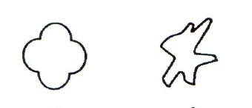  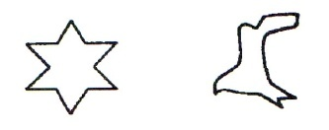 | 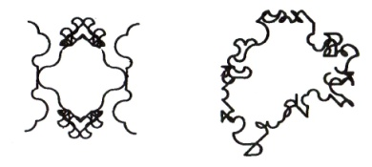  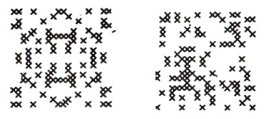 | 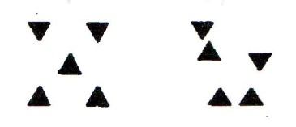  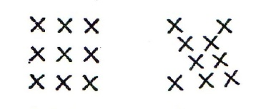  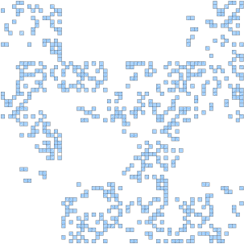
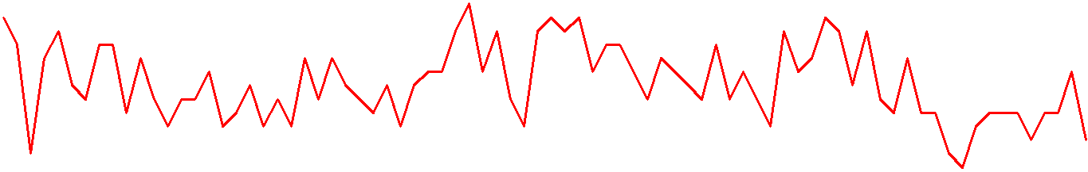
Figure 3: Similarity of random fractals and drawings characterised as ''more irregular''

Experiment results display a tendency to rank objects from the class of “more irregular” as more interesting. This outcome, where objects observed as more irregular or more complex are judged as – more interesting, is confirmed by Rasmussen’s [27] observations on “free” rhythms in architectural and urbanistic compositions which he himself described as – interesting rhythms. Furthermore, one can assume that in aesthetic judgements of rhythm in architectural and urbanistic compositions, nonexact rhythms, whether generated by an architect or created spontaneously (architecture-without-architects), through the recognition of some of these properties, such as: irregularity of arrangement, heterogeneity of elements, or asymmetry, would be assessed as – more interesting than exact rhythms.
The research mentioned above included another component of aesthetic experience for which Berlyne claims it is one of the most important and interesting issues in the analysis of aesthetic experience, the so-called “exploratory choice”. The author studied the impact of all above mentioned “complexity and incongruity variables” on “exploratory choice” [25:p.277], in other words, whether more or less irregular visual patterns are chosen more often, and for how long they are observed, both generally speaking and with regard to “initial exposure”. Based on result analysis, the author has reached the following conclusion: that at some point, the choice of more or less irregular, i.e. more or less complex visual patterns depends on the length of the previous exposure, or “satiation” with one or the other, but also on the intended length of future exposure, so as the author explains, if one should choose an object that he will have to watch for a long time hanging on the living-room wall [25:p.289], it is possible this person will be more inclined to avoid less irregular objects, such as those assessed not as more interesting, but as more pleasant in the research.
Here we will attempt to make a connection between other Rasmussen’s observations [27] and aesthetic experience in terms of visual complexity to illustrate just how complex is the question of aesthetic judgement of visual complexity in architecture and dependency of that experience on previous exposure, all of which suggests there is a right measure of complexity in a built environment, or in Bovill’s words: a ''mix of order and disorder'' [4: p.176], or a mix ''of order and surprise'' [4: p.6]. Namely, after visiting the medieval quarter of Rome for which he thought to be: as a piece of Nature that has been allowed to grow wild [27: p.129] and undisguised aesthetic pleasure in its “diversity”, Rasmussen describes contentment he experienced when he entered the Renaissance quarter as a contrast-amplified experience of “greater clarity” and order created by man in his effort to combat chaos: Man has brought order out of chaos; the hill has been tamed [27: p.129]. It is important to underline that the author here speaks primarily about an experience, an encounter with “more or less complex” that may co-exist side by side in an urban environment. Even if one fully accepts research results of the study on aesthetic preferences that speak in favour of visual stimuli of greater complexity, the above described experience of coming across the Renaissance Quirinal Street and Quirinal Palace cannot be denied or negated. When after exploring the medieval quarter of the city and perceiving its diversity and heterogeneity, regular and simple shapes, proportions and rhythms (straight lines of the street, orderly proportions of the windows and their regular arrangement along the wall) of the Renaissance quarter are experienced as visually pleasing rather than boring: Regular repetition found here is agreeable, rather than boring [27: p.130]. The author concludes by saying that in other cities, there are also buildings "whose great monotony'' provides something to compare other buildings with, it provides a ''keynote'' [27: p.130], a basic tone, which, in Rasmussen’s opinion, would be missing otherwise.
Wohlwill [28] also examines aesthetic preferences and “exploratory behaviour” in relation to visual complexity, and finds that the relation between the preferences and complexity is an ''inverted U-shaped function'' [28: p.311] that increases at first, reaching the maximum for the medium complexity level, and then decreases with further increase in complexity, whereas the ''amount of exploratory behaviour'' linearly increases with the increase in image complexity. The author points out this was expected, and explains: as the variability of elements on the visible surface is greater, there is more information to be processed [28: p.307]. The author’s explanation of the results is significant because it implicitly states his interpretation of the term – complex. Namely, Wohlwill equated greater complexity with higher variability, and the latter with a greater amount of information to be processed. Here, one could make parallels with a similar interpretation of complexity by Hildebrand [24] who, analysing the relation between order and complexity in architecture, recognises greater complexity in those places (e.g. old towns of different cities, like the medieval part of Rome Rasmussen wrote about) where “accretion and variety” are greater, which, emphasises the author, gives the mind ''more to discover'' [24:p.102]. The properties of “accretion and variety” may be associated with the properties that, in Berlyne’s opinion, increase complexity: ''amount of material'', ''number of independent units'' and ''heterogeneity of elements''. While examining the relationship between concepts mentioned by Birkhoff [22] in relation to his “aesthetic measure”, i.e. concepts of order and complexity, Hildebrand [24] claims these two concepts are not in contradiction, instead, they are allies, or more precisely, they are “necessary allies” so much so they can be semantically joined into ''ordered complexity or complex order'' [24:p.99]. According to him, disorder is the opposite of order, whereas the opposite of complexity is simplification. Hildebrand further explains that order without complexity is – monotony, and that it is monotony we feel when looking at “deadly repetition” of identical houses in an urban neighbourhood for example, which is why we need some measure of complexity in order, as a buffer against ''too-simple order'' [24:p.102]. On the other hand, continues Hildebrand, complexity without order is as unpleasant as order without complexity, which has been confirmed by preference studies in which images difficult to organise and interpret due their great complexity are always ranked very low.
We have noted another thing that explains how hard it is to find an optimal complexity level in a built environment – it cannot be viewed separately from other factors: the level of complexity that occurs in orderly repetition of identical elements, and that can be defined as the lowest level of complexity, was described by Rasmussen as ''great monotony'' [27: p.130] in one context, whereas Hildebrand in another context, characterises it as ''deadly repetition'' and ''too-simple order'' [24:p.102].
Another thing of importance here, which is related to the study conducted by Wohlwill [28], is: how to define measure of complexity, i.e. how to measure the level of complexity of visual objects? The author explains that when he was trying to define visual complexity, he relied on the concepts of other authors [29] who equated complexity with the amount of variability of certain visual attributes [28: p.307]. Wohlwill examined the level of variability of the following visual attributes for objects whose complexity he was trying to determine: colour, shape, dominant directions, textures, ''natural vs. artificial'' ratio. If higher variability of objects means greater visual complexity, and we have already encountered the same explanation of complexity in Eysenck’s work [23], then this will be relevant in determining the number of different values of an element’s visual property whose multiple repetition generates rhythm in architecture.

5. CONCLUSION

According to Graves [30], the basic relationships between elements of compositions are the following: they may be identical (repetition), similar (harmony), or totally different (discord). The difference among these three fundamental forms of relationship is one of degree of interval and the kind and number of intervals involved. [30: p.16]. He also lists different types of intervals: strong, great, or major intervals, medium intervals, and weak, small, or minor intervals, and underlines the importance of having different or unequal intervals in a composition: unequal intervals create interest through variety, whereas equal intervals are monotonous and uninteresting [30: p.36], which can be compared to previously mentioned relationships between the number of different elements, visual complexity and judgements of visual attractiveness which, as we have seen, is among major parameters in aesthetic preference studies.
The paper illustrates the dependency between visual properties of fractal objects and the value of their fractal dimension, as well as the relationship between fractal dimension and visual complexity, where objects with a higher fractal dimension are viewed as more complex. This dependency has led us to the conclusion that by using objects of fractal geometry in the design of architectural compositions, and by replicating their mathematical or geometric properties via analogical transfer, one could reproduce their visual properties which opens the possibility of managing the desired visual properties in architectural compositions, such as: more or less “erratic”, “fluctuating”, “jagged”, etc. or level of visual complexity in general through the selection of appropriate values of the fractal dimension.
In addition, when selecting an appropriate fractal as a mathematical model during rhythm generation, we can rely on research results in the field of experimental aesthetics of aesthetic preferences toward fractals with regard to the value of the fractal dimension which show that people express highest preferences toward objects whose fractal dimension is around 0.3-0.5 higher than the topological value, as well as on the results of studies on aesthetic preference toward visual complexity which show the medium level of visual complexity elicited highest preferences.

REFERENCES

[1] Taylor, R., Newell, B., Spehar, B., Clifford, C. Fractals: A resonance between art and nature. In M. Emmer (Ed.), Mathematic and Culture II. Berlin: Springer-Verlag. Part 1; 2005: 53-63.
[2] Voss, F.R. Fractals in nature: from characterization to simulation. In H.O.Peitgen, D.Saupe (Eds.), The Science of Fractal Images. New York: Springer-Verlag. 1988: 21-70.
[3] Pentland, P. A. Fractal-based description. Proceedings of the Eight international joint conference on Artificial intelligence. San Francisco: Morgan Kaufmann Publishers. Vol. 2; 1983: 973-981.
[4] Bovill, C. Fractal geometry in architecture and design. Boston: Birkhäuser. 1996.
[5] Devaney, R.L. Fractal patterns arising in chaotic dynamical systems. In H.O.Peitgen, D.Saupe (Eds.), The science of fractal images. New York: Springer-Verlag. 1988: 137-168.
[6] Feder, J. Fractals. New York: Plenum Press. 1988.
[7] Fraedrich, K., Blender, R., Zhy, X. Continuum climate variability: Long-term memory, scaling and 1/f-noise. International Journal of Modern Physics B; 23; Nos. 28 & 29; 2009: 5403-5416.
[8] Goldberger, A.L., Amaral, L.A.N., Hausdorff, J.M., Ivanov, P.Ch., Peng, C.-K., Stanley, H.E. Fractal dynamics in physiology: Alterations with disease and aging. In D.L.Turcotte & J.B.Rundle (Eds.) Proceedings of the National Academy of Sciences of the United States of America: Self-organized complexity in the physical, biological, and social sciences; Arnold and Mabel Beckman Center of the National Academies of Science and Engineering, Irvine, CA; Vol. 99, suppl.1; 2002: 2466-2472.
[9] Peitgen, H.O., Jurgens, H., Saupe, D. Chaos and Fractals: New Frontiers of Science. NY: Springer-Verlag. 2004.
[10] Saupe, D. Algorithms for random fractals. In H.O.Peitgen, D.Saupe (Eds.), The Science of Fractal Images. New York: Springer-Verlag. 1988: 71-136.
[11] Gilden, D.L., Schmuckler , M.A., Clayton, K. The perception of natural contour. Phychological Review, 100(3); 1993: 460-478.
[12] Mitina, O.V., Abraham, F.D. The use of fractals for the study of the psychology of perception. International Journal of Modern Physics C, Vol. 14, Issue 08; 2003: 1047-1060.
[13] Vaughan, J., Ostwald, M.J. Using fractal analysis to compare the characteristic complexity of nature and architecture: re-examining the evidence. Architectural Science Review. Volume 53, Number 3; 2010: 323-332.
[14] Knill, D.C., Field, D., Kersten, D. Human discrimination of fractal images. Journal of the Optical Society of America, 7 (6); 1990: 1113-1123.
[15] Spehar, B., Clifford, C., Newell, B., Taylor, R.P. Universal aesthetic of fractals. Computer & Graphic, 27; 2003: 813-820.
[16] Taylor, R. P., Spehar, B., Wise, J. A., Clifford, C. W. G., Newell, B. R., Hagerhall, C. M., Purcell, T., Martin, T. P. Perceptual and physiological responses to the visual complexity of fractal patterns. Nonlinear Dynamics, Psychology, and Life Sciences, Vol. 9, No. 1; 2005: 89-114.
[17] Cutting, J.E., Garvin, J.J. Fractal curves and complexity. Perception & Psychophysics, 42 (4); 1987: 365-370.
[18] Aks, D.J., Sprott, J.C. Quantifying aesthetic preference for chaotic patterns. Empirical Studies of the Arts, 14(1); 1996: 1-16.
[19] Hagerhall, C.M., Purcell, T., Taylor, R. Fractal dimension of landscape silhouette outlines as a predictor of landscape preference. Journal of Environmental Psychology, 24; 2004: 247-255.
[20] Richards, R. A new aesthetic for environmental awareness: Chaos theory, the beauty of nature, and our broader humanistic identity. Journal of Humanistic Psychology, Vol. 41, No. 2; 2001: 59-95.
[21] Sprott, J.C. Automatic generation of strange attractors. Computer & Graphic, Vol.17, No. 3; 1993: 325-332.
[22] Birkhoff, G. D. Aesthetic measure. Harvard: University Press. 1933.
[23] Eysenck, H.J. The empirical determination of an aesthetic formula. Psychological Review, 48(1); 1941: 83-92.
[24] Hildebrand, G. Origins of architectural pleasure. Berkeley, CA: University of California Press. 1999.
[25] Berlyne, D.E. Complexity and incongruity variables as determinants of exploratory choice and evaluative ratings. Canadian Journal of Psychology, 17(3); 1963: 274-290.
[26] Mandelbrot, B.B. The fractal geometry of nature. New York: Freeman. 1982.
[27] Rasmussen, S.E. Experiencing Architecture. MIT Press. 1959.
[28] Wohlwill, F. J. Amount of stimulus and preference as differential functions of stimulus complexity. Perception & Psychophysics, Vol. 4 (5); 1968: 307-312.
[29] Fiske, D. W., Maddi, S. R. Functions of varied experience. Oxford, England: Dorsey. 1961.
[30] Graves, E.M. The art of color and design. New York: McGraw-Hill. 1951.

