FREE STANDING CHARGING STATION FOR ELECTRIC VEHICLES
Srećko Simović¹, BSc in Electrotechnics; Tilka Sever², BA in English and Slovene
¹ ŠolskicenterKranj, SLOVENIA, srecko.simovic@sckr.si
² ŠolskicenterKranj, SLOVENIA, sever.tilka@sckr.si

Abstract: Electric mobility is a reality of the present time.The number of electric vehicles of all types is increasing from year to year. Setting up a dense network of charging stations for e-vehicles is an important prerequisite for a successful development in this area. The paper presents the conceptual design, planning and implementation of this unique charging station for e-vehicles which is located at School centre Kranj, Kidričeva 55 in Kranj. The project was a “joint venture” of secondary school students and one from high school (from electrical engineering programme) at STŠ ŠC Kranj and realized in Metron Institute, owned by Andrej Pečjak. The station is connected to low voltage grid via the main electricity cabinet at School Centre which enables charging through 22 kW socket.

Key words: electric mobility, electric vehicle, charging station for EV, Type 2

1. E-MOBILITY

It would be very difficult to imagine development in social and economic spheres of life today without mobility of an individual. The consequences of modern trends in development are increasing distances between people's homes and their work places, shopping centres, educational institutions, cultural and sports facilities. Mobility is something every person needs and wants. It is estimated that more than 70% of total mobility is done by cars. Electric mobility has become a reality as the number of vehicles is increasing every year, the availability of eletric chargers has become a standard in developed countries, and car factories are offering more and more electric and hybrid vehicles. In addition, electric mobility is being supported also by those countries which have committed themselves by different documents and strategies to actively solve the issues of encouraging e-mobility, connectivity of vehicles, development of infrastructure as well as energy production and storage.
Electric mobility is complex, fairly difficult and demanding to realize but is gaining ground nevertheless. With an adequate approach and ways of solving problems, economy, society and environment will in future be an interlacement of factors that will have a positive influence on everyday life (Leal Filho and Kotter, 2015).
Optimistic predictions show that there will have been about 20 million electric cars by 2020 worldwide. Electric motors are expected to become even more efficient, and the development of batteries will enhance the range of e-vehicles. There will be more and more charging stations which will enable smooth use of electric vehicles. Among the most advanced countries in the area of e-mobility is Estonia which is only preceded by Norway as regards the number of electric vehicles per citizen.

2. E-VEHICLES

Electric vehicles are those vehicles that are intended for driving along public roads and other public surfaces, and use an electric motor for propulsion. Electric vehicles comprise electric cars, scooters, motorcycles, bicycles, buses, trucks, ...
Electric vehicles are beneficial for countries because driving without fossil fuels reduces their dependence on imported oil and therefore such cars will bring about great changes in the environment, economic development, innovations, technological development, etc. Electric cars do not cause emissions. The prices of electric cars are expected to decrease in future because the conversions of electric cars will increase (Leitmand and Brant, 2009).
According to their propulsion system, electric vehicles are divided into:
- Battery Electric Vehicles (BEV) which only use electricity; powertrain is an electric motor. Batteries are charged from external power grid and with the energy produced by braking.
- Hybrid Electric vehicles (HEV) which can be serial hybrid vehicles which are driven by electric motor, and paralel hybrid vehicles which have an electric motor as well as an internal combustion engine. Electric batteries of hybrid vehicles are charged via alternator which is driven by an internal combustion engine, and by regeneration of the braking energy.
- Plug-in Hybrid Vehicles (PHEV) which have the same kind of powertrain as hybrid vehicles, the difference being in the battery charging where external electricity can also be used.
- Electric vehicles powered by fuel cells; powertrain is an electric motor. Batteries are charged from fuel cells and braking energy.
The number of electric vehicles in Europe presents approximately 2% of all registered vehicles with the exception of Norway where the number of all electric vehicles including hybrid is at 39% while the percentage of new electric vehicles sold per year present 31% of all vehicles sold.
»A person who decides to buy an EV is well aware of all the advantages and characteristics that such a vehicle brings, and also has a different view and mindset in general, as they are prepared to step out of comfort zone and face the upcoming challenges.« (Barbara Gril, 2018).

2.1. Electric cars in Slovenia

It is estimated that there are more than 1500 electric vehicles in Slovenia in 2019.
Passenegr cars, buses and cargo vehicles, first registration according to propulsion and fuel:
YEAR, PROPULSION TYPE AND FUEL, TYPE OF VEHICLE, MEASUREMENTS
 |  |  | Number of electric cars on 31. december 2017
2017 | Elektric drive | Passenger and special use cars | 780
2017 | Elektric drive | … passenger cars | 779
2017 | Elektric drive | … passenegrs cars up to 1399 ccm engine capacity | 778
2017 | Elektric drive | … special use cars | 1
2017 | Elektric drive | Buses | 3
2017 | Elektric drive | Cargo vehicles | 94
2017 | Elektric drive | … trucks | 91
2017 | Elektric drive | … worling motor vehicles | 3
Table 1: The number of electric vehicles in 2017 (source: Statistical Office RS)
The Republic of Slovenia offers subsidies from Eco Fund – Slovenian Public Environmental Fund to buy electric vehicles for individuals as well as legal entities. »Electric mobility is not just an environmental necessity, it is an important developmental opportunity for whole Europe, including Slovenia,« says ACS, Economic Interest Grouping Automotive Cluster of Slovenia (Delo 2013).

3. CHARGING STATIONS FOR ELECTRIC VEHICLES

»In Europe, the increasing trend of electric vehicles and infrastructure distribution is much greater than in Slovenia. Infrastructure for charging electric vehicles at home, at work place and other public areas is developing. There are various solutions because it is estimated that there will have been about 3 million electric vehicles on European roads by 2020 and the infrastructure in the region should present more than 4.1 million electric charging stations.« (Emobilnost.eu.b.l)
Charging stations can be divided according to different criteria. There are smart and ordinary charging station as regards the way of charging; there are private and public as regards the usage; and wall mounted, pole mounted and free standing charging station as regards their position. Public charging stations are located on public surfaces and car parks, and are free of use. In some cases, a user identification and registration is necessary in advance. Home charging stations are located in private garages or parking places and enable charging the vehicle at home. In case of home charging stations the charging power is limited with the installed power connection. There are two possibilities, one-phase charging up to 3.7 kW via an ordinary socket with protective contacts or a three-phase charging via an industrial socket up to 7.4 kW.
The charging time is defined first by the type of the electric vehicle and depends on the capacity of the installed batteries, their current charge status and only then on the charging station and its power connection.

3.1. Ways of charhing electric vehicles

Electric vehicle battery is usually charged directly from the grid.The standard used in Europe is »IEC 62196 Plugs, socket-outlets, vehicle couplers and vehicle inlets – Conductive charging of electric vehicles«, which defines several ways of charging.
Table 2: Ways of charging electric vehicles
Ways of charging | Type of electric current | Phase number | Plug-in connectors | Maximum current | Charging power | Converter | Charging time
Slow charging, suitable for small e-vehicles | AC (alternating current) | 1 | CEE 230 VAC | 16 A | 3,7 kW | installed in vehicle | 10 - 12 h
Slow charging, suitable for small e-vehicles | AC (alternating current) | 3 | CEE 400 VAC | 16 A | 11 kW | installed in vehicle | 10 - 12 h
Slow charging, suitable for larger e-vehicles | AC (alternating current) | 1 | Type 2 or Mennekes | 32 A | 7,4 kW | installed in vehicle | 3 - 8 h
Slow charging, suitable for larger e-vehicles | AC (alternating current) | 3 | Type 2 or Mennekes,  CEE 400 VAC | 16A/32 A | 11 kW/22 kW | installed in vehicle | 3 - 8 h
Medium fast charging | AC (alternating current) | 3 | Type 2 or Mennekes | 16 A | 11 kW | installed in vehicle | 3 h
Medium fast charging | AC (alternating current) | 3 | Type 2 or Mennekes | 32 A/63 A | 22 kW/44 kW | installed in vehicle | 1 h
Fast charging | DC (direct current) |  | CCS,  CHAdeMO,  Tesla supercharger | up to 400 A | 20 kW do 150 kW | in charging station | up to 40 min (80 %)

3.2. Plug-in connectors for charging electric vehicles

The charging stations can differ according to their plug-in connectors. Contemporary plug-in connectors (sockets and plugs) contain data and regulation contacts, and differ according to the number of phases (1 or 3) as well as charhing current, alternating (AC) or direct (DC). Data and regulation lines enable the necessary connection for communication with the vehicle. It also allows locking of the cable to prevent theft or unwanted unplugging and disruption of charging.
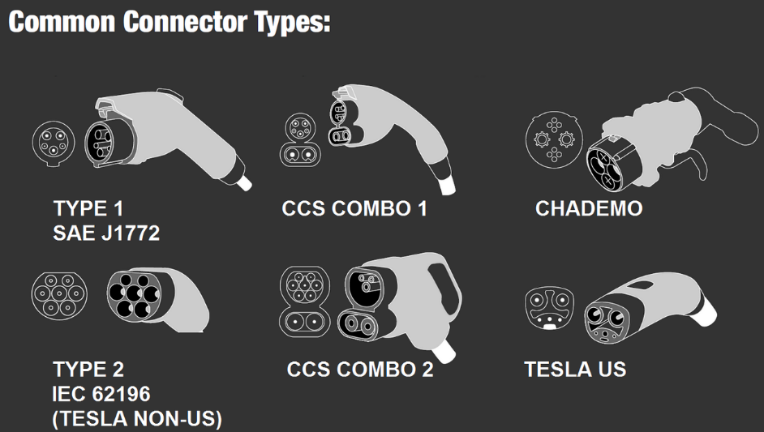

Picture 1: Plug-in connectors for EV at charging station (Photo: [6])

The types of plug-in handles (plugs) for connection with the charging station: a plug with protective contacts CEE 230 VAC, industrial plugs CEE 230 VAC and CEE 400 VAC, E-mobile plug for alternating one-phase connection Type 1 or Yazaki (SAE JI772-2009), E-mobile plug for alternating three-phase connection Type 2 or Mennekes (IEC 62196-2), combined socket called Combo 2, which integrates one-phase and three-phase alternating connection as well as direct current connection in one device on the side of the vehicle (IEC 62196-3). Type 2 is standardized charging system for EU. The direct current plug called CHAdeMO type 3, a combined socket called Combo 2 has one-phase and three-phase alternating current connection and direct current connection in one device on the side of the vehicle (IEC 62196-3).

3.3. Web browsers for charging stations

Applications for browsing for already existing charging station for electric vehicles on certain location in individual countries or wider are very practical and useful for owners of electric vehicles. Some web sites: Plugshare: https://www.plugshare.com/, GoElectric: https://www.goelectricstations.com/, E Tankstellen: https://e-tankstellen-finder.com/at/de/elektrotankstellen and in Slovenia: www.polni.si, https://www.gremonaelektriko.si/

4. CHARGING STATION FOR ELECTRIC VEHICLES AT ŠC KRANJ

As part of E-POL project called ''The development and realization of charging stations for electric vehicles intended for education purposes for secondary school students'' a unique charging station for electric vehicles was placed near the main entrance to school building at Kidričeva 55, Kranj in December 2018. The project was coordinated by Alpe Adria Green organization and the participating members were: METRON Institute owned by Andrej Pečjak, ŠC Kranj, ŠC Škofja Loka and SPSŠB Ljubljana. The project was financed by Eco Fund RS. The students of STŠ ŠC Kranj went on a three-day workshop in METRON Institute under the mentorship of a high school student from VSŠ ŠC Kranj from electrical engineering programme.
The basic idea was to design and build a unique free standing charging station with numerous charging sockets and additional equipment, USB ports for charging IT devices such as mobile phones, laptops, etc. The design, preparation and the body of the charging pole were made in METRON Institute.
The metal body of the free standing charging pole was made, and the necessary components and electronic parts were selected according to pre-prepared design. The students of Secondary Technical School (STŠ) ŠC Kranj installed the selected equipment and wiring in the METRON workshop under the mentorship of a high school student of electrical engineering from VSŠ ŠC Kranj.The charging station is equipped with a three-phase socket Type 2 – Mennekes 22 kW (3x32 A), a three-phase socket type 2 – Mennekes 11 kW (3x16 A) and two ordinary sockets with protective contacts 3.7 kW (16 A). The connected load of each connection on the charging station is calculated using these equations:

One-phase connection 16 A (a socket with protective contacts)
(1)
Three-phase connection 3 x 16 A (Type 2)
(2)
Three-phase connection 3 x 32 A (Type 2)
(3)

The charging station also enables mobile phone charging as it is equipped with 4 USB ports which are connected with a lithium-ion accumulator in case of a power failure. The cells in the accumulator battery are connected according to a preset design. It is charged from a low voltage grid or a smaller photovoltaic panel PERIGHT Solar Module type PLM-010M-36 which is set on the top of the charging pole. E-station is eqipped with an LCD monitor which enables certain information and marketing screening. The performance testing of the installed equipment was executed in METRON Institute.
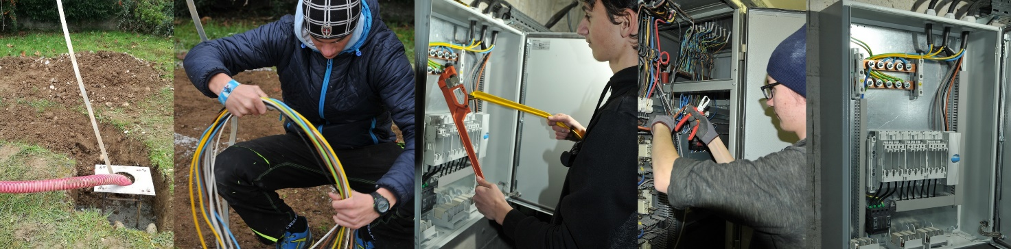
Picture 2: Preparation for setting up and connection of the charging station to power grid (Photo: S. Simović)

There is also a UTP cable in the charging pole which enables connection to the school network. In this way it is possible to communicate remotely to execute some interventions on the station such as power switch on or off. The connection of different elements and wiring as well as location are shown on Picture 3.
The charging station is connected to public low voltage power grid in the main power connection of ŠC Kranj. The preparatory work included defining a new route for the connecting cables and making a subdivision electricity cabinet with main fuses and on-off switch. In addition, some digging had to be done in the external part of the route up to the concrete base of the charging pole to lay the protective pipes for the cables. The cabinet was made by the students of 3.Ee from STŠ ŠC Kranj who also laid the cable and connected it with the charging station. The concrete base was made by the students of building trade programme SESGŠ ŠC Kranj. Picture 2 show the preparatory works, laying the connective cable and setting up the electricity cabinet.
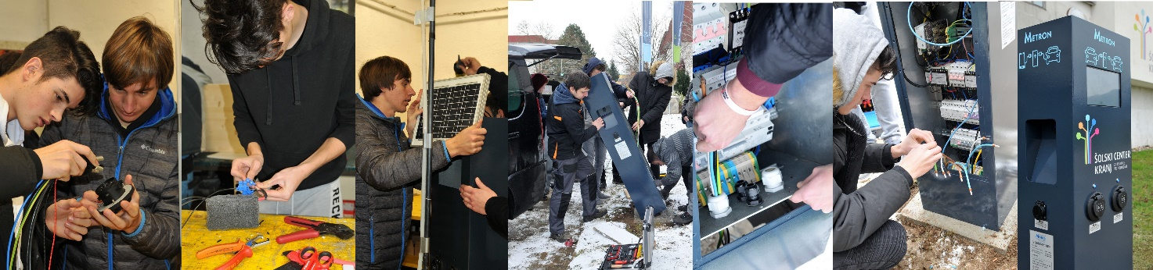
The connective cable consists of two earth cables Cu NYY-J 5x10 mm2. The charging station has an in-built differential protection RCD Iskra NFI4BK 40/0.03 for each socket separately. The charging station was connected to the connective cable and then the necessary measurements and performance test were performed before the final connection to the public low voltage grid.
Picture 3: Equipment installation and charging station set up (Photo: S. Simović)

The use of the charging station is freely available and charging is, for now, free of charge.
The parking places and the whole area around the station is under video surveillance.

5. CONCLUSION

»Electric car is in this way a prerequisite for an ideal means of transport in Slovenia because its current range already meets the needs of everyday transport in Slovenian environment. At the same time Slovenia can, because of its small size and as a transit country, become »a model example of overall sustainable mobility« by implementation of electric car and a perfect infrastructure, said one of the interviewees in our survey.« (Barbara Gril, 2018)
The unique model of charging station, developed in the project, with two charging sockets (Type 2 –Mennekes) for slow and medium fast charging of electric cars, offers a possibility of mass production and set up of numerous such charging poles with the same or modified characteristics.
The production of electric cars is increasing significantly all the time. We can claim with certainty that electric cars are a reality of modern mobility.
The network of charging stations presents an important factor in the development of electric mobility. The development, production and set up of charging stations as well as the density of charging infrastructure makes an accelerated development of modern mobility possible. These issues are especially pressing in city centres because of the need for reduced emissions, and in tourist resorts where the concepts of ecology and carbon-free society are well-known and a lot of resources are invested in the preservation of green nature.

BIBLIOGRAPHY

[1] Filho Leal, Walter in Kotter, Richard. E-Mobility in Europe. Springer International Publishing Switzerland, 2015
[2] Leitman, Seth in Bob Brant. Build your own electic vehicle. The McGraw-Hill Companies, Inc. 2009
http://ev-bg.com/wordpress1/wp-content/uploads/2011/08/build_your_own_electric_vehicle.pdf
[3] Gril, Barbara. »Zanimanje za nakup električnega avtomobila v Sloveniji.« Magistrska naloga., Fakulteta za uporabne družbene študije v Novi Gorici, 2018.
[4] Statistični urad RS. Osebni avtomobili, avtobusi in tovorna vozila ter prve registracije teh vozil glede na pogon in gorivo, Slovenija, letno, Dostopno 28. 3. 2019 na https://pxweb.stat.si/pxweb/Dialog/varval.asp?ma=2222109S&ti=&path=../Database/Ekonomsko/22_transport/08_22221_reg_cestna_vozila/&lang=2
[5] Emobilnost.eu. b.l.. Dostopno 23. 9. 2018 na http://emobilnost.studiotandem.si/?page_id=177
[6] Priključki za električna vozila, Dostopno 28. 3. 2019 na https://www.quora.com/Will-the-new-VW-electric-cars-use-the-same-plug-charger-as-Tesla

