PELLET PRODUCTION TECHNOLOGY IMPACTS ON WORKING AND LIVING ENVIRONMENT

Nataša Ćirović, PhD, Vesna Marjanović, PhD, Olivera Marić, MB, Bojana Špijunović, MB
College of applied sciences Užice in Užice, SERBIA, natasa.cirovic@vpts.edu.rs

Резиме: Дрвни пелет је био био-гориво израђено од компресованог и високо калоричног дрвета.Сировине из којих се добија су природног порекла. У дрвну пиљевину се не додају хемијска везивна средстава. Топлотна моћ пелета износи 5 kWh/kg или 18 МЈ/kg. Имају врло низак садржај влаге (испод 10%) што омогућава врло високу ефикасност сагоревања. Користи се у пећима за грејање стамбених објеката или као замена за угаљ у производњи електричне енергије. Грејање на дрвни пелет је у последњих неколико година постало популарно у свету и код нас, првенствено због еколошких и финансијских предности. Најбитнији елеменат је економска исплативост добијања топлотне енергије произведене од пелета, који је неколико пута јефтинији у односу на оне који се добијају из фосилних горива. Сагоревање дрвних пелета потпомогнуто је са вентилатором који снабдева сталан доток ваздуха до пећи, што доприноси мањој производњи дима и готово, да уопште, нема производње креозота, главног узрочника пожара у пећима и каминима. Модерна производња и прописани стандарди квалитета доприносе да пелет има уједначену горивост и константну енергију.
Кључне речи: пелет, технолошки поступак производње пелета, утицај производње пелета на радну и животну средину

Abstract: Wood pellets are bio-fuel made of compressed аnд high-calorie wood. It is obtained from the natural origin raw materials. No chemical binders are added to the wood sawdust. The heat power of pellets is 5 kWh / kg or 18 MJ / kg. It has very low humidity content (below 10%) which allows very high combustion efficiency. It is used in furnaces for heating residential buildings or as a substitute for coal in electricity generation. Wood pellets heating has become popular in the world and in our country for the last few years, primarily because of the ecological and financial advantages. The most important element is the economic profitability of pellet produced thermal energy, which is several times cheaper than those derived from fossil fuels. Combustion of wood pellets is supported by a ventilator that supplies steady airflow to the furnace, which contributes to less smoke production and almost no production of creosote, which is the main cause of fire in stoves and fireplaces. Pellets do not contain substances that are toxic to the working and living environment. Modern production and prescribed quality standards contribute to the pellet's balanced fuel and constant energy.
Keywords: pellet, technological process of pellet production, working and living environment

1. INTRODUCTION

Pellet is a product exclusively obtained by pressing under high pressure sawdust and turbidity of dry caloric wood without the addition of any binder, with very low humidity content (8%), which allows very high combustion efficiency. It is made of oak, beech, ash, hornbeam, heaters, limes, etc. Cylindric form of high-quality and very calorific fuel produces only 1% of ash during combustion. Due to shape and size, it is easily transported. During transport pellet compactness is the most visible because of about 0.5% of wood dust occurs.
They are used for the heating of residential buildings or as a substitute for coal in the production of electricity.
The use of heating pellets is considerably more cost-effective compared to other fuels or the use of heating energy. The heat power of pellets is 5 kWh/kg or 18 MJ/kg. The amount of heat produced by combustion of 1t of pellet corresponds to the heat released by combustion of 500 liters of fuel oil, or 450kg of propane-butane gas, or 600m³ of natural gas, or 4 800kW of electricity is spent to obtain the equivalent amount of heat.
In addition, pellets are also environmentally-friendly raw materials. Combustion of pellets produces the same amount of CO₂ as the tree used for growing. Therefore, the pellet is a neutral CO₂ carrier. During the production, preparation and transport of pellets, a negligible amount of CO₂ is generated. Compared to other fuels, in combustion there is significantly less emissions of harmful gases like carbon dioxide and sulfur dioxide.
The paper analyzes the impact of the pellet production technological process on the quality of working and living environment conditions, as well as on pollution of the environment, in a plant with a capacity of maximum 0,4 t of pellets/h (corresponding to 2-3t pellets/day or 700-800t of pellets/year).

2. TECHNOLOGIAL PROCESS OF PELLET PRODUCTION

Schematic diagram of the technological process of pellet production plant is shown in Figure 1.

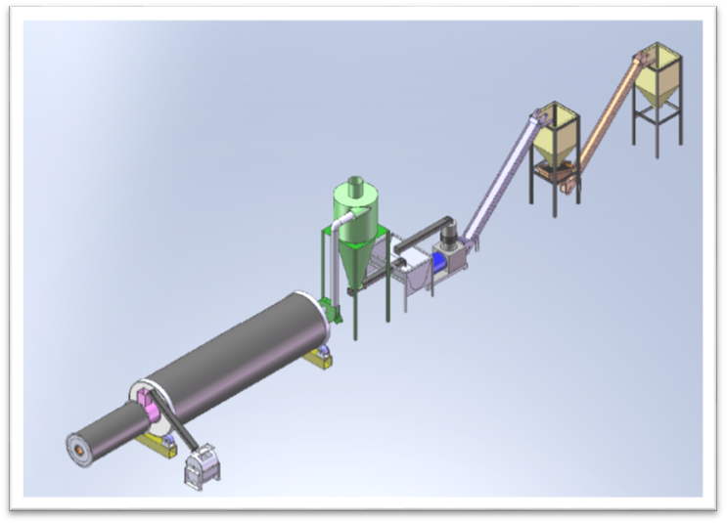
1.
2.
3.
4.
5.
6.
7.
Figure 1. Schematic diagram of the plant:

1. heat supply - boiler
2. drum dryers
3. ventilator
4. Silo for dry sawdust
5. Pellet press
6. Pellet cooler
7. pellet packer

The production hall is the dominant production part in which a technological line with complete equipment for pressing and cutting of ground raw materials and packaging is organized.

I PHASE – Entrance and crushing humid wood

The raw material for the production of wood pellets consists of:
• Firewood and cellulose wood,
• Wood chips, prepared in forests from branches, bark and other forest tree residues and
• Wooden scrap residues (sawdust, large pieces of wood ...).

Figure 2. shows the raw materials preparation (by loader or by hand) for the pellet production process.
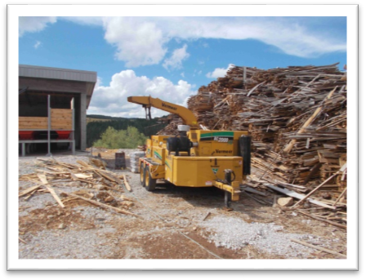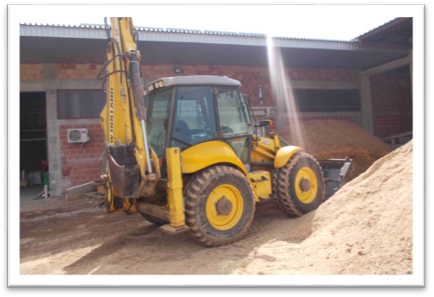
Figure 2. The raw materials preparation

The raw material is homogenized and prepared for the production process by crushing. The prepared, self-contained raw material is transported through the drum dryer.

II PHASE - Drying of a crushed humid spall

In this phase the most important information is the amount of raw material as well as humidity. Drying of the raw material in the drum is carried out by extending the warm air, temperature up to 70°C, Figure 3. The control of the raw material holding time in the dryer is done automatically. The display of the wet spall drying phase is given in Figure 1., (parts 1 and 2). The dust emission from the drum dryer is minimal. The emission research shows that its value is lower than the permissible values under the air protection regulations.

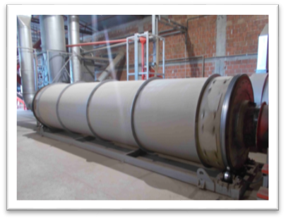
Figure 3. Drum dryers in the pellet production

III PHASE – Pressing and interception

The third phase of the pellet production technological process is located in the production hall. At the beginning of this phase, dry pelleting spall preparation is carried out.
After passes through the drum dryer, the raw material goes to cyclone to separate non-quality pieces and dust, Fig. 4. The warm air containing the finely dispersed particles is vacuumed by the ventilator through the pipeline, passing through the cyclone in which the aspiration of the drive is performed. The main objective is that dust emissions, which are actually fine particles of wood, are minimal and below the permissible requirements of air protection both in the working and living environment.

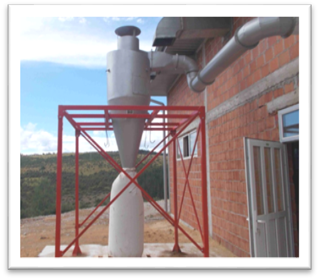
Figure 4. Cyclone for dusting

The prepared raw material (sawdust) is transported through the saw bin, Fig. 5. Then, the material enters the press, where it passes under high pressure through the matrix of the pellet presses. The process of pressing takes place by cutting sawdust with high temperature rollers, which causes the lignin to be heated and released as a natural adhesive and connects the sawdust to the resulting pellet. At the press, the pellet is cut to the desired length using the built-in knife, Fig. 6. After leaving the press, the pieces pass through the elevator - the conveyor to the saw bin.
The compact mass of high density is obtained by grinding and pressing the raw material and/or the starting material. This process produces a material of high thermal power.
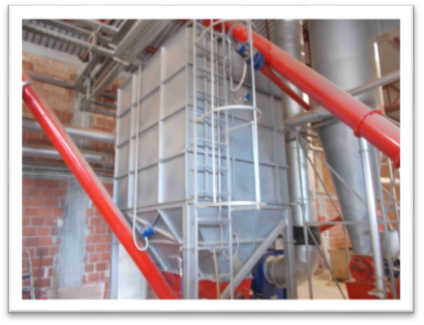Figure 5. Saw bin | 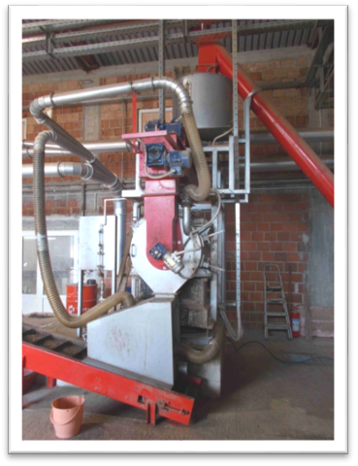  Figure 6. Pellet production press

Cooling of warm pellets is carried out by extruding cold air through the contents of the bin, which reduces the temperature of the pellet, Fig. 7. The retention time of pellets in the cooling bin is determined by achieving optimal pellet temperature.

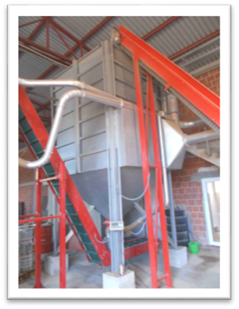
Figure 7. Pellet cooling bin

Vibrosite is placed at the bottom of the bin. Site perforations directly affect the desired granulation of the pellets.

IV PHASE - Packaging and dispatch of wood pellets

The pellet packaging line is in the same production hall as the pelleting line.
High quality pellets are sent to the packaging by a belt conveyor, Fig. 8.
Commercial packages are formed from PVC foil on a pellet packer and transport to the worker, who makes row-shaped stacking and forms a pallet. The formed pallet, further, is hand-wrapped with stretch foil, Figure 9.
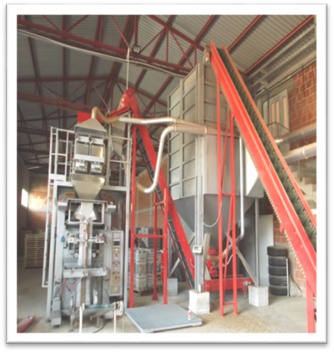  Figure 8. Pellet packaging | 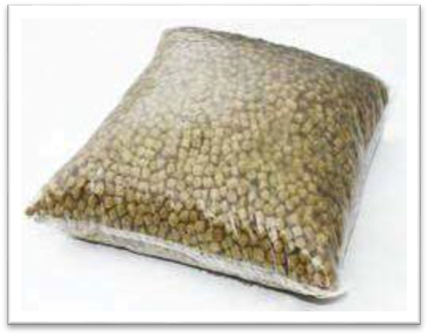  Figure 9. Commercial pellet packages

3. PRODUCTION TECHNOLOGY IMPACT AND THE DESCRIPTION OF MEASURES FOR PREVENTION, REDUCTION AND DISPOSAL OF SIGNIFICANT DAMAGE TO WORKING AND LIVING ENVIRONMENT

Potential pollutants during the technological process of production are municipal waste, sanitary-faecal wastewater and atmospheric wastewater, as well as emissions of air pollutants. Adequate measures of protection of working and living environment, infrastructure design, communal hygiene prevent the negative impacts of these pollutants on the working and living environment.

Possible changes and impacts on the working environment and its threats from the observed production should be considered from several aspects:

1. Impacts during the regular operation of the observed production and

2. Impacts in emergency situations - accidents.

3.1 Impact on air quality

Due to regular work, there are potentially several sources of air pollution that can impact living environment at the production location. It acts in different time intervals, different degrees of probability and different intensity.

Possible air pollutants in regular production operation come from:

• emissions of gas pollutants (products of combustion of petroleum products in internal combustion engines) from delivery and dispatch vehicles,

• wood dust emissions and

• emissions of fuel combustion products (wood pellets and waste wood) from dryers.

Due to low concentration of vehicles on the location every day, the emission of combustion products from internal combustion engines does not represent sources of air pollution, which can threaten the air in the observed area by emitting pollutants above the permitted limit values.

During the milling of the wood mass wood dust is emitted. Negative impacts on the working and living environment are minimized by placing adequate filters and dusting systems.

In the drying process of the wet spall in the dryer, which uses wood pellets and other wood waste as a fuel, there is an emission of combustion products. The minimum emission of dust is provided by applying a cyclone separator to the exit from the dryer.

3.2 Air protection measures

1. Technically correct and maintained air purifiers have been installed on dryers.

2. The maintenance and cleaning of the system for waste air purification is regularly carried out in the process of heating and drying wood chips.

3. In order to minimize dust emissions in the air from working and manipulative surfaces, which is created by performing traffic activities and in the occurrence of air flow (winds), dry cleaning and wetting of the plateau and roads are regularly performed.

4. The arrangement of free surfaces at the observed location is carried out by green areas formation and the middle and high autochthonous green plants planting along the border of the location. The green belt represents the protection zone from dust particles from traffic-manipulative and working surfaces.

5. The accredited laboratory performs air quality testing (measuring the concentration of suspended solids, SO, SO₂, hydrocarbons, nitrogen oxides, sulfur oxides) in accordance with the Regulation on limit values ​​of emissions of pollutants in the air from stationary pollutants, except combustion plants ("Sl. Glasnik RS", br. 111/15) and the Regulation on measuring emissions of pollutants into the air from stationary sources of pollution ("Sl. Glasnik RS", br. 5/16).

3.3 Impact on soil and water quality

During the regular operation of the production, there is no technological wastewater generation, so the negative impacts on soil and water are significantly reduced. During the operation, sanitary - faecal and atmospheric wastewaters are collected and taken out by sewerage network into a watertight septic tank, whose maintenance is in line with the regulative.

Atmospheric waters from manipulative plates, roads and equipment can contain precipitated and oily substances, in a small concentration, so that they can not lead to contamination of soil, surface and groundwater.

The land as a living environment and non-renewable (hard-to-renew) natural resource also impacts the generation of solid waste that comes from the regular operation and exploitation of the production.

Municipal waste occurs in the complex as a consequence of employees' stay. Containers with a lid were placed due to disposal of municipal waste in the complex. The collection of municipal waste was organized through the competent utility company according to the established dynamics. All types of waste are treated in accordance with the Law on waste management ("Sl. Glasnik RS" br. 36/09, 88/10, 14/16 and 95/18 - other law) and the Law on packaging and packaging waste ( "Sl. Glasnik RS" br. 36/09).

Recyclable waste is collected and transferred to the registered operator in accordance with the Ordinance on conditions and manner of collection, transport, storage and treatment of waste used as secondary raw material or for obtaining energy ("Sl. Glasnik RS", br. 98/10).

Waste of hazardous substances, which occur occasionally at the location (waste oils and lubricants, packaging waste from oil and lubricants), are kept and treated in accordance with the Regulations on the manner of storage, packaging and labeling of hazardous waste ("Sl. Glasnik RS", br. 92 / 10) until handing over to an authorized company for further treatment.

3.4 Measures for environmental protection against negative impacts on surface, groundwater and soil

1. The regular operation of the wood pellet production facility must be carried out in accordance with the project documentation.

2. Working with the means of work is entrusted solely to trained qualified workers.

3. In case of accidental spillage (accidental leakage due to engine failure) of the propellant (petroleum products), immediately suspend the work and clean the layer of soil contaminated with petroleum products. Generated waste disposal is carried out in accordance with the provisions of the Ordinance on the manner of storage, packaging and labeling of hazardous waste ("Sl. Glasnik RS", br. 92/10).

4. Municipal waste shall be collected in the intended containers set by the public utility company.

5. At the location and in the environment, it is not allowed to burn any category of waste that occurs in the normal operation, except for the needs of the technological process in the controlled procedure.

During the production of wood pellets, technological wastewater does not arise, since water is not used for technological purposes. However, within the complex, waste water is generated by the spill of atmospheric waters from manipulative and traffic surfaces. In accordance with the Law on waters, it is necessary to regularly monitoring the quality of atmospheric wastewater when leaving the complex.

3.5 Noise as a potential factor for thratening the working and living environment

The most important sources of noise in the production process are equipment for operation (technological milling plant with mill hammer, ventilator in the system of dust, elevators and conveyor belts, engaged machinery).

Possible significant negative environmental impacts may arise only in the event of an accident on location.

Due to the distance of residential buildings and the fact that most of the production process takes place in a closed building, there is no negative impact on the environment and the need for noise testing is not imposed. If, for justified reasons, the population living in the closest houses has objections to plant operation and increased noise, noise levels must be measured in accordance with the provisions of the Ordinance on noise measurement methods, the content and scope of the noise measurement report („Сл. гласник РС” бр. 72/10).

3.6 Measures of prevention of the accident situations and measures of response to the accident

1. Protection of objects and installations from atmospheric discharge is planned.

2. Regular inspection of installations of the approved equipment and means of work during regular work is carried out.

3. In order to reduce the consequences of any possible fire within the preventive protection measures remove all inflammable material from the complex

4. Within the observed complex, burning of waste and other fuel materials is not allowed.

5. In case of accidental spillage (accidental leakage due to engine failure) of the propellant (petroleum products), immediately suspend the work and clean the layer of soil contaminated with petroleum products. Generated waste disposal is carried out in accordance with the provisions of the Ordinance on the manner of storage, packaging and labeling of hazardous waste. ("Sl. Glasnik RS", br. 92/10).

6. Firefighting equipment daily to inspect. The equipment must be ready for action.

7. According to the provisions of the Fire protection act ("Sl. Glasnik RS", br. 67/93; 48/94, 111/09, 20/15), the Law on explosive substances, flammable liquids and gases ("Sl. Glasnik RS", br. 44/77, 45/85, 18/89, 53/93, 67/93 and 48/94) and prescribed conditions of the competent department of the firefighting police, obtain the approval of the competent body of the Ministry of interior to the Fire protection plan, carry out prescribed fire protection measures.

8. Check the hydrant network and firefighting equipment.

9. Highlight the prescribed warnings and tables in accordance with fire protection conditions (prohibition of introducing open flames, smoking ban etc.) in the complex.

10. Employees in the production process must have the appropriate qualifications, work permits and must be trained to work in the production. The obligation is to respect the working and technological discipline as well as the application of protective equipment in accordance with the provisions of occupational safety and health.

11. In order to fire protect on location, install fire brigade equipment and hydrant network according to the fire conditions and the consent of Ministry of internal affairs of the Republic of Serbia.

12. Protect the employees in accordance with the legal regulations, using means and equipment for personal protection at work, with training, education and vocational training.

4. LIVING ENVIRONMENT MONITORING

There is another mechanism of prevention and protection of the working and living environment - monitoring, ie. periodic testing of working environment conditions, which is carried out every three years, in winter and summer conditions of work, at the full capacity of the technological plant.
Environmental impact monitoring must be carried out by the bearer of the production, respecting the applicable legal regulations.
Report on the examined working environment conditions are kept in the records of the employer. Including this report, risk assessment was carried out and proposed measures for risk reduction.

5. OCCUPATIONAL SAFETY AND HEALTH OF WORK EMPLOYEES ON THE PELLET PRODUCTION LINE

5.1 Hazards and harmfulness at the workplace

Hazards in the pellet production line:

1. mechanical hazards, occurring by using equipment for work, such as:

- insufficient safety due to rotating or moving parts,

- the free movement of parts or materials that may cause injury to an employee,

- internal transport and movement of work machines or vehicles, as well as movement of certain equipment for work;

2. Hazards including the characteristics of the workplace, such as:

- dangerous surfaces (floors and all types of treads, surfaces with which the employee comes in contact with sharp edges - edges, spikes, rough surfaces, convex parts, etc.),

- wet or slippery surfaces,

- possible consequences or disruptions due to the obligatory use of personal protective equipment or equipment for personal protection at work,

- other hazards including the characteristics of the workplace and the way of work (use of personal protective equipment and personal protective equipment that burdens the employee, etc.) and

3. Hazards including electricity, such as:

- hazarad of direct contact with parts of electrical installation and equipment under voltage,

- hazard of thermal effects developed by electrical equipment and installations (overheating, fire, explosion, electric arc or sparking, etc.),

- hazards due to lightning strikes and consequences of atmospheric discharge.

Harmfulness in the pellet production line:

1. harmfulness occurs in work process, such as:
- chemical harmfulness, dust and fumes (inhalation, choking, entering the body, penetration into the body through the skin, burns, poisoning, etc.),
- physical harmfulness (noise and vibration),
- harmful impact of microclimate (high or low temperature, humidity and air flow rate),
- harmful climate impacts (outdoor work);
2. harmfulness arising from the psychic and psychophysiological efforts which are related to the workplace and the work of the employee, such as:
- effort or physical strain (manual transmission of the load, pushing or pulling the load, various long-term increased physical activities, etc.),
- the non-physiological position of the body (long standing, sitting, squatting, kneeling, etc.)
- efforts to carry out certain tasks that cause psychological burdens (stress, monotony, etc.) and
3. harmfulness related to the organization of work, such as: work longer than full time (overtime), shift work, part-time work, work at night, preparedness for intervention cases, etc.

5.2 Measures which is carrying out due to occupational safety and health work

Maintenance of all manipulative and working surfaces in a regular, dry and passable condition, safe for free manipulation of employees. The workplace must not have recesses and damage on the floor.

The workplace must be well lit.

Set warning signs on surfaces that are slippery and wet.

Pay attention to all spilled matter and slippery surfaces and repaired it as soon as possible.

Еnsure the correct operation of the machine, and above all the safe operation of the machine, it is necessary to maintain the machine during use.

Before starting work, make sure that the machine is in the proper condition and that all safety devices are ready for use.
- Maintenance machine is necessary due to properly work.

Never start any repair, cleaning, or adjustment of the machine while the machine is used.
- Clean the machine, the area around it and pay attention to the storage of the work items before and after the operation.
- Maintenance, repair and replacement of electrical equipment must be carried out only by a person who is professionally qualified for the performance of these tasks.
- Any person involved in the maintenance and cleaning of the machine must read the manufacturer's instructions.
- Any changes or modifications to the machine that endanger the safety and security of users are not allowed.
- The complete technical documentation should be kept in the immediate vicinity of the machine.
- Perform all maintenance tasks in a voltage-free state.
- Do not change, do not move and do not unscrew any parts that are designed for safety.
- Electrical repairs must be carried out by professionally trained personnel.
- Any defect in machine failure can only be carried out by a trained maintenance person.
- The machine must be handled by trained personnel and the machine must be used only for the purposes for which it is intended.
- Rotating parts of the machine and moving parts are protected by suitable devices.
- During work on the machine, the worker must maintain the concentration.
- Electrical installations must be designed and placed in such a way that they do not pose a risk of fire or explosion.
- Do not use electrical equipment with wet or damp hands, or in wet clothing.
- Electrical equipment under voltage must be fully protected.
- Get enough fire fighting appliances; Install the PP appliances on the appropriate wall mount at a height of about 1.5 m from the floor. Aparate service every 6 months.
- Smoking, use of open flames and glowing objects at places where storage of wood and similar materials is carried out
- Reduce the noise level by: correct tool selection, good sharpening of the tool, correct fixing of the workpiece.
- Always use appropriate personal protective equipment.

CONCLUSION

The pellet production technology which applied appropriate measures for the emission of potential pollutants into the working and livingenvironment, and which do not require large investments, are environmentally acceptable and have no adverse impactt on the working and living environment. The hazards and harmfulness the employees are exposed during the work, which can have harmful effects on their health, can be easily eliminated by applying simple measures in the field of occupational safety and health at work.

LITERATURE

- Valter Francescato, Eliseo Antonini – AIEL Italian Agriforestry Energy Association (Талијанско удружење за енергију из агрошумарства) – www.aiel.cia.it Luca Zuccoli Bergomi – Odjel TeSAF (Одјел за земљишта и агрономске и шумарске суставе), Свеучилиште у Падови – www.tesaf.unipd.it - ПРИРУЧНИК О ГОРИВИМА ИЗ ДРВНЕ БИОМАСЕ - Регионална енергетска агенција Сјеверозападне Хрватске Загреб, Хрватска (2008.)
- Study on impact assessment for pellet plant
- Law on Environmental Protection (Сл.гласник РС 135/2004, 36/2009, 36/2009,72/200 и 43/2011, УС, 14/16)
- Law on waters (Сл.гласник РС 30/10 и 93/12),
- Law on air protection (Сл.гласник РС бр. 36/2009, 10/2013),
- Fire protection act ("Sl. Glasnik RS", br. 67/93; 48/94, 111/09, 20/15);
- Law on explosive substances, flammable liquids and gases ("Sl. Glasnik RS", br. 44/77, 45/85, 18/89, 53/93, 67/93, 48/94)
- Law on Emergencies (Сл.гласник РС бр.111/09),
- Law on waste management (Сл.гласник РС бр.36/09, 88/2010 и 14/16),
- Law on packaging and packaging waste ( "Sl. Glasnik RS" br. 36/09),
- Ordinance on noise measurement methods, the content and scope of the noise measurement report („Сл. гласник РС” бр. 72/10)
- Regulation on limit values ​​of emissions of pollutants in the air from stationary pollutants, except combustion plants ("Sl. Glasnik RS", br. 111/15);
- Regulation on measuring emissions of pollutants into the air from stationary sources of pollution ("Sl. Glasnik RS", br. 5/16);
- Regulation on monitoring conditions and air quality requirements (Сл.гласник РС, број 11/2010, 75/2010, 63/2013),
- Ordinance on the manner of storage, packaging and labeling of hazardous waste. ("Sl. Glasnik RS", br. 92/10),
- Ordinance on conditions and manner of collection, transport, storage and treatment of waste used as secondary raw material or for obtaining energy ("Sl. Glasnik RS", br. 98/10),
- Regulation on the manner and procedure for risk assessment at the workplace and in the working environment ("Сл. гласник РС", бр. 72/2006, 84/2006, 30/2010 и 102/2015)

