MEASURING OF WORKING ENVIRONMENT CONDITIONS IN COLLEGE OF APPLIED SCIENCES UŽICE

Nataša Ćirović, PhD; Nenad Milutinović, MSc; Dragoslav Arsović
College of Applied Sciences Užice, 34 St. Sava’s Square, Užice, SERBIA

Abstract: The employer is obliged to provide a healthy and safe workplace for the employees. According to the Regulation on preventive measures for safe and healthy work in the workplace ("Off. Gazette of RS", no. 21/2009 and 1/2019), depending on the work and the physical load of employees, the workplace needs appropriate temperature, humidity and air flow.
If all the positive effects of well-defined microclimate ambient were taken into account and brought into conjunction with work productivity, it would be seen that in this case the influence of microclimate conditions, as a conceptual solution of the working environment protection system, is just another in a series of primary factors affecting efficiency of production/work process.
In closed working rooms, the microclimate is adjusted in order to create optimal working conditions. Generation of these conditions depends on the latitude, the altitude and the season. For certain geographical areas, heating of rooms is necessary, while other areas needs protection measures.

Key words: measuring of working environment conditions, microclimate, temperature, relative air humidity, air flow rate, illumination

1. INTRODUCTION

The working environment is one of the basic types of environment, together with the rural environment and urbanized and industrialized environment. The working environment, together with social relations and settlements, is one of the most important elements of man's social environment. In contemporary conditions of accelerated global industrialization, the working environment becomes the most vulnerable element in the human-environment system. Work environment greatly affects the environment, because it is an essential part of it. All the pollution and hazards in the working environment are directly or indirectly transferred to the environment. The working environment is the place where a work task is conducted and completed. If it is a work place, the working environment includes both the physical geographic location and the direct workplace environment (such as construction sites or business facilities).
"Work environment typically includes other factors related to the workplace, such as air quality and noise levels". “Under the working environment we mean the totality of material factors and social relations in which people achieve work and any other activity. Material factors comprehend physical and technical conditions of working environment, while social factors include relationships between people”.
"If we consider the work environment as a key component of the production process, we can say that the workplace implies all rooms or an open space where a production or other work process is being carried out. In that sense, in order to define some space as a working environment, it is necessary that there are numerous material, documentary, personnel and other conditions. "
Since there are a considerable number of elements and the factors that determine the conditions of the working environment (which is often very difficult to define and analyze) it is necessary to develop an appropriate methodology of the working environment analysis. For each work environment, the analysis will vary depending on the technological process that takes place in a particular work environment.
The microclimate conditions of the working environment comprise the following components:
• air temperature,
• relative air humidity,
• air flow rate and
• illumination.
These conditions significantly affect the health, comfort, quality and quantity of work and the working ability of the workers, therefore they have to be organized, adjusted and controlled in the work environment.
The aim of this paper is to point out to the great importance of accurate identification of conditions in the working environment and in the workplace. The health of all employees is directly related to working conditions, i.e. for the hazards, harmfulness and endevours that occur in performing the working tasks. Application of occupational safety and health measures in the working environment and in the workplace, defined by occupational safety and health regulations, technical regulations and standards, is controlled and determined through preventive and periodical testing of the working environment conditions.

2. MEASUREMENT METHODOLOGY

Measurement of the working environment conditions is conducted in compliance with the Occupational Safety and Health Law ("Official Gazette of RS" No. 135/2004, 36/2009, 36/2009 - other law, 72/2009 - other law and 43 / 2011 - decision of CC, 14/16), and with the Rulebook on the Procedure for Inspection and Testing of Work Equipment and Working Environment Conditions Measuring ("Official Gazette of RS", No. 94/06). In the analysis of the working environment it is necessary to respect methodological instructions that enable the collection and evaluation of the individual elements of the working area, as well as of certain elements of the working environment (the space surrounding the working environment).
Microclimate testing is performed in accordance with the accepted methodology for microclimate testing, safety and health at work regulations, technical regulations, standards and recommendations. How the worker will feel at the workplace depends on the value and the ratio of the microclimate parameters. This can significantly affect the results of the work, as well as the overall health and psycho-physical condition of the worker.
Inadequate microclimate parameters result in increased fatigue of worker, stress and cause a variety of health problems, while long-term exposure can couse serious occupational diseases. Allowed values of the microclimate parameters in the working and auxiliary premises are defined by the Rulebook on Preventive Measures for Safe and Healthy Working at the Workplace ("Official Gazette of RS", No. 21/09).
Microclimate tests are performed at workplaces in the working environment where the work process is conducted, or where employees move or retain more than two hours during a work shift. Microclimate tests are carried out in the summer and winter periods, but these tests are not performed in premises where the technological process couses specific climatic conditions.
Microclimate tests in the summer period are performed when the outdoor temperature is over 15°C, and in the winter period when the outdoor temperature is below 5°C.
Measurements should be performed in the residence zones, in the places where the most time is spent. Such locations may be workplaces or sitting places, depending on the space function.
The air temperature and airflow velocity are measured at 0.1 m, 0.6 m and 1.1 m above the floor level for reduced physical activity at previously defined locations. For constant physical activities, measurements are performed at hights of 0.1 m, 1.1 m and 1.7 m above the floor. The temperature in the seating area is measured at the height of 0.6 m, and in the standing zone 1.1 m.
Air humidity is measured at any level in the residence zone, if only one measurement is required. Otherwise, it is measured at a height of 0,6 m for the seating zone and 1,1 m for the standing zone.
Airflow velocity in the working premises depends on the type of work and the technological process, and must not exceed 0,5 m/s in the winter period (outdoor air temperature less than 283°K), 0,6 m/s in the transition period (outdoor air temperature from 283°K to 300°K) and 0,8 m/s in the summer period (outside air temperature over 300°K). Measuring period for determining the average air velocity is three minutes, at any location.
Temperature, relative humidity and airflow velocity in the working premises must be in line with the values given in Table 1.

Table 1: Allowed values of the microclimate parameters in the working environment
Type of work | Outside air temperature
Type of work | up to +5°C |  |  | from +5 to +15°C |  |  | more than +15°C
Type of work | Tempe-rature (°C) | Relative humidity (%) | Air flow velocity (m/s) | Tempe-rature (°C) | Relative humidity (%) | Air flow velocity (m/s) | Tempe-rature (°C) | Relative humidity (%) | Air flow velocity (m/s)
easy work (without physical strain) | 18-28 | max 75 | max 0,3 | 18-28 | max 75 | max 0,6 | max 28 | 28°C→55  26°C→60  24°C→65  < 24°C→73 | max 0,5
medium work (light physical work) | 15-28 | max 75 | max 0,5 | 15-28 | max 75 | max 0,6 | max 28 | 28°C→55  26°C→60  24°C→65  < 24°C→73 | max 0,7
heavy work (heavy physical work) | 15-28 | max 75 | max 0,5 | 15-28 | max 75 | max 0,6 | max 28 | 28°C→55  26°C→60  24°C→65  < 24°C→73 | max 1,0

The Rulebook on Preventive Measures for Safe and Healthy Working at the Workplace ("Official Gazette of RS", No. 21/09) defines illumination of the working and auxiliary premises: “The workplaces must have, to the greatest possible extent, enough natural light and must be equipped with artificial lighting sources that must provide adequate illumination in order to achieve safe and healthy working conditions. The standard that defines lighting requirements for most of the indoor workplaces in terms of quantity and quality of lighting and also providing recommendations for illumination is: SRPS EN 12464-1: 2012 Light and lighting - Workplace illumination - Part 1: Indoor work places. The standard that determines the quality of illumination as a result of daylight and electric lighting combined is SRPS U.C9.100:1962, i.e. the level and uniformity of the workplace and working environment illumination, and the assessment through comparison with the allowed values depending on the visual requirement and type of activity are defined.
The illumination needed at workplaces for different requirements are given in Table 2, in luxes and daylight factors.
Table 2: Illumination needed in workplaces for daylight
Visual requirements | Illumination (lux) | Daylight factor (%)
very low | 30 - 50 | 0,6 - 1,0
low | 50 - 80 | 1,0 - 1,6
medium | 80 - 150 | 1,6 - 3,0
high | 150 - 300 | 3,0 - 6,0
very high | 300 - 600 | 6,0 - 12,0
remarkably high | over 600 | over 12,0

Good spatial uniformity of illumination is achieved best only by general lighting. The room must be sufficiently illuminated in its every part. For general lighting, the ratio between the illumination of the least illuminated place in the room to the average illumination of the entire room must be in accordance with Table 3.

Table 3: Spatial uniformity of illumination
Visual requirements | Uniformity
very low | from 1:6 to 1:3
low | 1:3
medium and high | 1:2,5
remarkably high | 1:1,5

Standard SRPS EN 12464-1: 2012 prescribes the light requirements for indoor work places according to different activities.
Amphiteatres 500 Illumination must be controlled
Student affairs office 300

Prior to the measurement, the plan of the room where the measurements will be performed should be designed. This plan includes position of the workplaces, data on the reflection of the ceiling, walls, floors, windows and curtains, the purpose of the rooms, the type of work and requirements regarding the light intensity, the type of luminaries, etc.
Measurement of the illumination with the luxmeter is usually performed at the height of the working table (usually 0,85 m above the floor).

3. MEASURING INSTRUMENTS

Devices shown in Figure 1 are used for measuring the working environment conditions (temperature, relative air humidity, illumination and airflow velocity) at the College of Applied Sciences Užice.

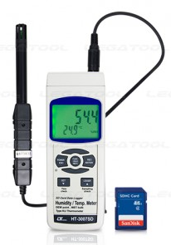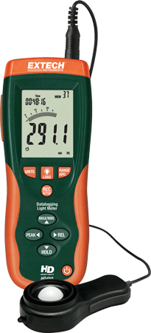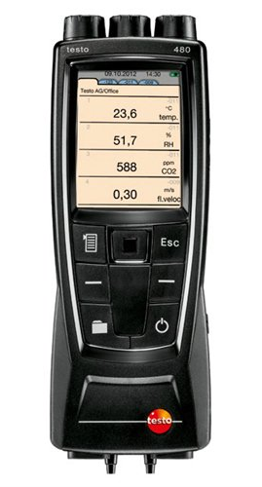
Figure 1: Measuring instruments (HT 3007SD – temperature and relative air humidity, Testo 480 - airflow velocity and HD450 - illumination)

In the Laboratory, the device HT - 3007SD is used for measuring the microclimate parameters, that is for determining the temperature and relative air humidity in the working environment. For the temperature and relative air humidity measurement, first thing to do is to connect sensor to the device, then to select measuring parameters (Humidity/Temp. " measurement.), and units in which the selected parameters will be displayed (for relative air humidity - %RH, and for temperature - °C or °F). By pressing the appropriate key, the maximum and minimum measurement values can be read, and all the test results can be recorded on the SD card. By inserting the card into the PC, where Excell Software is installed, all the measurement results can be processed and graphically displayed.
When measuring the illumination level in the working environment, the device HD450 is used. Measurement procedure includes removing the lid and displaying the white surface of the sensor, which is placed horizontally, below the light source to be measured, the measurement range is selected and the illumination level on the screen (numerical or gradient) is read out. The device can be connected to the PC, where the software is installed, a program enabling to read out, process, graphically display and print the measured values in real time.
In the Laboratory, the device TESTO 480 is used to measure the temperature and airflow velocity in the working environment. Two cards are displayed on the screen - FAVOURITES card (denotement ♦) and Int card, where the temperature and differential pressure measurements are automatically displayed. By inserting a probe for measuring the air flow velocity in the appropriate connector, another card is displayed on the screen, with a denotement representing the last three digits of the serial number of the connected probe. In total, the temperature values (TC1 and TC2) in °C degrees, airflow velocity in m/s and pressure in hPa can be read off. Measurement results can be processed and tabulated by connecting the device to a PC with the preinstalled software (EasyClimate sofware).

4. MEASURING RESULTS

Microclimate testings in College of Applied Sciences Užice are conducted in the working environment at the following workplaces: Clerk at the Student Services Department and Professor of Vocational Studies. Working environment conditions are measured in the premises of Student Affairs Office and in amphitheatre 109, where both professors and students perform their duties, in the same conditions. Microclimate tests should be carried out in the summer and winter periods, but the tests in College of Applied Sciences Užice were conducted in March 2019, with the outdoor air temperature of 15°C and relative air humidity of 71,1%.
Air temperature and airflow velocity were measured at 0.1m, 1.1m and 1.7m above the floor level for constant physical activities. Air humidity was measured at a height of 0.6 m above the floor for the sitting zone. Measuring period for determining the average air velocity is three minutes, at any location.

Work place: CLERK AT THE STUDENT SERVICES DEPARTMENT
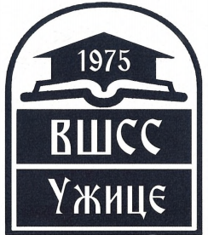 |  |  |  |  |  | WORKPLACE PARAMETERS MEASURING
19
19 19 19

MEASURING POINT DATA
Place: |  |  |  |  |  |  |  |  |  | Užice
Location: |  |  |  |  |  |  |  |  |  | College of Applied Sciences Užice
EXTERNAL CONDITIONS DURING MEASURING
Date/time: |  |  |  |  |  |  |  |  |  | 12.04.2019. god.
Air temperature, °C |  |  |  |  |  |  |  |  |  | 15°C
Relative air humidity, % |  |  |  |  |  |  |  |  |  | 71,1%
Airflow velocity, m/s |  |  |  |  |  |  |  |  |  | 0,4m/s
Illumination, Lx |  |  |  |  |  |  |  |  |  | 950Lx
DATA ON WORKPLACE WHERE MEASUREMENT IS PERFORMED
Workplace: |  |  |  |  |  |  |  |  |  | Clerk at the student services department
Aeration: |  |  |  |  |  |  |  |  |  | Natural
Heating/cooling: |  |  |  |  |  |  |  |  |  | Radiator / air condition
Description of the workplace (purpose, processes, work operations), working premises, space and immediate surroundings:

Performs enrollment of students to proper year of study and semester verification, performs all the activities related to student’s paper and electronic records, keeps the records of student’s payments, processes submitted requests for issuing resolutions, decisions, certificates, etc., kindly and professionally works with students and other parties at the counter, keeps records of passed exams, conducts activities concerning acceptance, control and archiving of examination applications, keeps and updates student’s files, conducts activities regarding disenrollment of students, performs expert analysis within his competence and prepares complex reports, based on the order received and defined procedures, etc.
Workplace scheme:  a) without luminaires  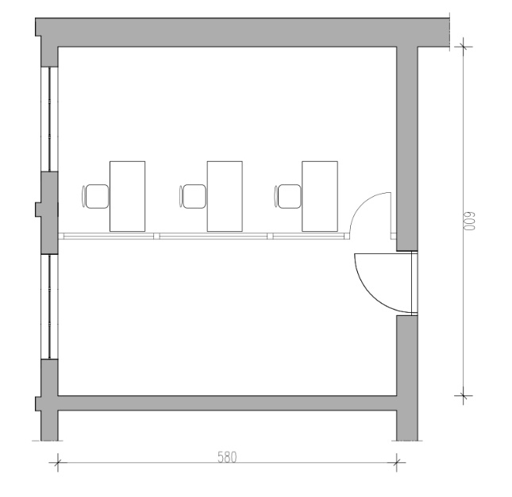 |  |  |  |  |  |  |  |  |  |  |  |  | 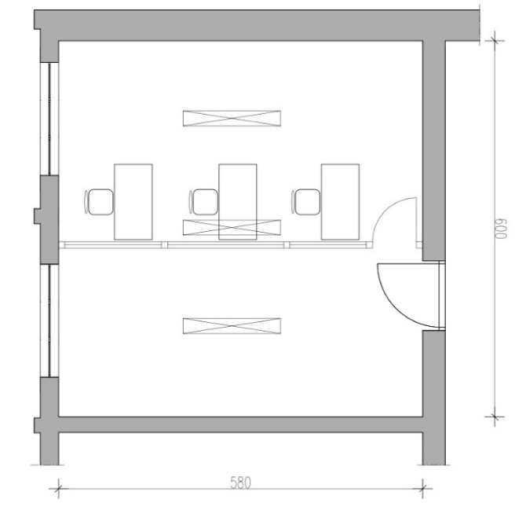  b) with luminaires
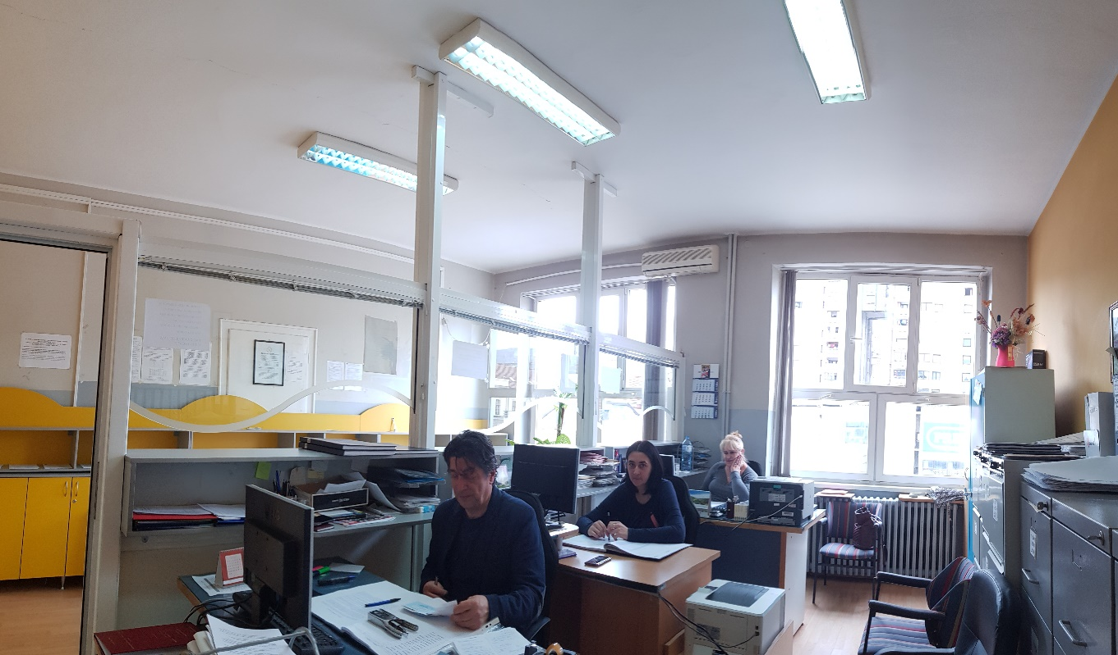
Workplace photo:
 |  |  |  |  |  | REPORT ON WORKPLACE MICROCLIMATE PARAMETERS MEASURING
20
20 20 20

MICROCLIMATE PARAMETERS MEASURING RESULTS
Outdoor air temperature
Type of work: |  |  |  |  |  |  |  |  |  | - Easy work (without physical strain)  - Medium work (light physical work)  - Heavy physical work
Microclimatic parameters: |  |  |  |  |  |  |  |  |  | Allowed values |  |  |  |  | Measured values |  | Results assessment
Air temperature, °C |  |  |  |  |  |  |  |  |  | max 28°C |  |  |  |  | 20.2°C |  | Satisfying
Relative air humidity, % |  |  |  |  |  |  |  |  |  | max 73% |  |  |  |  | 63% |  | Satisfying
Airflow velocity, m/s |  |  |  |  |  |  |  |  |  | max 0,5 m/s |  |  |  |  | 0 m/s |  | Satisfying
Potential risks: |  |  |  |  |  |  |  |  |  | Uneasy feeling |  |  |  |  | YES/NO |  | Chronic diseases |  |  |  |  |  |  | YES /NO
 |  |  |  |  |  |  |  |  |  | Obstruction of activities |  |  |  |  | YES /NO |  | Headache |  |  |  |  |  |  | YES /NO
MEASURING EQUIPMENT DATA
1. |  | HT - 3007SD for microclimate parameters measuring, i.e. determining the temperature and relative air humidity in the working environment.
2. |  | Device TESTO 480 – a digital anemometer, a probe for measuring the air flow velocity.
 |  |  |  |  | REPORT ON WORKPLACE ILLUMINATION MEASURING
20
20 20 20

DATA ON SOURCES IN THE NEAR ZONE
Light source |  |  |  |  |  |  |  |  |  |  | Type of illumination
- Daylight |  |  |  |  |  |  | - Artificial |  |  |  | - general |  |  |  |  |  |  |  | - supplementary
 |  |  |  |  |  |  |  |  |  |  | - indirect |  |  |  |  |  |  |  | - mostly direct
 |  |  |  |  |  |  |  |  |  |  | - mostly indirect |  |  |  |  |  |  |  | - diffuse
Type of electric source |  |  |  |  |  |  |  |  |  |  | Lighting driving force conditions
 |  |  |  |  |  |  |  | - fluorescent |  |  |  |  |  | - on |  |  |  |  |  | - off
NATURAL ILLUMINATION MEASURING |  |  |  |  |  |  |  |  |  |  | MEASURING OF THE NATURAL AND ARTIFICIAL ILLUMINATION COMBINED
Measuring point |  |  | Measured values  (Lx) |  |  |  |  |  |  |  | Measuring point |  |  |  |  |  |  | Measured values  (Lx)
1 |  |  | 200 |  |  |  |  |  |  |  | 1 |  |  |  |  |  |  | 700
2 |  |  | 550 |  |  |  |  |  |  |  | 2 |  |  |  |  |  |  | 750
3 |  |  | 600 |  |  |  |  |  |  |  | 3 |  |  |  |  |  |  | 850
4 |  |  | 350 |  |  |  |  |  |  |  | 4 |  |  |  |  |  |  | 750
Mean value |  |  | 425 |  |  |  |  |  |  |  | Mean value |  |  |  |  |  |  | 762,5
MEASURING RESULTS
Request by type of activity |  |  |  | Required values |  |  |  |  |  |  |  | Measured values
 |  |  |  | Minimal average illumination (Lx) |  |  |  |  | Uniformity |  |  | Average illumination (Lx) |  |  |  | Minimal illumination (Lx) |  |  | Uniformity |  | Results assessment
 |  |  |  | 300 |  |  |  |  | 1:1,5 |  |  | 762,5 |  |  |  | 700 |  |  | 1,09 |  | satisfies
MEASURING EQUIPMENT DATA
1. | Device HD450, for measuring the illumination level in the working environment

Workplace: PROFESSOR OF VOCATIONAL STUDIES
 |  | WORKPLACE PARAMETERS MEASURING
21
21 21 21

MEASURING POINT DATA
Place: |  |  | Užice
Location: |  |  | College of Applied Sciences Užice, Amphitheatre 109
EXTERNAL CONDITIONS DURING MEASURING
Date/time: |  |  | 12.04.2019. god.
Air temperature, °C |  |  | 20,2°C
Relative air humidity, % |  |  | 71,1%
Airflow velocity, m/s |  |  | 0,4 m/s
Illumination, Lx |  |  | 950Lx
DATA ON WORKPLACE WHERE MEASUREMENT IS PERFORMED
Workplace: |  |  | Professor of vocational studies
Aeration: |  |  | Natural
Heating/cooling: |  |  | Radiator/air condition
Description of the workplace (purpose, processes, work operations), working premises, space and immediate surroundings:
Amphitheatre 109 is designed for teaching, courses, roundtables, ceremonies, etc.
Professor of vocational studies prepares and conducts teaching, as well as other forms of work specified by the study program, monitors and implements innovations in teaching methods, organizes and implements various forms of tests and exams, organizes and effectuates individual and joint professional work with students, participates in implementation of research and development projects, participates in various activities relevant for the quality and development of education at all levels, including lifelong learning.
Workplace scheme:  a) without luminaires  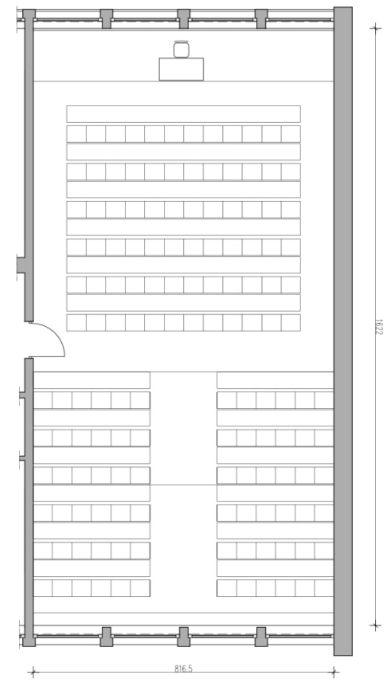 |  |  |  | b) with luminaires  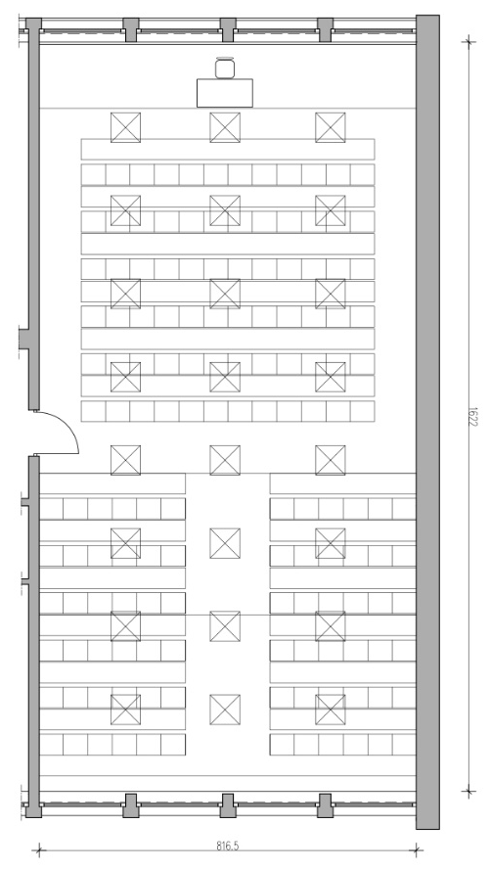
Workplace photo:
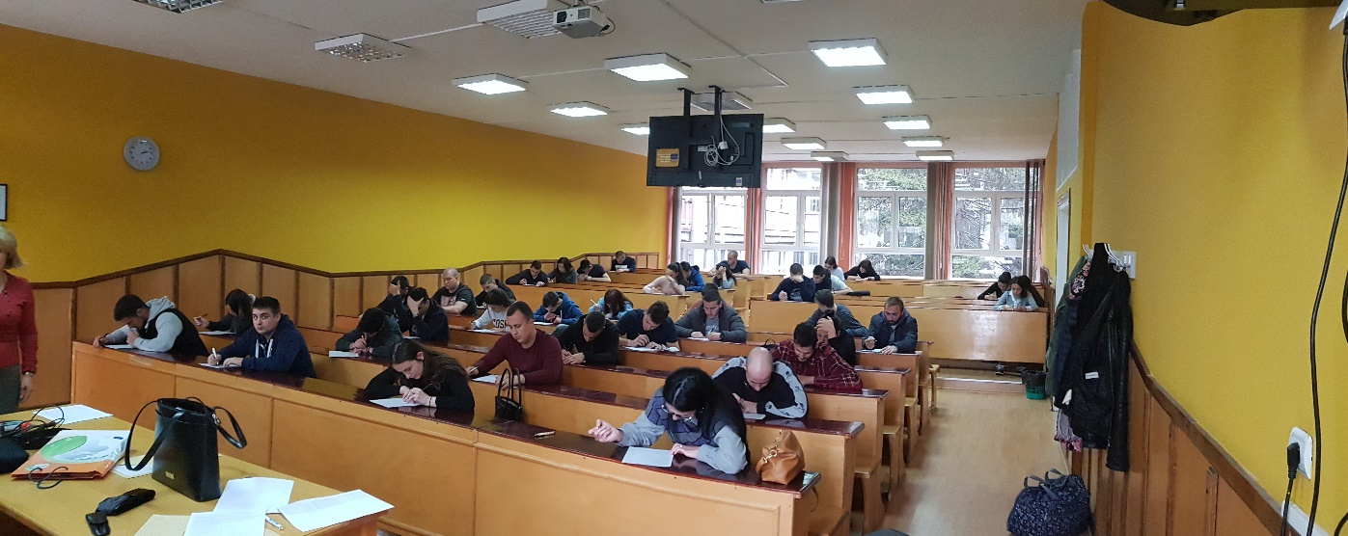

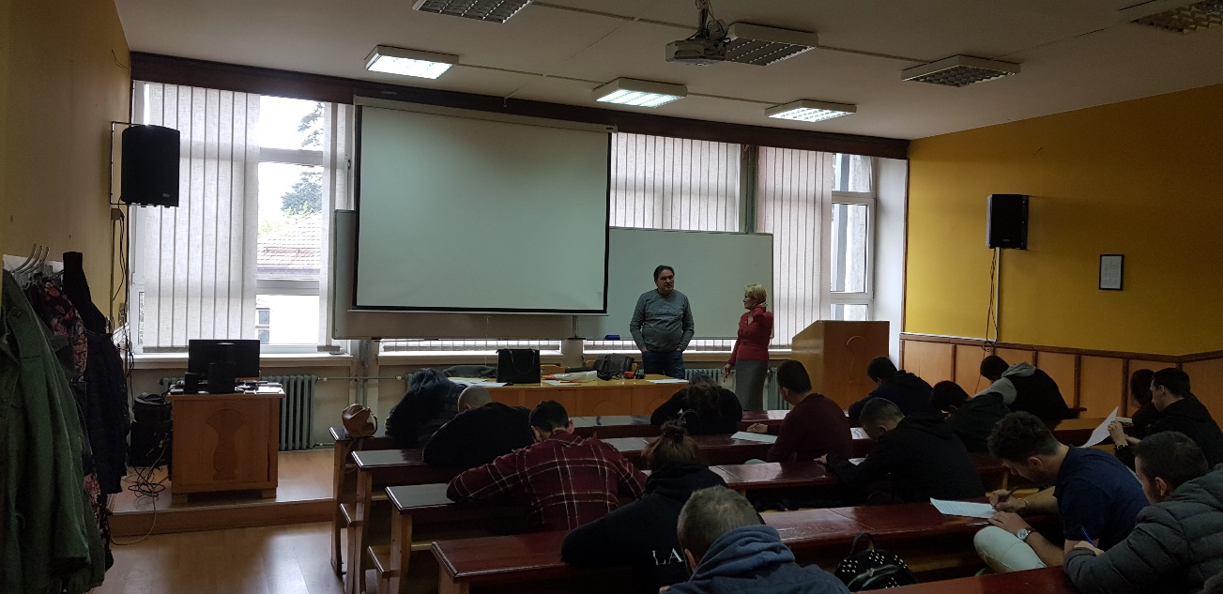
 |  | REPORT ON WORKPLACE MICROCLIMATE PARAMETERS MEASURING
23
23 23 23

MICROCLIMATE PARAMETERS MEASURING RESULTS
Outdoor air temperature
Type of work: |  |  | - Easy work (without physical strain)  - Medium work (light physical work)  - Heavy physical work
Microclimatic parameters: |  |  | Allowed values |  | Microclimatic parameters: | Allowed values
Air temperature, °C |  |  | 18 - 28°C |  | 22 | Zadovoljava
Relative air humidity, % |  |  | max 75% |  | 45 | Zadovoljava
Airflow velocity, m/s |  |  | max 0,6 m/s |  | 0 | Zadovoljava
Potential risks: |  |  | Uneasy feeling |  | YES/NO | Chronic diseases |  | YES /NO
 |  |  | Obstruction of activities |  | YES /NO | Headache |  | YES /NO
MEASURING EQUIPMENT DATA
1. | HT - 3007SD for microclimate parameters measuring, i.e. determining the temperature and relative air humidity in the working environment.
2. | Device TESTO 480 – a digital anemometer, a probe for measuring the air flow velocity.
3.

 |  |  |  | REPORT ON WORKPLACE ILLUMINATION MEASURING
23
23 23 23

DATA ON SOURCES IN THE NEAR ZONE
Light source |  |  |  |  |  |  |  | Type of illumination
- Daylight |  |  |  |  | - Artificial |  |  | - general |  |  |  |  | - supplementary
 |  |  |  |  |  |  |  | - indirect |  |  |  |  | - mostly direct
 |  |  |  |  |  |  |  | - mostly indirect |  |  |  |  | - diffuse
Type of electric source |  |  |  |  |  |  |  | Lighting driving force conditions
 |  |  |  |  |  | - fluorescent |  |  |  | - on |  |  |  | - off
NATURAL ILLUMINATION MEASURING |  |  |  |  |  |  |  | MEASURING OF THE NATURAL AND ARTIFICIAL ILLUMINATION COMBINED
Measuring point |  | Measured values  (Lx) |  |  |  |  |  | Measuring point |  |  |  | Measured values  (Lx)
1 |  | 350 |  |  |  |  |  | 1 |  |  |  | 655
2 |  | 400 |  |  |  |  |  | 2 |  |  |  | 725
3 |  | 440 |  |  |  |  |  | 3 |  |  |  | 745
4 |  | 290 |  |  |  |  |  | 4 |  |  |  | 700
Mean value |  | 370 |  |  |  |  |  | Mean value |  |  |  | 706,25
MEASURING RESULTS
Request by type of activity |  |  | Required values |  |  |  |  |  | Measured values
 |  |  | Minimal average illumination (Lx) |  |  |  | Uniformity |  | Average illumination (Lx) |  | Minimal illumination (Lx) |  | Uniformity |  |  | Results assessment
 |  |  | 500 |  |  |  | 1:1,5 |  | 706,25 |  | 655 |  | 1,07 |  |  | zadovoljava
MEASURING EQUIPMENT DATA
1. | Device HD450, for measuring the illumination level in the working environment.

5. CONCLUSION

Achieving the auspicious working environment conditions enables working in optimal conditions, which is positively reflected on workers' health and working capabilities. Although exposure to inadequate microclimate values does not pose a direct risk to humans, excessive and long-term exposure to unsuitable values can damage the organism and affect the quality of life.
Testing and measuring of the microclimate parameters (air temperature, relative air humidity and air flow velocity) in the working premises of the Uzice College of Applied Sciences has shown that these parameteres correspond to the required values.
On the basis of the performed measurements and tests, the values obtained are within the limits of the required minimum average illumination at the workplace.

REFERENCES

[1] Zakon o zaštiti na radu („Sl. Glasnik RS“, br. 135/2004, 36/2009, 36/2009 - dr. zakon, 72/2009 - dr. zakon i 43/2011 - odluka US, 14/16),
[2] Pravilnik o postupku pregleda i ispitivanja opreme za rad i ispitivanja uslova radne okoline, „Službeni glasnik RS“, br. 94/06 i 108/06.
[3] Pravilnik o preventivnim merama za bezbedan i zdrav rad na radnom mestu „Službeni glasnik RS“, br. 21/09.
[4] Standard SRPS EN 12464-1:2012 – određivenje inteziteta osvetljenosti za radna mesta u zatvorenim prostorima.
[5] Standard SRPS EN ISO 7726, oktobar 2008 Ergonomija toplotne sredine - Instrumenti za merenje fizičkih količina
[6] SRPS U.C9.100:1962 – Dnevno i veštačko osvetljenje. 9.
[7] SRPS EN 12464-1:2012 – Svetlost i osvetljenje - Osvetljenje radnih mesta - Deo 1: Radna mesta u zatvorenom prostoru.
[8] Veličković M., Lenard J. D., Mudri Lj. Prirodno osvetljenje prostora – zašto, kako i koliko? 2009. Online: http://www.dososvetljenje.org.rs/

