DARK TOURISM IS A FORM OF MORBID TOURISM
Spec.mtd. Bojana Janković; Msc Nenad Milutinović
College of Applied Science Užice, in Uzice, Serbia

Abstract: Dark tourism is a form of morbid tourism, that’s widespread since the Middle Ages. This is a problem, because that’s not enough explored and understood. Because, dark tourism is, actually, like as other forms of morbid tourism, a disease that requires treatment. The goal of this paper is, exactly, pointing on a problem that devastate, on a quite and strategic way, the tradional tourism. Results of this and all other research should be useful to everyone whose engage in development of tourism in destination and to tourists, the real and potential users of tourist services.

Keywords: morbid tourism, dark tourism, problem

1.INTRODUCE

Tourism is an art of realization the idea in unimproved places in the time of creating funds and freedom. Tourism is love that develops entire economy of the country, in that we have to invest all time. The touristic, as like as all other market, moves the borders of supply and demand, where the tourist supply depends of the tourist demand, while modern tourst demand depends of the tourist supply in modern ice age, that implies regression the man in the progress thechnology. [1] Because, if one man is not devised the warm water, other man will not ask for it. If Nikola Tesla was turned on the light, why other people turn off it one? Is that the end or an inception of tourism? An asnwer depends of our courage to see the deep under surface of the light. Because, an every inception has own the end, and every the end has own an inception.
Is the dark under the light, does someone make the transplatation of the touristic organs? You will understand an answer in continue of this paper.

2.MORBID TOURISM

Morbid tourism is a consequence of modern life and modern understanding the tourist trends. Although, morbid tourism, as phenomenon and as an acitivity, tooks a leading position at the tourist market, a long time ago, the same one is not a field of research and study. Because, the modern way of life has not the time and freedom to swim in deep water, and a modern undesrtanding the tourst trends implies copying the world trend, considering that all coming from somewhere are good, all from our own are bad. Trend says that our village is not adequate tourist destination, but Medellin, the city of the famous deceased the kong of cocaine, a city of crime – sex tourism, is an ideal tourist destination, after numerous monotonous sea waves. To „refresh“ the tourism, to breake „established“ tourist destinations. Inovations are welcome, whatever ones are, black or gliterring black, all those are „an attractive darkness places“. Because, someone have to destabilize a destabilized society. And morbid tourism (the toursm of suffer) will do it on the best way. Who else?
Morbid tourism represents all tourist visit to a glittering-black decorated destinations thats make the destabilization and suffering of all and everyone.
The reasons of engage of this theme are an consequensces by morbid tourism nad try to stop or reduce the devolop and expansion the morbid tourism, and in useful of traditional and some of contemporary forms of tourism. However, we, with our silience, approve all bad things that happening in the world tourism, all nad things that happening during the free time and work time. But, we can to stop the devolop of morbid tourism, while we breathe. [2];[1]
However, by silence, we approve of the bad things that are happening in the world of tourism, all the bad things that happen during the free and working time of the society. As long as we breathe and we can stop the further development of morbid tourism. [2]; [1]

Forms of morbid tourism

Forms of morbid tourism are: 1. Disaster tourism; 2. Dark tourism (war tourism, transplatation tourism, public grave’s tourism, crime tourism); 3. Sex tourism (male, female, juvenile sex tourism); 4. Vicious tourism (drug tourism, alco-tourism, the tourism of tobacco industry, casino tourism); 5. Vamp tourism and 6. Virtual tourism (3 D virtual trips and 3 D virtual games for potential tourists and investors, bookish and filmy tourism).
All of these forms and subforms has its own combination and no one is creativity, nor creation art, nor tourism, nor modern, but the destruction of tourism, suffering the free time and work time, rrespectively, the normal modern and traditional forms in tourism, and imposing the pain and suffer through the low by power. [10]
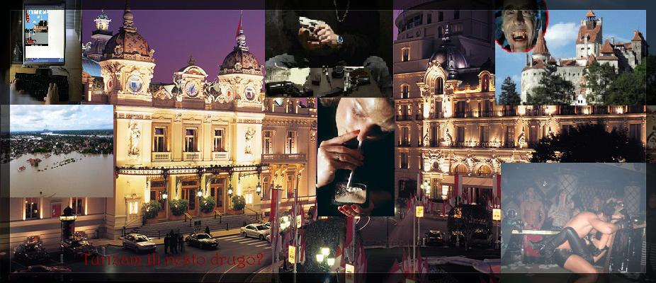
Slika 1.: Morbid tourism (forms) [10]

Destination of morbid tourism:

„Nuclear disaster in Chernobyl 1986., Eartquake in Japan 2011., Eyyjafjallajokull Volcano 2010., Floods in Obrenovac and other cities in Serbia and Bosnia and Herzegovina in May 2014., wildfire in Mati (Greece) in August 2018.; an example of sex tourism is Thailand (Bangkok, Pattaya), that’s, with help by US and the World bank, became the industry of sex, in time of Vietnam war, and then „an ideal“ destination of sex tourism; Vicious tourism giving Netherlands for drug tourism, Slivovica (West Serbia) for alco-tourism through the traditional Rakijada festival, and tobacco indusrty tourism could be and should not be the leading tours in poorly developed countries, especially the countries of the ex Yugoslavia, where cigarettes burning the most money, but the tour should start in America, where the tobacco plant was took notice at 1st century BC, and that 15th October be the world day of tobacco tourism, because Christopher Columbus got a gift the leaf of tobacco by American Indians, that date in 1492. Monte Carlo is the most popular destination of casino – tourism; and the Castle of earl Dracula in Transylvania is the first association for vamp tourism. The virtual tourism, as like as introduce in tourism, emphasizes YTF Uzice (Serbia), Kustendorf in Mokra Gora (Serbia), Trash film festival in Gradiska (Bosnia and Herzegovina), book fair (Belgrade, Berlin...), books: „Boy from the yellow house“ by Sasha Milivojev, „Serbian heart by Johannes“ by Veselin P. Dzelatovic, „Death is unverified rumor“ by Emir Kusturica, „Closing time in Sarajevo“ by PhD Nele Karajlic, „Jelena 1 and Jelena 2“ by Mile Kordic, etc; movies and series: Beautiful villages nice burn, Dying out, Life is a miracle, Budva on the foam of the sea, Octopus, Dangerous games, Saint Tropez, Magnificient Suleiman, Institute, The tourist, Assassin, Matrix, etc.“ [1] [10] [11] Destinations of dark tourism will presente in next lines.
We devoted the special attention in this paper to an analysis of dark tourism, a generic name for the phenomenon that includes presentation the real and commodified deaths, organized tourist visits to locations: battlefields and scaffolds, where done mass murders or genocides, graves and tombstones, places where celebrities died, prisons, dungeons with cells and devices for torture, monuments of wars, [3] and as an inevitable form in dark tourism today, we add places of terrorist attacks. These are normal for someone. Someone enjoys in this. Someone looking throug the pink glasses and does not want to feel the pain of reality. But, education have to talking about this. We were enough suffered.

3. DARK TOURISM

The first tour, of the darkest human nature, with a guide, organized in Cornwall 1838., to see hung the murders. Also, battlefields in Waterloo attracted the tourists, so that way of tourist trips called tanatottourism. In XIX century, visits to morgues were constituent of tourist supply by Paris, like as forerunner of exhibitions in London (Body Wolds), Tokyo, Los Angeles, and so on.
The study of dark tourism is justified and important for several reasons.
Dark tourism is a touris trip in places of suffering, victims and death, desecration the tragic past in re-suffering. We can free call „bloody tourism“ this form in morbid tourism, because we make that blood go out of victims when we present bloody past. Also, tourists whose watching and listening about it become bloody. [1] [10]
The nature of places of dark tourism point to interconnected problems requires research, understanding and solving this problem. That include: 1. Ethical / moral problems, 2. Media / promotional problems, 3. Interpretation / political problems, 4. The problems of directing and government, and 5. Sociocultural / tanatological problems. [5]

3.1. The tourist motivation in dark tourism

Many people agree that motivation in dark tourism is multi-dimensional, because of different understand of tragedy, which is associated with human suffering. Motivation comes from different psihological consciousness of visitors and internal push for the visit to tragecical places. Also, the dissimilarity of motivation evident is in different attitude about circumstance in that tragedy ensued, especially, when word is about the suffer of people whose are and consequence the society conflicts bigger dimensions as like as wars, genocides, etc. Differences in intesity of motivation comes from more reasons, that every individual looks the tragedy from ones aspect and with individual level. Some people have a bigger self-control, while other visit that places and being deep stressed. [6]
According to an interest of tourists for the theme of death, there is 4 kind of dark tourism:
Prema interesu turista za temu smrti, razlikuju se 4 vrste mračnog turizma [5]:
- Pale tourism – tourists whose have a minimal or limited interest for death theme and visiting random places and attractions of dark tourism.
- Gray tourist demand – tourists whose are fascinated the death theme and visiting random places of dark tourism.
- Gray tourist supply – purposely made places with goal an exploitation the death and attracts the visitors with interest for death theme.
- Black tourism – „pure“ dark tourism that’s characteriized fascinated death.

3.2. Pertition of dark tourism in supply contest

Except the pertition according to interest and motivation of tourists, an important characteristics are an authenticity places and time that’s Stone made shades in localities of dark tourism. According to this pertition, touristic product is more pale an less authenitical that farther time and place of historical happend. Visitors are more intensely experiencing the authentic place of tragedy and happend in closer past. Except time differences and authentic, causes of tragedy and weight of one impact on
Differentiation places of dark tourism. [6]
Philip Stone proposes a typology of seven sources of dark tourist attractions from theme park of dark tourism as the brightest to concentration camps as the darkest attractions [5]: dark theme parks, dark exhibitions, dungeons and prisons, cemeteries and mass graves, sanctuaries (close to the place of death), cities of major conflicts, concentration camps.

3.3. The forms of dark tourism

Subforms in morbid tourism, and forms in dark tourism are: The public death through the tourism, crime tourism and war tourism. [11]
Public death through tourism, that is, cemetery tourism presents visits to locations where celebrities have died or killed, as well as visits to the cemeteries on which they are buried: graves of Merlin Monroe, Michael Jackson, Elvis Prisley, Princess Diana (certainly a tunnel where the princess the place visited by tourists), Dostojevsky, Ivo Andric, Alekse Santic, Jovan Ducic, Desanka Maksimovic, "House of flowers" - mausoleum of Josip Broz Tito, Njegos mausoleum in Cetinje, grave and museum of Tose Proeski; on the southern side of the Novodevichy Monastery in Moscow, the cemetery of the famous, famous Parisian cemetery Pere Lachaise, in Serbia, the giant of the giant in Belgrade ... that tourism sings dying or that tourism dies singing ?! [10]
Crime tourism is touristic travels in palces of popular criminals whose are in prison or they are death: their houses, settlements, places of their movements and acts (The tour of Pablo Escobar, La Casa Nostra, Mafia from Zemun, Pink Panters, mafia from America, Albania, Croatia, Montenegro, Russia...), prisons as like as Alcatraz in San Francisco. [11]
War tourism is every visit to areas, that are, in far or close past, were in war, and that are use in an aim of „education“ today. There is not important that is main destination, bypass destination or facultative excursion. Just use it. Abuse the tourism. We can give commemorate to victims on other way. No abuse tourism. Because, war tourism is causative-consequence connection between war and war, prolonged mission war in peace. [10]
War tourist arrangements exist since 1854., when Henry Gaze began war tourist tour „watch battle field near the Wateloo in Belgium“. Also, there is „Field of death in Cambodia“, concentration camp and Auschwitz-Birkenau death camp in Poland, Memorial park of peace in Hiroshima in Japan (nuclear attack) and many other that reflects suffering from far past, and that include tour war arrangements from closer dates: Iraq, Syria, Libya... and so on, and of course, the tourist arrangement „Break SFRY“, that started since the Ronald Reagan’s governance that made the plane for destruction SFRY in name called „The directive od national security 133“, and then in 1979., Germany with cooperate with secret services of US was formed the team of secret agents in Zagreb, with mission to promote ethnic hate that comes to break Yugoslavia - with mass riots in Kosovo and Metohia – Albanian people were enounced destruction Yugoslavia at 11st March 1981, later, opened war in Croatia 1991., Bosnia and Herzegovina 1992., to 21st Novmeber 1995, when ended of war, with Dayton agreement. [7]
And Yugoslavia broken. During the war, were many unforgettable horrors, murders, genocides, rape, massacres, demolitions of cities, bridges ... From this war there are, also, facultative excursions: Nor silver not gold (Srebrenica, 11st July 1995), Blaze (1st – 3rd May 1995.), Storm (4th and 5th August 1995.), The yellow hous at the end of village – Transplatation tourism un yellow house (village Robe, North Albania, where Albanian operated and took organs by Serbian and unalbanian people ... ) [10] After that, the mission of deplated uranium on Balcan „Operation by Allled Force“ – 24th March – 10th June 1999 – and for that NATO agressors are not criminally punished, whose were bombed SR Yugoslavia, and that feel today.
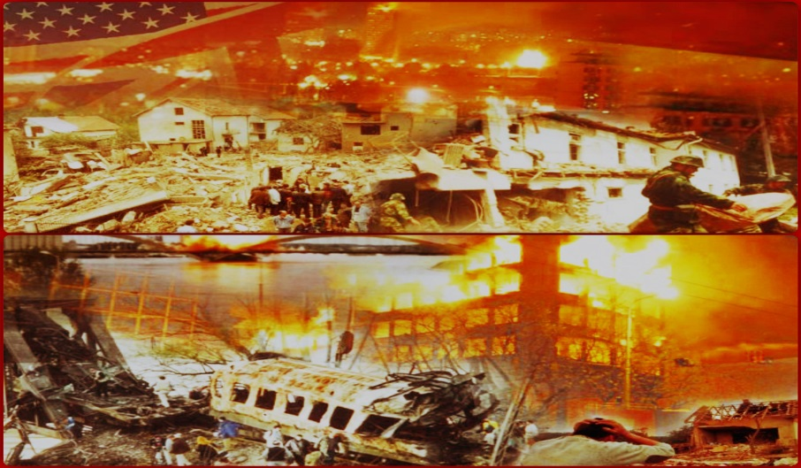
Slika 2.: NATO Agression to Serbia 24th March – 10th June 1999. [12]

If we remember how US became, will be US an ideal tourist destination and land paradise? Is one power or war tourist arrangement „The Third War“ can to start?

4. TERORISM – LINES BETWEEN TERRORISM AND TOURISM

The big changes that happend over the years on geopolitical plan, as consequence of terrorist attacks, influenced on a fall of the economy. Tourism is an field on that terrosm has a direct impact, because the that giving publicity to terrorists, with message of injured tourists, destroyed cultural significance or infraastructure, that send to the world.
Today, there are numerous studies that engage with the lines between terrorism and tourism, where most confirm that the attack of tourists and tourist destinations is intentional, because it brings publicity, the destruction of the region's economy, the imposition of ideology. Sonmez claims that global tourism and terrorism are paradoxically lines through common features, such as crossing national borders, involving residents of different countries and using communication technologies. [8]
Since the become of terrorism, goal and motives of terrorist attacks were changed . When we talk about international terrorism, tourist destinations are on the target of attack. List targets included the various objects – airplanes, buses, restaurants and cafes, festivals, cultural and sport manifestations. At the end of ’70s, a numerious terrorist attacks were intenified, and at the start od ’90s, terrorist attacks were happend in popular tourist destination. That trend is continue today.
Places of terrorist attacks on tourist destination have a long list, but we extract some of those:
* Franch (1800., 1835., 1858., 1961, 2015., 2016.)
*US (bombed WTC 1993., bombed Ocklahoma 1995. And explosion in Atlantic during the Olympic games 1996., and the most famous terrorist attack on WTC 11st Spetembre 2001., where demolished twins, and according to the latest research, the reason of that famous is in an answer was it terrorist attack or something else (https://www.kurir.rs/planeta/3042529/video-kakav-sok-u-americi-ministarstvo-pravde-dobilo-nove-dokaze-o-napadu-11-septembra-nije-onako-kako-izgleda-evo-sta-je-srusilo-kule-bliznakinje).

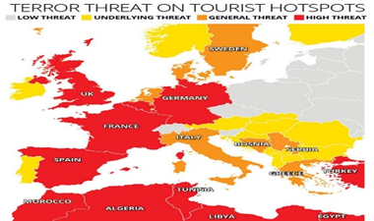
Slika 3.: The map of dangerous by terrorist attacks [13]

The list of terrorist attacks is long, and if any attacked place could use for tourism purposes, then terrorist tourism would be highly ranked on the list of utilizing the capacity of terrorist tourist destinations. According to the map of the danger of terrorist attacks, Croatia is marked as a basic menace, while the safest countries and as tourist destinations are: Switzerland, Czech Republic, Poland and Slovenia.

5. CONSLUSION

One of an important aspect of equilibrium is the relationship between educational and entertaining character. Since this is a place of human suffering, misfortune and death, sensitivity must manifest itself, both to the dead and to their living relatives, who rightly expect such sites to be treated in a dignified manner. [9]
During the research of morbid tourism, the authors came to the conclusion of tourists, creators of these forms, tourist, and educators, that there are tourists who like to visit such destinations. Also, there are a justification that this is an educational character and / or giving honor to the victims. It is true that exist. But, this is no a subjcet of taste that we no talking about taste. Demands no exist without the supply. Education and giving a honor to victims on other way. Especially dates and that just for it purpose. Without an abuse of tourism. Because, the tourism is and art that loving. Morbid tourism is not love, nor art, nor tourism. Morbid tourism is desecration the life, desecration the death, desecration the tourism. Dark tourism is one of forms in morbid tourism, the tourism of suffering.
Where you will on holiday at this summer? Maybe, Jasenovac is the best destination. To sunbathe on bones of Serbian victims and cure the rheumatism. And Margel Tourist Institute, in cooperate with Documentation Information Center Veritas, could lead you on excursion in camp Jadovno. What is the tourism, today?
Will we keep calm and approve, because life, so and death, man habits to all?! And there is enough that we stand up and stop that black and glittering black tourism.

LITERATURE

- Janković, B., Morbidni turizam – specijalistički rad, Užice, Visoka poslovno-tehnička škola strukovnih studija, 2016.
- PutujSigurno, turistički portal
- Rabotić, B., Selektivni oblici turizma, predavanja, Beograd, Visoka turistička škola strukovnih studija, 2012. god.
- Stone, Philip R., Death, Dying and Dark Tourism in Contemporary Society: A Theoretical and Empirical Analysis, Lancashire, 2010
- http://www.history.com/this-day-in-history/achille-lauro-hijacking-ends,pristup 5.08.2015.
- http://www.iags.org/costof911.html (pristup 19.8.2017.)
- Šaran, Lj., Američka uloga u raspadu Jugoslavije i nastanak država s „grčkim sindromom“, Hrvatska, članak Matrix World, http://www.matrixworld.com , 2015
- Sonmez, S.F., (1998.), Tourism, terrorism, and political instability, Annals of Tourism Research, Vol. 25, 1998.
- Petrić, L. : Osnove turizma, Sveučilište u Splitu, Split, Ekonomski fakultet, 2003.
- Janković, B., Milutinović, N., Morbidni turizam – stradanje turizma, Užice, Visoka Poslovno-tehnička škola strukovnih studija, 2016.
- Janković, B., Morbid tourism with accent on war and crime tourism, Lumbert Academic Publishing, Subricken, Germany, 2016
- https://www.srbijadanas.com/vesti/info/nikada-zaboraviti-ovih-19-drzava-je-bombardovalo-nasu-zemlju-video-2018-03-24

B.Janković, Morbidni turizam, Užice, 2019
US are as like as country built on slavery and exploitation of black people. An American nation formed on a blood, bones, lands and property by a more millions tortured and killed Indians – the real owners of this State… O., Platonov, Zašto će propasti Amerika (Why an America will calamity), prevod dela (translated) Laus, Split, 2002
http://jugoslavija.forumsr.net/t48-ustake-lazi-o-jasenovcu

